TECHNICAL SPECIFICATION FOR CONSTRUCTION
Reconstruction and Restoration of the Residential Annex Building
According to the Requirements of
the Embassy of the Republic of Latvia to the United States of America
Table of Contents
Section 1: The RFP 2
Section 2: Design Changes to Floor Plans 9
Section 3: Design Changes to Courtyard 17
Section 4: Known Structural Conditions & Corrective Work 22
Section 5: Known Work by Division 24
Section 6: General Conditions 29
Section 7: Deduct Alternates 43

Section 1: The RFP
- General Project Information
  - Project Name: Reconstruction and Restoration of the Latvian Embassy Annex Building at 2304 Massachusetts Ave., NW Washington DC according to the requirements of the Embassy of the Republic of Latvia to the United States of America.
  - Project Purpose: To provide support spaces for the embassy when hosting events and to offer visiting personnel residential accommodations when travelling from abroad. The following regulations published by the Environmental Protection Agency (EPA):
  - Address of the property:
2304 Massachusetts Ave NW, Washington, DC 20008, United States
  - Proposal Type: To make changes to the Construction Documents in accordance with the Client's instructions, to renew the building permit, to reconstruct the buildings and perform site improvements.
  - User: Embassy of the Republic of Latvia to the United States of America.
  - Client:
State Joint Stock Company "State Real Estate"
Talejas iela 1, Latvia, Rīga, LV-1026,
phone: +371 65407922, e-mail: vni@vni.lv.
  - Client Contact Representative:
Senior Development Project Manager
Herberts Bucenieks,
e-mail: herberts.bucenieks@vni.lv phone: +371 29823878
- Terms Used
  - Client: State Joint Stock Company: State Real Estate of Latvia
  - DB: Design Builder - the designer and the building general contractor.
  - Author Supervisor: the architect of record and the engineer(s) who will develop the design documentation.
  - CDs: Construction Documents - the existing design documentation attached as Annex No. 1 and 2.
  - Works: all works to be performed by the DB in accordance with the laws and regulations governing construction, the Technical Specifications, the requirements of the Client and other responsible authorities.
  - Tender: Response to the RFP
- Project Location & Documentation
  - The project entails renovating the interiors, exterior facades, and rear courtyard and of a residential building. The building is a four-story (basement included) 1910 row home and is located on the prominent Mass Ave Circle. It shares two party walls, west wall with the Latvian Embassy and the east wall with the Turkish Ambassador’s residence. The rear yard cascades into Rock Creek Parkway.
  - The Client had a previous contract with another General Contractor who was removed from the job; the contract was terminated in May 2022. This contractor demolished and disposed of integral architectural features and elements that defined the historic character of the home.
  - Photos showing the building prior to construction are available to review.
Refer to the Annex 6: Site Photos BEFORE the Commencement of Construction Works.
  - Photos showing the progress of the previous Contractor and current state of the building are also available to review.
Refer to Annex 4 and 5: Site Photos AFTER the Suspension of Construction.
  - The existing drawing sets contained errors which unintentionally lead to the removal of the wooden interior finishes, historic and all. The drawing set was completed by a Latvian architecture firm JaunRīga Eco and their US partners Atelier MjK. They are dated July 28, 2020, with revisions published on February 16, 2021. The current architect of record, Atelier MjK, is no longer in business. The Construction Documents are available for DB’s reference and use.
Refer to Annex 1 and 2 Construction Design.
  - Prior to the design phase, JaunRīga Eco completed an extensive existing building conditions survey entitled Technical Study Report in 2021. This survey is available for the DB’s reference and use.
Refer to Annex 2 Technical Survey Report.
- RFP Intent & Project Description
  - It is the intent of this RFP is to procure a Design-Build Contractor and their selected team of professional consultants that will repair, restore, and build anew the interiors, exteriors, and grounds of the Latvian Annex Building.
  - The Client will enter a fixed amount with the DB under a design and build contract.
  - This project scope will carry out the work intended in the original Construction Documents and to replace selected portions of the historical features to the house. The emphasis of the historic restoration is to be reserved for the first-floor public spaces. And although, the Client appreciates the lost historic elements, a historically accurate restoration is not required; the final interiors can mimic those illustrated by the pre-demolition photos.
  - The project will be divided into two phases: 1.) Amend the existing Construction Documents in line with the Clients’ goals defined by these Technical Specifications, the existing conditions, & the awarded budget, and 2.) using those amended drawings, and staying within the awarded budget, restore and rebuild the Annex to full functionality.
  - The DB shall make amendments and additions to the design in accordance with the Technical Specification and the found building conditions.
  - The DB will procure additional surveys required by these Technical Specifications to inform the revised design.
  - The DB shall use the existing Construction Documents, these technical specifications, the building condition, and further building surveys to amend the existing and draft a new set of Construction Documents for Construction.
  - The modified or amended design shall in no way reduce the scope of construction to be carried out, as defined in the Construction Drawings and Specifications.
- Laser Scanning
  - The Design-Builder (DB) shall be responsible for carrying out laser scanning and generating the point cloud using either a terrestrial or a mobile laser scanner as part of the Project.
  - The point cloud shall be used as the source data for BIM modelling and the development of the Design Documentation.
  - The point cloud shall take precedence over the building inventory documentation in the event of any discrepancies.
  - The accuracy of the 3D models developed by the DB shall be verified against the point cloud.
  - The data obtained through 3D laser scanning shall be registered and integrated into a single coordinate system. The data shall comply with the Latvian Geodetic Coordinate System LKS-92 (EPSG:3059) and the LAS-2000.5 vertical datum, which is the implementation of the European Vertical Reference System (EVRS) in the territory of Latvia.
  - Laser scanning and the generation of the point cloud shall be completed prior to the commencement of the development of the Design Documentation for the construction proposal.
  - Detailed requirements for laser scanning are set out in Annex No. 9 "Building Information Modelling (BIM) Requirements", Section 3.4 "Laser Scanning".
- Building Information Modelling (BIM)
  - Building Information Modelling (BIM) shall be implemented throughout the design and construction phases of the Project in accordance with Annex No. 9 "Building Information Modelling (BIM) Requirements." The Design-Builder (DB) shall be responsible for complying with the BIM requirements, ensuring that the specified BIM processes, information management procedures, modelling requirements, and quality control requirements are implemented throughout the Project lifecycle.
  - Following the execution of the Contract, the DB shall prepare and submit a post-contract BIM Execution Plan (BEP) within the period specified in the Contract, as a response to the Employer's BIM Requirements, using the template provided by the Employer. The BIM Execution Plan shall describe the DB's approach to Project delivery and compliance with the Employer's requirements. The BIM process shall ensure clear allocation of responsibilities, regular collaboration among Project participants, and the timely preparation, submission, and updating of BIM deliverables in accordance with the established Project review and approval milestones.
  - All Project-related information, including 3D BIM models, drawings, and documentation, shall be submitted to and maintained within the Employer's Common Data Environment (CDE), using the prescribed information states (Work in Progress, Shared, Published, and Archived). The Project shall utilize the Dalux Common Data Environment platform to provide centralized storage, management, and exchange of Project information among all participating parties.
  - The DB shall perform regular model coordination and quality assurance, including internal model reviews, clash detection, and data compliance checks, and shall ensure the timely resolution of all identified non-conformities. All models shall be mutually coordinated, interoperable, and appropriate for the relevant stage of Project development.
  - The DB shall develop BIM models for the architectural, structural, and all relevant building services disciplines required for the building, with a minimum Level of Development (LOD) 300. The models shall use a common coordinate system and include accurate element geometry and information content. BIM models are not required for the site development and external works portion of the Design Documentation.
  - The models shall be delivered in both IFC format and the native formats of the authoring software used, ensuring full usability of the data. No mandatory requirements are established regarding the inclusion of non-graphical information (attributes) for individual model elements.
  - All 2D documentation shall be generated directly from the BIM models. No discrepancies between the BIM models and the corresponding drawings shall be permitted.
- Existing Building Conditions
  - The building was damaged by the 2011 Virginia earthquake resulting in structural cracks. Subsequent moisture infiltration has caused further damage.
  - Before the earthquake, 100 years of settling produced visible cracks throughout the building. Between 2000 and 2004 the foundations under the load-bearing masonry walls were reinforced using ~ 88m3 of packing mortar. Since then, the observed wall cracks have not continued to expand suggesting the building settling has stabilized. Several metal packing tubes are preserved in the foundations.
  - The same forces have cracked the front façade in a zigzag line from the first-floor arch entry to the third floor. The alignment of some stones has slipped exposing wide gaps. Other less significant cracks are visible but are more cosmetic.
  - The roof is to be replaced after structural repairs.
  - The building interiors are mostly gutted with wood framing exposed on all the floor, ceilings, and the interior walls. The exterior and party walls are solid masonry.
  - The rear courtyard has suffered obvious years of neglect. Even if the garden walls, planter edgings, stairs, wall fountain, iron canopy, and sculptures remain in place; few have survived the years intact. The rear wall, along Rock Creek Parkway, has separated from its perpendicular counterparts. There is roughly a 5’ elevation change (drop) between the Annex and the Turkish residence; significant wall displacement has occurred. The brick pavers are complete in surface area, yet they are heaved with irregularities. Old growth trees dominate the yard; no smaller shrubs are any significant matter. The fountain does not operate. Sculptures are broken. There are no handrails despite the numerous level changes.
  - The Client has cleared the basement and yard debris. The Client has felled the tree in the yard which is noted on the CDs to remove (see photos in Section 3).
  - Utilities: The existing electrical connection is inadequate to support the renovations. A non-functioning gas radiator system was the heat source. Standard, if not aged, city sewage connections exist.
- Scope of Work to Include
  - Prior to Bid Submission
    - Before submitting a proposal, the DB shall inspect the site and consider all costs related to the existing situation and shall carry out all activities at its own expense.
    - The DB shall carry out a study of the design documentation during procurement, where any gaps or uncertainties shall be clarified as to the changes and additions required.
    - After signing the contract, Client will not accept any additional costs for structural repairs of existing conditions.
    - After signing the contract, the DB will not be entitled to claim additional funds for documented situations or conditions known prior to submission.
    - Bid submission must address all aspects of the Technical Specs and Regulations. Any submission that makes an exclusion from these RFP documents will not be accepted.
  - Contract
    - After the conclusion of the contract with the DB, the Client shall not be liable for any scope not included in the proposal if it is defined in the Technical Specification or in the Construction Documents.
    - The Technical Specification for construction will form an integral part of the contract and the DB must include in the scope of work all construction resulting from the Technical Specification for construction.
  - Site Assessment Survey
    - Before commencing work, the DB shall carry out a Site Assessment Survey to establish the existing conditions of the building and the neighboring properties fence lines. Emphasis should be placed on the structural condition of the Annex.
    - Existing damage and/or defects and other relevant details should be identified and photographed.
    - Such report shall be submitted to the Client in electronic form before the start of the Construction Works.
    - All costs related to the assessment of the existing situation, the design, coordination, and construction of solutions shall be included in the DB's proposal.
  - Reports and Surveys
    - If a Site Survey is required for permitting or any other reason, the DB will pay for and provide.
    - A Hazardous Materials survey will need to be conducted prior to work commencement. It will be the DB’s responsibility to pay for and provide the survey.
    - Termite damage has been observed. A Termite Inspection needs to be conducted pre-design phase to define the extent of the damage. It will be the DB’s responsibility to pay for and arrange the inspection.
    - DB to obtain three prices for any remediation or corrective work before presenting to the Client.
  - Contracts with Specialists
    - The DB shall provide replacement or contracting of specialists for all sections of the design, e.g. Structural, HVAC Mechanical, Plumbing, Storm Drainage, Electrical, Fire Alarm System, Video Intercom. The DB takes full responsibility for the entire design.
    - The Client will hire IT and Security specialists with whom the DB will need to coordinate their relative installations.
  - Design
    - The existing Construction Documents do not contain a detailed interior design, the interior design is to be based on the existing in the CDs documents DB shall draw up an interior design based on the existing documentation and the Technical Specifications.
    - Overall, the interior finish needs to be renovated in line to match the status of the embassy, its purpose, and to preserve the historic architectural details as much as possible.
    - Emphasis on historic authenticity, and hence the restoration budget, should be concentrated on the first floor where the Client would like to restore the original historical elements. The upper two floors and the basement can be more modern, or a modern interpretation of traditional, to blend with the first-floor historicism.
    - When redecorating the indoor finish of the building, historic architectural details such as alcove ornaments, metal and wood ornaments of the main staircase, door detail ornaments, groin ceiling ornament, beam support ornaments, must as closely recreated as economically feasible.
    - The DB shall include in its proposal all the built-in furniture and equipment (e.g. kitchen unit, kitchen top, ovens and hob, built-in cupboards, plumbing and bathroom fittings) specified in the Technical Specification and in the design. The DB shall exclude only movable furniture (e.g. workbench, chairs, etc.). The DB must illustrate the movable furniture in the interior floor plans and 3-D modeling. DB will not procure moveable furniture on behalf of the Client.
    - A 3-D DIGITAL MODEL of the interior spaces needs to be built and rendered with material finishes, scale figures, and interior accents to realistically visualize the interior environments of the three stories above grade.
    - A summary of Client requested PLAN CHANGES are outlined in Section 2.
    - The requirements for the REAR GARDEN & WALLS design scope are defined in Section 3 of this document.
    - Additional INTERIOR DESIGN, EXTERIOR ENVELOPE, and REAR GARDEN scope is outlined in Section 5 of this document.
  - Construction Documents Preparation
    - The DB shall also ensure the preparation of such detailed drawings necessary to obtain permits for the commencement of construction.
    - The DB may, if necessary, rearrange the Construction Documents provided in the Appendix and take full responsibility for all new and existing conditions developed in the project. The DB may make changes to the design on its own initiative but must obtain the Client's consent before doing so. The changes made shall in no way increase the cost or expense to the Client after the RFP has been awarded.
    - Known STRUCTURAL CONDITIONS and NEEDED CORRECTIVE WORK drawing changes and noted requirements are listed in Section 3 of this document.
    - An EXPANDED SCOPE OF WORK is outlined in Section 5 of this document.
    - The DB shall design the project into two stages:
      - Stage 1 – Full Building Completion. Including - Structural works, Building envelope, All MEP systems, All life safety systems, All testing, commissioning, balancing, All works required to obtain Certificate of Occupancy,
      - Stage 2 – Client Finish Works. Including - Interior decorative finishes, Painting, Floor finishes, Wall panels, Decorative ceilings, Millwork / cabinetry installation (non-MEP affecting), Interior aesthetic elements. Stage 2 shall expect no systems, no inspections, no commissioning. Any works not explicitly listed as part of Stage 2 shall be deemed to be included within Stage 1.
    - The client may convene design meetings if necessary. The Author Supervisor must attend the meeting.
  - Pre-Construction
    - The DB shall renew or extend the building permit attached as appendix No. 3 and replace the architect of record with whom the DB has selected for this project.
    - The DB shall apply to the authorities and obtain all permits, licenses, and other documents necessary to carry out the construction works before starting work. The DB shall bear all costs necessary to obtain permits and licenses.
  - Utilities
    - The DB shall carry out the construction of utility connections (electricity, water, domestic sewerage, storm sewerage, gas and fire protection services, as well as other connections if required by the Construction Documents). The DB shall note that the information on the utility connection included in the existing Construction Documents is not sufficient, the DB shall develop and supplement the information as necessary.
    - The DB shall communicate with the utility suppliers and coordinate the installation of the utility connections. The DB shall request the connection from the utility suppliers.
  - Neighboring Properties
    - The DB shall contact the neighbors prior to construction, to inform them of the construction schedule, duration, and possible impacts.
    - The Client will work with the DB to obtain site access, if required.
    - The DB shall take a photographic record of the neighboring roof, walls, and other elements before starting the work and shall monitor it independently.
    - The DB shall include in the proposal all actions necessary to protect the neighbor’s building from damage. If the neighboring buildings suffer damage to the finishes, roof waterproofing, or property as a result of construction, the DB shall repair them at its own expense. In the event of structural cracks, the DB shall call in experts and an architect to develop specific repair technology.
    - If the access agreement is required, then DB must notify the Client at least 4 months before construction commences and provide necessary information about the type of access required and the scope of work to be performed.
    - Additional Insurance: Contractor also must include the neighboring properties, client, and client experts on his general liability policy.
  - Construction
    - DB is to survey the existing work in place to determine work not in accordance with drawings and specifications. Work required to rectify that in place must be included in the bid proposal.
    - The DB shall complete the dismantling of the structures to be dismantled according to the existing Construction Documents and restore the wooden, metal decorative elements.
    - The DB shall carry out all construction to the satisfactory quality as specified in the existing Construction Documents or Technical Specification
    - The DB shall include in its proposal the necessary testing of the materials, the Client will not provide the testing of the materials.
  - Construction Management Activities
    - Establish a general CPM construction schedule indicating the commencement and completion of specific works (plumbing, electrical, structural, finishing, MEP construction), time required for obtaining necessary permits, time required for preparation and approval of working drawings, time required for issuance of DOB building permit, coordination of works and estimated time available for completion of works. The schedule will be supplemented with a 4-week look-ahead updated weekly, and monthly updates to the CPM schedule during construction to ensure that up-to-date information is provided at each reporting period.
    - The Client will organize weekly remote construction meetings, in some cases on-site, but at mutually agreed times. All parties shall attend the meeting. Minutes of the meetings shall be taken, and the meeting minutes shall be kept by the DB. Two working days before the next meeting, the minutes must be approved by all the persons who attended the meeting. After distribution, parties will have two business days to respond with corrections and/or additions to the meeting minutes.
    - The full requirements of Construction Management activities are described in Section 6, General Conditions.
- Incidentals
  - DB shall include all incidentals for work not specified in design but resulting from the nature of the project and the final design intent to provide a fully operational project.
  - The DB shall include in the proposal all works and works not specified in the design but resulting from the nature of the work and the purpose of the project.
- Product Substitutions
  - The DB may offer other manufacturers and products than those specified, but these must be better than, or equivalent to, and at no additional cost to the Client.
  - If any of the materials specified is not manufactured or available in the USA, the DB shall offer another substitute product which is better than, or equivalent to, the material specified at no additional cost to the Client.

Section 2: Design Changes to Floor Plans

The existing Construction Documents details windows, doors, stairs, WC plumbing, floor, and wall finishes. This section is not intended to change the design described in the Construction Drawings; it is meant to correct errors and supplement those drawings with missing information.
- Building Plans
  - Draw up a detailed interior design based on Construction Documents included in Annex No 1 and 2.
  - It is necessary to detail built-in furniture (cupboards, kitchen equipment with fittings), decorative metal and wood elements (wooden panels, decorative ceilings, railings, cladding, and other elements), movable furniture, luminaires, and outlets, including internet receptacles.
  - The DB shall specify the type and location of switches, outlets, internet receptacles, luminaires in accordance with the arrangement of furniture and fixtures. Their exact height and position on the plan shall be provided.
- Interior Design Concept & Image Boards
  - It is the duty of the Author Supervisor to conceive of a unifying interior design concept that includes all four building floors.
  - The interior designs must be illustrated on an Image Boards that includes architectural finishes, furnishing, bath/kitchen cabinets, floor patterns, and paint colors.
  - The image boards will be presented to the Client for approvals.
- Restoration of Millwork
  - Using remaining wood and plaster elements in the building, pre-demolition photographs, and knowledge of historic building techniques, the Author Supervisor is to draw details for the following millwork and carpentry to restore and rebuild on site.
    - CENTRAL STAIRCASE. including newel posts in needed variations (starting, over-the-post, half newels), balusters, rake balusters, handrails.
    - Wood Panel WAINSCOT at the stairs and first floor half bath.
    - COFFERED CEILING in the main hall.
    - BUILT-IN FURNITURE and STORAGE that framed windows in the main hall.
    - FIREPLACE SURROUNDS & MANTELS that are missing or have been damaged. Provide elevations for Client approval. On the second floor, rooms No 203 "FIREPLACE HALL" and No 207 "BEDROOM"; third floor, room No 306 "BEDROOM." Fireplaces will remain decorative and nonfunctional.
  - Floor 1 TRIM PACKAGE: Restore and rebuild missing composite crown moldings, baseboards, door and window casement trims, and other moldings to recreate the trim work found in the house.
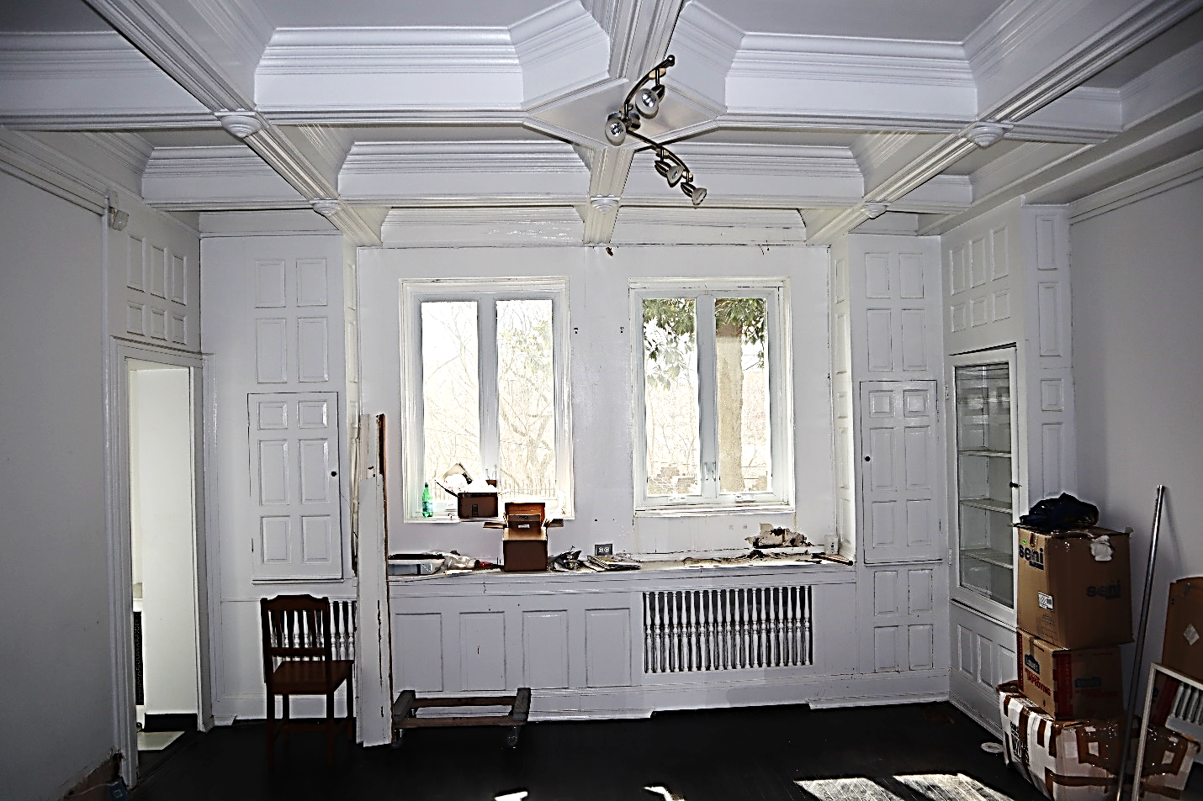
  - Floors 2, 3 and Basement TRIM PACKAGES: Provide a complete, yet simplified, trim package for the two upper floors and the basement. Provide crown molding,- single piece, baseboards, door and window casements, corner blocks, etc.
- Millwork Details
  - Design details for the proposed millwork solutions will have to be reviewed and approved by the Client before manufacturing or purchasing materials.
- Basement
  - In room No 003 "MECHANICAL ROOM", install appropriate patch panels where all data, internet and TV network cables are connected. After completion of construction, the Client Vendor will connect the internet from the adjacent building. The DB shall test and label the cables before completion of construction.
  - In room No 002, two electrical outlets and one internet outlet are required for the TV, the location of which will be specified by the Client in the future.
  - Sheet A-501, section No 10 WALL & SLAB-ON-GRADE describes the installation of foundation waterproofing detailed in the Structural sheet S-03 using KOSTER technology and products. Submit foundation waterproofing details prior to installation.
- First Floor
  - Reconstruct and replace Missing Historic Millwork
    - Central Staircase, Floors 1-3.
    - Built-in furniture and storage
    - Coffered Ceiling in Hall
    - Composite crown moldings and wall moldings
    - Wainscot wall paneling at stairs and bathroom hall.
    - To be reconstructed using any salvaged parts on site, by drafting shop drawings from photos, and by milling woodwork to closely replicate the lost elements.
  - Room No 103, 2 electrical outlets and 1 internet outlet are required for the TV, the location of which will be specified by the Client in the future.
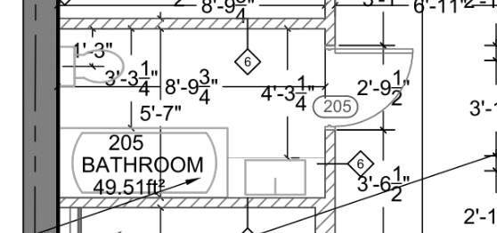
- Second Floor
  - Remove bathtub and replace with walk-in shower.
  - Doors No 202, 207A, 206A and the new door to room no 203, must have access control hardware. Hardware type, but it can be different manufacturer:
  - Doors shall be equipped with access card readers, closers, and electronic strikes. The new door to room 203 must be lockable with a key. Electric strikes for these doors must be LOCKWOOD ES2100. DB to coordinate wiring and provide to the doors through the ceiling.
  - Card readers will be provided and installed by Client hired vendor. DB to coordinate power installation with vendor.
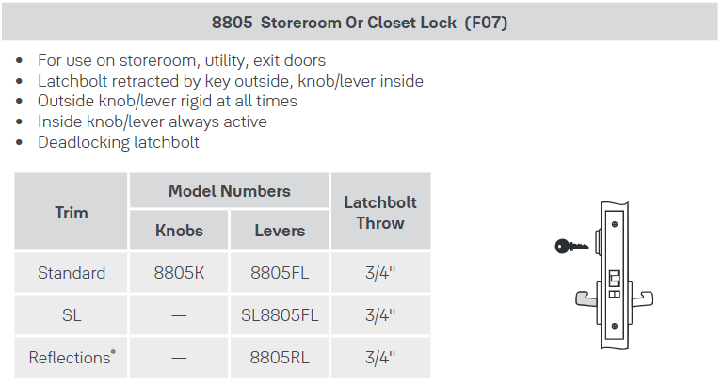
  - Create an additional wall with door passageway to separate room No 203 from the anteroom. (refer to plan on page 12)
  - Move the kitchen door to the staircase. (refer to plan on page 12)
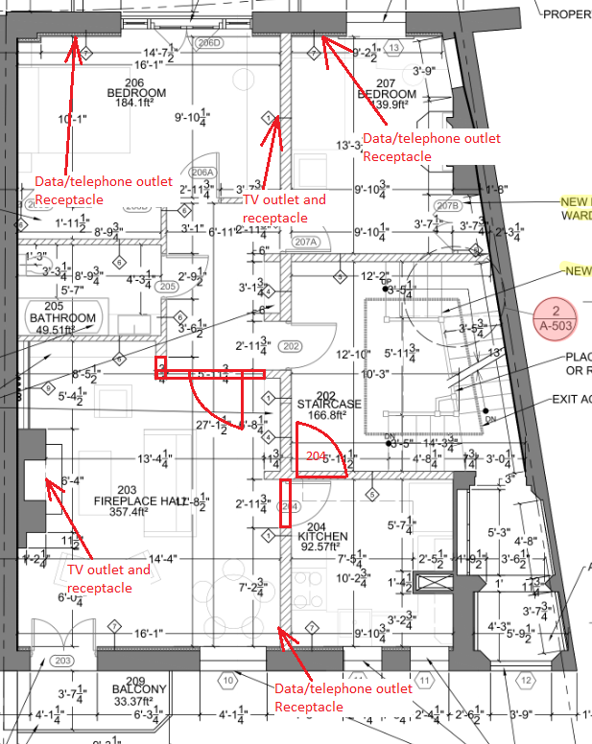
  - Install 6 (six) electrical outlets and 4 (four) internet outlets at each of the designated "Data/telephone outlet" locations. In addition, at each of the designated "TV outlet and receptacle" locations, install 2 electrical outlets and 1 internet outlet for connecting a TV set in rooms No 203 and 206. (refer to plan on page 12)
- Third Floor
  - In the dining room, modify the plans to show and install the kitchen on Floor 2.
  - At the indicated location "TV outlet and receptacle", install 2 electrical sockets and 1 internet socket for connecting a TV set in room No 303.
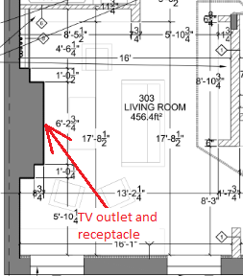
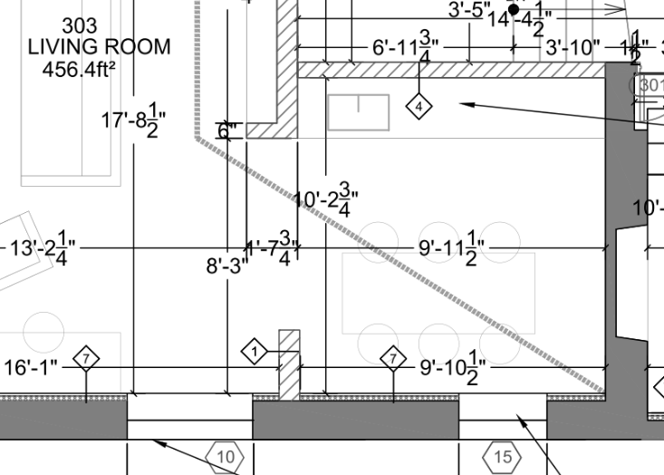
  - Remove wall :
8.3 designate wall to remove
- Wardrobes
  - Provide Elevations and/or Shop Drawings for the proposed wardrobes (closets) for rooms No 002, 203, 206, 207, 303, 305, 306. Shelf dimensions, design layout to be agreed with by Client.
  - Shelves to be made of EGGER PerfectSense Premium Matt lacquered boards or equivalent system. Minimum wall thickness ¾" (19.0 mm). The architect shall choose the color tones to fit in with the overall image of the building.
  - Provide a panel at the rear of the cabinet to cover and protect the wall.
- Kitchens
  - Kitchen elevations need to be drawn by the Author Supervisor and approved by the Client.
    - The arrangement of the shelves, doors and drawers is agreed with the Client. The DB shall design the kitchen according to the dimensions of the space and the intended functional purpose.
    - The kitchen unit is built in 2 or even 3 parts - if the ceiling heights of the room allow (lower cabinets and upper cabinets for levels 1-2).
    - The cabinet construction and kitchen specifications described herein are the MINIMUM REQUIREMENTS set forth and expected by the Client.
  - Kitchen Cabinet Construction
    - Build as many built-in cabinets, both upper and lower, as possible for storage and placement of crockery, TYPICAL.
    - Kitchen unit doors, drawers and cabinets must be made of EGGER PerfectSense Premium Matt lacquered boards or equivalent.
    - Minimum cabinet panel thickness is ¾" (19.0 mm).
    - The architect shall choose the color tones to fit in with the overall image of the building.
    - Drawer opening must be provided with PUSH-Open system.
    - Pulls: Provide bottom cabinets with Hafele, Continuous Handle, Aluminum. Upper cabinets to open with an overhang from bottom of cabinet door, without a handle. The opening of cabinets on level 3 must be provided by the PUSH-Open system.
    - Provide all cupboard doors and drawers with SOFT close accessories.
    - Fit the bottoms of the upper cabinets with built-in LED strip lighting. 3000K, 6w.
    - Use the Hafele system Magic Corner I, for Blind Corner Cabinets or equivalent for corner cabinets.
    - Sky Cutlery Tray in the drawer.
  - Countertops, Wall Panels, & Sinks
    - Corian® Solid Surface at least ½" thick. The Author Supervisor to choose color/pattern.
  - Kitchen Specs, Provide the Minimal Requirements:
    - Refrigerator: Ikea, SUPERKALL
(approximate dimensions Width: 21 ¼", Depth: 21 5/8", Height: 70 1/4")
    - Refrigerator: Ikea, STJARNSTATUS French door refrigerator, Stainless steel (approximate dimensions Width: 36", Depth: 28 ½", Height: 69 7/8");
    - Range Hood: Built-in hood Faber, Inca In-Light 21 SSV with VAM. Width: 21, model no. INLT21SSV.
    - Cooktop: SUMMIT 24" Wide 230V 4-Burner Radiant Cooktop, model no. CR4B23T5B.
    - Dishwasher: Ikea, RENGJORD Built-in dishwasher, panel-ready, 24”.
    - Microwave Oven: SUMMIT, built-in, model no. MHOTR24SS
    - Oven: SUMMIT, built-in, model no. SEW24SS.
    - Sink: Hansgrohe S51 S510-U770. Under-mount sink 370/370 with D17-11 Automatic waste and overflow set for double bowl, granite.
    - Faucet: Hansgrohe mixer tap, Focus M42 Single lever kitchen mixer 180, pull-out spray, 2jet.
    - Waste Bin: Hafele, Waste Bin, Hailo US Cargo, model no. 502.74.573.
    - Garbage disposal: Moen, Chef Series, 1-HP Continuous Feed with integrated lighting and Sound Reduction. Model #EXL100C.
  - Kitchen, Basement
    - Refrigerator: STJARNSTATUS
    - Range Hood
    - Cooktop
    - Dishwasher
    - Microwave Oven
    - Oven
    - Sink
    - Garbage Disposal
    - Faucet
    - Waste Bin
    - Provide new and adequate network connections for all installations.
  - Kitchen, First Floor
    - Sink
    - Garbage Disposal
    - Faucet
    - Dishwasher
    - Build as many built-in cabinets, both upper and lower, as possible for storage and placement of crockery.
  - Second Floor: (kitchenette)
    - Refrigerator: SUPERKALL
    - Waste bin
    - Sky Cutlery Tray
    - Dishwasher
    - Microwave
    - Sink
    - Faucet
    - Provide adequate network connections for all equipment.
  - Kitchen, Third Floor (full kitchen)
    - Refrigerator: SUPERKALL
    - Range Hood.
    - Cooktop
    - Waste bin
    - Dishwasher
    - Microwave
    - Built-in oven
    - Built-in sink
    - Faucet
    - Provide new and adequate network connections for all installations.
- Washer & Dryer
  - In room No 006, provide the following Minimal Requirements:
    - LG 5.5 Cu. Ft. White Top Load Washer with TurboWash3D™ and
    - LG 7.3 Cu. Ft. White Electric Dryer.
- Bathroom Accessories Specs, Provide the Minimal Requirements:
  - Hand Dryer: Saniflow M17AB-UL
  - Soap Dish: Matte liquid Soap dispenser
  - Towel Hangers: Kraus, KEA, model no. 18801MB
  - Toilet Paper Holder: Butler, paper holder Type 1 (4601),
  - Towel Dryer: Bathroom butler NATURAL 5 Bar 20inch Straight Heated Towel Rack with PTSelect Switch, model NAT05121-PTS (Size: 20,55 in width, 28,94in height, 4,30in depth).
  - Shower: Custom shower enclosure. Mortar shower pan framed and poured over waterproofing membrane. Backerboard wall underlayment, taped seams. EZ Drain, Linerar shower drains COMPACT. Rolled with waterproofing sealer. Tiled walls, floors, and curb. Tempered glass walls and shower doors. Shower head and controls TBD.
  - In room No 007, provide the following:
    - Hand Dryer
    - Soap Dish
    - Towel Hangers, 3 pieces
    - Toilet Paper Holder
    - Towel Dryer
  - In room No 105, provide the following:
    - Hand Dryer
    - Soap Dispenser
    - Toilet Paper Holder
  - In room No 205 provide the following:
    - Replace the proposed bath with Shower described in 12.7.
    - Hand Dryer
    - Sopa dispenser
    - Towel Hangers, 4 pcs
    - Toilet Paper Holder
    - Towel Dryer
  - In room No 304, provide the following:
    - Provide tempered glass sliders doors for tub enclosure.
    - Soap Dispenser
    - Toilet Paper Holder
    - Towel Dryer
- Exterior Spigot/Faucet, Street Façade
  - Provide a water spigot to the front, street façade, of the building.

Section 3: Design Changes to Courtyard
- Wrought Iron
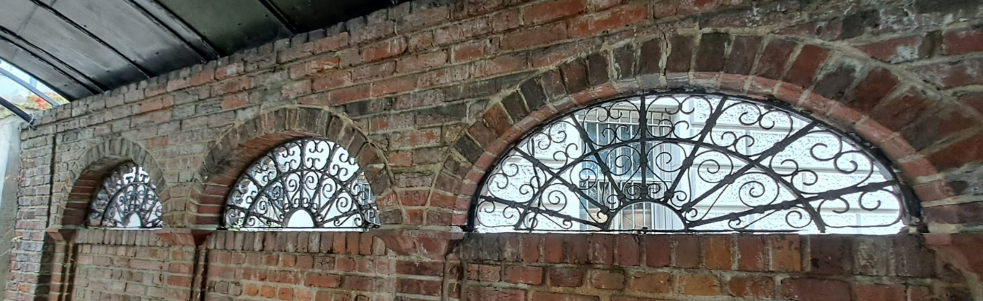
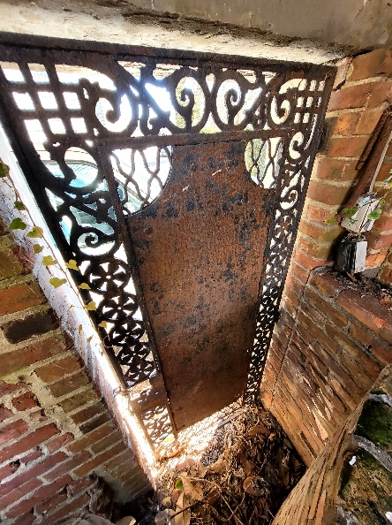
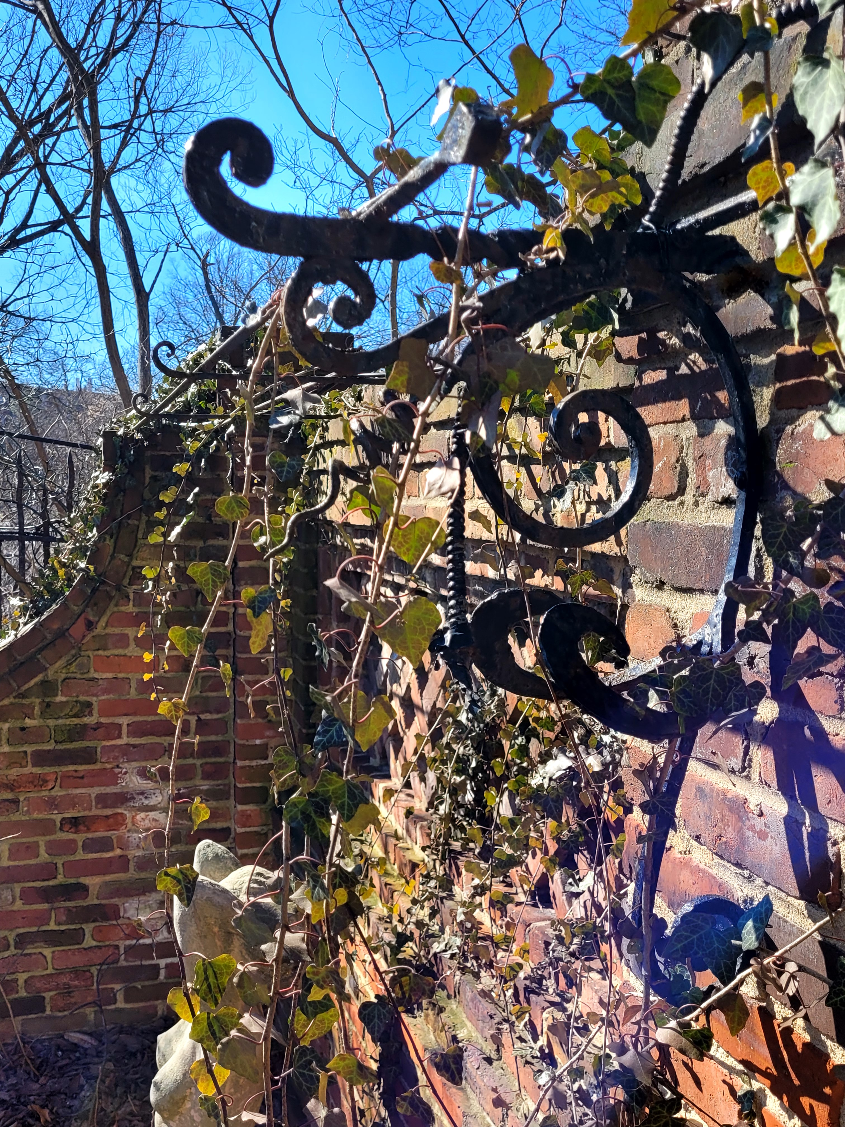
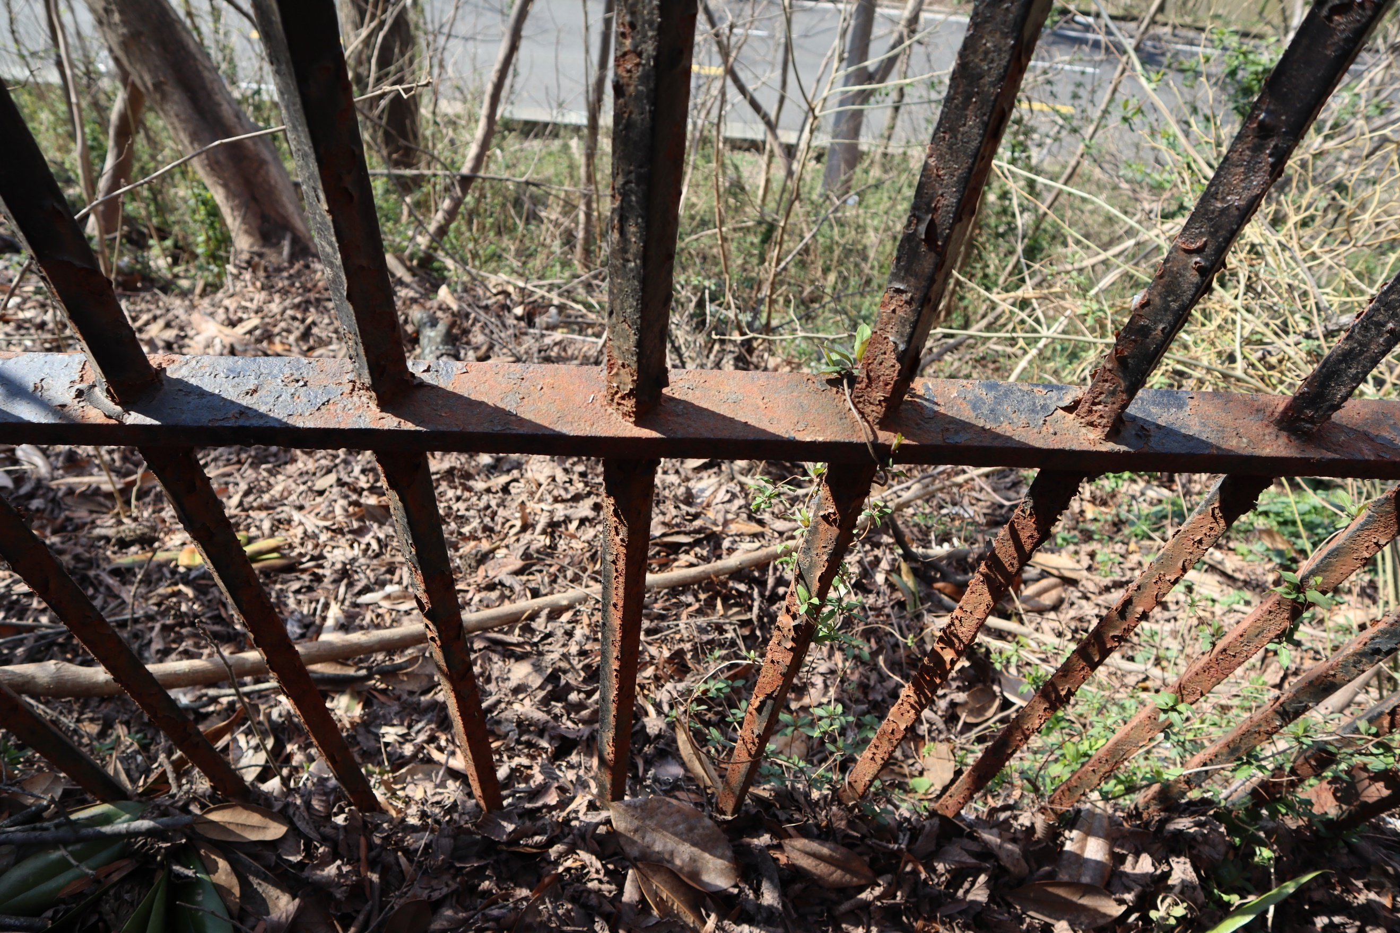
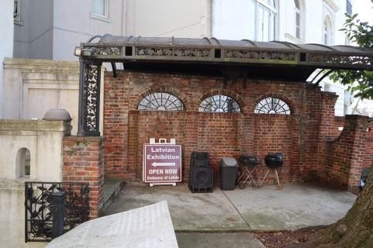
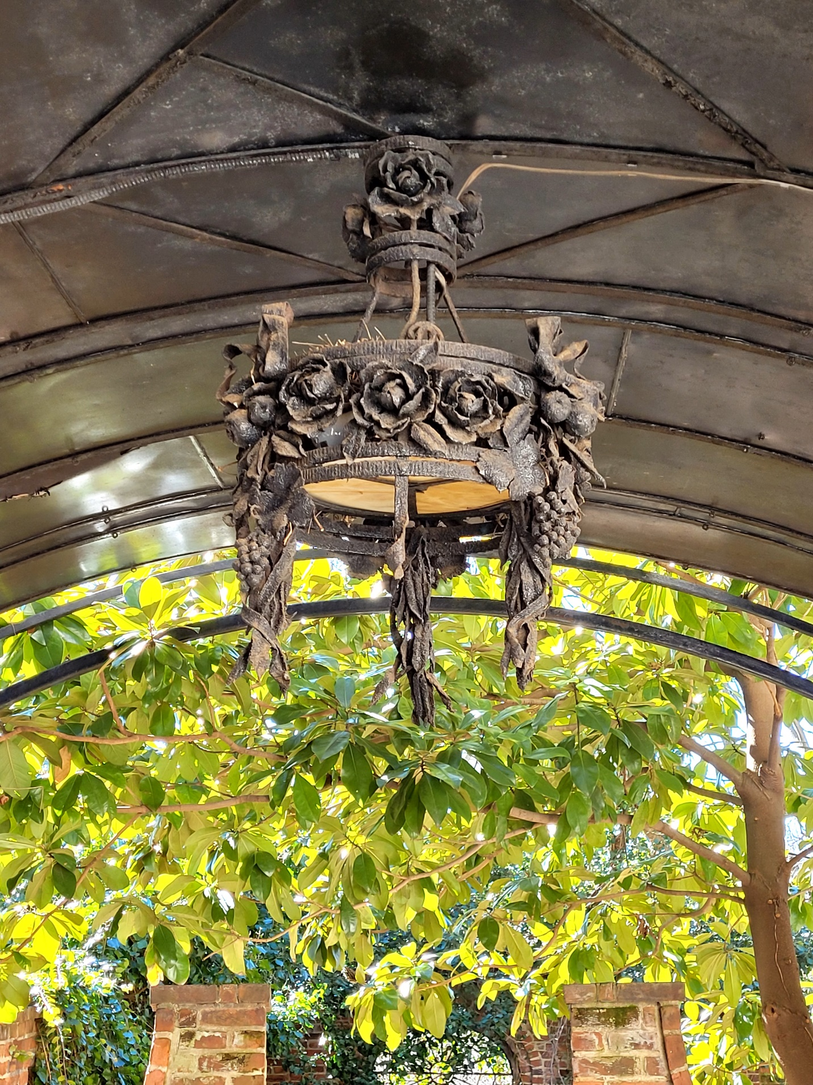
  - Renovation of the metal canopy and support structure is required, with a solution to restore missing and damaged parts. Mostly the intent is to properly clean, prime, and repaint. Replace missing pieces with like-in-kind.
  - All garden wrought iron, no limited to but including those illustrated below, to receive the same restoration attention described above:
  - Chandelier under metal canopy to be revived: inspect for damage, disassemble, clean, repair, rewire using new electronic components, reassemble and reinstall.
- Handrails
  - Provide new handrails for steps from basement level up to garden elevation.
  - Provide new handrail for stairs from garden elevation to rear, street exit.
  - Materials: Handrails to be made of bronze. Balusters and posts to be steel: black painted, anodized finish.
- Stump Removal
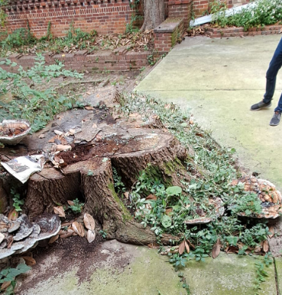
  - A five-foot diameter tree stump remains in the back courtyard; the stump needs to be grinded down to a depth of 12” below finished grade.
- Brick Paving & Steps
  - Damaged bricks and steps need to be restored. Concrete joints should be symmetrical so that they do not stand out.
  - Replace damaged bricks with other bricks of the same appearance.
  - Repair the crumbling seams.
  - Clean the masonry from moss and hard elements.
- Patio Paving
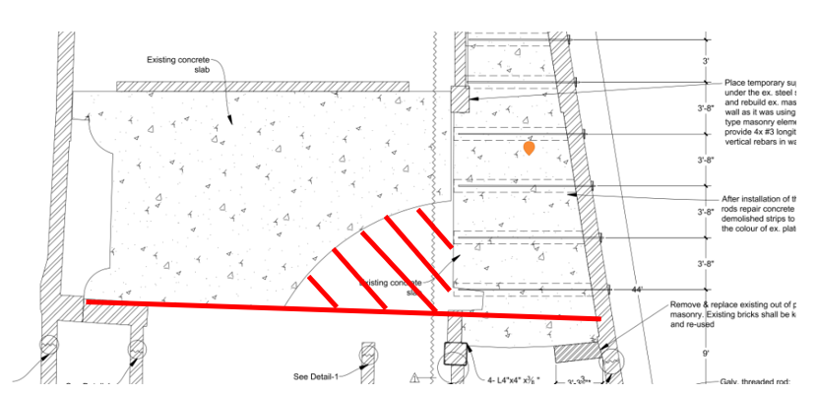
  - Concrete
    - The void left by the stump removal is to be back filled with soil. New concrete is to be poured to match existing in color, aggregate, and finish, typical. Protective sealant to be applied, typical.
    - The existing concrete paving needs to be cleaned of stains and organic matter. Protective sealant to be applied, typical.
  - Brick & Stones
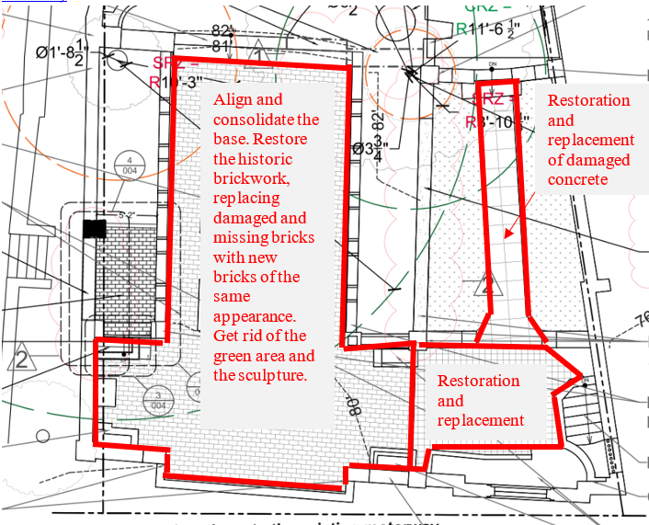
    - Existing brick and stone paving will need to be raised, setting bed prepared with gravel and sand, and reset to be level and sturdy. Clean paving material, typ.
- Party Wall with Turkish Residence Structural Reinforcements
  - Drawing Sheet S-07 describes a solution to reinforce the wall along the Turkish Embassy.
  - The design needs to be supplemented with a restoration solution so that the concrete paving is fully restored to its original condition (without exposure cuts).

- Planter Modifications, Center of Courtyard
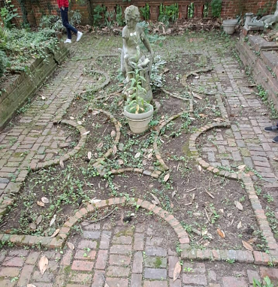
  - Relocate sculpture to another planter in the garden (to be determined with Owner).
  - The new patio paving is to incorporate the historic geometry of the planter. The existing planter “edging” is to be level with adjacent paving.
  - Infill the current planting area with new paving. The infill patio paving material to be brick and to match existing historic brick in size, color, and patina.
- Planting Plan, Bed Preparation, Landscape Installation
  - Provide a landscape planting plan with Planting Schedule.
  - Planting Schedule to show Botanical Name, Common Name, Pot Size, Quantity, and plant type (groundcover, small/medium shrub, screening plant, ornamental tree).
  - Soil Preparation: Excavate the top 12” of the existing soil in the beds and discard. Fill with garden soil and organic matter. Churn into earth before planting.
  - Install plants, shrubs,
  - Provide 3-4” of shredded bark mulch after planting.
- Pruning
  - Perform maintenance and pruning of existing tree (figure, right).
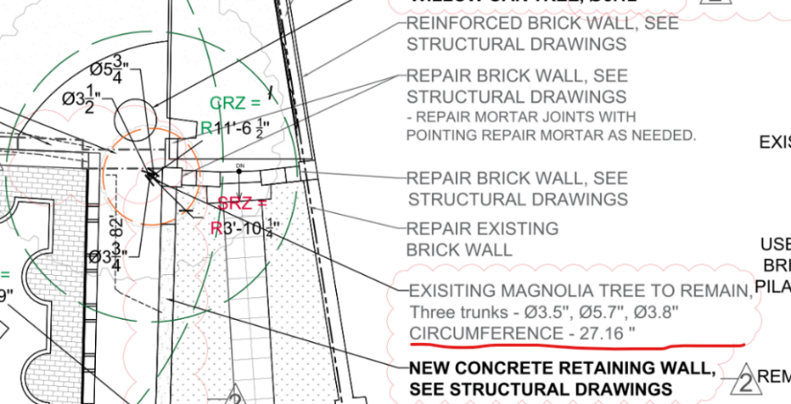
- Wall Fountain.
  - The Wall Fountain is to be restored to be fully operational.
  - The three wall spouts are to remain, concrete restored as described in the Sc including three wall spouts and the water basin.
  - Basin under the three wall spouts, was converted to a planter. The basin is to be converted to a pool that can hold and recirculate water.
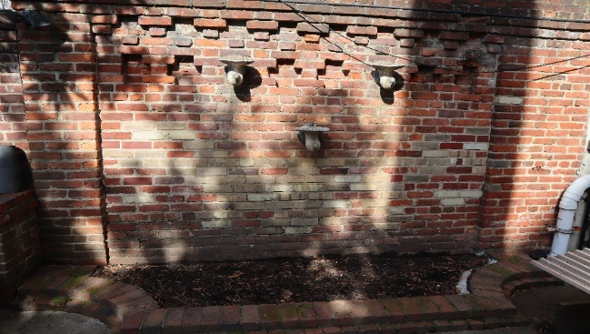
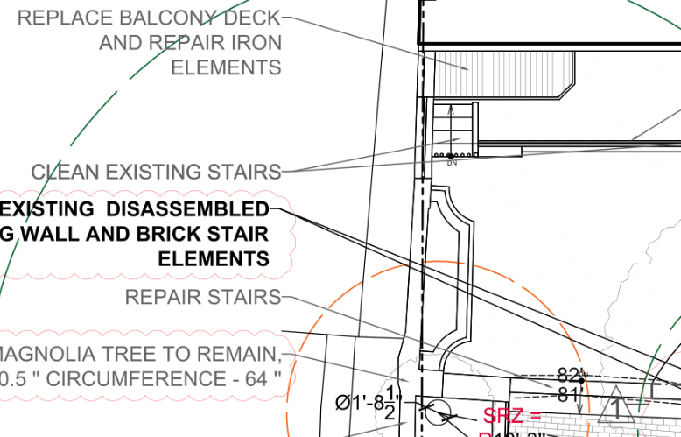
  - Mechanics: Pump will require pump(s), wall pipes or tubing, water supply, power supply, control valve or flow regulator, and control panel. Include underwater LED lights.
- Garden Spigots/Water Faucets
  - Provide a minimum of three garden faucets in the rear garden.
  - Faucets locations should be triangulated to be the furthest distances apart from each other to service the entire garden.

Section 4: Known Structural Conditions & Corrective Work
The building was surveyed in 2020, during which time the existing structure has deteriorated.
- Known Conditions
  - During the dismantling of the wall, new cracks in the walls and door lintels were revealed, the DB must provide solutions for repairing all cracks in the revised design.
  - Construction documents shows solution developed by JaunRīga Eco, but the solutions do not show all the locations of the new cracks.
  - A solution is needed to reinforce the structure that provides the load-bearing capacity of the fireplace chimney/ventilation shaft.
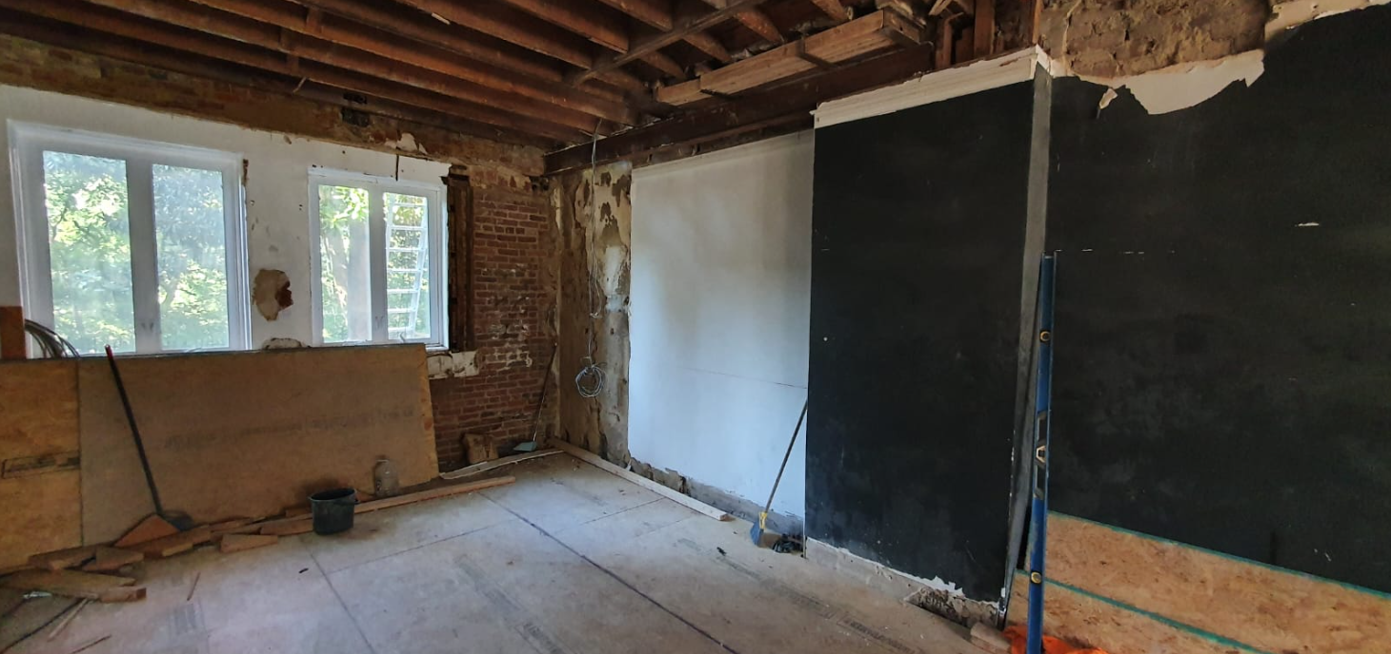
  - Client will reconsider removal of chimney(s) as an alternate. Architectural team to make determination during design phase.
- Corrective Work
  - Beams installed by the previous contractor need to be inspected for deviations from the construction documents and corrected accordingly in the field. The inaccuracies indicated are for information only, the DB shall carry out a survey of the whole building:
    - New beams were improperly sistered into the existing beams.
    - The beams should be placed at the specified location for the entire length of the story, but this has not been respected:
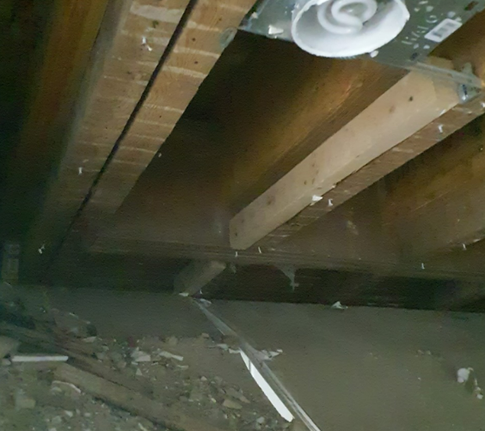
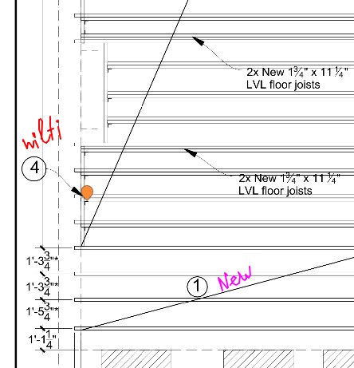
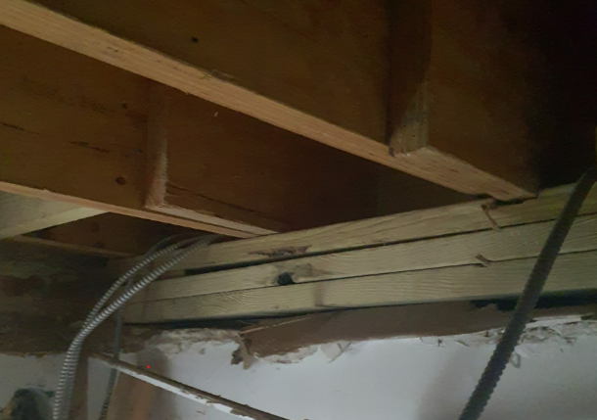
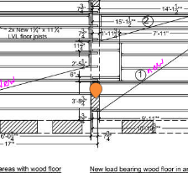
    - The bottoms of the beams are to be resting on masonry. Yet there are instances where the beams are supported by wood battens.
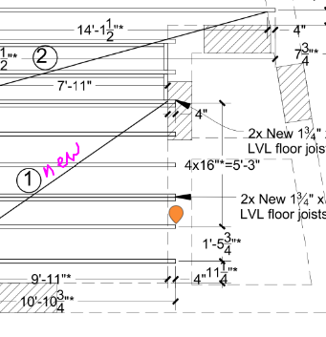
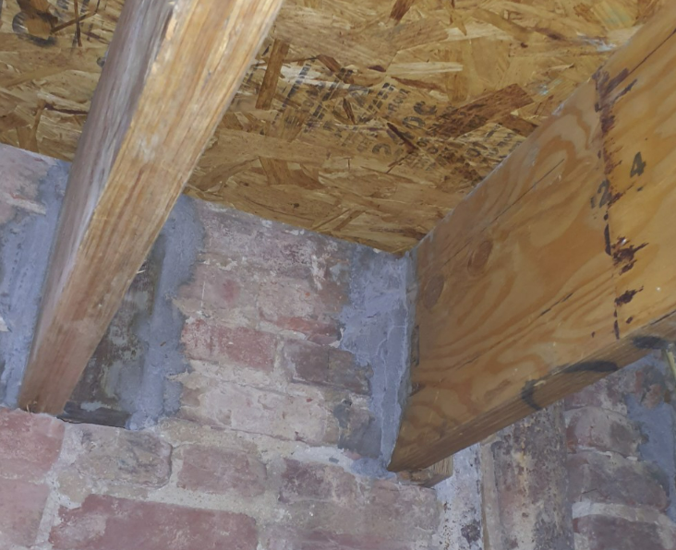
    - The new beams in the wall do not follow the design and methods described in the CD’s.
    - New beams do not use the connectors/ties specified and are not properly secured in the wall:
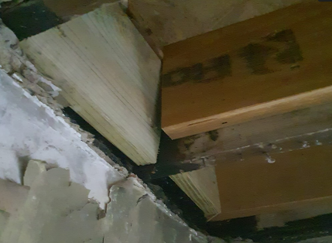
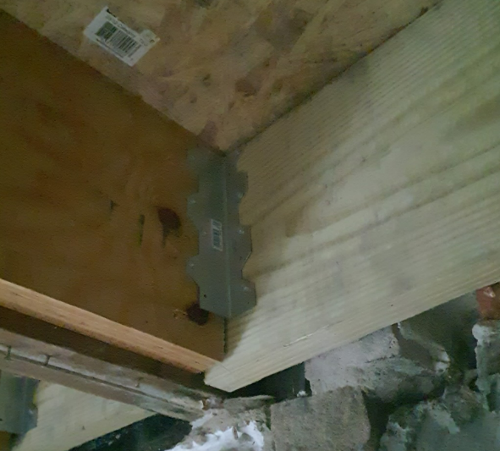
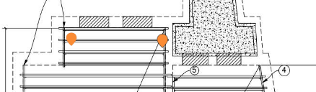
………………………

Section 5: Known Work by Division

Division 01- General Conditions

NOTE: The CDs Drawing Notes reference “BUILDING STANDARDS.”
There are no BUILDING STANDARDS, and these references can be ignored.
- General Conditions
  - See Section 5
- Site Work
  - Sheet A-001 Existing Site Plan should designate the existing concrete paving to be demolished to build the structural reinforcements for the garden wall shared wall with the Turkish Chancery.
  - Refer to drawing S-07 for the garden wall reinforcements and the corresponding area of patio concrete that will need to be demolished.
  - Remove bollard and concrete footing at gas meter.
  - Damaged steps, paving, curb, cobblestone, slabs in front of the building to be repaired (straightened, leveled out) or replaced with new.
- Concrete
  - Sheet A-004 Proposed Site Plan, the notes that read
“RENEW CONCRETE SLAB AFTER STRUCTURAL SOLUTIONS. SEE STRUCTURAL DRAWINGS”
should state the following:
“REPOUR NEW CONCRETE SLAB AFTER STRUCTURAL SOLUTIONS. SEE STRUCTURAL DRAWINGS.”
  - Backfill and repair exterior concrete at building perimeter.
  - After completing corrective work in Basement, level with concrete floor leveler, if required.
- Masonry
  - Sheet A-004 Proposed Site Plan, the notes that read,
“REPAIR BRICK WALL, SEE STRUCTURAL DRAWINGS”
should state the following:
“DOCUMENT EXISTING WALL IN HEIGHT AND COURSING. AFTER UNDERGROUND STRUCTURAL WORK IS IN PLACE, REBUILD BRICK WALL TO MATCH ORIGINAL DESIGN.”
  - Remove miscellaneous metal fasteners from elevations. Repoint and patch as necessary.
- Metals
  - Stairwell handrails for exterior garden.
  - Restore and replace central stair metal handrail salvaged on site.

- Woods, Plastics & Composites
  - Millwork
    - Central staircase.
    - First floor wainscoting, built-in furnishings, and coffered ceiling.
    - Fireplace surrounds & mantels.
    - Floor 1 trim package.
    - Floors 2 and trim packages.
    - Basement trim package
  - Carpentry
    - Restore and rebuild missing coffered ceiling on first floor Hall.’
    - Restore and rebuild missing “built-in” wall cabinets.
- Thermal & Moisture Control
  - The roof is to be replaced. A new roofing system is not called out on the drawings and will need to be designed by DB and approved by Owner.
    - Roof flashing details will need to be developed: flashing at masonry parapet, at roof penetrations such as the hatch,
    - Auxiliary Space Floor 3, the condition of the existing roof needs to be accessed and repairs made accordingly.
  - Downspouts
    - Leaf catchers are required for all gutters.
    - All gutters are to be half round. Downspouts are to be round. The existing gutters and downspouts on the adjacent Embassy building are prototypes to replicate.
    - Street façade gutters, downspouts, and leader heads are to be copper.
    - On the rear of the building, gutters, downspouts, and leader heads may be an alternate metal and painted, as is the case on the Embassy rear elevations.
  - Box Gutter in Balcony Cornice
    - On the street elevation, the is a box gutter that captures the runoff from the balcony floor; however, the condition is unknown.
    - There is also a roof drain on the balcony floor; the condition is unknown.
    - Box gutter, roof drain, and downspouts are to be restored to working conditions.
- Openings
  - Doors
    - Sheet A-502, DOOR SCHEDULE, differentiates between existing doors and new (Standart Profile). Confirm the inventory of existing doors that remain on site.
    - The DOOR SCHEDULE calls out for all doors to be painted white and “historical white.” DB’s architectural team may recommend an alternate paint color(s) that may be more historically appropriate to the house’s origins.
    - The DOOR SCHEDULE calls for “renewable” door type. “Renewable” is meant to be understood as a “new” door.
    - Existing historic doors to remain, are to be stripped, sanded, and primed to prep for painting. Doors may be dipped.
  - Door Hardware
    - Hardware: door hardware package is not described in the drawings. Author supervisor is to make a recommendation of hardware that is sympathetic to the historic character of the house.
    - The DOOR SCHEDULE calls out the hardware to have a “traditional black” finish. Author Supervisor may recommend an alternate finish.
    - Assa Abloy is the Client’s preferred hardware and can be used for bid pricing. A substitute of equal or greater quality will be considered.
    - All doors must have separate keys but with master key option.
    - Total keys to be cut: 5 master keys and 3 keys for each door with individual locks.
    - Existing historic front doors will have a video intercom system. Existing door hardware will require modifications to be operable with the video intercom system.
  - Sealing Doors and Windows:
    - Provide weatherstripping, doors weeps, and thresholds, at existing, exterior door locations.
  - Windows
    - Wood windows to have aluminum exterior cladding.
    - Sheet A-503, Window Schedule, calls for Le Page windows in the color “Historical White.” This color appears to no longer be available. to recommend an alternate finish color for both the interior and exterior window finishes.
    - Window hardware is called out to have a standard “white” finish. Author Supervisor to make a recommendation of finish that suites the proposed interior scheme.
- Finishes
  - Paint: Author Supervisor to recommend paint colors that may best suite the proposed interior scheme.
  - Drywall & Acoustical
    - Sheet A-601, Ceiling Plan Key Clarification: Ceilings “C1” are to follow Floor/Ceiling details 8 & 11 on sheet A-501.
    - Ceilings “C-2” are described as a new suspended ceiling system. The DB will need to specify an available product.
  - Stucco
    - Install parge coating underneath entrance steps (as viewed from front basement door entrance) to encase exposed rebar to a minimum thickness of 3/4”.
    - The top (horizontal surface) of the stucco wall, rear garden, is spalling. Repair as necessary.
- Specialties
  - Room 201 was a Chapel Room in the old floor plan with the walls and ceilings constructed of wood framed mirrored panels. The Author Supervisor may determine a new use for this space since the Client is not inspired to maintain the Chapel.
  - The minimum requirement for Auxiliary Room 201 is a new storage room.
- Equipment
  - The Roof Access Panel has not been specified by manufacture and model number. The DB will need to submit cutsheets for a roof access panel for the Client to approve.
- Furnishings
  - The Author Supervisor will submit an interior design furnishings package where the DB selects interior furnishings available locally.
- Specialty Construction
  - Fountain restoration as described in Section 3.
- Conveying Equipment
  - Dumbwaiter: the existing Construction Documents do not define the dumbwaiter construction details, conveying mechanisms, nor operational details. DB to determine functioning mechanisms and submit cutsheets to Client for approval.
- Fire Suppression
  - No additional items. Refer to drawings.
- Plumbing
  - Adding the Kitchen on Floor 3 and modifying the Kitchen Plan on Floor 2 will change the plumbing riser diagrams and may require a redesign of the plumbing system in the CDs.
- HVAC
  - Provide ceiling air vent in each bathroom.
  - Adding the Kitchen on Floor 3 and modifying the Kitchen Plan on Floor 2 will change the heating and cooler requirements; this may a redesign of HVAC decisions in the CDs.
- Electrical
  - Provide electrical for dumbwaiter.
  - Provide electrical to exterior fountain.
  - Adding the Kitchen on Floor 3 and modifying the Kitchen Plan on Floor 2 will change the electrical plans; this may require a redesign of electrical decisions in the CDs.
- Utilities
  - Water, sewerage, storm water drainage, electricity, and gas connections to the city networks are not fully detailed, and need to be ensured:
  - To complement the design documentation with an appropriate solution according to the requirements of the Technical Specification.
  - A pipe survey is needed to be able to complement the design documentation with an appropriate solution. It is required to determine pipe diameters, condition, and location, including for city network connections. The pipes need to be inspected by camera (TV inspection) for assessment to determine if they can handle the future flow demands of the proposed uses.
  - Connection to the city storm sewer system is required and appropriate connection is to be made. If connection to the city network is not possible, it is necessary to connect sanitary/storm water to the existing connection. 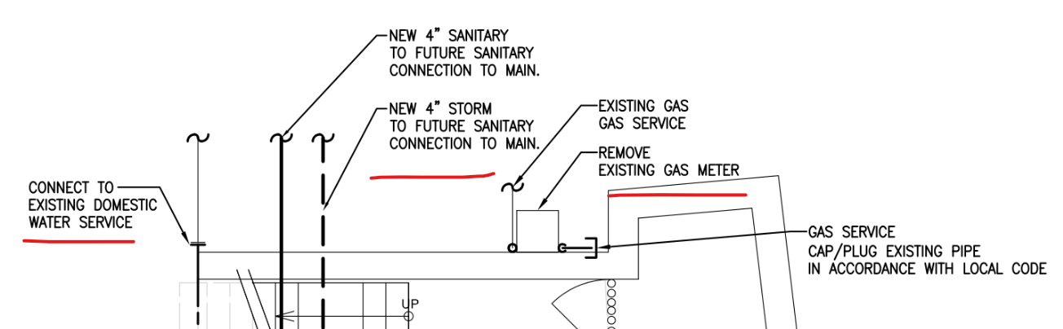
  - Gas Supply: disconnect and remove completely above ground gas meter. All necessary actions shall be provided for according to the building code.
  - DB to determine the electrical demands of the proposed use and size the upgraded panels accordingly in tandem with the local power utilities.
    - Include the cost of any supplement the drawings that may be necessary and PEPCO fees/costs.
    - DB shall carry out all communications with PEPCO and shall coordinate the application and connection installation.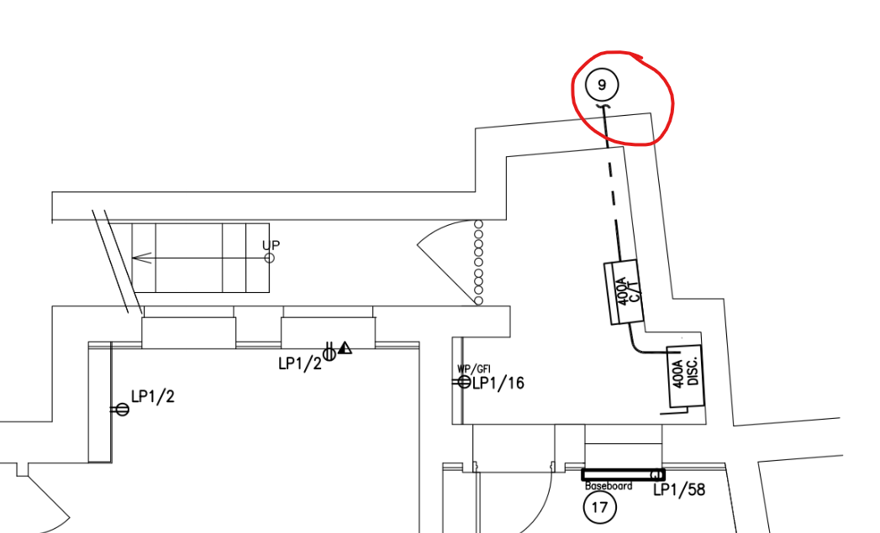

Section 6: General Conditions
- General Provisions
  - The Technical Specification shall include instructions and requirements for the quality of the execution of the Construction Works. The Construction Works shall be carried out using generally accepted technologies, materials, and equipment with good references. The DB shall be solely responsible for ensuring that the Construction Works are carried out to a high quality, in accordance with the requirements of modern technology and correct installation methods. The DB shall also be responsible for ensuring that the Construction Works are carried out by suitably qualified personnel equipped with the necessary machinery, technology, and tools. The DB shall be responsible for ensuring that the Construction Documents is carried out in accordance with the District of Colombia Building Codes approved at the time of this RFP (https://codes.iccsafe.org/codes/district-of-columbia), applicable city enforcements, and the Technical Specifications. The DB must consult the entire documentation. The DB shall coordinate all essential materials, equipment, and samples thereof with the Architect and the Client prior to their delivery to the Facility. The DB shall be familiar with and base its proposal on the Regulations, the Construction Documents, and all sections of the Technical Specification.
  - The DB shall be responsible for ensuring that the Construction Works are performed in accordance with applicable Washington and United States laws and regulations, the Construction Documents, standards, material manufacturers' technology, and this Technical Specification.
  - Before commencing the Construction Works, the DB shall thoroughly inspect the Site, obtain all necessary permits and approvals for commencing the Construction Works, erect demarcation and warning signs and take other necessary precautions to set up the Site.
  - The DB shall draw up an occupational health and safety plan as required by the DOB. After the approval of the OSH Plan by the DOB, the DB shall submit it to the Client. In addition, the DB shall draw up a scheme of work organization, where specified: site layout, fence location, lighting, location of video surveillance cameras, location of the site office, location of the water supply, location of the electricity supply, location of meters, location of bio-toilets, location of the construction waste container, location of hazardous waste, location of construction materials, location of escape routes and fire extinguishers, location of the first aid kit and the assembly point in case of evacuation.
  - The DB, as a professional DB, shall make provision for any works, equipment, or materials the execution or use of which is required by the nature and/or extent of the Construction Facility and the execution or use of which may be necessary for the quality execution of the Construction Works and the obtaining of a permit from the DOB. The DB shall hand over to the Client a building ready for use, where all systems, functioning of the building have been checked, adjusted, and the building has been authorized by the DOB for operation. The DB shall be materially responsible to the Client and to Third Party for the protection of materials, equipment against damage and soiling during the execution of the Construction Works.
  - The Client shall use Dalux or other equivalent approved software as agreed with the Client for mutual communication on construction matters. The DB shall ensure that all subcontractors' representatives, the Client's representatives, and any experts designated by the Client have access to the software and pay for the necessary licenses (at least 10 users on the Client's side). If necessary, the DB shall provide an introductory briefing on how to operate the software to be used. The DB shall provide an appropriate software package for this project, with a minimum program ensuring the following: Project overview, defect indication (possibility to add defect location and photo), structured redirection of questions and defects, material approval forms, and commenting.
- Site Preparation
  - DB’s Working Territory
    - The DB shall provide and maintain suitable facilities on site for the conduct of construction meetings, lunch for staff, staff changing rooms, toilets, the necessary number of storerooms and other facilities required for the implementation of the project.
    - The DB shall include in its costs all expenses that may be incurred for the establishment and maintenance of the necessary premises or Site.
    - The DB shall make its own arrangements between its own personnel and the subs working on or near the Site for the areas it/they wish to use as an access or storage area for its/their equipment and materials and as a working area. All costs for this purpose shall be borne by the DB.
  - Pre-Construction Survey/Condition Report:
    - Before commencing Construction Works, the DB shall carry out a survey of site layouts, structures, pavements, etc., adjacent structures likely to be affected by the Construction Works. Areas close to the construction Site that could be affected by construction activities should also be surveyed. All existing damage and/or defects and other relevant details should be identified and photographed.
    - DB to survey the neighbors’ walls and document their existing condition. Client will not hire third party to conduct this survey Pre-Construction. It will be the DB’s responsibility to capture these pre-existing conditions.
    - Such report shall be submitted to the Client in electronic form before the start of the Construction Works.
    - The DB shall arrange the inspection jointly with a representative of the Client.
  - Protection Against Damage
    - The DB shall take all necessary precautions to avoid causing arbitrary damage to roads, land, property, trees, and other objects, and shall promptly resolve any complaints from the owners or occupiers of the objects during the Contract Period.
    - If networks are found which are not under the control of the Client, the DB shall ascertain their ownership and dismantle them (if the network is not in use) or carry out works around them to ensure that the network is not affected. Each specific situation must be agreed with the Client.
    - The DB shall immediately inform the Client in writing of any damage or injury (personal injury, accident) occurring during the execution of the Construction Works.
    - Should any damage or leakage be discovered, the DB shall immediately inform the Client and the relevant statutory company, road authority and owner (Third Party). The DB shall promptly (in agreement with the Client and Third Parties) provide a repair or replacement schedule for any damaged equipment if the damage is caused by the DB's acts or omissions.
  - Temporary Structures, Access, and Surveys:
    - The DB must obtain its own access information for all parts of the Site and, if the DB wishes to use roads through private properties or otherwise encumbered areas, he must settle all formalities with the persons in possession of the territory.
    - The pavements used or crossed by the DB for the purposes of the Contract shall be maintained in a satisfactory condition during the performance of the Contract and, after its performance, the DB shall restore the pavements at least to their original condition acceptable to the Client and the Control Authorities, at its own expense. The DB must regulate the way its vehicles operate to ensure that they are not unnecessarily damaged on the Site, whether in public or otherwise.
    - All temporary structures necessary for the completion of the work under the Contract (such as safe scaffolding, fencing, lighting, bridges, etc., as well as labor, equipment, materials, and structures necessary for the safe, timely and satisfactory performance of the contractual obligations) shall be deemed to be included in the price of the DB's proposal and shall not be subject to additional payment.
    - The DB shall be responsible for verifying the Site conditions, subsurface, groundwater elevations, existing Site structures, etc. of all data and information contained in the proposal documents and the Client shall not be responsible for the completeness or Interpretation of such Information.
    - It is up to the DB to determine the conditions relevant to construction.
    - The DB shall, before submitting its proposal, make a thorough inspection of the Site and acquaint itself with its condition as regards general Site conditions, soil characteristics, existing facilities and services and any other aspect, construction and methods of execution of construction, if the DB needs to carry out additional investigations to clarify the situation and prepare its proposal, the DB shall carry out the investigations at its own expense and inform the Client, specifying the time and duration of the investigations and the results obtained.
    - The DB shall make a special study of the conditions relating to access to the Site, the existing obstructions and shall, as far as possible, identify any difficulties on the Site which might interfere with the execution of construction.
    - The DB shall be deemed to have analyzed the existing traffic conditions and their impact on the execution of construction.
    - All related costs shall be deemed to be included in the price of the DB's proposal.
- DB’s Permits Licenses & Approvals
  - The DB shall be responsible for obtaining all permits, licenses, and approvals required by Washington and U.S. laws and regulations prior to commencing any activities in the Construction Documents and the Technical Specifications.
  - The DB must pay all costs and fees associated with obtaining these permits, licenses, and approvals. The Client shall bear only the fees charged to the DOB.
  - The DB shall comply with all requirements and provide the necessary support and assistance to the Client to obtain permits which only the Client can obtain.
  - The DB shall comply with all conditions imposed by the permits granted by Third Parties (lease agreement between the Client and the neighboring land), incl. conditions of the permits received from the Client.
- Client Payments to DB
  - The Client will pay the DB for construction carried out based on a monthly financial statement in the form of a contractual estimate, showing, for each reference period, the proportional performance, the total performance since the start of the Contract and the balance of construction to be carried out.
  - The DB shall submit the implementation by the 20th of each month (if the 20th falls on a holiday, the document must be submitted earlier).
  - The Client will check the performance by the last day of the month and provide confirmation or comments.
  - The DB shall then submit the approved execution together with a progress report.
- Progress Reports shall include the following:
  - The DB shall submit a progress report to the Client by the 7th of each month (if the 7th falls on a holiday, the document shall be submitted earlier), describing:
  - General information about the project.
  - Proceedings of work shop drawing development:
    - Shortcomings in the Construction Documents identified during the reporting period.
    - Work shop drawings completed during the reporting period.
    - Description of the work shop drawings planned for the next reporting period.
    - Approved technical documentation (up-to-date list of Construction Documents resumes) and list of work shop drawings.
  - Identified problems and errors that have occurred on the Site, an objective analysis of them and the DB's proposed solutions to the problems.
  - Construction Works progress:
    - Construction Works performed on Site during the reporting period.
    - Inspections and material tests carried out during the reporting period.
    - Description of the Construction Works planned for the next month.
  - Financial report:
    - A financial statement approved by the Client as specified in this section, paragraph 4.1, of the Technical Specification.
  - Report on the implementation of the calendar schedule:
    - Each progress report should include an updated timetable for all remaining Construction Works, clearly indicating the critical path.
    - If a delay is detected in any of the construction, it must be shown in red on the schedule.
    - The schedule must be updated and supplemented at each reporting period.
  - Risk Assessment of the possible product delays, lengthy approval processes, critical findings and the likes that may impact the schedule or budget. Solutions and/or recommendations that may avert or minimize the risk should be presented.
  - Current versions of all lists of as-built documents:
    - List of material submittals forms.
    - List of change orders.
    - List of fact-finding acts.
    - List of defects acts.
    - List of work shop drawings.
  - Meter readings for utility consumption, including photographic records.
  - At the end of the report, photos
    - of the Site should be included to show the work carried out during the reporting period.
    - Photographs should be detailed so that progress from the previous reporting period can be seen.
  - The progress report must be submitted in electronic form with the electronic signature of the responsible manager.
- Site Security & Video Surveillance
  - The DB shall be responsible for the Site and the property placed on the Site (building materials, tools, structures, equipment, machinery, and anything else on the Site) and the DB shall be responsible for their security. The DB shall include in its proposal the provision of security and the installation of video cameras as specified by the Client.
  - Provide full-time security and continuous video surveillance of the Site with at least 3 (three) video cameras, remote accessibility of the online image and video archive to the Client via the Client's browser (Internet Explorer 11, Google Chrome 63 or higher), standard HTTPS connection, and storage of the video surveillance recordings for a period of not less than 1 month).
  - The cameras are primarily deployed to provide security, but at the same time they are installed to see the progress of the Site and whether construction work is underway.
  - The technical characteristics of the video cameras, the initial locations and the software to be used shall be agreed with the Client before the date of signing of the Handover and Acceptance Certificate. The video recordings referred to in this subparagraph shall be submitted in video formats that can be read by standard software at the Client's disposal (built-in media players in Microsoft Windows 10 or later), such as AVI, MPG, MPEG, MP4, MPEG-4 or similar;)
  - Video quality shall be not lower than HD 1080p and shall feature night vision function.
- Temporary Utilities and Communications
  - The DB shall make its own arrangements for the supply of electricity, water, telephone, and other communications necessary for the Site and for the supply, maintenance, and removal on completion of construction of all pipes, cables and fittings connected with the installation of these communications. The DB shall ensure an adequate supply of tested drinking water at the Site. All electrical installations in temporary structures must comply with the current regulations.
  - The DB shall coordinate and install all temporary installations in accordance with the rules and regulations of the competent local authorities or utility companies.
  - On completion of construction, or if the temporary installations are no longer required, they shall be demolished, and the pavement and the area used shall be restored to its original condition. All costs related to temporary installations, including but not limited to maintenance, relocation, and removal of installations, shall be included in the DB's proposal.
  - Prior to commencement of construction, the DB shall ensure the installation and metering of utility meters, the Client shall pay utility bills up to USD 600 per month, if utility charges exceed the specified amount the Client shall deduct the same from the utility (electricity and water, sewerage, etc.) according to input meter readings or control meter readings if such connections are required.
  - The DB is obliged to pay for utilities (electricity, water and sewerage, heating, etc.) during the construction period, according to the input or control meter readings.
  - Temporary water supply:
  - The DB shall provide and pay for all water supply requirements for construction, sanitary installations, site offices and flushing and testing of pipelines.
  - Temporary power supply:
    - The DB shall supply, install, operate, and maintain, at its own expense, all the electrical supply system necessary for construction, site offices and testing. The DB must make all formalities with the local electricity supply company for temporary power supply. The DB must pay the local electricity supply company for all connection services and provide all labor, materials, and equipment to install the temporary electricity supply. Upon completion of construction, the DB shall disconnect the electricity and remove the temporary power supply system in agreement with the local electricity supply company. Where motor-generator stations are used as temporary power supplies, they must be acoustically isolated by special fencing from adjacent dwellings.
  - Sanitary Services:
    - The DB must provide and pay for temporary toilets for its employees. Appliances should be appropriately segregated from publicly accessible areas and installed and maintained in suitable areas. Toilets must be kept clean and emptied as needed. On completion of construction, the sanitation equipment must be removed, and the Site returned to its original condition.
  - Geodetic Works:
    - The DB shall set up temporary rappers and survey stations at suitable locations on the Site and shall periodically check the height marks of the rappers and the coordinates of the stations in relation to the original reference points given during the work.
- Waste Management & Site Maintenace
  - Waste Management
    - Areas for waste management: The DB shall not be offered any areas for the placement of waste, including ground storages, and the DB shall arrange for the placement of construction and excavation waste and ground storages at its own expense. Unauthorized placement of waste and ground storages is not permitted.
    - DB needs to determine placement/location and obtain required city permits for waste management.
  - Cleanliness of the Site
    - The DB is responsible for adequate maintenance of the Site and structures. Materials and equipment should be placed, stored, and stowed in an order that minimizes disruption and interruption to local activities.
  - Street Cleaning
    - The DB shall clean up any dirt, gravel or other unauthorized material resulting from the Construction Works from all streets and roads in the vicinity of the site after the completion of construction each day. Cleaning shall include washing with water, scrubbing with a brush and the use of manual labor where necessary to bring the condition of the street to a level comparable to that of the adjacent streets unaffected by construction.
    - The DB must take all necessary measures to prevent vehicles from dumping mud or other waste on roads and pavements and must immediately remove any material so dumped.
- Road Equipment
  - The DB must reinstall any road equipment (street lights, traffic signs or traffic lights) that was removed during construction.
  - Road equipment shall be installed in its original location as soon as practicable after the completion of construction on the Site and the quality of the equipment shall be in accordance with the requirements of the local authorities.
- Street & Pavement Obstructions
  - All works affecting traffic on public roads shall be planned to the satisfaction of the supervising authorities and to the satisfaction of the Client. Before commencing work, the DB shall draw up an agreed program of planned work.
  - The DB shall co-operate with the road and supervising authorities throughout the duration of the Contract in relation to road works or access. The DB shall inform the Client of any requirements of, or dealings with, traffic authorities and supervising authorities.
  - The DB is responsible for informing the relevant authorities of its intentions to excavate on driveways and must comply with any orders from these authorities. Notice of commencement of construction shall be given to the relevant authorities before construction are due to commence in such time as not to delay the commencement of construction.
  - In the event of road closures or other traffic restrictions, the DB shall make adequate adjustments and supply, erect and maintain warning, instruction and other signs and control signals, if deemed necessary, for the duration of the work.
  - Where temporary roads, bypasses or ramps are required, they shall be constructed and supplied and maintained to all standards appropriate to the class(es) of transport or pedestrian for which they are required.
  - The DB shall be responsible for all costs associated with changes, lights, signs, signal operators, signalers, etc. and shall be deemed to be included in the DB's price.
  - The DB shall take all necessary measures to prevent dirty vehicles from leaving the site, leaving dumped mud or other debris on adjacent roads or pavements, and shall immediately remove any materials so dumped.
  - If one-way traffic is unavoidable in a lane, the DB shall provide a traffic control system in agreement with the Client and the competent authorities.
- Cleaning
  - Last Cleaning: Upon completion and testing of the structures, the DB shall remove all debris and surplus materials (including all temporary structures, warning signs, tools, scaffolding, materials, raw materials and construction machinery or equipment used by the DB or any of its subs in the performance of construction) from the Site and its surroundings.
  - The DB must clean up any structures and leave the Site in good order.
  - Client's cleaning rights: If the DB refuses or neglects to carry out or fails to carry out satisfactorily the removal of debris, waste, temporary structures, cleaning of paved areas, sidewalks or premises as required hereunder, the Client may, at its option, remove and dispose of such debris, waste and temporary structures, perform cleaning of paved areas, sidewalks, premises itself or through third parties and deduct the cost thereof from the amount due to the DB under this Technical Specification and the Contract.
- Existing Communications
  - The DB shall consult all relevant authorities before commencing excavation works and ascertain the exact location of existing utilities that may affect or be affected by construction.
  - The DB shall comply with the conditions that may be imposed by the Institutions relating to the maintenance and protection of water mains, sewers, telephone cables, electricity cables or other communications on the Site, repairing any damage to the communications at its own expense.
  - Fences, walls and other restrictive structures, where present, shall be temporarily opened to allow access to the Site. They shall be reinstalled in a condition acceptable to the Client.
  - In the event of damage to water, sewerage, electricity, or telephone installations (irrespective of their markings) caused by the DB, the DB shall immediately inform the relevant authority, sending a copy of the notification to the Client.
  - Any damage caused by the DB to existing communications shall be repaired to its original or better condition at the DB's expense.
  - If necessary, the DB shall carry out, at its own expense, exploratory excavations to confirm or determine the types, dimensions, and locations of existing communications.
  - The DB shall ensure the undisturbed operation of all utilities and their installations during the construction period, the DB shall take the necessary steps to rebuild utilities and installations, and the DB shall restore all utilities and installations to their original location after completion of the Construction Works, unless otherwise specified by the Client. All activities and costs shall be included in the DB's proposal.
- Installation And Testing of Materials and Equipment
  - General
    - The DB must have sufficiently qualified personnel, suitable equipment, tools, and instruments on Site to carry out the project.
    - The work shop drawings must include a complete set of the manufacturer's installation instructions, including the tolerances allowed.
    - All equipment shall be installed in accordance with the approved shop drawings, including the manufacturer's specifications and drawings, and within the tolerances specified.
  - Failures during testing and training periods
    - During training and testing, the equipment and all installations shall be the responsibility of the DB. The DB shall be responsible for any damage to equipment and materials, tools, and instruments.
  - Manufacturer's specialist services
    - The cost of the manufacturer's specialist services during the construction and warranty period shall be borne by the DB.
- Inspections & Acceptance
  - The DB shall be obliged to invite the Author Supervisor, the Special Inspector, and the Client three days before the inspection. The following shall be indicated in the request for inspection:
    - Date of the inspection.
    - The requested inspection periods.
    - The object to be inspected and the type of work.
  - Inspections shall be recorded in accordance with the building regulations.
  - The Client's representatives shall have the right to visit and stay at the Construction Site, the Construction Facility, and the places where materials and equipment are being manufactured at any time.
  - The DB shall be obliged to carry out or participate in inspections as directed by the Special Inspector and the Author Supervisor. The DB shall ensure that all necessary equipment and devices are available on site for carrying out all types of inspections and measurements of Construction Works.
  - The approval of the procedures for the assembly work, testing and inspection procedures, and the approval or waiver of the results of the relevant tests, shall not relieve the DB of its obligations to provide the work in accordance with the requirements of the Technical Specification
  - Approval of Materials
    - Prior to the materials being brought on site or ordered, the DB shall approve all materials, technologies, and equipment to be incorporated on Site or their replacement with the Author Supervisor, the Construction Supervisor and the Client's representative through the Material Submittals. All approved materials, technologies, equipment, and their guarantees are summarized in a table with up-to-date information. Samples must be provided/prepared for all visually visible finishes and visible parts of engineering systems (if requested by the Client).
    - Replacement of materials specified in the Construction Documents shall be permitted where the materials, equipment or technological solutions provided for in the Construction Documents have become obsolete or where a better-quality result will be achieved by replacing those originally provided for. The DB shall prepare and submit to the Client a comparison of the materials, equipment or technologies provided for in the Construction Documents with the new materials, equipment, or technologies to be replaced. The new materials and/or equipment and/or technologies shall be equivalent or better in quality and performance than those to be replaced. The DB certifies that the proposed changes in the subsequent performance of the Construction Works will not result in additional costs to the Client and will not affect the time limit for completion of the Construction Works specified in the Contract. The DB shall assume full material responsibility for any consequences that may arise in the performance of the Contract due to the agreed replacements.
    - Prior to handing over the visually visible (finishing works and exposed engineering systems) Construction Works, the DB shall prepare samples of finishing or engineering systems, where the quality and performance of the executed Construction Works shall be assessed and approved by the Client and the Author Supervisor. Failure to agree on a sample in time cannot be an excuse for delaying the Contract deadline.
    - The DB shall use the complete material system of a single manufacturer, including ancillary materials, in the Construction Documents and Construction Works, unless otherwise specified in the design.
    - The DB shall be responsible for independently monitoring the quality of the materials and work.
  - Compliance Checks
    - To determine the conformity of the quality of materials, equipment or workmanship offered by the DB to the requirements of the Technical Specification, samples of products and test results shall be submitted to the Client for approval prior to commencement of the Construction Works. Samples of the materials tested shall be stored until the end of the Construction Works Period. If any material, equipment, or workmanship is of a quality lower than the agreed sample, it must be replaced or redone at no extra cost.
    - The DB shall carry out all inspections required by the Construction Documents and shall bear all costs incurred in connection therewith. Any evaluation of materials or test results submitted shall comply with the provisions of the applicable regulations or those in force in the Republic of Latvia.
    - The DB shall submit to the Client for review and evaluation certificates, catalogues, manuals, test reports, drawings, etc., information prepared by the manufacturer certifying that the proposed materials and equipment comply with U.S. regulatory requirements and the requirements defined in the Construction Documents and the Technical Specification. The DB shall be responsible for demonstrating to the Client that the equipment and materials to be supplied comply with the standards and requirements set out in the Technical Specification and the Construction Documents by producing the relevant documents certifying compliance.
  - Equipment & System Inspections
    - On completion of the installation of the equipment and systems, the DB shall, with the assistance of the Special Inspector, the Client, and the Responsible Engineer, carry out inspections thereof to ensure that they comply with the requirements of the work shop drawings and/or the manufacturer. If the regulatory enactments do not prescribe a particular inspection methodology, the DB shall prepare an inspection program to be approved with the Client. The DB shall provide all instruments, equipment, and personnel necessary for the inspections and shall bear all expenses incurred by the DB in carrying out the prescribed inspections.
    - Construction of the DB shall be accepted and accepted only after all equipment and system inspections have been fully completed. On completion of the inspections, the DB shall prepare and submit to the Client a report containing the measurements and an opinion on the readiness for acceptance of the equipment and systems. It must include documentation on control, adjustment, testing, etc., drawn up during assembly checks and at commissioning.
  - On Site Staff Training
    - After installation of equipment, the DB shall provide the Client's designated representatives with a complete training course on the operation and maintenance of the installed systems in general. The training shall be organized as on-the-job training and shall be provided by the staff of the DB who shall install and commission the equipment. The User Manual is used as the basic training document, but in addition a more detailed training program prepared in advance by the DB shall be used.
  - Site preparation before completion of construction
    - Prior to submitting a claim for completion to the DOB, the DB shall remove all temporary structures, machinery, surplus soil, and debris arising from construction from both the Site and the adjacent area. All paving surfaces, squares and lawns must be cleaned. The façades, retaining walls, curb stones and other enclosing structures of the building shall be cleaned and tidied. Rooms must be washed and cleaned; drains must be cleaned. All window and door mechanisms, plumbing fixtures, other appliances, and equipment must operate as required. Construction waste and unused materials must be removed from the Site.
    - The installation work may be considered complete when the systems have been fully commissioned and adjusted, the operating instructions have been prepared, and all reports and records have been approved and signed.
  - Final inspection
    - The DB shall inform the Client and the Author Supervisor in writing in good time, but not later than 30 (thirty) working days prior to the completion of construction, of the date when all the Construction Works will be fully completed and available for final inspection.
    - The final inspection is carried out after the Construction Works have been fully completed and the final cleaning has been carried out.
    - The DB shall record all defects and the DB shall submit a final defects list with photographic evidence and descriptions of defects, which may be compiled in Dalux or other equivalent, approved software, not later than 10 (ten) working days after final inspection.
    - After the final inspection, the DB shall provide information on how long it will take to rectify the defects and carry out the rectification.
- Other Requirements
  - Development of Shop Drawings
    - The DB shall be obliged to draw up, during the Construction Works but before the actual work, the more detailed drawings necessary for the implementation of the individual parts and elements of the Construction Documents. The detailed drawings shall be agreed with the designer of the Construction Documents, the Construction Supervisor, and the Client.
  - Scaffolding assembly
    - Scaffolding must be installed only according to a detailed assembly scheme. A permit and payment of the fee are required before the scaffolding can be assembled.
  - Dismantling
    - Before the start of dismantling work, measures must be taken to protect existing buildings from dust, noise, and vibration, and to drain storm water. When dismantling operational utilities, temporary measures must be taken to ensure their continued operation. All necessary permits and fees must be obtained before dismantling work can start.
  - Vibration And Crack Monitoring
    - For the construction of load-bearing structures, foundation excavation and soil compaction at foundations and other works likely to cause vibration, the DB shall carry out real-time vibration monitoring 24 hours a day for the duration of the performance of the above works. Define precise vibration tolerance criteria in the Construction Documents.
    - Real-time monitoring of cracks in the building's load-bearing structures during dismantling and Construction Works. The monitoring program shall be agreed with the Author Supervisor and the Client.
  - Fire-Proof Dampers
    - The DB shall install fire-proof dampers (at the crossing points of the Interconnection Compartments) in accordance with the Construction Documents and applicable building code regulations. The installation of the fire-proof dampers shall be carried out in accordance with the design and the detailed assemblies agreed with the manufacturer.
- Quality Requirements for Construction Work
  - Quality requirements for construction to be carried out:
    - All work must be carried out to a high quality in accordance with the technology and requirements of the material manufacturer.
    - The interior finishes shall be provided to the same standard as specified by the Client in Annex No 7.
    - Unless explicitly specified otherwise, all new visible building components and elements shall be factory-finished to the greatest extent practicable. On-site painting or finishing shall only be permitted where factory finishing is not feasible or has been expressly approved.
- .Documentation to be Handed Over to the Client:
  - Upon completion of the Construction Works, the DB shall prepare and execute all necessary documentation in accordance with the requirements defined in this Description.
  - The DB shall deliver to the Client approved as-built drawings and work shop drawings of all sections of the Construction Documents, summarizing all changes made during the Construction Works Period. Drawings shall be in pdf and DWG versions. The detailed drawings shall show the exact positions of all systems and objects with attachments.
  - The DB must request and obtain positive opinions from the authorities and bodies that have issued technical regulations or provided annotated opinions in the design documentation.
  - The DB shall fill in the management questionnaire using the form in Annex No 8. The management questionnaire shall be submitted by the DB in draft form at least 6 months before the completion of construction and the fully completed management questionnaire shall be submitted by the DB no later than 1 month before the completion of construction.
  - The DB shall prepare operating and maintenance manuals when commissioning equipment and systems.
  - The manuals must contain the following information:
    - Detailed description containing full and complete details of the equipment, its assembly, components and accessories, software, etc.
    - Brief technical description of the operation of the system or installation, including piping and instrumentation diagrams, block and line diagrams, circuit and loop diagrams, piping schematics, functional description of the data acquisition system, etc.
    - Instructions for use describing the steps in sequence.
    - Testing and adjustment, indicating how the test is carried out and the procedure for adjusting the system or equipment before start-up and in subsequent operation, including the procedure for resuming operation after repair/replacement of parts or operation during the recommended periodic inspection.
    - Maintenance instructions, with a separate section for preventive maintenance, which shall specify the periodic inspections required, their sequence, routine checks, calibration, etc., repair and adjustment, which shall describe the inspections, as well as the removal and replacement of parts that may be changed and the inspection and repair of parts that require inspection and repair.
  - The handover documentation shall be accompanied by printouts of the manufacturers' technical characteristics of all equipment and element catalogues for the systems designed, and by color visual reference material and Manuals for all equipment and elements of the systems.
  - Final As-Built Documentation
    - The as-built documents of Construction Works shall be submitted in hard copy and in their entirety, in addition, on a USB storage medium. The graphical part shall be prepared electronically in a format that is compatible with the AutoCAD software. Certain information may be submitted in Adobe Acrobat file form, subject to prior agreement with the Client. The text part must be in a format that can be read by Word and Excel software. The documentation must be prepared and bound in a user-friendly way.
    - The as-built documentation, test and measurement results, system passports and reports shall be prepared and submitted to the Client prior to notification of completion of construction and commissioning of the Facility.

Section 7: Deduct Alternates

Please provide the following scope of work as Alternate Deducts 1, 2, 3, and 4.
ALTERNATE #1: HISTORIC MILLWORK RESTORATION
SECTION 2, Design Changes to Floor Plans
1.1 Under Item #3, Restoration of Millwork, DELETE:
First floor wainscoting, built-in furnishings, and coffered ceiling.
Fireplace surrounds & mantels.
Floor 1 trim package.
Restore and rebuild missing coffered ceiling on first floor Hall.
Restore and rebuild missing “built-in” wall cabinets.
1.2 Under Item #3, Restoration of Millwork, ADD:
Replace Floor 1 Trim Package with the Floors 2 & 3 Trim Package.
Replace “restore historic staircase” with “build traditional wood staircase.”
ALTERNATE #2: WATERPROOFING AT BASEMENT
2.1 Under Item 5. Basement, DELETE:
5.3. Waterproofing at basement.
ALTERNATE #3: BATH & KITCHEN CABINETRY & FIXTURES
For Kitchen & Baths Finish-Outs
3.1 DELETE installation of KITCHENS (Basement, Floors 1, 2 and 3)
Install no appliances, no cabinetry, and no fixtures.
PROVIDE plumbing & electrical rough-ins for future installation.
3.2 DELETE installation of BATHROOM on Floor 3.
Install no cabinetry or fixtures.
PROVIDE plumbing & electrical rough-ins for future installation.
ALTERNATE #4: DUMBWAITER
4.1 Under DIVISION 14, Conveying Equipment:
DELETE: Procurement and installation of dumbwaiter components.

ALTERNATE #5: COURTYARD WORK
SECTION 3, Design Changes to Courtyard
5.1 DELETE the following work:
Part 1. Wrought Iron
Part 2. Handrails
Part 5. Patio Paving, Item 5.2. Brick & Stones. (KEEP Item 5.1 Concrete)
Part 7. Planter Modifications at Center or Courtyard
Part 8. Planting plan, Bed Preparation, Landscape Installation.
Part 9. Pruning
Part 10. Wall Fountain Restoration
5.2 Under DIVISION 5. Metals, DELETE:
“Stairwell handrails from exterior garden; restore and replace central stair case metal handrail salvaged on site.”
5.3 Under Section 5, DIVISION 13, Specialty Construction, DELETE:
“13.1 Fountain restoration as described in Section3.”
ALTERNATE #6: COURTYARD WALL OPENING
SECTION 3, Design Changes to Courtyard
6.1 DELETE scope of work described in architectural details:
4/A004 Wall Opening Elevation
&
5/A004 New Steps & Wall Opening
ALTERNATE #7: OTHER
SECTION 5, Known Work by Division
7.1 Under DIVISION 2 Site Work, DELETE:
“Remove bollard and Concrete Footing at gas meter.”
7.2 Under DIVISION 12, Specialties, DELETE:
“Room 201 was a Chapel Room in the old floor plan with the walls and ceilings constructed of wood framed mirrored panels. The Author Supervisor may determine a new use for this space since the Client is not inspired to maintain the Chapel.”
7.3 Under DIVISION 28, Utilities, DELETE:
“28.5. Gas Supply: disconnect and remove completely above ground gas meter. All necessary actions shall be provided for according to the building code.”

