
Reg. No 40103680902, Duntes iela 28-3, Riga, LV-1005, construction merchant reg. No 11096-R
Phone: +371 26451630,
info@jaunriga-eco.lv

1875 Connecticut Avenue, 10TH Floor, Washington, D.C., 20009 (202)-643-3995
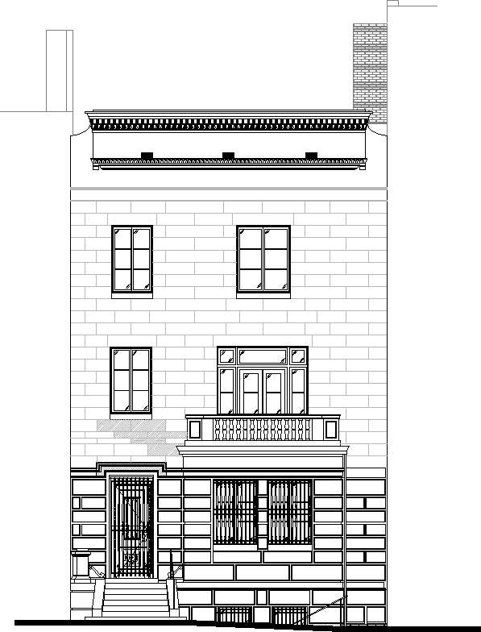

LATVIAN EMBASSY
2304 MASSACHUSETTS AVE, NW, WASHINGTON, D.C.,
20008

(CONSTRUCTION DESIGN)

Volume 1 Architectural Part Structural Part MEP
Electronic communication systems

Riga, 2021

DESIGNER: | SIA JaunRīga ECO, reg. No 40103680902,  Duntes iela 28-3, Riga, LV-1005  Construction merchant reg. No 11096-R  ATELIER MjK  1875 Connecticut Avenue, 10TH Floor Washington, D.C., 20009  (202)-643-3995
CLIENT: | VAS ‘Valsts nekustamie īpašumi’,  Vaļņu iela 28, Riga, LV-1980;
ORDER No: | IZD/2019-VV/689-26
CONSTRUCTION SITE  NAME:  ADDRESS: | Inspection, development of a construction design, and design supervision for the building at 2304 Massachusetts Avenue, NW,  Washington, DC 20008, United States of America
CONSTRUCTION DESIGN  STAGE: | LATVIAN EMBASSY  (CONSTRUCTION DESIGN)
VOLUME NUMBER: PARTS CONTAINED IN THE VOLUME, THEIR DESIGNATIONS: | Volume 1 Architectural Part Structural Part MEP  Electronic communication systems ESS
SIA JaunRīga ECO  board member | Edgars Sturmovičs

Riga, 2021

CONTENTS OF THE VOLUME
Title page |  | 1
Contents of the volume |  | 2-3
General part | VD | 4
Design terms of reference |  | 5-12
Photographic records of the current situation |  | 13-14
Technical inspection report |  | 15-101
Architectural Part |  | 102
Cover sheet | 001 | 103
General Notes | 002 | 104
General Notes | 003 | 105
Site Plan | 004 | 106
Demo Plans | D-001 | 107
Demo Plans | D-002 | 108
Existing Floor Plans | A-101 | 109
Existing Floor Plans | A-102 | 110
Existing Floor Plans | A-103 | 111
Proposed Floor Plans | A-104 | 112
Proposed Floor Plans | A-105 | 113
Proposed Floor Plans | A-106 | 114
Proposed RCP | A-154 | 115
Proposed RCP | A-155 | 116
Proposed RCP | A-156 | 117
Existing Exterior Elevation | A-201 | 118
Proposed Exterior Elevation | A-202 | 119
Proposed Section | A-301 | 120
Proposed Section | A-302 | 121
Details | A-501 | 122
Door Schedule | A-502 | 123
Window Schedule | A-503 | 124
Stair Detail | A-504 | 125
Attic Hatch Stair Detail | A-505 | 126
Lift Detail | A-506 | 127
Existing windows | A-507 | 128
New windows | A-508 | 129
Doors | A-509 | 130
Finish Floor Plans and Schedules | A-601 | 131
Finish schedule |  | 132
Door Schedule in metric |  | 133
Plumbing fixtures |  | 134
Structural Part |  | 135
General notes. Table of contents. Load plans | S-01 | 136
Connection details for wood elements and aisle detailing | S-02 | 137
Basement floor plan & 1st floor plan | S-3 | 138
1st floor framing plan and 2nd floor framing plan | S-03.1 | 139
2nd floor plan & 3rd floor plan | S-04 | 140

3rd floor framing plan and attic floor framing plan | S-04.1 | 141
Attic plan and Roof framing plan | S-05 | 142
Internal stair detailing | S-06 | 143
Site structure detailing | S-07 | 144
MEP |  | 145
Cover Sheet | 001 | 146
Mechanical notes and symbols | M001 | 147
Mechanical basement floor plans | M002 | 148
Mechanical first floor plans | M003 | 149
Mechanical second floor plans | M004 | 150
Mechanical third floor plans | M005 | 151
Mechanical attic & roof plans | M006 | 152
Mechanical schedules | M007 | 153
Mechanical details | M008 | 154
Mechanical details | M009 | 155
Mechanical VRF diagram | M010 | 156
Plumbing cover sheet | P001 | 157
Plumbing floor plans | P002 | 158
Plumbing floor plans | P003 | 159
Plumbing floor plans | P004 | 160
Plumbing diagrams | P005 | 161
Electrical cover sheet | E001 | 162
Electrical floor plans - lighting | E002 | 163
Electrical floor plans - lighting | E003 | 164
Electrical floor plans - power | E004 | 165
Electrical floor plans - power | E005 | 166
Electrical floor plans | E006 | 167
Riser diagram notes and schedules | E007 | 168
Fire alarm floor plans | F001 | 169
Fire alarm floor plans | F002 | 170
Energy Verification sheet | EVS001 | 171
Elektronisko sakaru sistēmas | ESS | 172
General information | ESS-AS-1 | 173
Block diagram of the security alarm system | ESS-AS-2 | 174
Basement and first floor with security alarm system | ESS-AS-3 | 175
Second and third floor with security alarm system | ESS-AS-4 | 176
Attica and roof floor with security alarm system | ESS-AS-5 | 177
Proposed site plan with security alarm system | ESS-AS-6 | 178
Equipment and material specification | ESS-AS-7 | 179
General information | ESS-PK-1 | 180
Block diagram of the videointercom network and specification | ESS-PK-2 | 181
Basement and first floor with videointercom network | ESS-PK-3 | 182
Second and third floor with videointercom network | ESS-PK-4 | 183
ESS specification |  | 184-187

GENERAL PART

STATEMENT OF WORK (TECHNICAL SPECIFICATIONS)
Inspection, development of a construction design, and design supervision for the building at 2304 Massachusetts Avenue, NW, Washington DC 20008, United States of America
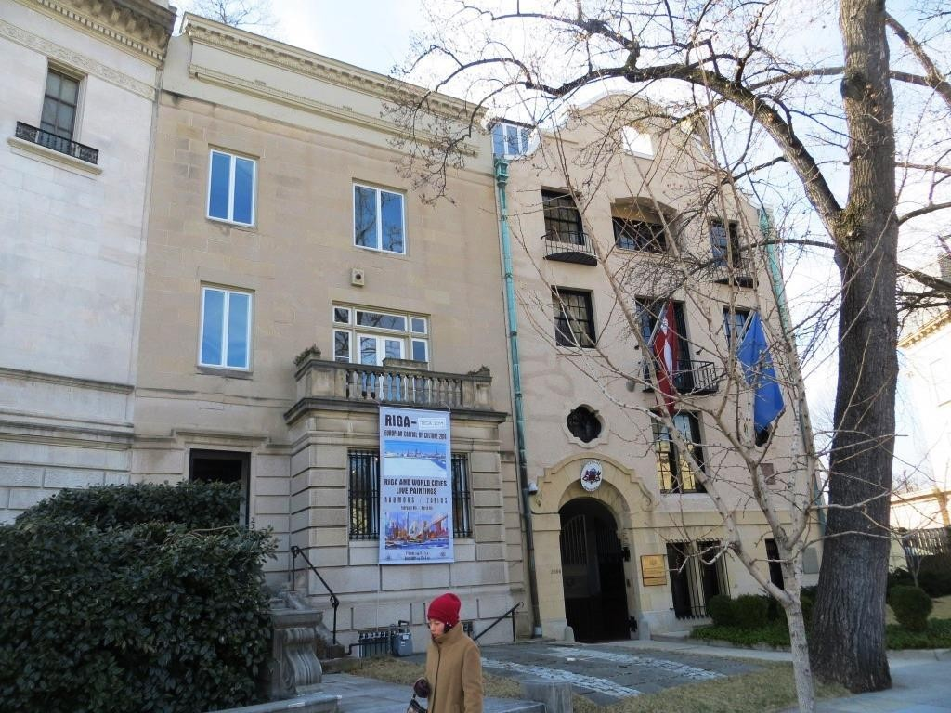

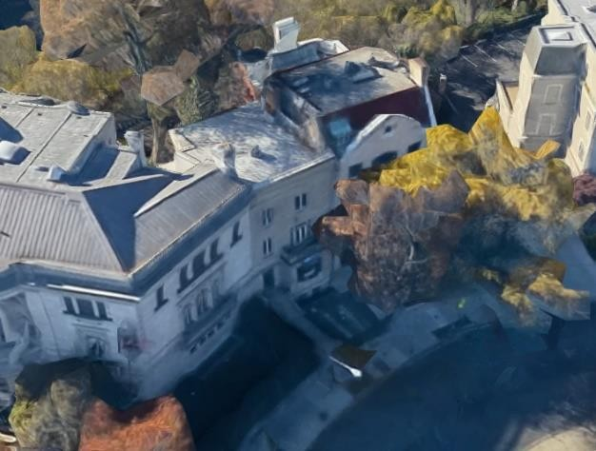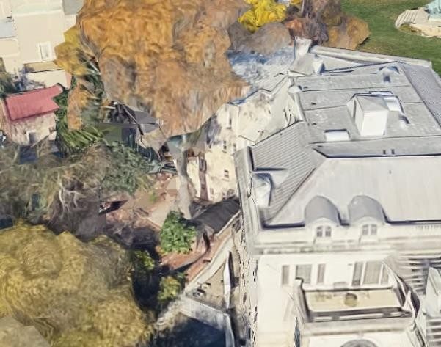

 | Site | Inspection, development of a construction design, and design supervision for the real property at 2304  Massachusetts Avenue, NW, Washington DC 20008,

 |  | United States of America
1. | Land unit cadastral  designation | 20008 2810
2. | Site address | 2304 Massachusetts Avenue, NW, Washington, DC  20008, United States of America
3. | Type of construction | Reconstruction;
4. | Construction group | Group II;
5. | Current main use of the structure | 1110;
6. | Planned main use of the structure | 1121;
7. | Cultural and historical  heritage status | None;
8. | Client | VAS ‘Valsts nekustamie īpašumi’,  Vaļņu iela 28, Riga, LV-1980;
9. | Client representative | Miks Krūmiņš, development project manager, Office and Maintenance Portfolio Management Division, phone  26417630, e-mail: miks.krumins@vni.lv;
10. | User | Embassy of the Republic of Latvia in the United States of America  ;
11. | Required  design document | Construction design that has been developed and approved (must be approved by VAS ‘Valsts nekustamie īpašumi’) in accordance with the applicable laws and regulations of the Republic of Latvia. Sections of the construction design requiring approval by local authorities before the work can begin:  design documentation prepared and approved in accordance with the laws and regulations of United States of America;
12. | Source of funding | VAS ‘Valsts nekustamie īpašumi’
13. | Design statement of work goal/objective | Development and approval of design documentation;  Design supervision provided during the construction and warranty period;
14. | Design requirements | The construction design work must be carried out in accordance with Cabinet Regulation 500  ‘General construction regulations’ of 19 August 2014, laws and regulations governing construction (of the Republic of Latvia and the United States of America), as well as the technical specifications and the financial resources available to the Client;  Within ten (10) business days after the Contract takes effect, the Contractor must submit to the Client  a schedule for the survey and design work.

The Contractor must prepare a progress report once (1) a month, describing the status of the project from the Contractor’s point of view, as well as the specific details of the work carried out in the previous period and planned for the next period.
At least once a week, or less frequently if agreed by the Parties, joint meetings with the representatives of the Designer and the Client must be arranged to take place, with the recording of minutes, to discuss matters pertaining to the performance of the Contract. The meetings must be organised and conducted in the Republic of Latvia.
15. | Construction design development stages | Inspection of the current situation at the site, including an inspection of the existing utility lines to determine their actual situation on site (including a confirmation of their current capacity), preparation of diagrams of the utility lines to be kept, requesting and obtaining of technical specifications necessary for the development of the construction plan, updating of the design terms of reference with the Client (if necessary), preparation of a topographic plan in digital format (.dwg), preparation of precise floor plans in digital format (.dwg), technical inspection of the buildings with the preparation of a report, defining of the scope of work for conducting a construction tender, obtaining of approvals for the construction plan from the user of the site, the Client and authorities in charge.  Full development, structured arrangement, obtaining of approvals, and submission to the Client of all construction plan documentation.
16. | Technical inspection, photographing of the building | The technical inspection is to be carried out in accordance with Cabinet Regulation 337  ‘Regulations on Latvian construction standard LBN 405-15  “Technical inspection of structures”’ of 30 June 2015, and the requirements and scope of the technical specifications. Prepare and submit to the Client the technical inspection report (two (2) hard copies and two (2) identical digital copies in *.pdf or *.doc formats) no later than 60 calendar days after the date of conclusion of the Contract.

17. | Measurement drawings | All drawings must be prepared in accordance with the applicable laws and regulations governing construction, and the requirements and scopes set in the technical specifications  .
18. | General requirements | The solutions of the construction design must guarantee the mechanical strength and stability, energy efficiency, acoustic properties, fire safety, operational safety, environmental protection, hygiene requirements, including safety during construction and operation, as well as compliance with the User’s requirements.  The materials and products used must be certified in the European Union or the United States of America, and with a manufacturer warranty period of at least 2 years;  The construction planning documentation must contain all the sections necessary to fully implement the design in accordance with the requirements of the authorities in charge, the Client, and the User. The documentation must be prepared in Latvian and English. For sections requiring approvals by United States authorities, the documentation must be prepared in English and, separately, in Latvian.  The construction plan documentation must be prepared in four (4) copies:  - 1 copy for the Contractor’s archive;  - 3 copies  are handed over to the Client with the acceptance certificate;  All the four (4) copies must be accompanied by a data storage medium containing the entirety of the volume of the documentation in electronic form. The entire design volume must be in *.pdf format. The drawing sheets and spreadsheets must also be enclosed, in *.dwg and *.xls formats.  If approval by United States authorities is required, appropriate documentation must be provided: the Contractor must provide the entirety of the documentation requested by the authorities in the specified submission format.

All the work specified in the construction design must be shown in the table of construction quantities and a costed work estimate that must be included in the digital documentation for the site and on the data storage medium. Based on the work estimate, a template for the financial offer must be prepared and
included it on the data storage medium.
19. | Contract duration | The total time for the completion and approval of all the work specified in these Technical Specifications may not exceed six (6) months after the date of signing of the Contract.  The construction design must be approved by the Users defined by the Client, by the Client itself, and by the national, municipal, and other authorities of the Republic of Latvia or the United States of America, if required by applicable  laws and regulations.
 | Design supervision requirements | Design supervision is carried out in accordance with the laws and regulations governing construction, monitoring compliance with quality standards and requirements and recording the results of inspections in the construction log;
20. |  | During design supervision, the designer, at no additional charge, corrects any deficiencies and errors in the design documentation and prepares the necessary additional drawings. Any increases in the cost of the construction work resulting from deficiencies or errors in the design are paid by the designer;
 |  | If changes are made to the approved construction plan documentation during design supervision, the designer must ensure that these changes are approved by the Client and, in the cases specified in laws and regulations, by the institutions that issued the technical specifications, and other bodies;
 |  | The cost of design supervision includes all that is necessary to ensure that the design supervision team can work continuously at the site throughout the duration of the construction. Design supervision is paid in accordance with the performance of the construction work;

The price of design supervision is specified by the Designer in its financial bid, and it is a fixed amount not to be changed throughout the construction process, or adjusted after the conclusion of the contract for the construction of the site and the exact determination of the expected construction costs;

The Client must be immediately notified of any problems or unforeseen circumstances; a reasoned written request must be submitted to the Client to suspend the construction if unauthorised deviations from the construction design documentation are found or if the requirements of the laws of the Republic of Latvia and/or the United States of America are not complied with, to the extent necessary.

Request the institution that issued the construction practice certificate of the construction foreman in charge that the certificate be revoked if the contractor’s instructions on the rectification of the deviations and violations found are not followed within the specified time;

The Designer must attend the meetings held for interested contractors as part of the tender procedure for the construction and answer questions
associated with the construction design during the tender procedure.
21. | Insurance requirements | Professional third-party liability insurance for construction professionals involved in the performance of the contract at the site in question, with a limit of liability of no less than 100% of the contract amount for the design and related services (design supervision) and a deductible of no more than five hundred euros and zero cents (EUR 500.00).  Contractor third-party liability insurance for the specific Site with a total limit of liability and a limit per insurance event of no less than one hundred and fifty thousand euros and zero cents (EUR 150,000.00) and a deductible of no more than  five hundred euros and zero cents (EUR 500.00).

Design requirements.

- Outdoors:
  - replacement of windows (with windows of historical arrangement and appearance);
  - grounds improvements (courtyard, walkway, fencing, utility access cabinets, and other renovation), if necessary;
  - removal (if possible) of the concrete paving in the courtyard and restoration of the historic appearance of the site;
  - connecting of the courtyard to the courtyard of the adjacent building (2306);
  - renovation of the facade and exterior wall finish of the building; renovation and reinforcement of both the balconies
;
  - replacement of all windows with wooden-frame glass unit windows and renovation/replacement/insulating of the exterior doors (to comply with LLDRA 0219 ‘Requirements and recommendations for windows and doors’ of the Latvian Window and Door Manufacturer Association, to the extent that these do not contradict the regulation in effect in Washington and the United States);
  - reinforcement of the entrance porch stair;

- Basement floor: GUEST ACCOMMODATIONS/AUXILIARY ROOMS FOR PUBLIC EVENTS:
  - replacement of damaged load-bearing elements (rot/insect damage);
  - redecoration of the premises for the function of accommodating guests and public event auxiliary rooms;
  - technically and economically justified levelling of the floor;
  - renewal/replacement of utilities after the inspection;
  - installation of a lift to the first floor (next to the first floor kitchen);

- Floor 1 — PUBLIC EVENT ROOMS:
  - replacement of damaged load-bearing elements (rot/insect damage);
  - redecoration of the premises for the function of rooms intended for public event;
  - technically and economically justified levelling of the floor;
  - renewal/replacement of utilities after the inspection;
  - conversion the kitchen into an event support staff room;

- Floor 2/Floor 3 — RESIDENTIAL ROOMS:
  - replacement of damaged load-bearing elements (rot/insect damage);
  - redecoration of the premises for the function of residential rooms;
  - technically and economically justified levelling of the floor;
  - renewal/replacement of utilities after the inspection;
  - make it possible to use the premises as one two-floor apartment or as two separate apartments on each floor: this decision will be made based on the designers’ recommendations;

  - provide sound insulation and sound insulation solutions between the apartments and the surrounding spaces (essential for slabs connecting them with public premises);
  - restoration of the fireplaces (and an assessment of the effectiveness of using them, or the possibility of bricking them up);

- generally for all the premises (utility systems)
  - inspect and update/replace the utility systems where necessary
  - set up a VAS (BMS) system with the ability to remotely get readings from and monitor utility lines and equipment;
  - renovate/build a new air-conditioning system;

Enclosed:
Annex 1 — ‘Building (structure) visual inspection report’ of 21 February 2014, prepared by VAS ‘Valsts nekustamie īpašumi’, on 25 pages;
Annex 2 — 7-page building plan (.pdf and .dwg formats) prepared by T. Cave on 5 November 2007;

Prepared by:
Miks Krūmiņš
Development Project Manager, 67024644
Miks.Krumins@vni.lv

We hereby approve and guarantee:
- that we understand and accept every requirement specified in the Sections of the Technical Specifications;
- that we undertake to provide the Service in accordance with the Technical Specifications;
- the veracity and accuracy of the information provided.
(signature of the head of the company or their authorised representative (provide the original or a certified copy),

2019 .

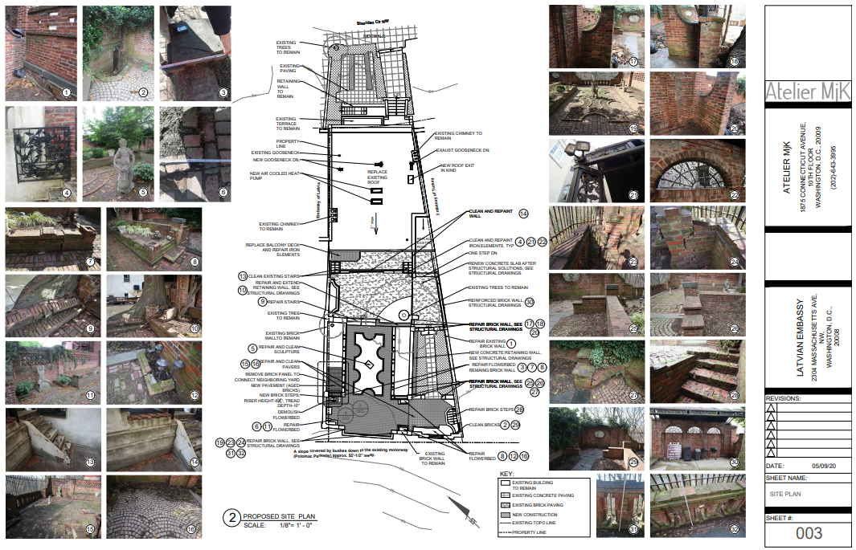
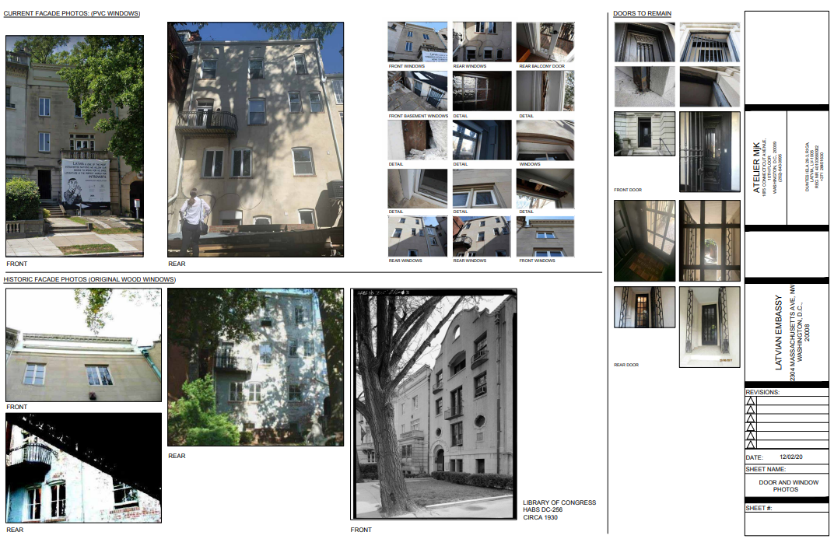


Reg. No 40103680902, Duntes iela 28-3, Riga. LV-1005 Construction merchant reg. No 11096-R
Phone: +371 26451630
info@jaunriga-eco.lv
(details of the inspecting party: name, surname, certificate number for individuals; name, registration number, construction merchant certificate number, registered address, phone number, e-mail address of the legal entity)

Technical inspection report

Residential building, 2304 Massachusetts Avenue, NW, Washington, DC 20008, United States
Cadastral No 20008 2810 0699
(name of the structure, cadastral number and address of the land unit)
VAS ‘Valsts nekustamie īpašumi’, contract No IZD/2019-VV/689-26 of 13 January 2020
(owner of the building, date and number of the contract)
In accordance with the technical specifications of contract No IZD/2019-VV/689-26 signed by the parties
(inspection statement of work; date of issue)
Report issued on 6 April 2020.
SIA JaunRīga ECO, reg. No 40103680902, Duntes iela 28, Riga, LV-1005,
Construction merchant reg. No 11096-R
(party performing the inspection: (if private individual) name, surname, cert. No, or (if legal entity) name, reg. No)

In accordance with the Annex to Latvian construction standard LBN 405-15 ‘Technical inspection of buildings’ with necessary additions by VAS ‘Valsts nekustamie īpašumi’

General information about the building
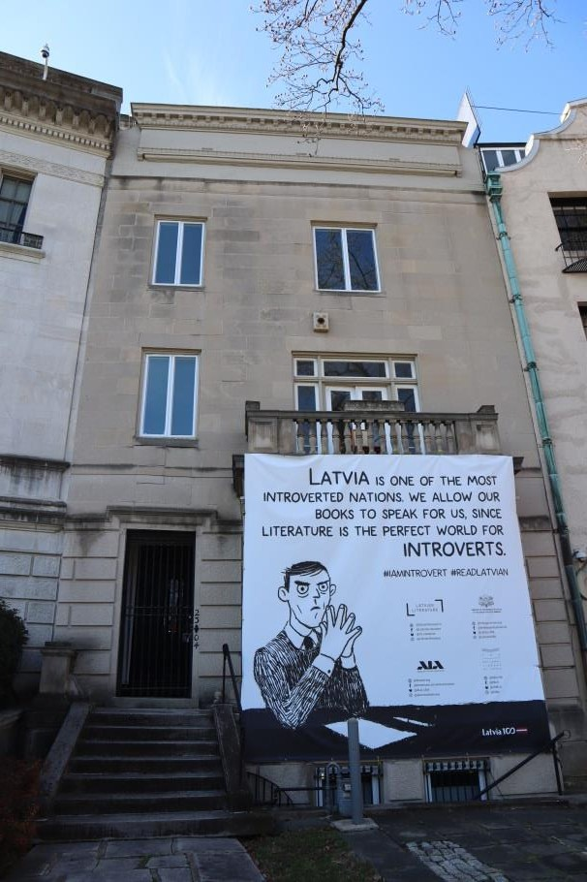
    - figure. Residential building in Washington

Table 1
1.1. | Building type | 11 — Residential building
1.2. | Soundness group | II
1.3. | Development area (m²) | 146.20
1.4. | Building volume (m³) | 2950
1.5. | Total/useful/habitable area (m²) | 410.3/410.3/410.3
1.6. | Number of floors/above-ground floors/basement/attic | 4/3/1/0
1.7. | Number of apartments | 1
1.8. | Cadastral designation of the land unit | 20008 2810
1.9. | Land plot area (m²) | 358
1.10. | Previous owner of the building | Richard G. and Elizabeth H. Turner
1.11. | Current owner of the building | VAS ‘Valsts nekustamie īpašumi’
1.11a. | Operator, building manager (acceptance date) | Ministry of Foreign Affairs
1.12. | Author of the construction design | N/D
1.13. | Construction design name, year and date of approval | Reconstruction design: 20 April 1914.
1.14. | Year and date of commissioning (acceptance) of the structure | 1910.
1.15 | Building mothballing year and date | N/A
1.16. | Year of renovation (overhaul), reconstruction, restoration | 1914 and 1934 — the building was reconstructed;  The building’s foundations were reinforced in 2000.
1.17. | Cadastral measurement files of the structure: number, date of issue | N/D
1.18. | Structures: Bases  Wall slabsRoof covering | Field stone/bricks  Clay brick masonry/wooden frame walls Wooden beam slabs  PVC membrane
1.19. | Medium level of visual deterioration | 43%
1.20. | Signs of unauthorised construction | Not detected.
1.21. | Situation of the building within the plot | NE part of the plot.
1.22. | Inclusion in state registers of protected cultural heritage sites | Sheridan-Kalorama Historic District, Massachusetts Avenue Historic District

Situation

Table 2

2.1. | compliance of the use of the land in accordance with spatial planning
The use of the land complies with the spatial planning, the zoning and development regulations, and other laws and regulations. | According to the official zoning of Washington, the land plot is within an R-3 zone (Residential) (see Figure 2). The purpose of R-3 zones is to allow row houses while including land plots where row houses include detached houses, semi-detached houses, and houses in rows of three or more.  The land plot is within the Sheridan-Kalorama Historic District area and the Massachusetts Avenue Historic District area.  The use of the land is in accordance with the zoning.  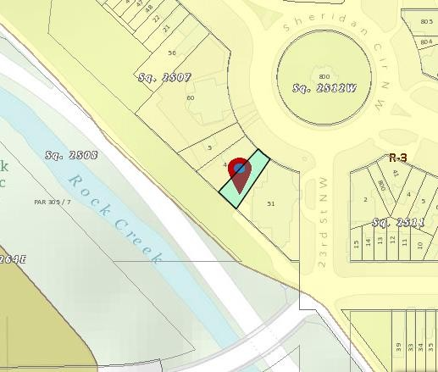  Figure 2. Zoning of the city of Washington (Source: http://maps.dcoz.dc.gov/zr16/ )

2.2. | situation of the building within the plot
Frontage line, building line, encumbrances, layout of structure | No data available on street frontage lines. See Figure 3 for the plan of the structures. The building is constructed in the NE part of the plot. There is a natural slope to the Rock Creek and Rock Creek and Potomac Pkwy NW in the SW portion of the site (see Figures 3–4).  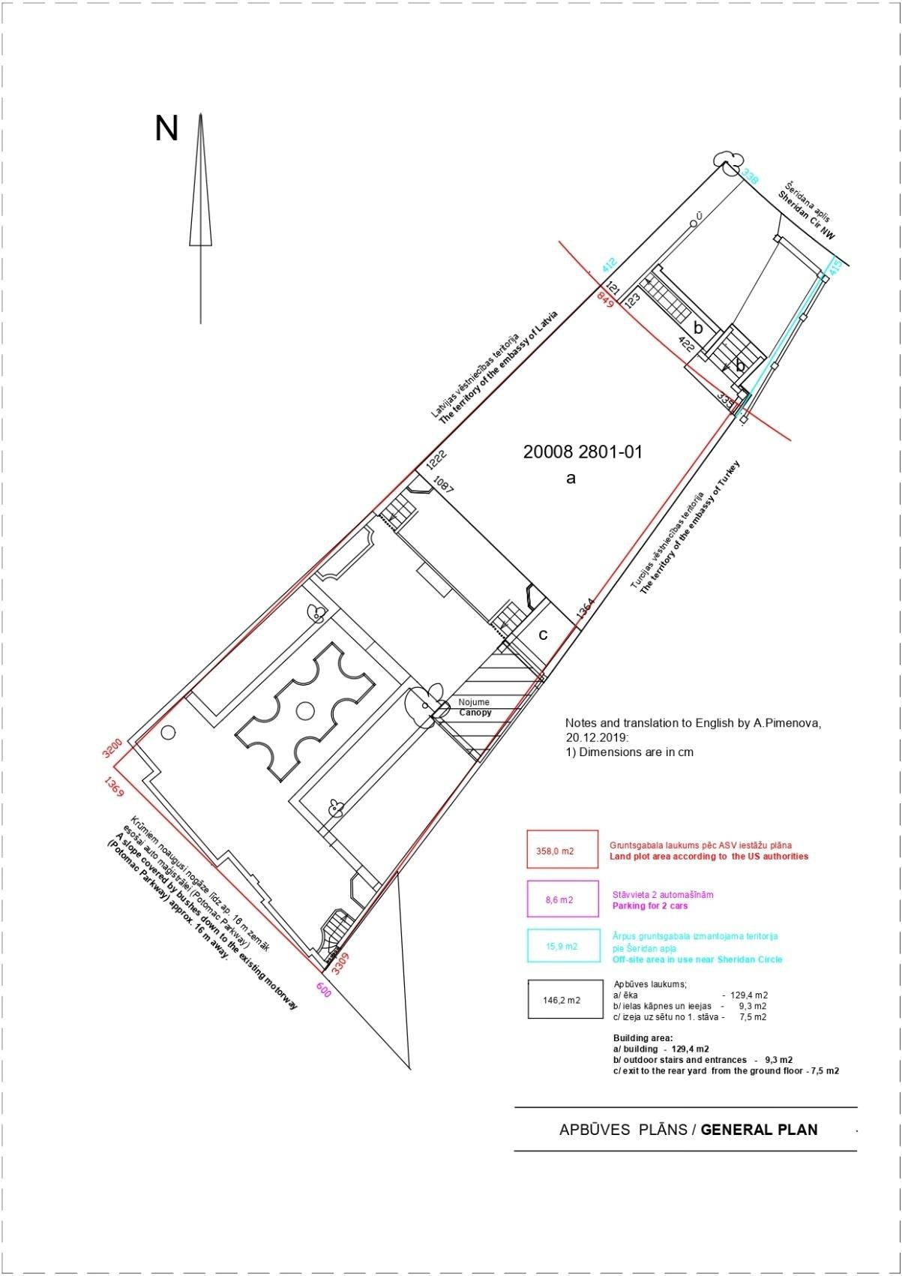  Figure 3. Building development plan

Existing structure

Figure 4. Location of the building
2.3. | layout of the building
Actual use of the building, its compliance with the intended use of the building specified in the zoning. | The existing layout of the building is that of a residential building with a single apartment. The building has 3 above-ground floors and a basement (see Fig. 5–10). There is an unheated attic above Floor 3. The roof structure is that of a single-pitch roof. The main entrance is oriented to the NE, with an entrance to the basement and first floor. The building has adjacent building volumes in the NW and SE. The courtyard is oriented towards the SW of the plot, with an entrance to the basement and the first floor. The courtyard is developed and separated from the adjacent land volumes and slope. Bathrooms are built in the basement, on the first floor and on the third floor (there is a water connection in the kitchen on the second floor). The building has one general staircase enabling access to all floors. A terrace is built on the level of the second floor oriented towards the NE of the land plot. A balcony is built on the same floor, facing the courtyard. The volumes of the SE perimeter walls and fences are built in the adjacent plots (Turkish embassy), see Figure 3.  The existing layout of the structure is in line with the use of the structure. The floor plans are shown in Figures 5 to 10.
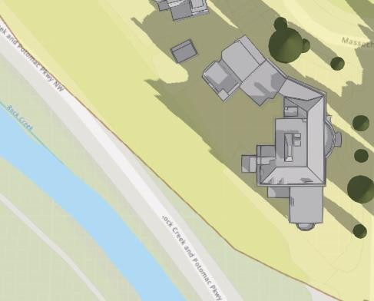

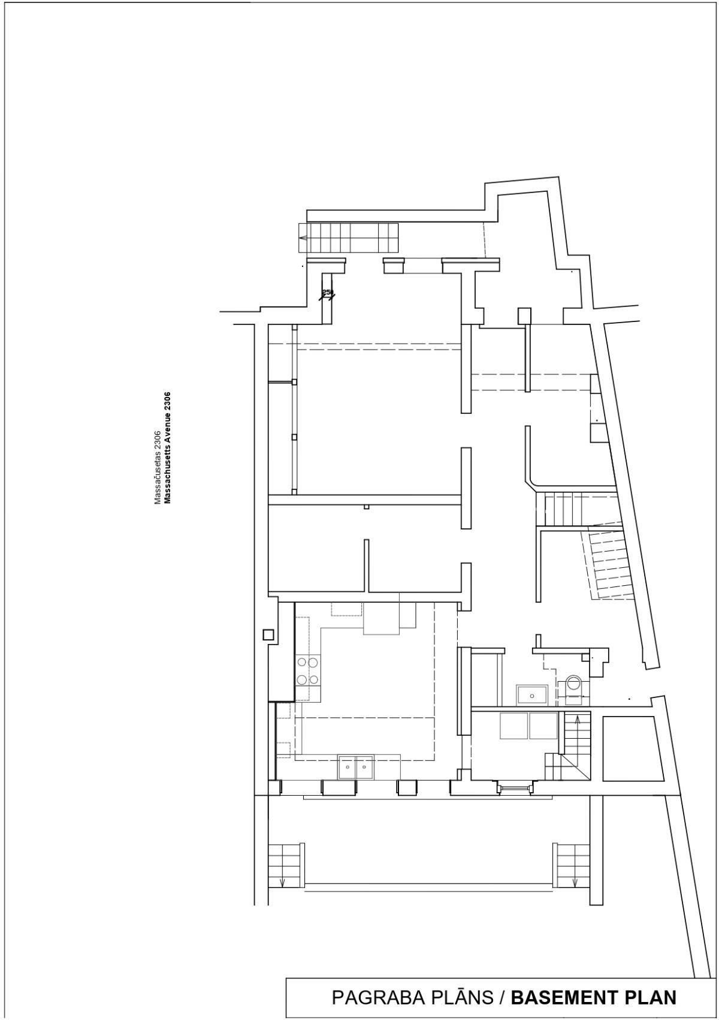
Figure 5. Basement plan

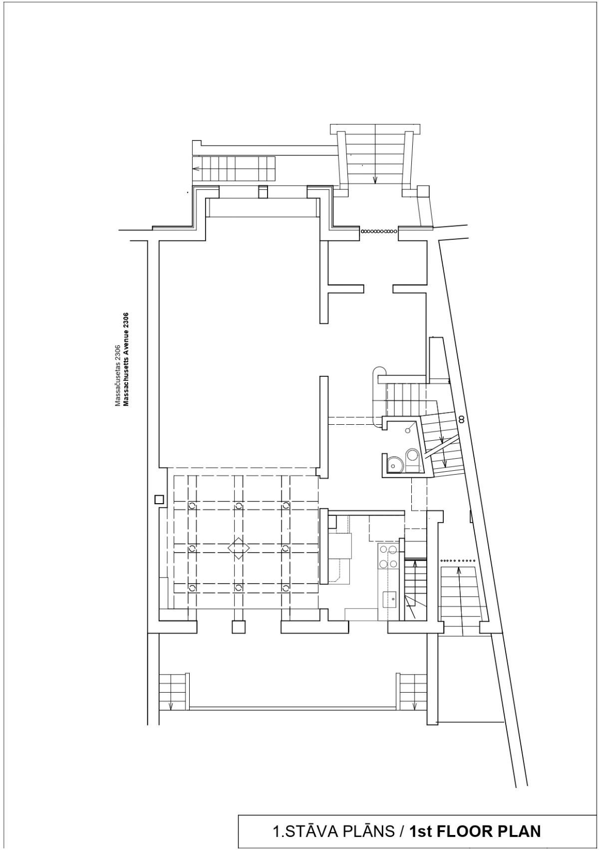
Figure 6. First floor plan

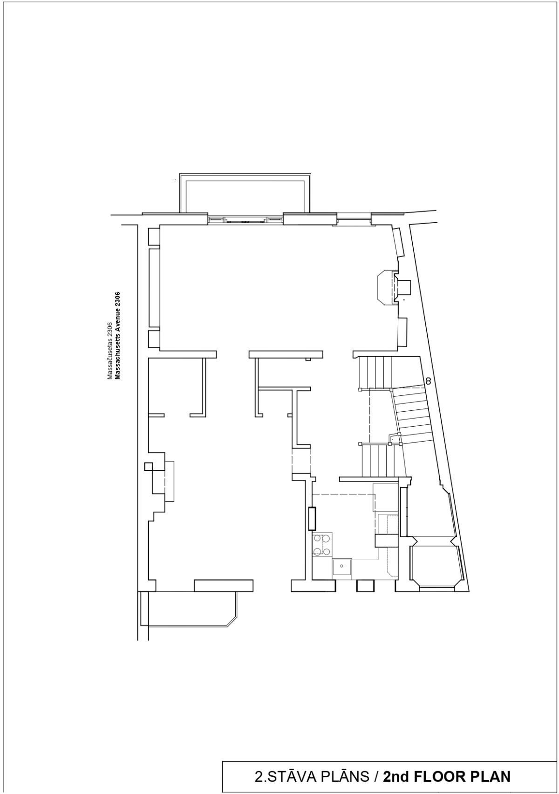
Figure 7. Second floor plan

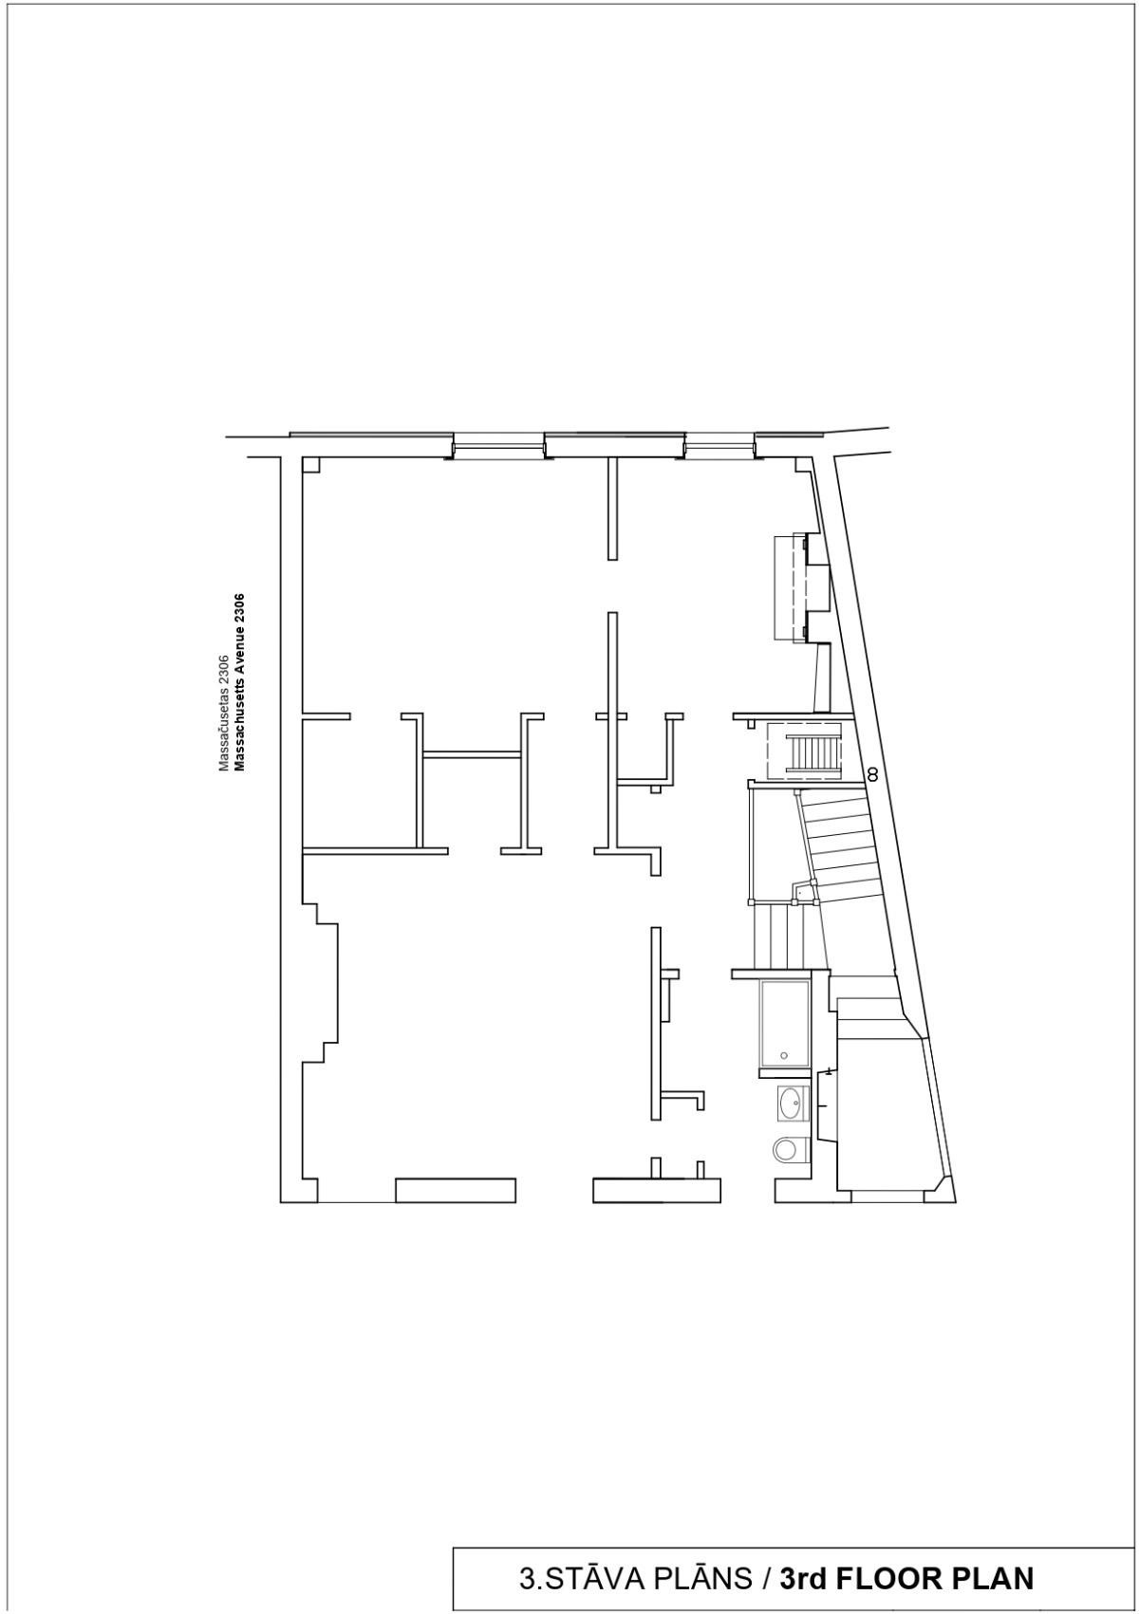
Figure 8. Third floor plan

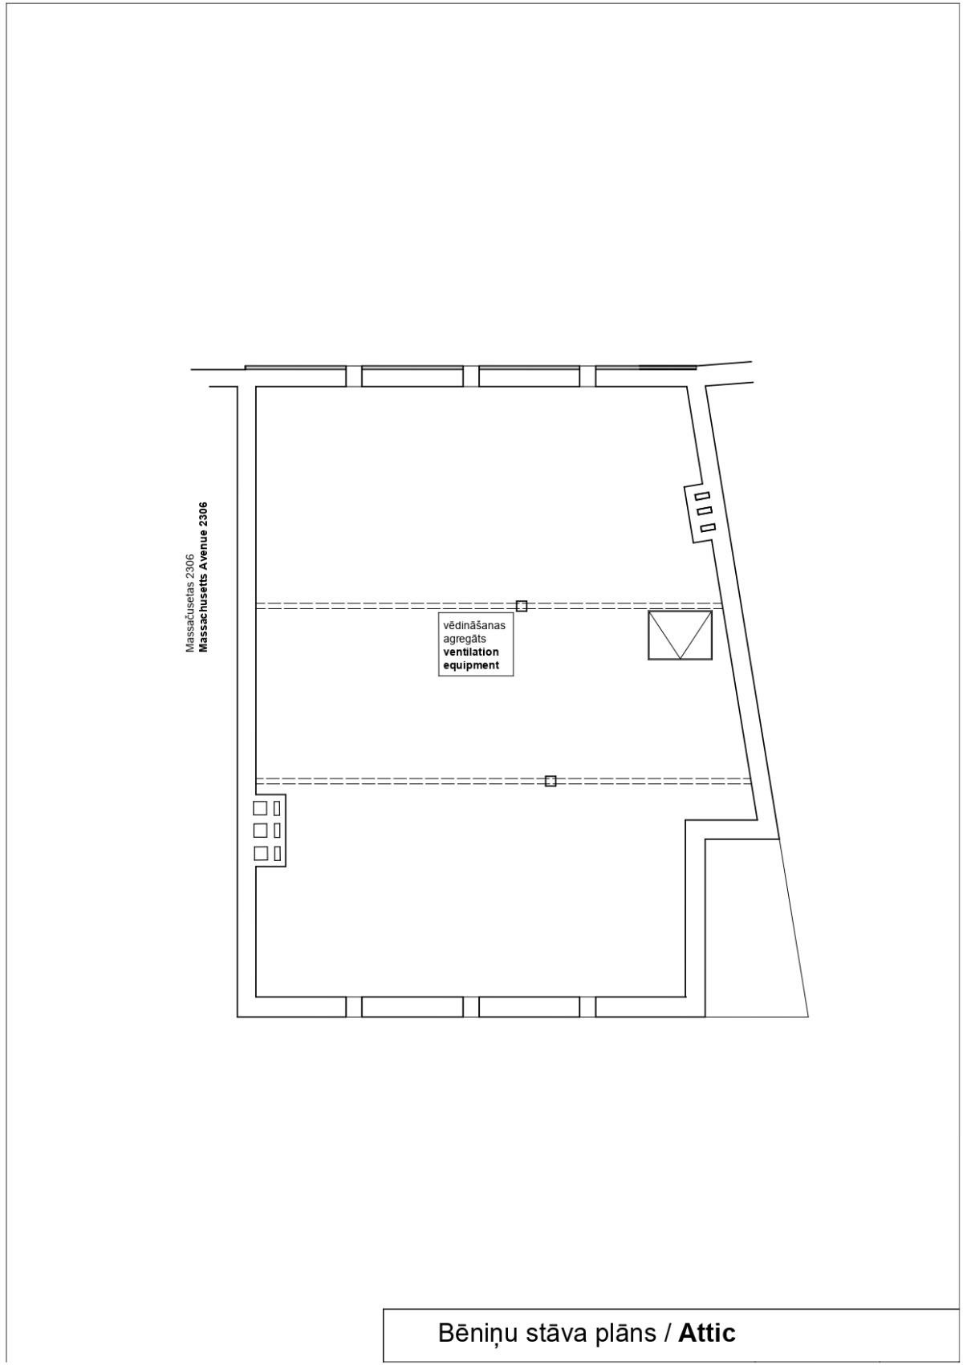
Figure 9. Attic floor plan

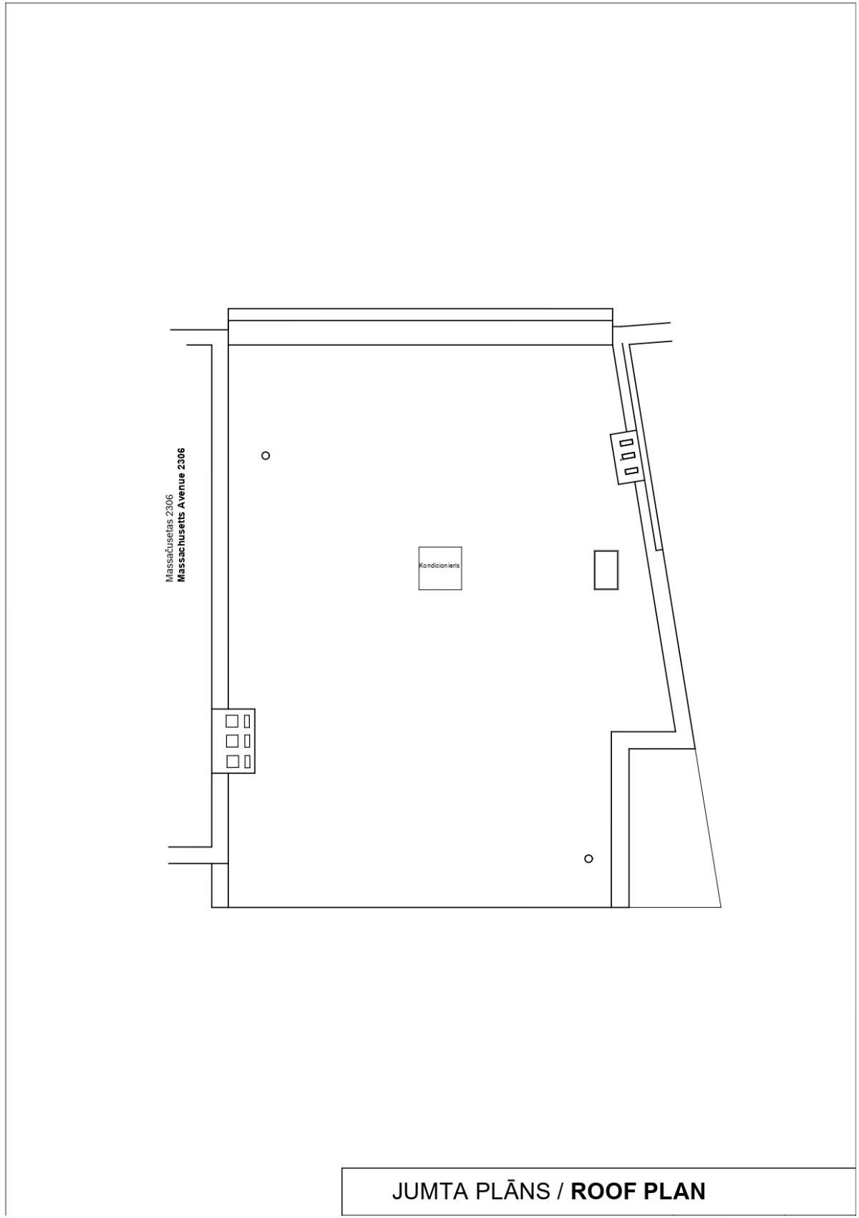
Figure 10. Roof plan

Grounds improvements

Table 3

Inspection site or object name | Brief description of damage/defects found and of their causes; assessment of the technical condition of individual structural elements, types of structures and parts of the structure. Compliance with laws and regulations |  |  |  | Technical wear, %
1 | 2 |  |  |  | 3
3.1. | traffic ways, walkways, paths, and utility areas |  |  |  | 45
3.1.1. surface, material,  finish | 75. Walkways, roads, and surfaced areas;  On the NE side of the building plot, there is a concrete plate walkway leading to the main entrance and the basement entrance. On the street side, there is a small front yard with concrete plates and granite pavestone elements (see Figures 11–16).  The building’s courtyard is surfaced using different materials: concrete plates, concrete screed, bricks, and granite pavestone. The roots of the trees in the courtyard have forced some surfacing and vertical boundary elements out, creating deformations in the surfacing structures.  Overall technical condition of the walkway, roads, and surfaced areas: unsatisfactory  (wear 45%). |  |  |  | 45
3.1.1. surface, material,  finish |  | 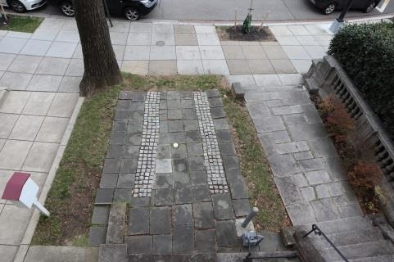  Figure 11. Street-side surface | 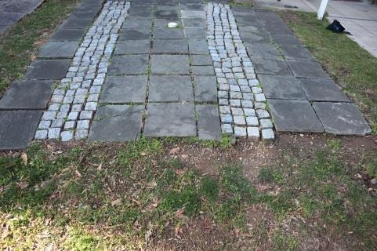  Figure 12. Street-side surface |  | 45
3.1.1. surface, material,  finish |  | 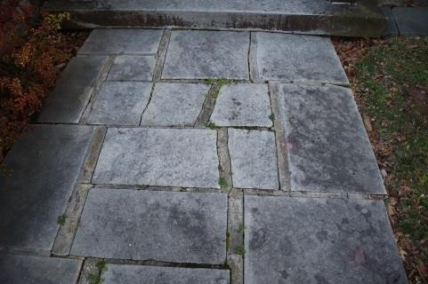  Figure 13. Street-side surface | 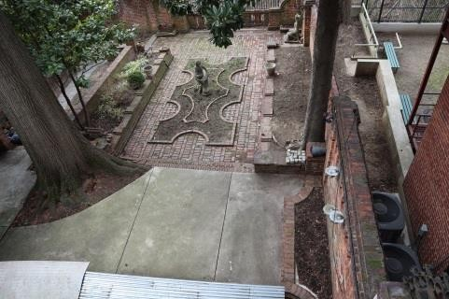  Figure 14. Courtyard surface |  | 45
3.1.1. surface, material,  finish |  | 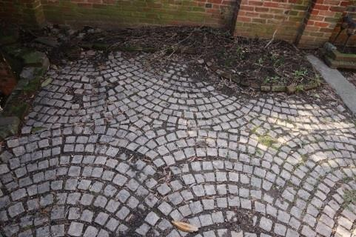  Figure 15. Courtyard surface | 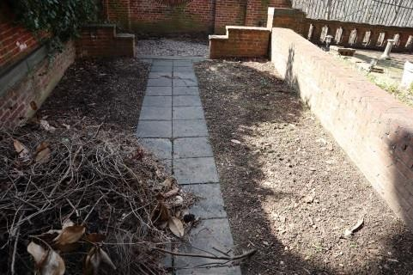  Figure 16. Courtyard surface |  | 45
3.2. | Playgrounds, recreation and sports grounds |  |  |  | ---
3.2.1 surface, materials, equipment | 75a Playgrounds, recreation and sports grounds  There are no playgrounds or sports grounds at the site. Certain courtyard areas could be considered recreation areas. The courtyard greenery and improvements require regular maintenance. |  |  |  | ---

3.3. | Greenery and small architectural forms |  |  |  | 60
3.3.1. ornamental greenery, lawn;  gazebos, water pools, sculptures | 76. Greenery;  76a. Small architectural forms;  In the front yard of the building, there is a concrete/stone fence along the area adjacent to the main entrance, maintaining the historic architectural style (see Figure 17–18). No deficiencies were found in the fence.  In the courtyard, there is a brick-wall garden shed with a metal (probably cast-iron) slab (see Figure 19). The support areas of the slab structure are sagging and cracked (see Figure 20). The surface of the vertical brick structures of the bricks is eroded and covered in vegetation (see Figure 21). The metal structures have corroded significantly (see Figure 22). Two sculptures are on display in the courtyard (see Figures 23–24). Elements of the sculptures have local damage, with a need for treating the surface and conducting careful restoration. There is a fountain (see Figure 25) embedded into the brick wall on the NE side of the adjacent plots, not used for a long time. The historic metal gate has also been preserved (see Figure 26). The courtyard greenery and landscaping requires regular cleaning and maintenance (see Figures 27–28).  Technical condition of greenery and small architectural forms: unsatisfactory  (wear 60%). |  |  |  | 60
 |  | 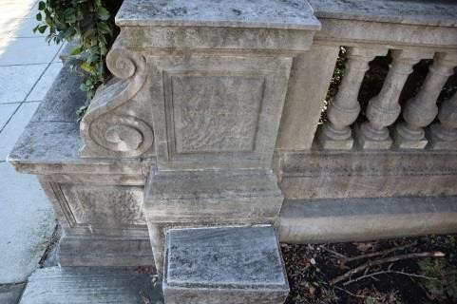  Figure 17. Adjacent building fence | 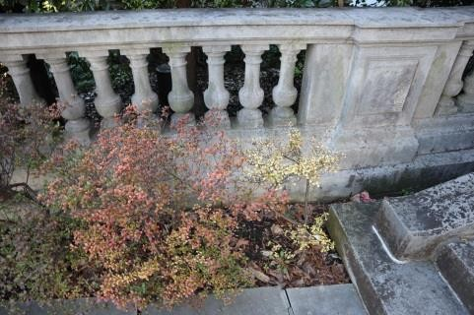  Figure 18. Adjacent building fence |  | 60
 |  | 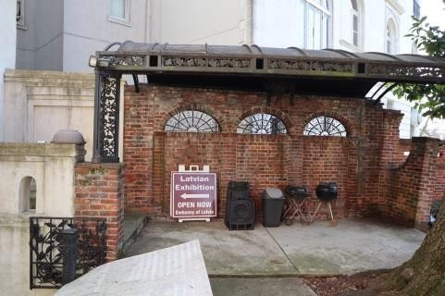  Figure 19. Courtyard awning | 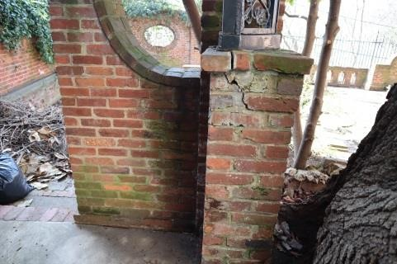  Figure 20. Tilting awning support |  | 60
 |  | 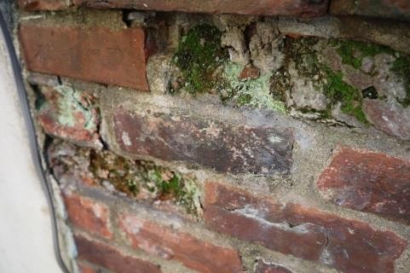  Figure 21. Brick erosion | 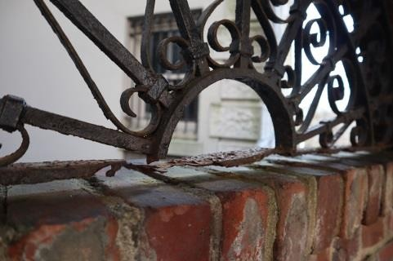  Figure 22. Corrosion damage |  | 60

 |  | 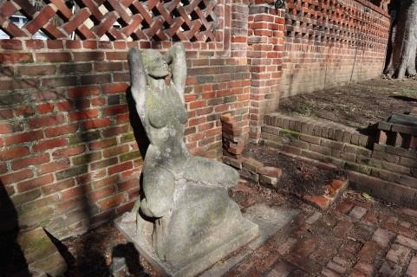  Figure 23. Sculpture of a woman | 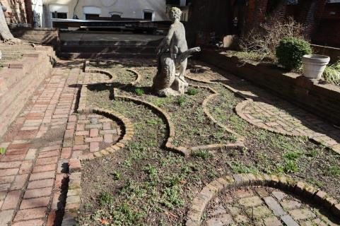  Figure 24. Sculpture
 |  | 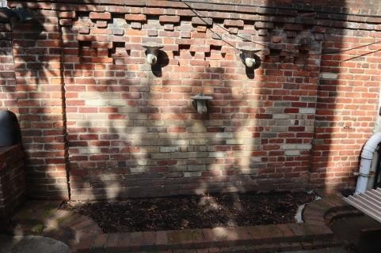  Figure 25. Fountain | 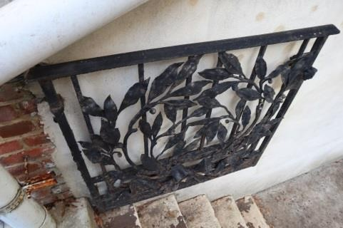  Figure 26. Metal gate
 |  | 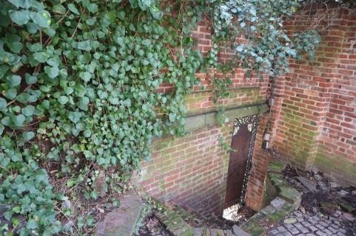  Figure 27. Exit to an adjacent area | 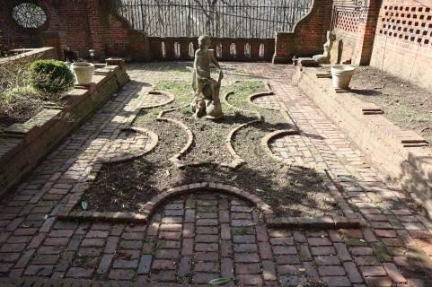  Figure 28. Courtyard
3.4. | Fences and supporting walls |  |  |  | 60
3.4.1. type, material (construction product), finish of fencing | 74. Fences;  The courtyard of the land plot is enclosed by a brick wall with historical metal elements installed in it. The thickness of the brick fence is that of one brick (~20 cm) with brick pilasters (see Figures 29–30). There is a small brick wall built on the side of the natural slope (in the SW), which has become detached from the main stone fence (see Figures 33–35). The wall is separated from the slope via a metal fence (see Figure 36). The lower structures of the metal fencing are corroded. The brick wall most probably detached as a result of the earthquake in 2011 ( no detaching of the wall recorded in the 2007 technical inspection by T. Cave). The adjacent wall is one and a half bricks thick and has retained its vertical orientation. Surface erosion and vegetation growth were observed on some bricks (see Figures 31–32). The wall enclosing the outdoor awning has tilted towards the adjacent plot of the Turkish embassy (see Figure 19). The masonry foundation revealed open cracks due to unevenness in the deformations (see Figures 37–40). There is no information about the cracks being repaired. The foundations show no visible tilting, suggesting the influence of the concrete surface located above and, possibly, tree roots on the tilting of the brick masonry. The perimeter wall can only be reinforced from the side of the Turkish embassy due to the significant differences in the ground level between the plots. A number of brick walls have lost their vertical orientation. Preserved historic decorative metal gates are installed at the courtyard entrance to the basement of the building (see Figures 41–42).  Given the close proximity of the slope, as well as the possible geometric changes in the slope during the last earthquake, the courtyard and the building require slope monitoring during the future operation of the structure (see Section 7.2 for conclusions).  Technical condition of the fences: unsatisfactory, with some wall planes in pre-failure and collapse state (wear 60%). |  |  |  | 60

 |  | 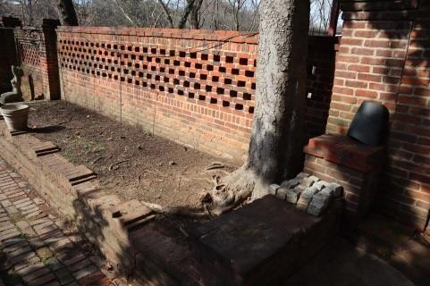  Figure 29. Latvian embassy fence | 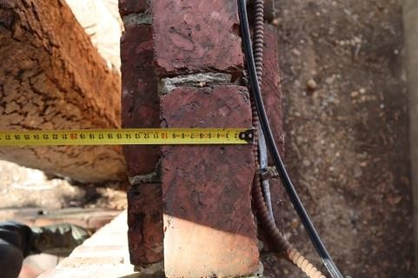  Figure 30. Fence thickness (20 cm)
 |  | 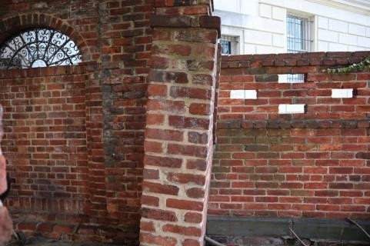  Figure 31. Tilted masonry wall | 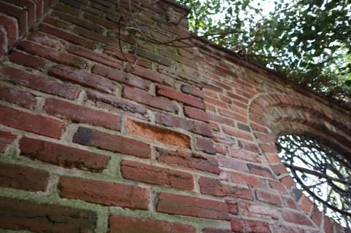  Figure 32. Brick erosion
 |  | 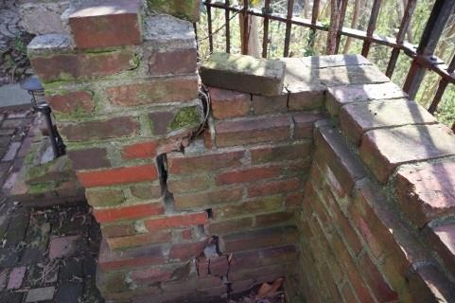  Figure 33. Detached fence | 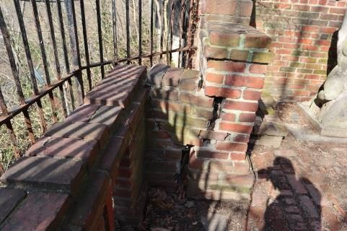  Figure 34. Detached fence
 |  | 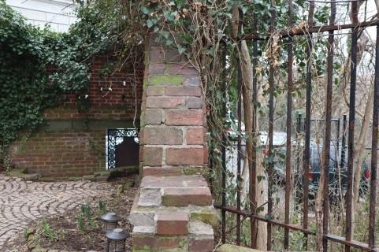  Figure 35. Vertical fence wall on the side of the slope | 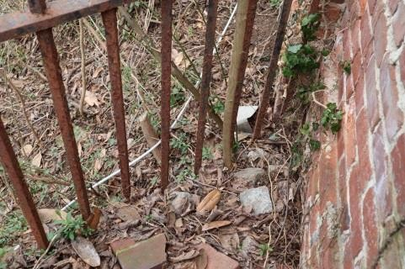  Figure 36. Corroded metal fence
 |  | 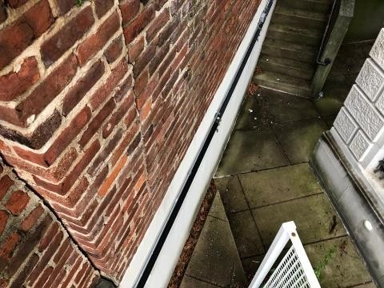  Figure 37. Crack in the brickwork abutment | 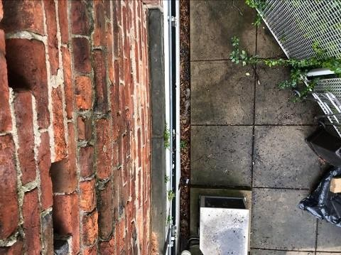  Figure 38. Brick wall fence on the side of the Turkish embassy

 |  | 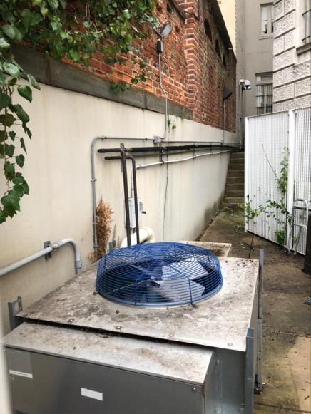  Figure 39. Brick wall fence on the side of the Turkish embassy | 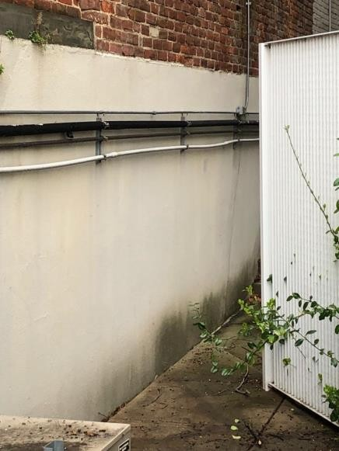  Figure 40. Brick wall fence on the side of the Turkish embassy
 |  | 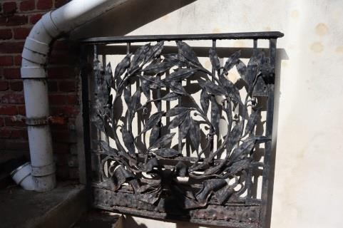  Figure 41. Metal gate in the courtyard | 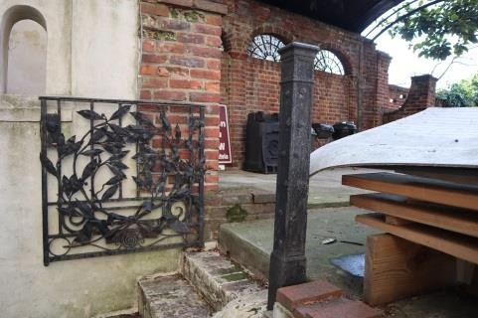  Figure 42. Metal gate in the courtyard
3.4.2. type, material (construction product), finish of the supporting walls | Some supporting walls and brick walls are built in the courtyard of the plot (see Figures 43–47). Brick structures in most of the courtyard have tilted and lost their vertical orientation. In some areas, the brick walls are displaced by roots of a larger tree. The brick elements near the trunk of the large tree need to be removed. No defects were found in the supporting wall of the gate in the SE corner of the plot.  The condition of the supporting walls is unsatisfactory, with some in pre-failure condition (wear 60%). |  |  |  | 60
 |  | 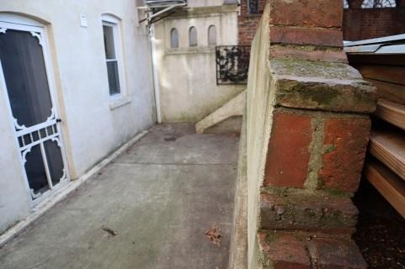  Figure 43. Tilted support wall | 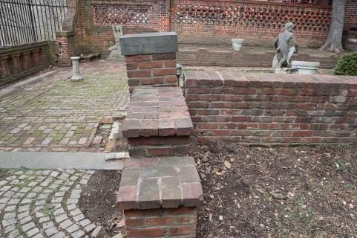  Figure 44. Tilted support wall |  | 60

 |  | 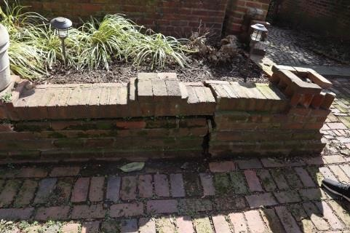  Figure 45. Tilted support wall | 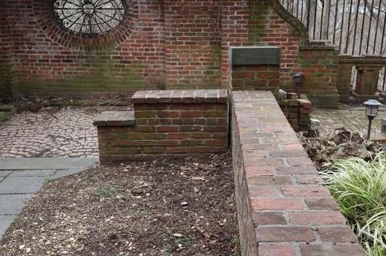  Figure 46. Tilted support wall
 |  | 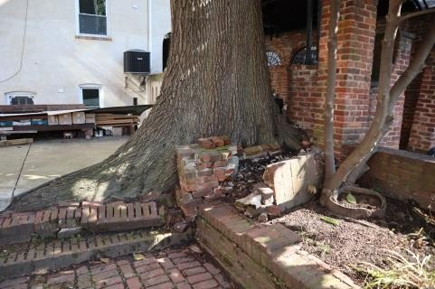  Figure 47. Displaced bricks | 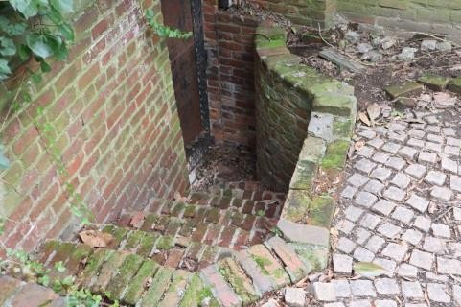  Figure 47. Support wall at the gate in the SE corner

    - Parts of the building
(includes only the parts of the building that were inspected in accordance with the inspection statement of work)
Inspection site or object  name | Brief description of damage/defects found and of their causes; assessment of the technical condition of individual structural elements, types of structures and parts of the structure. Compliance with laws and regulations | Technical wear, %
1 | 2 | 3
4.1. | Base and foundation | 40
4.1.1. geomorphological features of the site; geodetic reference point (wall or soil reference, polygon measurement point) for determining the absolute elevation marks. Range of ground surface absolute marks within the surveyed area.  Main and auxiliary field and laboratory geotechnical activities, excavations, height survey, laboratory analysis, amounts of activities. Types of sedimentation in the surveyed soil; types of soil that constitute the base of the building, and their estimated strength. | During the inspection, the foundations of the building were not exposed and the base soil was not inspected. No wall or soil references, marks, polygon measurement points were determined. No field and laboratory geotechnical activities took place.  The 2007 technical inspection by T. Cave, included control excavations in the existing DR slope, identifying old layers of debris, sand and clay mixture, which according to LBN 207-01 have a ground resistance of R0=200 kPa.  In 1999, a geological survey was carried out at the base of the building (by Schnabel Engineering DC, Reference No 17C41025), which recorded the parameters of the soil only from the basement floor level:  - 0,9 m — sandy clay, water-saturated, with pieces of brick and concrete;  - 1.5 m — silty sand, backfilled, fine gravel, water-saturated;  - 3.0 m — sandy clay, possibly backfilled, soft;  - 9.1 m — sand with gravel, water-saturated.  Seismic activity was recorded in 2011. | ---
4.1.2. type of foundation  for the external walls, its depth; construction products used in the foundation, theirstrength;  foundation waterproofing, drainage; building perimeter pavements; external wall moisture protection | C.1 Cast concrete, natural stone, and brickwork perimeter foundation  The building has a concrete perimeter foundation supporting load-bearing brick walls. The thickness of the load-bearing brick external walls is ~0.32 m. It is not possible to identify the structural design of the foundations without exposing them, but given the historical construction patterns observed in the adjacent building (2306 Massachusetts Avenue, NW, Washington DC 20008), and the 2018 Geotechnical Engineering Report (by Schnabel Engineering DC, Reference No 17C41025), it is increased-thickness, multi-tier brick masonry resting on a concrete perimeter base. The concrete foundation base has an approximate depth of 0.5–0.7 m. | 40
 | The foundations of the building have a history of uneven settlement, which has led to vertical cracks in the load-bearing brick masonry, and significant tilting of the floor slabs. The 2007 technical inspection by T. Cave recorded the reinforcement of the soil under the basement brick masonry in 2000. The base reinforcement work involved the use of ~ 88 m³ of grout mix, retaining several metal grouting pipes in the base. See Annex 2 for the reinforcement diagram and a statement issued by the building contractor.
 | The settlement of the foundation did not progress after the reinforcement of the substructure and, based on the findings of the previous technical inspections (in 2007 and 2014), there are no indications of further development of the cracks. The visual inspection of the foundations of the building did not reveal any crack openings, increased deformations, or any other signs indicating a loss of bearing capacity of the foundations or base, or a rapid deterioration of their technical condition. The building’s foundations have so far been able to withstand the load.
 | No horizontal or vertical waterproofing of the foundations was found at the time of the inspection. Brick masonry planes with 100% relative humidity saturation were found in some basement areas (see Figure 48). The external planes of the brick exterior walls also showed high relative humidity levels (>60%) and salt residue (see Figure 49), indicating poor or even no horizontal waterproofing. No moisture damage to the brickwork was found on the upper floors.

A concrete perimeter pavement and courtyard open area are built around the exterior wall plane in the NE and SW.
The technical condition of the foundations is satisfactory (wear 40%).
 |  | 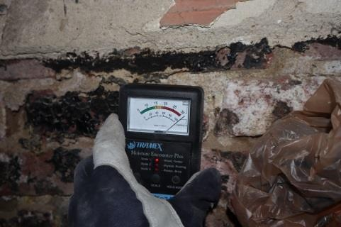  Figure 48. Moisture-saturated masonry  walls | 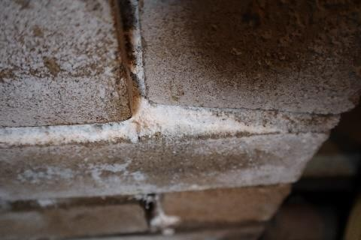  Figure 49. Salt deposits on bricks at basement level
4.1.3. type of foundations for internal walls, their depth; construction products used in the foundation, their strength; waterproofing of foundations, drainage; perimeter pavements of the building; | C.1b Cast concrete, natural stone, and brickwork perimeter foundations  The building has a concrete perimeter foundation under load-bearing brick walls (see Figure 50). The thickness of the brick load-bearing interior walls is ~0.21 m. It is not possible to identify the structural design of the foundations without exposing them, but given the historical construction patterns observed in the adjacent building (2306 Massachusetts Avenue, NW, Washington DC 20008), and the 2018 Geotechnical Engineering Report (by Schnabel Engineering DC, Reference No 17C41025), it is increased-thickness, multi-tier brick masonry resting on a concrete perimeter base. No moisture saturation was found in the masonry (see Figure 51). |  |  |  | 40
 | The visual inspection of the foundations of the building did not reveal any crack openings, increased deformations, or any other signs indicating a loss of bearing capacity of the foundations or base, or a rapid deterioration of their technical condition. The building’s foundations have so far been able to withstand the load.
 | The technical condition of the foundations is satisfactory (wear 40%).
 |  | 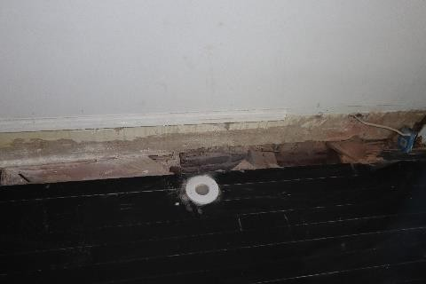 | 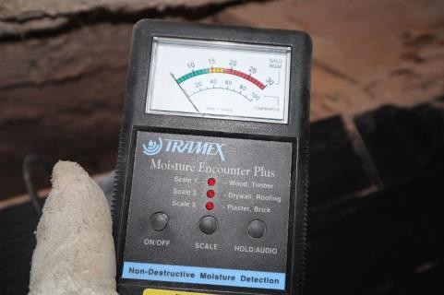
 |  | Figure 50. Internal brick load-bearing  wall | Figure 51. Moisture content of the masonry (0% RH).
4.2. | load-bearing walls, opening beams and lintels |  |  |  | 40
4.2.1. design and material (construction product) of external load-bearing walls of the basement; structural diagrams; thickness and cross-section of the main structural elements; separating insulation and vapour barrier; strength of materials used in basement walls , results of tests on structural elements and masonry strength estimates; results of control probing; weak points in the masonry of load-bearing walls; | C.5 Brick masonry walls;  The external load-bearing wall structure is constructed along the perimeter of the building, of clay brick ~32 cm thick (full brick dimensions (±1 cm): 20x10x6 cm) (see Figures 52–53).  The brick masonry of the basement is saturated with capillary moisture, suggesting non-functional horizontal waterproofing (see Figures 54–55). Historical crack openings were identified throughout the height of the structure, with no further development recorded.  The technical condition of the basement load-bearing external walls is satisfactory (wear 40%). |  |  |  | 40

crack size measurements; crack development monitoring data; biological damage in wooden elements |  | 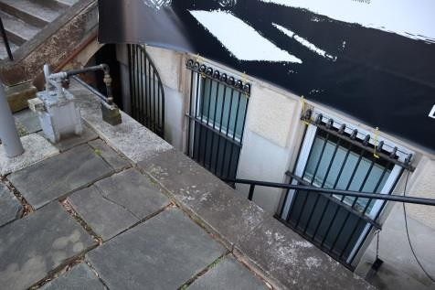  Figure 52. Load-bearing masonry wall in the basement | 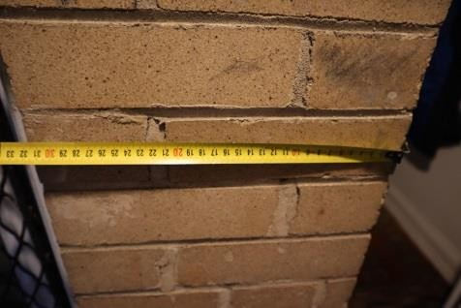  Figure 53. Thickness of the load-bearing masonry wall  (32 cm)
 |  | 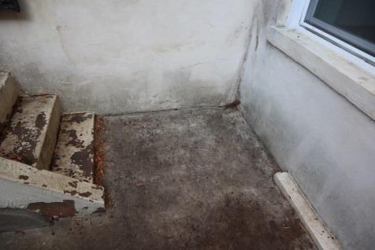  Figure 54. Brick wall with high moisture saturation | 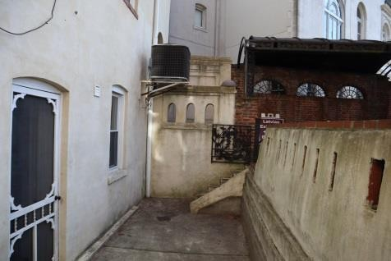  Figure 55. Brick wall with high moisture saturation
4.2.2. design and material (construction product) of internal load-bearing walls of the basement; structural diagrams; thickness and cross-section of the main structural elements; separating insulation and vapour barrier; strength of materials used in basement walls , results of tests on structural elements and masonry strength estimates; results of control probing; weak points in the masonry of load-bearing walls; crack size measurements; crack development monitoring data; biological damage in wooden elements | C.5 Brick masonry walls;  The internal load-bearing wall structure is constructed in the middle (longitudinally) of the basement, of clay brick ~21 cm thick (full brick dimensions (±1 cm): 20x10x6 cm). The load-bearing interior wall of the basement is plastered (thickness: 30). No cracks or other visual signs of insufficient load-bearing capacity of the masonry were found.  Condition of the load-bearing interior wall in the basement: satisfactory (wear 40%) |  |  |  | 40
4.2.3. design and material (construction product) of external load-bearing walls; structural diagrams; thickness and cross-section of the main structural elements; separating insulationand vapour barrier; strength of materials used in above-ground walls , results of tests on structural elements and masonry strength estimates; results of control probing; weak points in the masonry of load-bearing walls; measurements of crack openings and crack development | C.5 Brick masonry walls;  The load-bearing brick walls of the above-ground floors are built along the perimeter of the building, with a thickness of ~0.32 m (1.5 bricks), up to the level of the roof structures (see Figures 56–59). Uneven settlement of the foundation resulted in through open cracks (some even going through the entire height of the structure), which have not grown after reinforcement of the foundation (see Figures 60–65). For a mapping of the cracks in the building, see Annex 1. The settlement of the foundation also resulted in the settlement of the external load-bearing brick walls above it with a tilt to the SW and NW, resulting in changes in the level of the slab between the floors of up to 200 mm. No plane buckling or dislocations in the brick walls were found. At Floor 2 level, a timber-frame annex was constructed in the SE corner of the building, which was not originally in the main volume of the historic building.  The technical condition of the above-ground load-bearing external walls is satisfactory (wear 40%). |  |  |  | 40

observation data;  Biological damage in wooden elements |  | 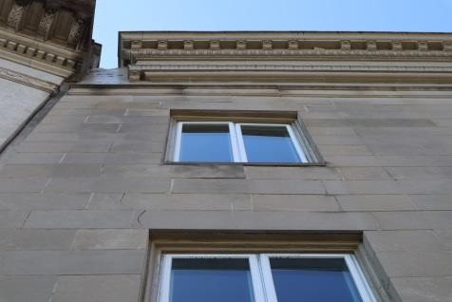  Figure 56. Above-ground floor exterior wall (street facade) | 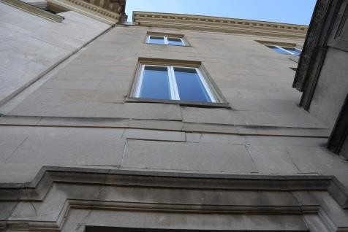  Figure 57. Above-ground floor exterior wall (street facade)
observation data;  Biological damage in wooden elements |  | 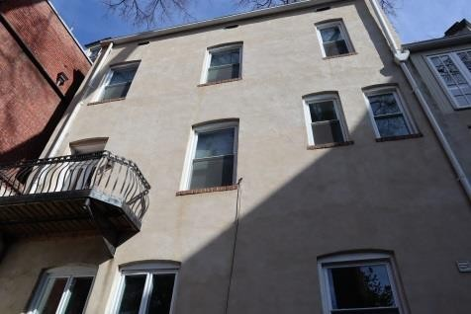  Figure 58. Above-ground floor exterior wall (courtyard facade) | 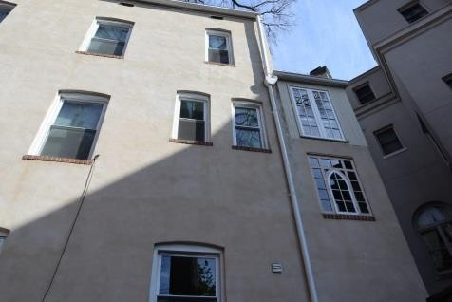  Figure 59. Above-ground floor exterior wall (courtyard facade)
observation data;  Biological damage in wooden elements |  | 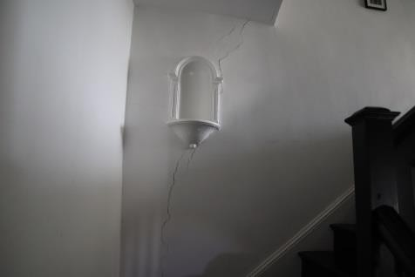  Figure 60. Open crack in a brick wall | 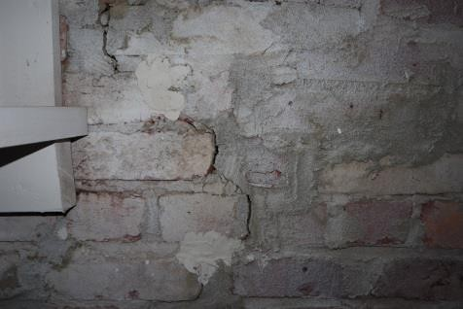  Figure 61. Open crack in a brick wall
observation data;  Biological damage in wooden elements |  | 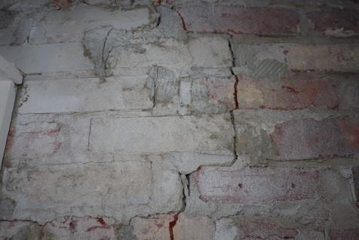  Figure 62. Open crack in a brick wall | 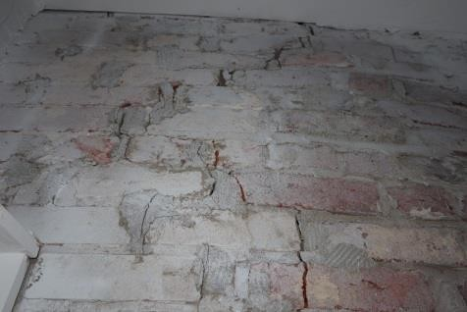  Figure 63. Open crack in a brick wall
observation data;  Biological damage in wooden elements |  | 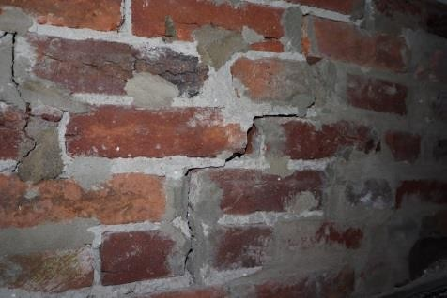  Figure 64. Open crack in a brick wall | 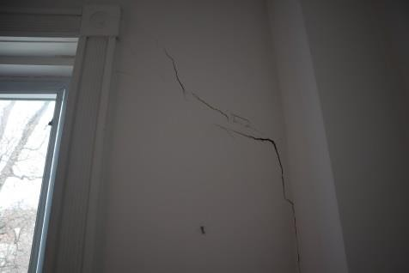  Figure 65. Open crack in a brick wall
4.2.4. structure and material (construction product) of the above-ground interior load-bearing walls; structural  diagrams; main structural element | C.5b Interior load-bearing brick walls  C.11b Timber-frame (pile) walls;  In the middle of the building (longitudinally), there is a brick wall ~0.21 m (one brick) thick, reaching up to the floor level of Floor 2. |  |  |  | 50

thickness and  separating insulationand vapour barrier; strength of materials used in above-ground walls , results of tests on structural elements and masonry strength estimates; results of control probing; weak points in the masonry of load-bearing walls; measurements of crack openings and crack development observation data;  Biological damage in wooden elements | As part of the technical inspection report, inspection areas were exposed at Floor 1 and 2 levels, confirming the existence of the brick wall (see Figures 66–69). The upper layer of the masonry wall (the bearing location of Floor 2 mezzanine slab) has unsatisfactory bonding among the bricks. No open cracks, plane buckling or dislocations were found in the brick masonry.  The structural arrangement of the middle (longitudinally) part of the building on Floors 3 and 4 is based on timber frame structures (see Figures 70–73) (50x100 mm base elements, ~450 mm interval). The wooden structures are constructed with an offset (eccentricity) from the centre axis of the brick masonry below. The eccentricity of Floor 2 with respect to the middle axis of the brick masonry reaches e~0.07–0.21 m. The load-bearing solutions of the load-bearing timber frame walls are inadequately constructed and do not ensure the symmetrical transfer of loads to the load-bearing elements below.  The eccentricity of the load-bearing plane of Floor 3 load-bearing wall with respect to the middle axis of the brick masonry reaches e~0.7 m. The wooden structures have not been treated with any protective agents.  The technical condition of the internal wall structures of the above-ground load-bearing walls is  unsatisfactory (wear 50%).
 |  | 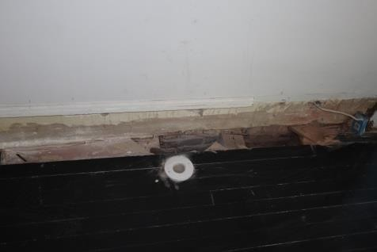  Figure 66. Exposed inspection area at Floor 1 level in the building | 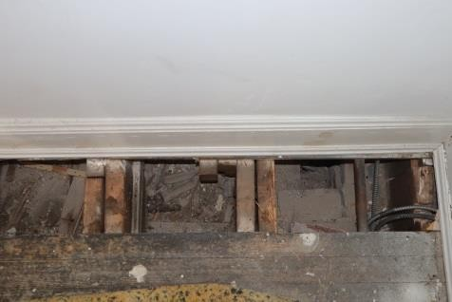  Figure 67. Exposed inspection area at Floor 2 level in the building
 |  | 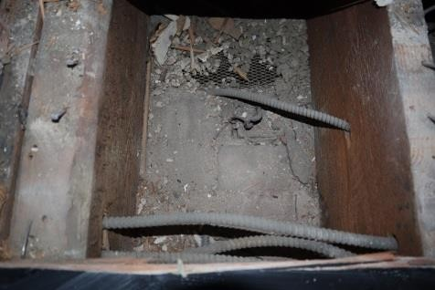  Figure 68. Brick masonry | 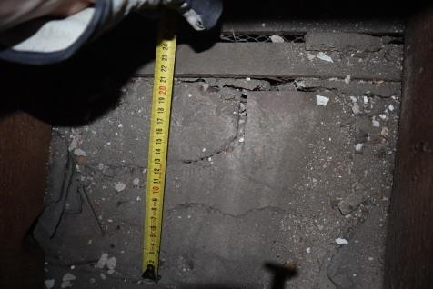  Figure 69. Brick masonry (21 cm)
 |  | 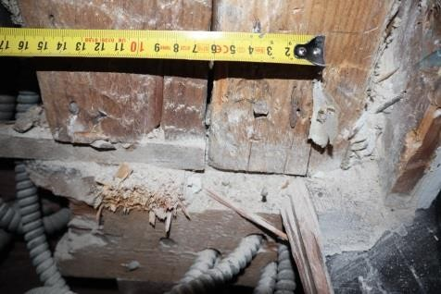  Figure 70. Location of timber-frame structure supports | 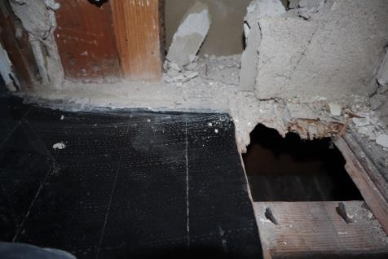  Figure 71. Exposed inspection area for timber-frame structures
 |  | 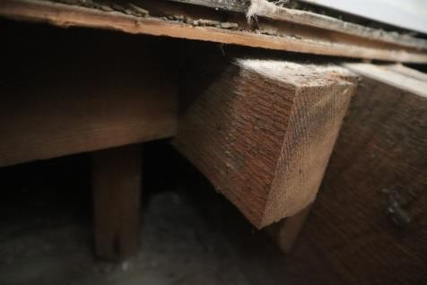  Figure 72. Location of timber-frame structure supports | 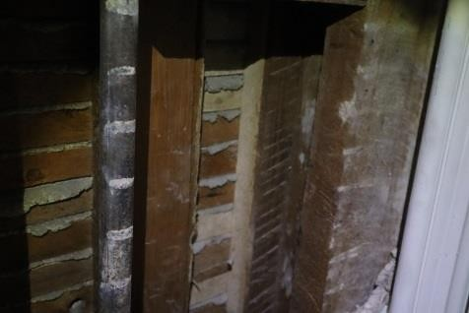  Figure 73. Exposed inspection area for timber-frame structures

4.2.5. beams and lintels of wall openings, their support points and other characteristic indicators | The building has brick vault lintels, steel lintels, and timber structure lintels (see Figures 74–79). The steel lintels in the NE part of the basement are visually curved at the entrance and have insufficient support location areas (see Figures 74–75).  The brick vault lintels in window and door openings do not have any visible cracks. The brick vault between Floor 1 and 2 has deformed due to foundation settling (see Figure 78). No new deformations in the brick vaults were detected.  Some brick crumbling was found in the opening of the basement window facing the courtyard (see Figure 79–81). During the inspection, it was possible to detach whole pieces of brick by hand. No visual defects were found in the timber structure lintels.  Condition of openings and lintels: satisfactory, with some lintels in unsatisfactory condition (wear 40%). |  |  |  | 40
 |  | 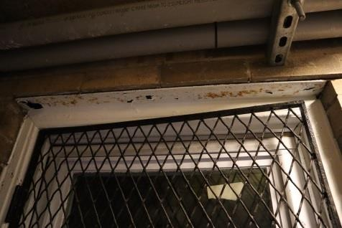  Figure 74. Steel lintels for the basement opening on the NE side of the building | 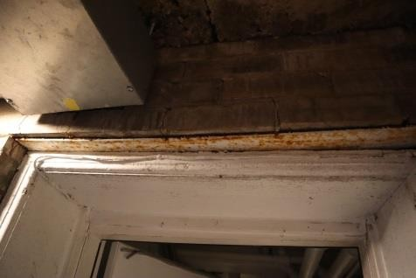  Figure 75. Steel lintels for the basement opening on the NE side of the building |  | 40
 |  | Figure 76. Window openings facing in the courtyard | 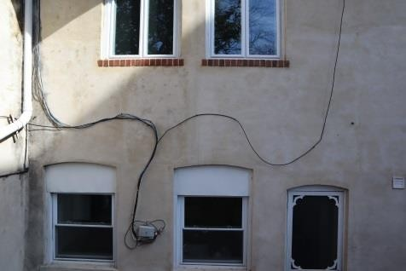  Figure 77. Window openings facing in the courtyard |  | 40
 |  | 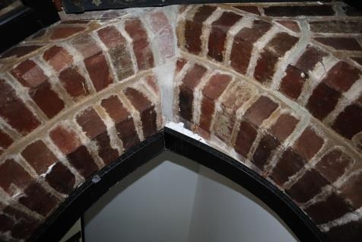  Figure 78. Deformed brickwork  vault | 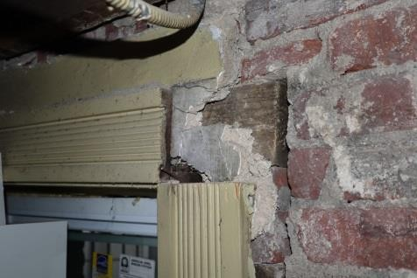  Figure 79. Wooden lintel |  | 40
 |  | 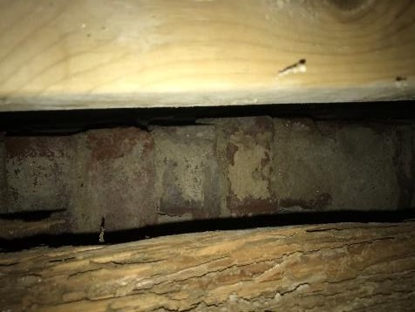  Figure 80. Crumbling brick vaults | 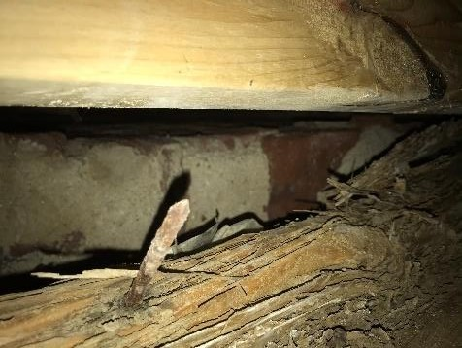  Figure 81. Crumbling brick vaults |  | 40

4.3. | Frame elements: columns, joists, beams |  |  |  | ---
4.3.1. column, post, joist, and beam structure and material | The building has no frame elements. |  |  |  | ---
4.4. | Self-supporting walls |  |  |  | ---
4.4.1. Structure and material of self-supporting walls | The building has no self-supporting walls. |  |  |  | ---
4.5 | Sealing of seams, water-proofing, heat insulation |  |  |  | 45
4.5.1. sealing and waterproofing material, its condition | No horizontal or vertical waterproofing of the foundations was found at the time of the inspection. Brick masonry planes with 100% relative humidity saturation were found in some basement areas. The external planes of the brick exterior walls also showed high relative humidity levels (>60%) and salt residue, indicating poor or even no horizontal waterproofing.  The technical condition of the waterproofing is unsatisfactory (wear 60%). |  |  |  | 60
4.5.2 Thermal insulation materials, their condition | The building was found to have thermal insulation in the attic slab consisting of loose cellulose wool with an average thickness of 200 mm under the plank cover (see Figures 82–85). It is recommended to add a thermal insulation layer in accordance with the requirements of LBN 002-19, to achieve U≤0.20 W/(m²K).  The building’s other external envelope structures are not insulated. It is recommended to design comprehensive measures for improving the energy efficiency of the building, taking into account the heritage status of the building and its area. It is recommended to insulate the external walls of the building (50 mm) from the inside, with the construction of a frame.  The technical condition of thermal insulation is satisfactory (wear 30%). |  |  |  | 30
4.5.2 Thermal insulation materials, their condition |  | 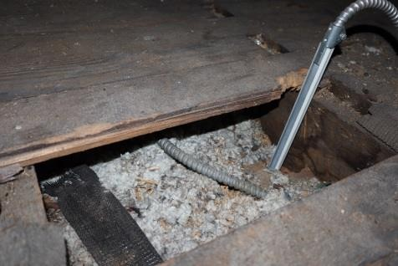  Figure 82. Attic insulation | 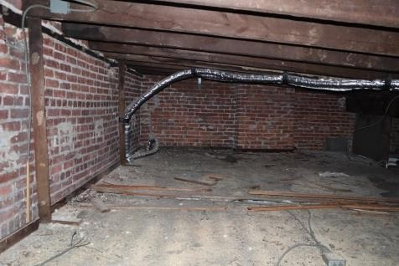  Figure 83. Attic insulation |  | 30
4.5.2 Thermal insulation materials, their condition |  | 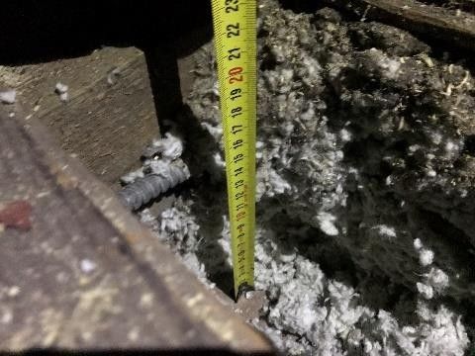  Figure 84. Attic insulation (200  mm) | 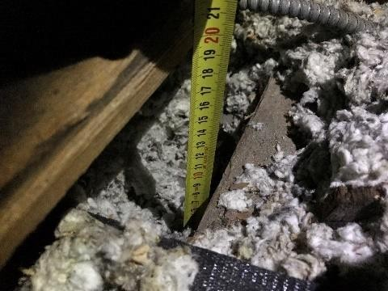  Figure 85. Attic insulation (200  mm) |  | 30
4.6. | Basement, mezzanine, attic slabs |  |  |  | 60
4.6.1 Basement structure calculation diagrams, structure and material; thickness or cross-section of load-bearing elements; deformations and damage found, and their possible causes; crack measurement data; control probing and inspection exposure results; load capacity test estimate results | - Non-plastered timber slabs;  - Plastered timber slabs;  The basement slab is constructed of timber beams supported by load-bearing brick walls (see Figures 86–89). Cross-section dimensions (±5 mm) 50x290 mm, with an interval of 310–420 mm, max. free span ~5 m. In some places, the slab beams installed have double cross-section. The beams above the middle load-bearing wall are tied with an overlap. The slab structures on the ceiling side of the lower floor are lined with 20 mm thick lathing with 20 mm lime mortar plaster (the ceiling is exposed in certain areas). The top of the slab is covered with 22 mm plank flooring (with another layer of planks under the flooring). No sound insulation was found in the slab. |  |  |  | 60

The saturation of moisture in the wooden beams near the brick masonry is 15% RH (see Figures 90–91). In the exposed areas in the middle load-bearing wall, the moisture content of the wood was low, at <5% RH. Overall, the condition of the beam bearings is satisfactory. Waterproofing under the wooden beams was found only in some areas.
Some wooden beams have biological damage due to moisture (on the courtyard side of the building) (see Figures 92–93). Moisture infiltration has also damaged the timber-frame structures of the window openings. Moisture infiltration was detected on the side of the courtyard facade, where water drains along the corner of the building and saturates the plaster with moisture. Water infiltrates into the interior of the building along the timber frame and contributes to the deterioration of the wood. Slab beams in the basement (~4) on the inner side of the courtyard show increased vibration, indicating loose movement of the beam support locations. These slab beams must be replaced in the volumes of all the floors.
No deformations exceeding standard values were detected in the existing wooden beams, but due to the settlement of the load-bearing walls caused by historical, uneven deformations in the foundation, the slab is tilted in the transverse direction of the building by approximately ~200 mm.
The condition of the basement slab is unsatisfactory, with some beams in pre-failure condition (wear 60%).
 |  | 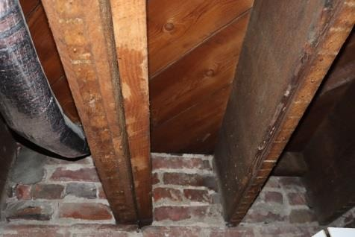  Figure 86. Basement slab beams | 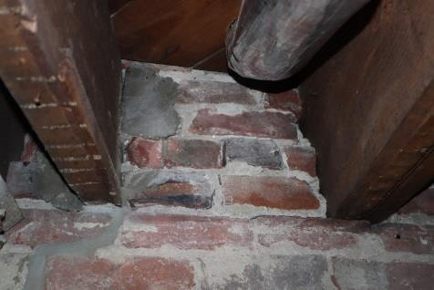  Figure 87. Basement slab beam  support points
 |  | 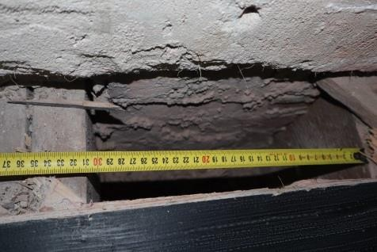  Figure 88. Basement slab beam intervals  (31 cm) | 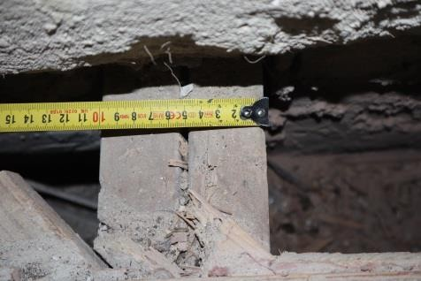  Figure 89. Basement slab beam  width (50 mm)
 |  | 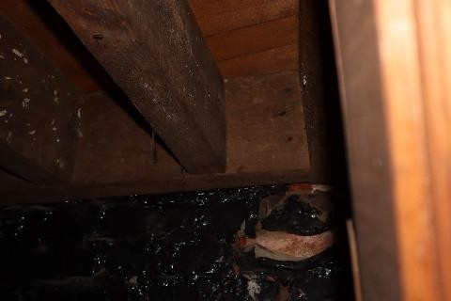  Figure 90. Basement slab structures at brick wall | 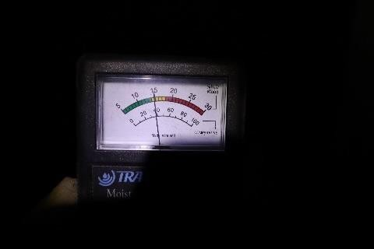  Figure 91. Moisture saturation of wood at brick wall (15% RH)

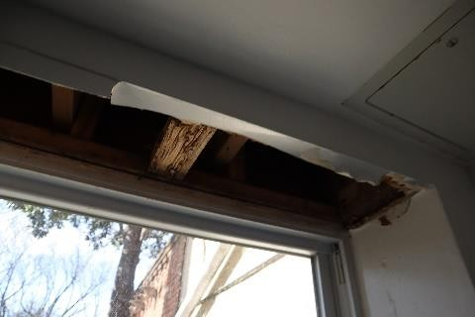
Figure 92. Timber frame structures
in a window opening
Figure 93. Moisture infiltration along a timber-frame
structure window opening
4.6.2. inter-floor and attic slab calculation diagrams, structure and material; thickness or cross-section of load-bearing elements; deformations and damage found, and their possible causes; crack measurement data; control probing and inspection exposure results; load capacity test estimate results | C.20b Plastered timber slabs;  Inter-floor slabs:  The inter-floor slabs are built of timber beams supported by load-bearing brick walls, supporting trusses, and timber frame load-bearing walls (see Figures 94–111). Cross-section dimensions (±5 mm) 50x290 mm, with an interval of 310–420 mm, max. free span ~5 m. Some beams have a cross-section of (±5 mm) 70x290 mm. Above Room 201 on Floor 2 (see Figure 100), there are two beams with a cross-section of (±5 mm) 2x75x290 mm oriented along the longitudinal axis of the building. In some places, the beam slabs installed have double cross-section. The beams above the middle load-bearing wall are tied with an overlap. The slab structures on the ceiling side of the lower floor are lined with 20 mm thick lathing with 20 mm lime mortar plaster. The top of the slab is covered with  22 mm thick plank flooring. No sound insulation was found in the slab. In the exposed timber beams, moisture saturation at the brick masonry was <5% RH, in the exposed areas in the middle of the building the moisture content of the timber was low, <9% RH. Overall, the condition of the beam bearings is satisfactory. |  |  |  |  |  | 60
 | Slab beams between floors (~4) on the inner side of the courtyard show increased vibration, indicating loose movement of the beam support locations. Some beams were out of plane and tilted towards the longitudinal axis of the element (see Figure 110). These slab beams must be replaced in the volumes of all the floors. Local openings were made in the beams for intersections with electric lines. The attic floor space is used inexpediently as storage for household items.
 | No deformations exceeding standard values were detected in the existing wooden beams, but due to the settlement of the load-bearing walls caused by historical, uneven deformations in the foundation, the slab is tilted in the transverse direction of the building by approximately ~200 mm.
 | Following an on-site recalculation of the load-bearing capacity of the inter-floor slab beams together with the designer of building structures, some slab beams were found not to meet the load capacity requirements, and their reinforcements must be included in the building structure part of the construction design. A calculation report for the Building Structure (BS) part of the design will be prepared based on the results.
 | The technical condition of the slabs between the floors is unsatisfactory (wear 60%).
 |  | 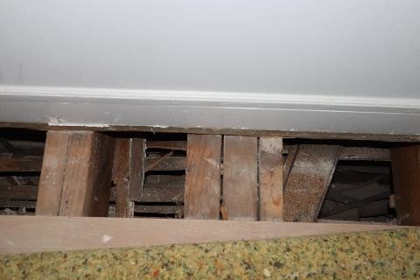 | 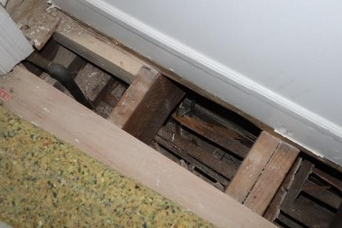
 |  | Figure 94. Exposures of wooden beams on Floor 3 | Figure 95. Exposures of wooden beams on Floor 3
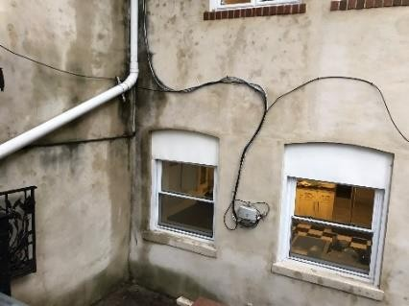

 |  | 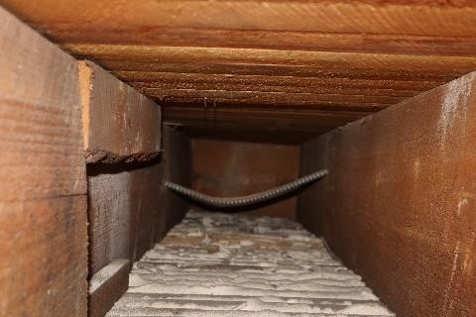  Figure 96. Composition of Floor 3 slab | 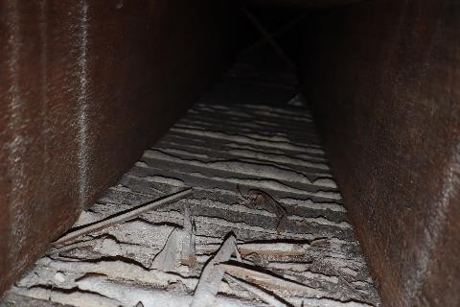  Figure 97. Ceiling finish
 |  | 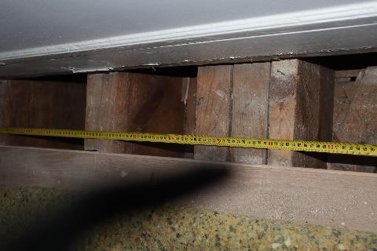  Figure 98. Wooden beams | 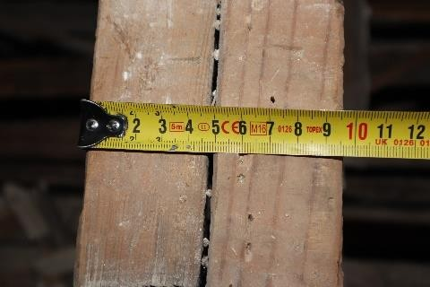  Figure 99. Width of wooden beams (50 mm)
 |  | 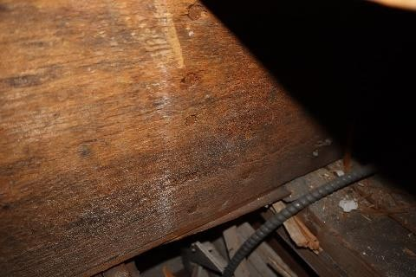  Figure 100. Two timber beam nailing locations above Room 201 (end of beam) | 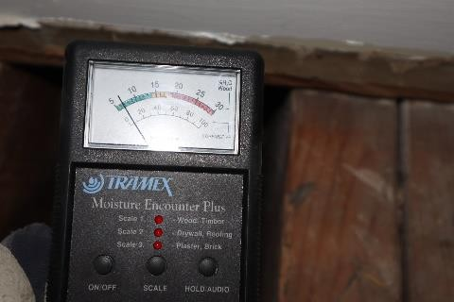  Figure 101. Timber moisture content at its support  location (7% RH)
 |  | 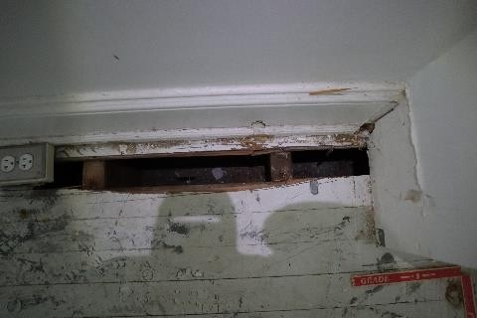  Figure 102. Exposed areas in the rooms of Floor 3 | 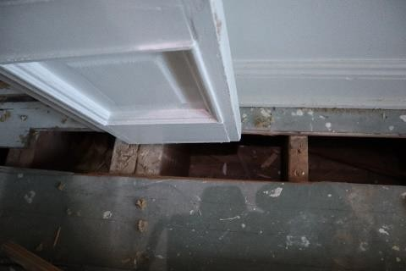  Figure 103. Exposed areas in the rooms of Floor 3
 |  | 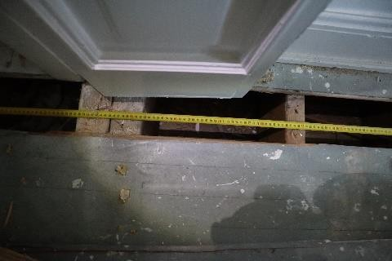  Figure 104. Exposed areas in the rooms of Floor 3 | 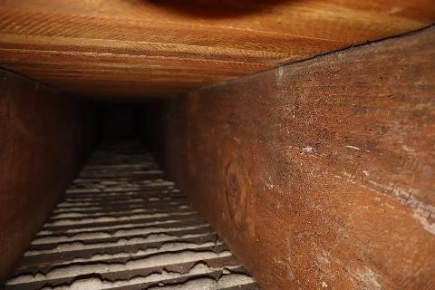  Figure 105. Composition of Floor 3 slab

 |  | 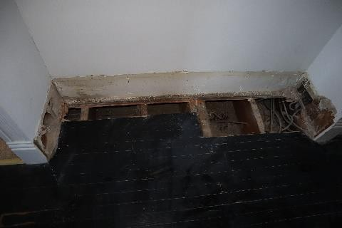  Figure 106. Exposed areas in the rooms of Floor 2 | 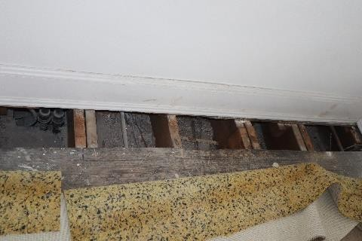  Figure 107. Exposed areas in the rooms of Floor 2
 |  | 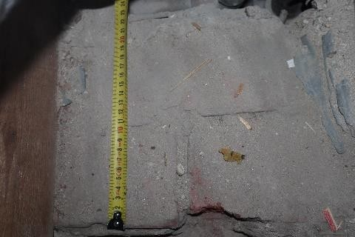  Figure 108. Brick masonry at Floor 3 level  (21 cm) | 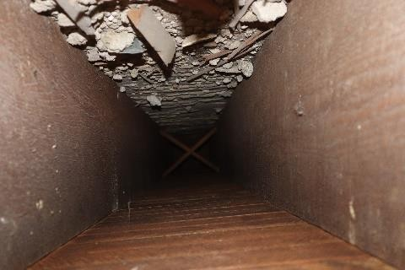  Figure 109. Composition of Floor 2 slab
 |  | 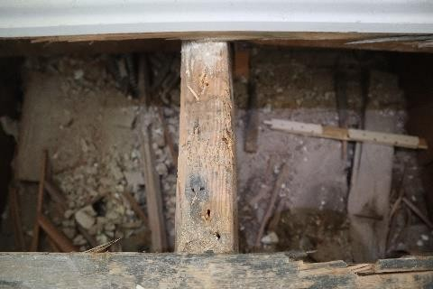  Figure 110. Exposed areas in the rooms of Floor 2 | 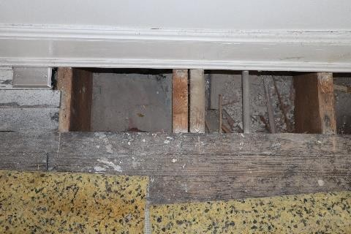  Figure 111. Exposed areas in the rooms of Floor 2
Attic slab:
The attic slab is constructed of timber beams supported by load-bearing brick walls and timber frame load-bearing walls (see Figures 112–114). Cross-section dimensions (±5 mm) 50x200 mm, with an interval of 310–420 mm, max. free span ~5 m. The beams above the middle load-bearing wall are tied with an overlap. The slab structures on the ceiling side of the lower floor are lined with 20 mm thick lathing with 20 mm lime mortar plaster. The top of the slab is covered with 22 mm thick plank flooring. In the attic slab, ~200 mm thick cellulose wool thermal insulation was found (see Figure 114). Historical water leaks were found on the attic ceiling (see Figure 115). No vapour barrier was found.
No deformations exceeding standard values were detected in the existing wooden beams, but due to the settlement of the load-bearing walls caused by historical, uneven deformations in the foundation, the slab is tilted in the transverse direction of the building by approximately ~200 mm.
Following an on-site recalculation of the load-bearing capacity of the attic slab beams together with the designer of building structures, some attic slab beams were found not to meet the load capacity requirements, and their reinforcements must be included in the building structure part of the construction design.
The technical condition of the attic slab is satisfactory (wear 40%).

 |  | 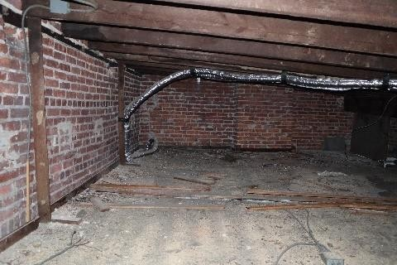  Figure 112. Timber beam attic slabs | 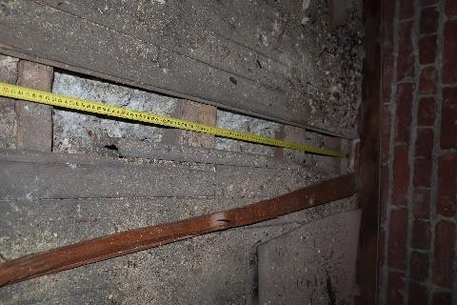  Figure 113. Exposed attic slab area
 |  | 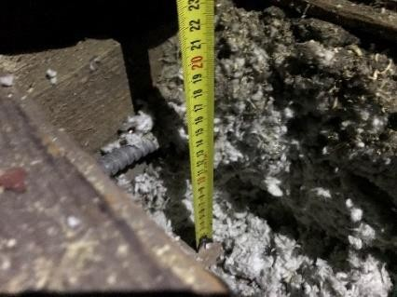  Figure 114. Thickness of thermal insulation in the attic slab | 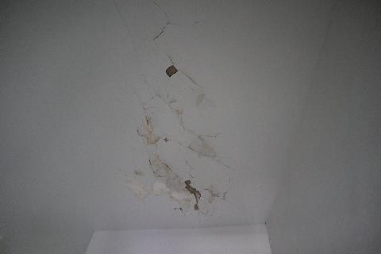  Figure 115. Historical leaks in the attic  ceiling
 |  | 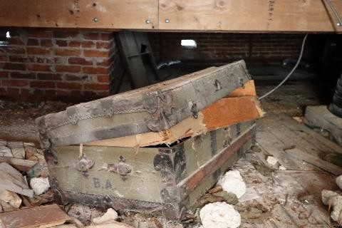  Figure 116. Inexpediently used attic spaces | 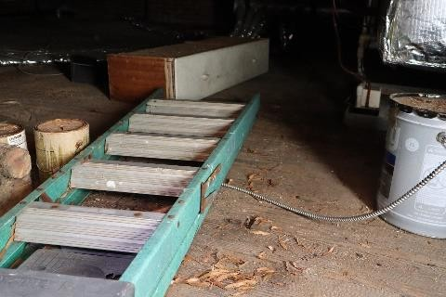  Figure 116. Inexpediently used attic spaces
4.6.3. temporary reinforcements, stress-relief structures | There are no temporary reinforcements or stress-relief structures in the building. |  |  |  | ---
4.6.4. strength of concrete, Corrosion in metal structures and rebar; | There are no concrete, metal, or rebar elements in the slabs between floors. |  |  |  | ---
4.6.5. mould (sap rot)  and insect damage | Damage in the timber of basement floor beams and certain partition walls was detected.  (see Section 4.6.1 and Section 4.11.1) |  |  |  | ---
4.6.6. Sound insulation | Exposed parts of slabs revealed the absence of sound insulation. |  |  |  | ---
4.7. | Spatial rigidity elements of the building |  |  |  | 40
4.7.1. Diagrams, description | The spatial stability of the building is achieved via load-bearing brick masonry walls and load-bearing timber-frame walls, built with an offset from the centre axis of the load-bearing brick masonry inner wall. Given that no dynamic deformation processes were detected in the building, the technical condition of the spatial stability of the building can be assessed as satisfactory.  The technical condition of the spatial stability elements is satisfactory (wear  40%). |  |  |  | 40

4.8. | Elements of the roof: load-bearing structure, roofing, roof deck, rainwater drainage system |  |  |  | 40
4.8.1. roof load-bearing structure and material; defects found and their possible causes;  overall assessment of the technical condition, broken down by individual types of structures | C.25 Wooden roofs (load-bearing structure);  The roof load-bearing structures consist of 50x190 mm (±5 mm) timber rafters with a 3° incline towards the courtyard of the building (see Figures 117–124). The rafters are supported on brick lath and two 2x50x305 mm (±5 mm) tie beams oriented transversely relative to the building. The tie beams are supported by the brick wall and a 2x50x90 wooden post (±5 mm) covering a span of ~8.8–9.2 m. The spans of the rafters are 4.1, 3.3, and 4.1 m, respectively along the longitudinal axis of the building, forming a beam slab. The post support locations are offset and supported on timber-frame load-bearing walls. One supporting truss was reinforced with 2x45x265 mm wooden beams (see Figures 121–122).  The supporting units of the wooden rafters and supporting roof trusses are in a satisfactory technical condition. Historical leaks were found in the wooden load-bearing elements, caused by the previously installed metal sheet roofing and the absence of anti-condensation film, and the poor installation of the previous roofing (previously identified). The roof hatch structures were restored (see Figure 123). A freestanding outdoor cooling unit is mounted on the roof structure (Figure 124).  The load-bearing structures of the roof have so far been able to withstand the current load.  Following an on-site recalculation of the load-bearing capacity of the load-bearing structures of the roof together with the designer of building structures, some wooden load-bearing elements were found not to meet the load capacity requirements, and their reinforcement must be included in the building structure part of the construction design.  The technical condition of the roof load-bearing structures is satisfactory (wear 40%). |  |  |  | 40
 |  | 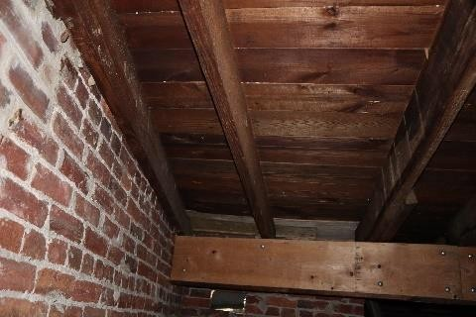  Figure 117. Timber roof load-bearing  structures | 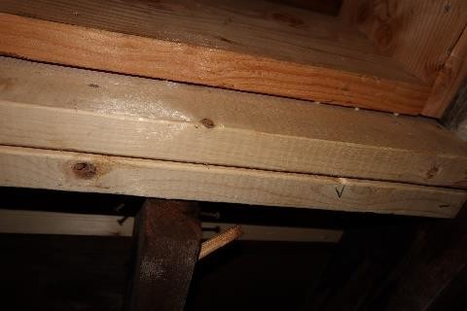  Figure 118. Replaced wooden roof hatch  elements |  | 40
 |  | 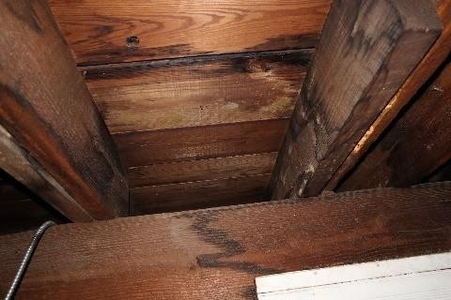  Figure 119. Leaks on timber load-bearing structures of the roof | 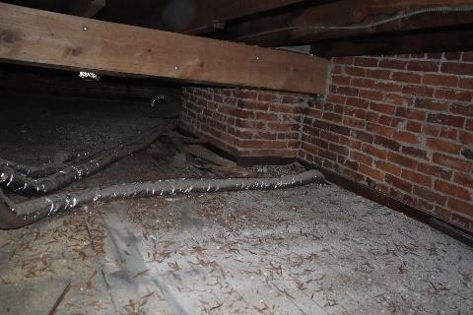  Figure 120. Roof load-bearing structure  supporting truss |  | 40
 |  | 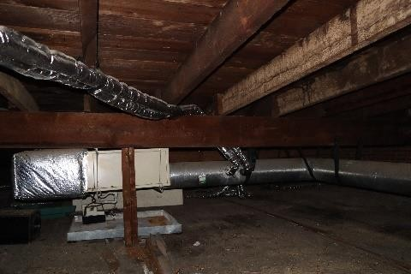  Figure 117. Roof load-bearing structures with  a post | 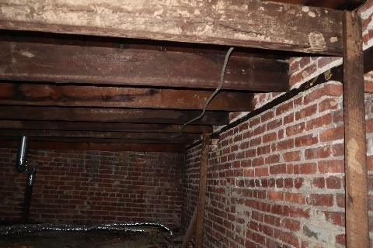  Figure 118. Roof rafter support locations on brick lath |  | 40

 |  | 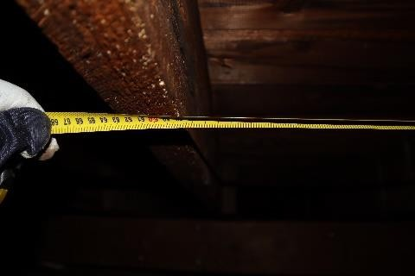  Figure 119. Wooden rafter interval (57 cm) | 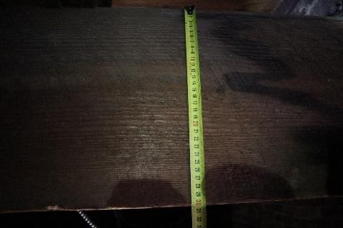  Figure 120. Wooden rafter height (300  mm)
 |  | 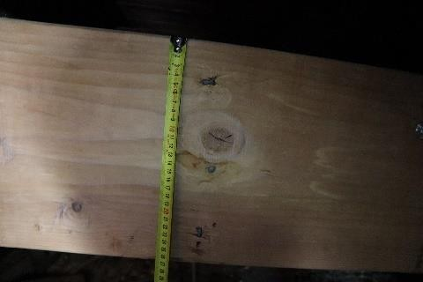  Figure 121. Reinforced supporting roof truss | 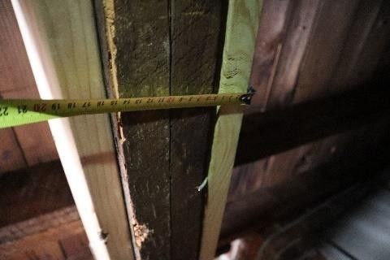  Figure 122. Reinforced supporting roof truss
 |  | 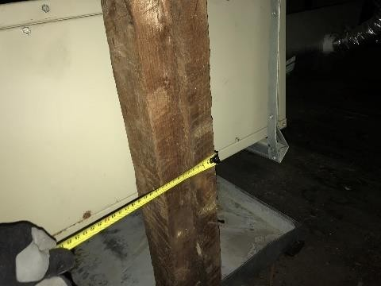  Figure 123. Wooden post | 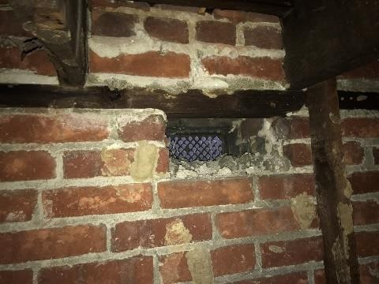  Figure 124. Wooden rafter support locations on brick lath
 |  | 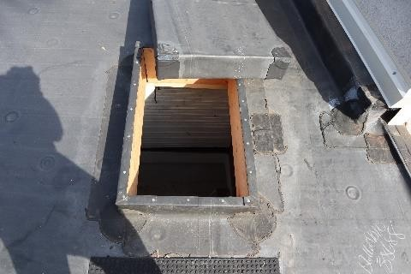  Figure 125. Roof hatch | 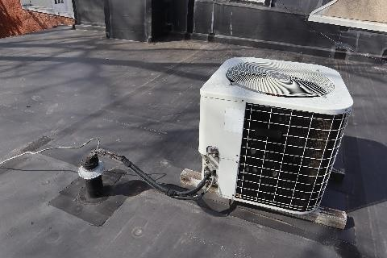  Figure 126. Free-standing outdoor unit
4.8.2. type, structure, and material of the roofing and the rainwater drainage system, defects found and their possible causes; overall assessment of the technical condition, broken down by individual types of structures | C.28 Rolled-material surfaces;  The building has rolled-material roofing (PVC membrane) on timber lathing (see Figures 127–133). Historical leaks and moisture damage were found on the lathing. Holes were found in the roofing (see Figure 134), but no moisture damage was observed in the attic space below. The roof is covered in various types of patches and putty at plane junctions (see Figures 128,131,132). A parapet of 0.83 m height is built on the street side of the building (see Figure 129). Along the SE and NW sides of the building, there is the wall of an adjacent building, >2.23 m tall (see Figure 130). Replacement of the entirety of the roofing is recommended, with a condensate drainage layer connected the building’s rainwater drainpipes.  Rainwater drainpipes are built on the street side of the building and on its courtyard side (see Figures 137–140). The street-side drainpipe has a lot of free play and |  |  |  | 60

does not ensure that rainwater is discharged into the centralised drainage system. The current drainpipes in the courtyard are built along the edges of the building, moving the rainwater into the municipal sewer system. The rainwater drain pipes in the courtyard are built into the basement floor volume. A leaf trap was installed in the horizontal gutter in the courtyard, and not installed in the annex below it. Rainwater drains were found to have high free play. The drains are not regularly cleaned.
The technical condition of the roofing and the rainwater drainpipes is unsatisfactory
(wear 40%).
 |  | Figure 127. Wooden lathing | 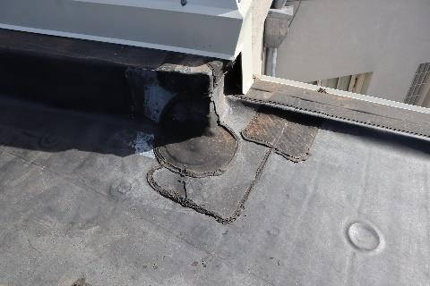  Figure 128. PVC membrane cover with connection points
 |  | 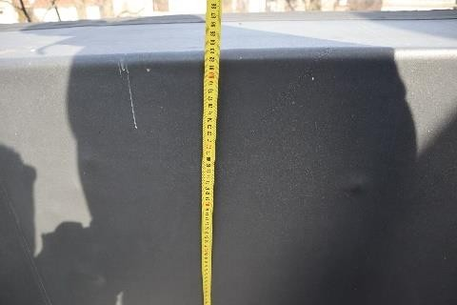  Figure 129. Parapet height on the NW facade of the building (83 cm) | 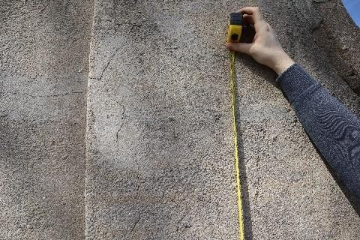  Figure 130. Height at the nearby  amount of snow (>2.23 m)
 |  | 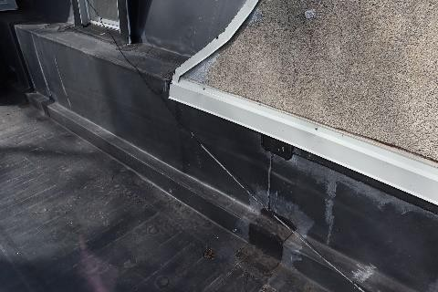  Figure 131. Roof deck connections to nearby building volume | 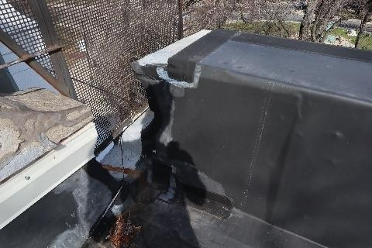  Figure 132. Roof deck connections to nearby building volume
 |  | 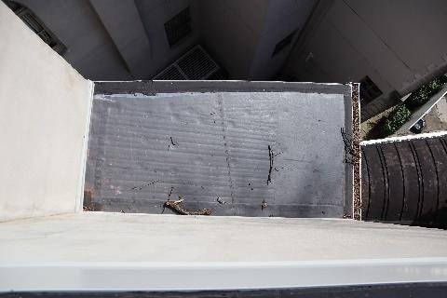  Figure 133. Wooden annex  deck | 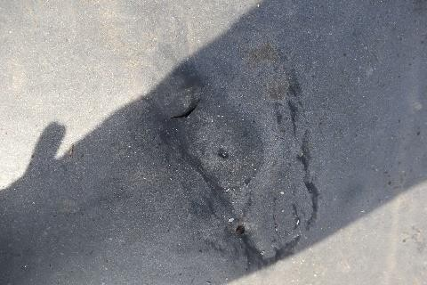  Figure 134. Hole in the roofing

 |  | 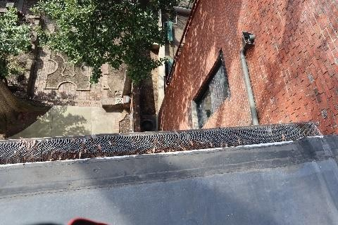  Figure 135. Roof drain with a leaf trap | 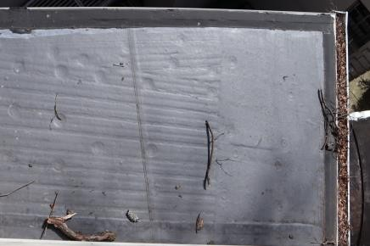  Figure 136. Rainwater drains without leaf traps
 |  | 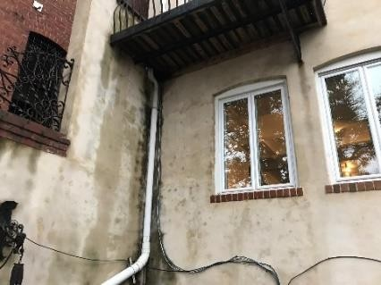  Figure 137. Vertical rainwater gutters on the courtyard side | 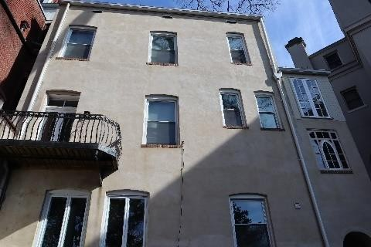  Figure 138. Vertical rainwater gutters on the courtyard side
 |  | 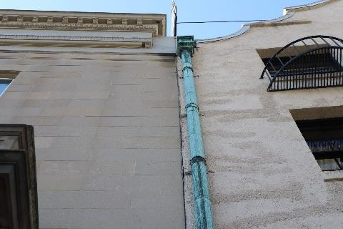  Figure 139. Vertical rainwater gutters on the street side | 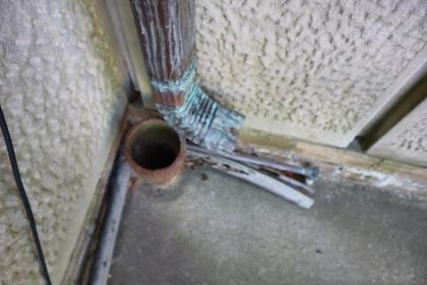  Figure 140. Vertical rainwater gutter on street side
4.8.3. circulation of air, temperature and air humidity in the attic | In the attic space, there are 300x130 mm ventilation openings (6 in total) on the building’s facades to enable the circulation of air (see Figures 141-142). The total area of the openings is 0.234 m², while the floor area of the attic is 98 m², and according to Section 69 of LBN 211-15, the area of the openings must be no less than 1/500 of the floor area of the attic. 98/500=0.196 m².  The air circulation solution in the attic space is sufficient and in good condition (wear 20%). |  |  |  | 20
 |  | Figure 141. Ventilation openings in the attic spaces | 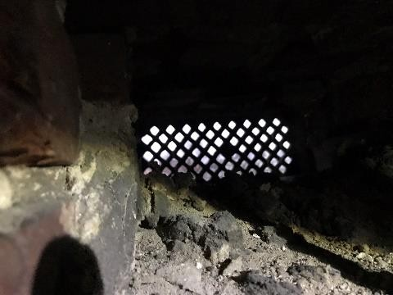  Figure 142. Ventilation openings in the attic spaces |  | 20
4.9. | balconies, loggias, porches, canopies |  |  |  | 50
4.9.1. protrusions: balconies and canopies, their structure and material; explanation of term: protrusion  — a projecting part of a building, structure; balcony  — a projection of the external wall of the building enclosed in the facade; porch | C.17 Balconies, porches, and canopies;  A steel-structure balcony is built on the side of the courtyard (see Figure 143). The steel elements are in good technical condition, treating them with protective paint is recommended. The wooden structures are overgrown with vegetation, soaked with moisture, and have started to rot (see Figures 144–146). The balcony floor has tilted with the building, |  |  |  | 60

— a covered open or enclosed extension at the entrance to the building; canopy — a small roof, e.g. over a gate, door | directing all the water to the adjacent wall and wall corner, which saturates the facade with moisture. The balcony currently cannot be used.  The technical condition of the balcony is unsatisfactory (wear 60%).
 |  | 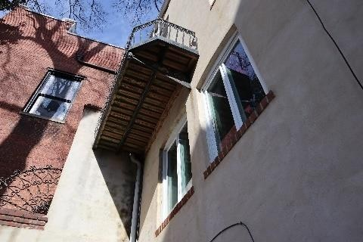  Figure 143. Balcony in the courtyard | 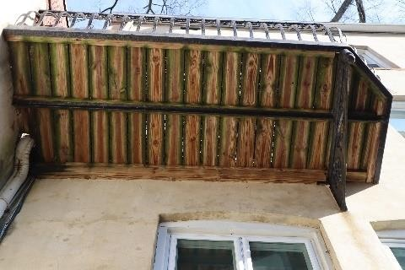  Figure 144. Wooden structures of the balcony
 |  | 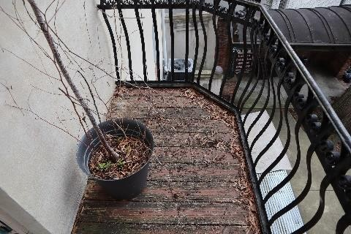  Figure 145. Steel structures/flooring of the balcony | 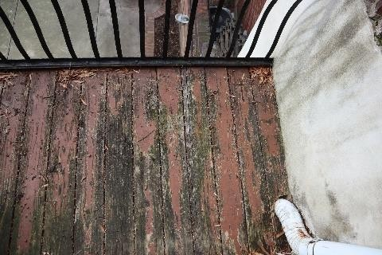  Figure 146. Steel structures/flooring of the balcony
4.9.2. protrusions: loggias, bay windows, avant-corps, and awnings. Their structure and material;  Explanation of term: protrusion  — a projecting part of a building, structure; bay window — an enclosed projection in the external wall of a building located on its facade or at its corners, not necessarily extending to the ground; loggia — a space built into the facade of a building, enclosed by a railing instead of an external wall; avant-corps — a projection of a part of a building over its entire height; awning — sun shade (usually made of canvas) over windows, doors, balconies, etc. | C.18 Loggias, bay windows, avant-corps, and awnings  A projection with an open terrace is built at second floor level of the street facade (see Figures 147–148). The terrace is paved with stone tiles. The rainwater drain in the terrace is clogged with leaves (see Figure 149). No water leaks were found in the ceiling of the first floor. It is recommended to renovate the railings of the terrace.  The technical condition of the structure is satisfactory (wear 40%). |  |  |  | 40
 |  | 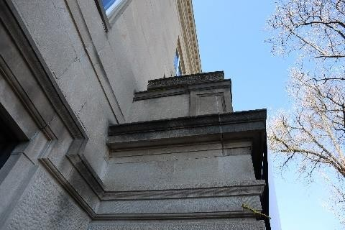  Figure 147. Terrace in the front yard of the building | 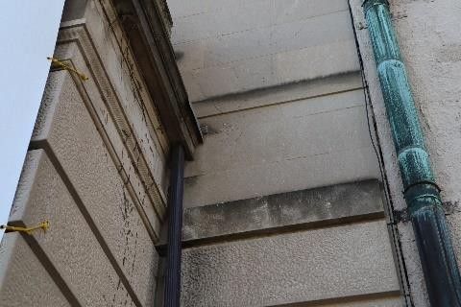  Figure 148. Rainwater drain in the terrace |  | 40
 |  | 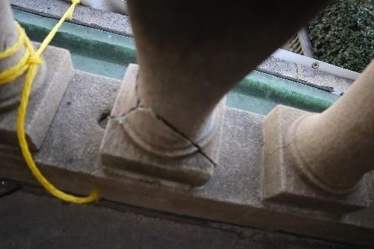  Figure 149. Damaged terrace railing | 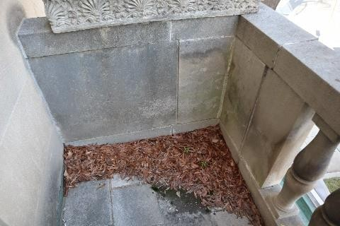  Figure 150. Rainwater drain clogged with leaves |  | 40
4.10. | Stairs and ramps |  |  |  | 50
4.10.1. type, structure and material of stairs; stair landings and railings; | C.34 Wooden stairs; C.34a Metal stairs; |  |  |  | 50

railings; condition of stairwell walls at the locations where stair elements are embedded; porches; emergency, basement, fire escape and auxiliary stairs; structure and material of ramps | See Figures 151–154 for the staircases on the floor plans. Indoor stairs:  The indoor staircase is built of wood with carved steps propped by trusses under the flights. Central indoor staircase 1 connects all the floors of the building with two and three-flight stairs with a half-landing (see Figures 155–166). The flight trusses are constructed of beams with a cross-section of 50x290 mm. The flight trusses are attached along the edges of the steps and in the middle of the steps. At the step edges, the flight trusses have double cross-section. The half-landing structure is built using beams with a cross-section of 50x200, supported by a brick wall and functioning as a cantilever structure. The central staircase has tilted considerably and the cantilever supports have been displaced out of their original clamping positions in the load-bearing walls. No free movement was detected in the handrails.  Indoor staircase 2 is built of wood (see Figures 167–168), historically intended to connect the basement kitchen with the first-floor dining room. Currently, one of the entrances to the stairwell is bricked up, and the stairwell is used as a utility room. The historic staircase between the first and second floors has been partially rebuilt and has no entrances. Staircase 3 is a wooden staircase leading to the annex between Floor 2 and Floor 3 (see Figure 169).  Staircase 4 connects Floor 3 to the attic floor (see Figure 170). The stairs are  made of wood (not compliant with fire reaction class A1) with much free play and tilt. Outdoor stairs:  Staircase 5 is made of metal, heavily corroded, with free play in the steps (see Figures 171–174). The stair fastening elements are of poor quality, locally attached to external finish plates.  Staircases 6 and 7 are built of stone steps, without significant defects  (see Figures 175–176). It is recommended to install handrails for the stairs.  Staircase 8 was built out of brick (see Figure 177), later coated with white paint (original brick shown above).  Staircase 9 is made of stone steps supported by a reinforced concrete slab (see Figures 178–180). The slab shows significant crumbling in the concrete protective layer below and significant corrosion in the metal reinforcement, reducing the load-bearing capacity of the slab. The defects indicate that no waterproofing layer was built under the steps. The stairs are visibly tilted.  The technical condition of the stairs is unsatisfactory, with some stairs (1 and 9)  in pre-failure condition (wear 50%).
No 5.

No 1.

No 2.

No 6 No 7.

Figure 151. Basement floor plan
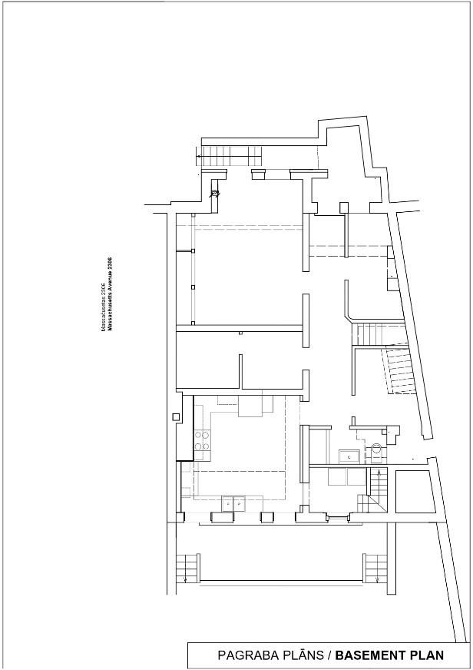

No 9.
No 5.

No 1.

No 2.
No 8.

No 6 No 7.

Figure 152. First floor plan
No 1.

Figure 153. Second floor plan
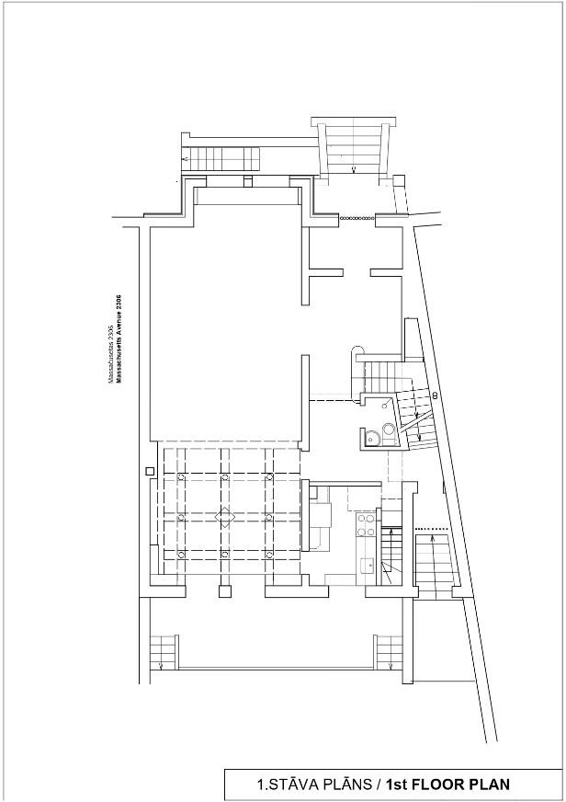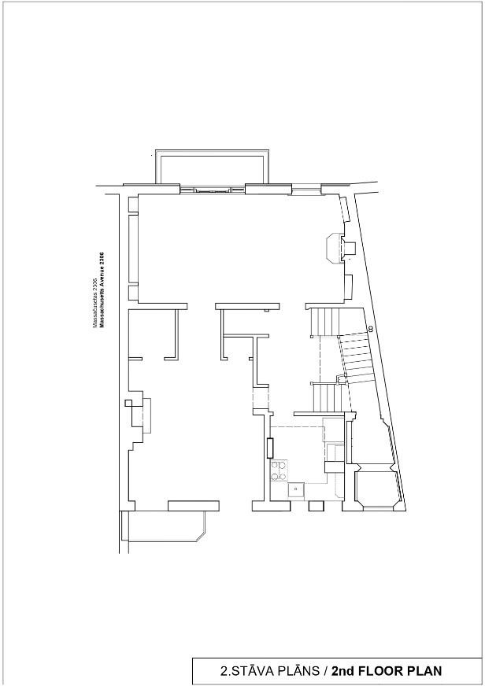

No 4.

No 1.
No 3.

Figure 154. Third floor plan
 |  | 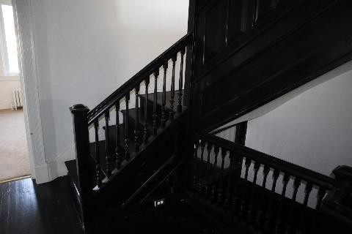  Figure 155. Staircase 1. | 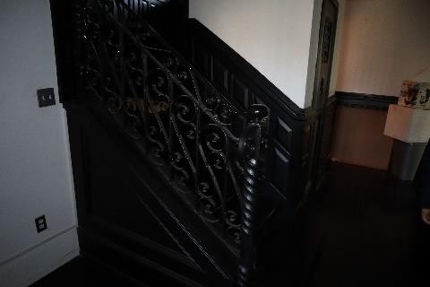  Figure 156. Staircase 1.
 |  | 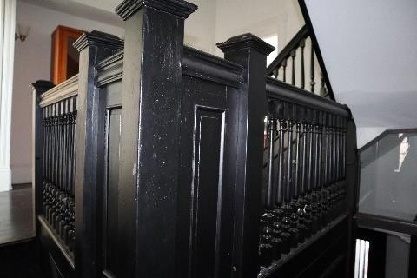  Figure 157. Staircase 1. | 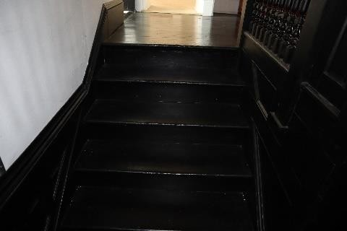  Figure 158. Staircase 1.
 |  | 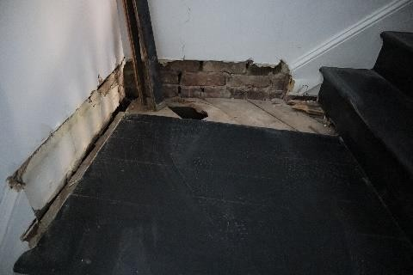  Figure 159. Exposed area on Staircase 1. | 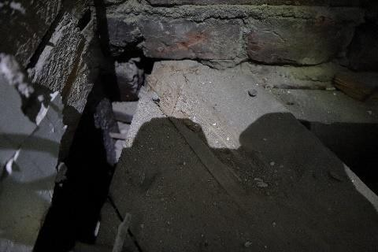  Figure 160. Exposed area on Staircase 1.
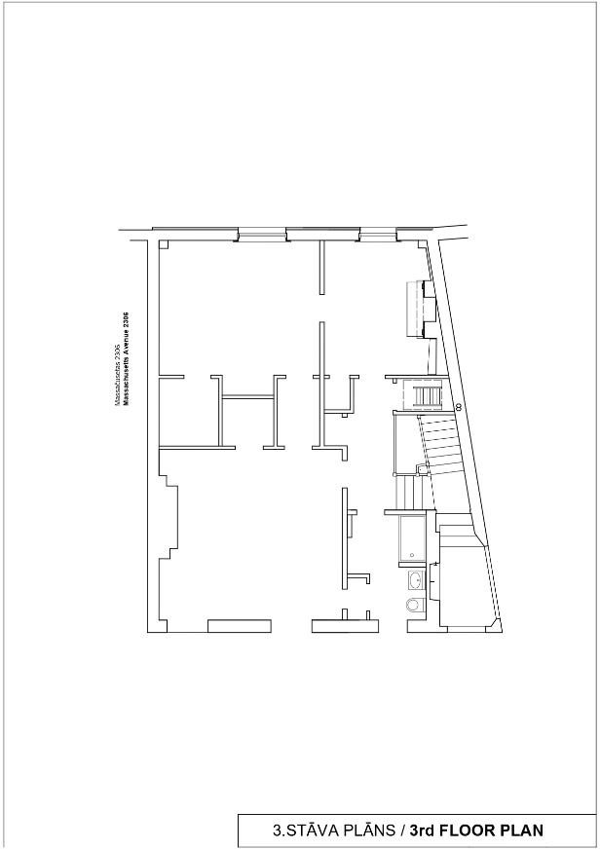

 |  | 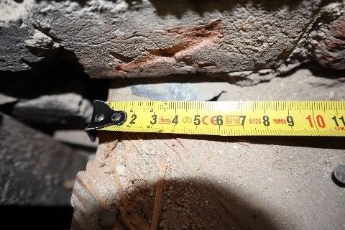  Figure 161. Landing wooden beam support location  in the brick wall (50 mm) | 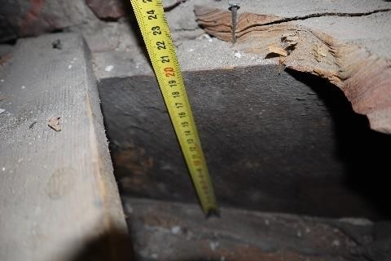  Figure 162. Landing wooden structure (200 mm)
 |  | 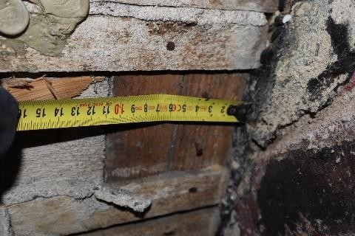  Figure 163. Exposed area on staircase 1. (105 mm) | 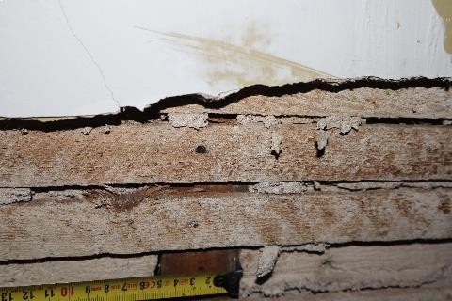  Figure 164. Exposed area on staircase 1. (50 mm)
 |  | 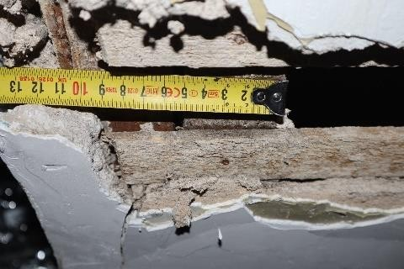  Figure 165. Exposed area on staircase 1. (110 mm). | 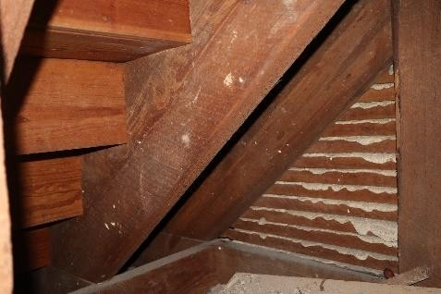  Figure 166. Staircase 1.
 |  | 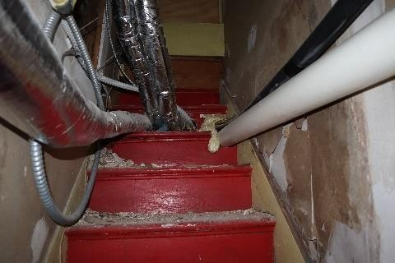  Figure 167. Staircase 2. | 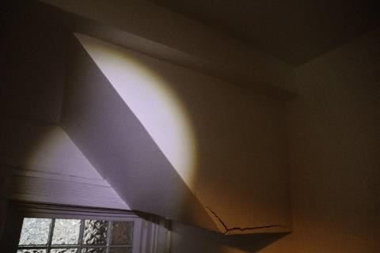  Figure 168. Staircase 2.
 |  | 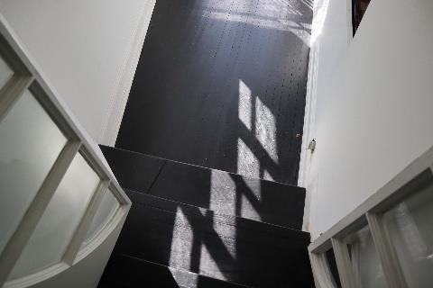  Figure 169. Staircase 3. | 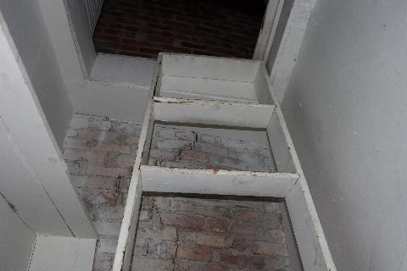  Figure 170. Staircase 4.

 |  | 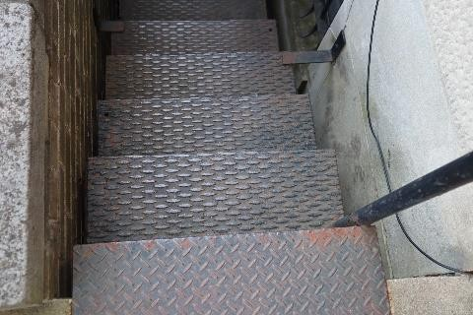  Figure 171. Staircase 5. | 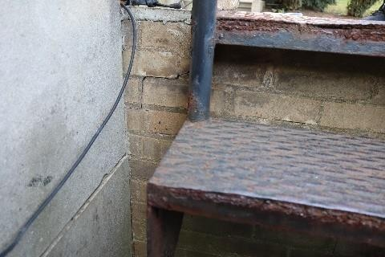  Figure 172. Staircase 5.
 |  | 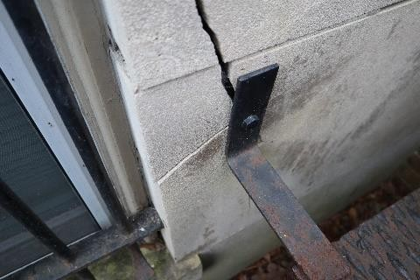  Figure 173. Attachment of Staircase 5 to the outdoor finish plates | 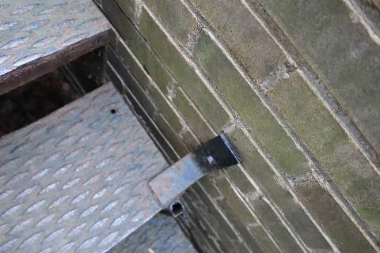  Figure 174. Staircase 5. Insufficient stair attachment elements
 |  | 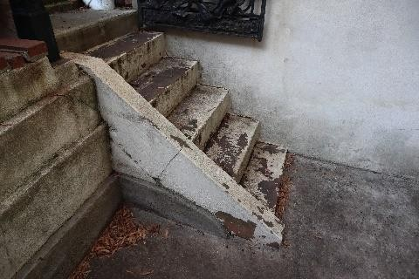  Figure 175. Staircase 6. | 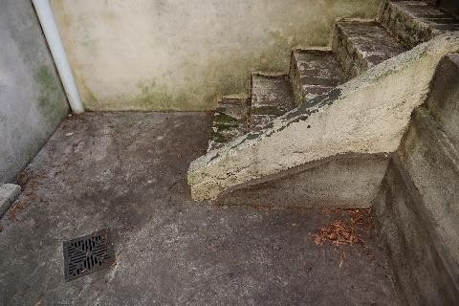  Figure 176. Staircase 7.
 |  | 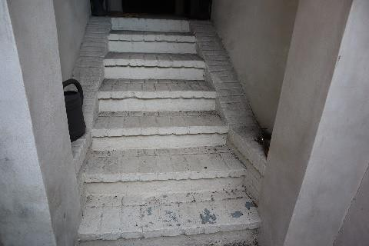  Figure 177. Staircase 8. | 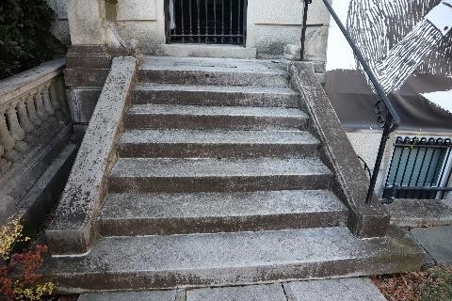  Figure 178. Staircase 9.
 |  | 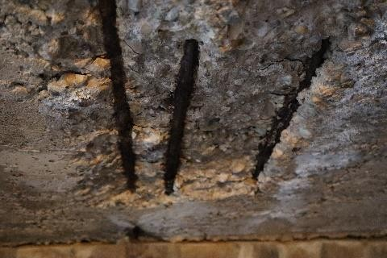  Figure 179. Staircase 9.  Separation of the concrete protective layer | 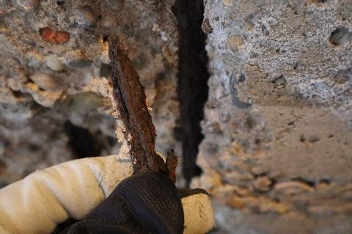  Figure 180. Staircase 9. Corrosion of metal reinforcement
4.11. | Partition walls |  |  |  | 40
4.11.1. Types, structures and materials or partition walls; soundproofing | - Brick partition walls;  - Non-plastered timber partitions;  - Plastered timber partitions;  The partition walls in the building are constructed of brick (load-bearing walls at basement and Floor 1 levels), as well as with timber-frames, in plastered and non-plastered  versions (see Figures 181–184). Partition walls for closets and wardrobes are |  |  |  | 40

built in the form of a frame with lining. The partition walls consist of 50x100 mm timber frames with an interval of ~450 mm. The partition walls are plastered have timber lining. Some partition wall planes have tiles. Some wooden partition structures were found to have rot and termite damage (see Figures 185–186). In general, there are no signs of lacking load capacity or loss of stability in the partitions.
Technical condition of partition walls: satisfactory, with some locations in unsatisfactory condition (wear 40%).
 |  | 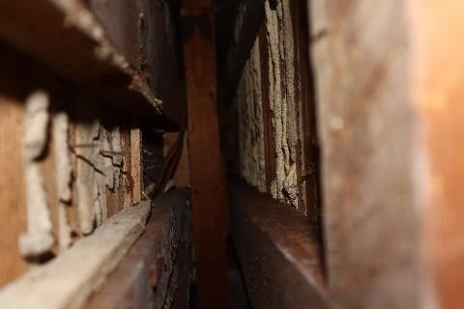  Figure 181. Timber partition wall design | 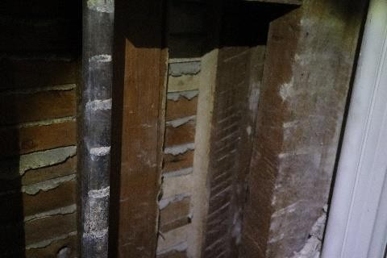  Figure 182. Timber partition wall with  wooden lathing and plaster finish
 |  | 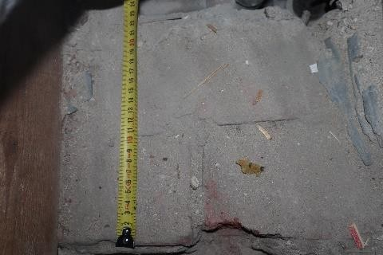  Figure 183. Brick masonry finish | 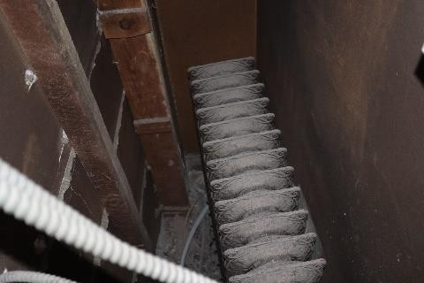  Figure 184. Timber partition around  a heating element
 |  | 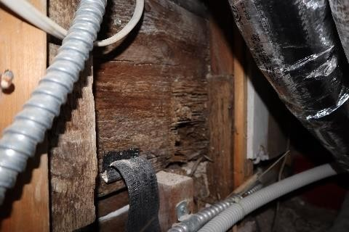  Figure 185. Damage to timber partitions (termites) | 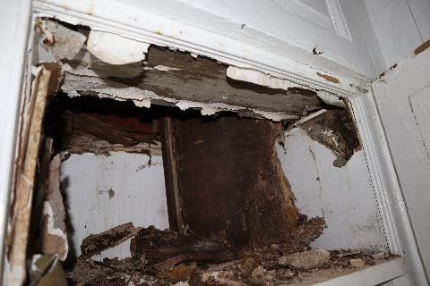  Figure 186. Timber shelf structure with moisture damage (rot)
4.12. | Floors |  |  |  | 40
4.12.1. floor structures, flooring and additional flooring types; sound and thermal insulation | - Sand-cement, concrete screed flooring;  - Ceramic tile flooring;  C.45 Wooden plank flooring;  C.47 Soft rolled-material flooring;  The building has ceramic tiles in the kitchen and bathrooms (see Figures 187–188). Parts of the basement have concrete screed flooring (see Figure 189). Wooden flooring is laid in the hallways and rooms. Rolled-material flooring is used in some locations (see Figures 190–192). There is no step insulation under the wooden floorboards.  The technical condition of the flooring is satisfactory (wear 40%). |  |  |  | 40

 |  | 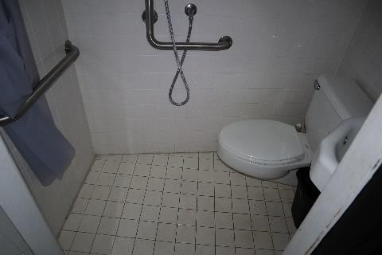  Figure 187. Ceramic tile floor | 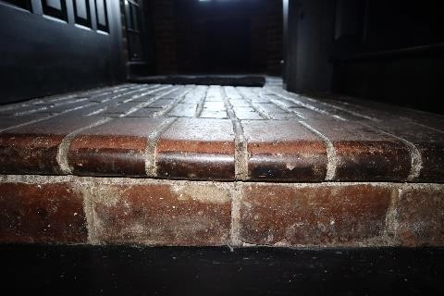  Figure 188. Ceramic tile floor
 |  | 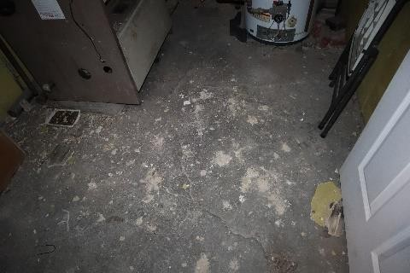  Figure 189. Concrete screed floor in the basement | 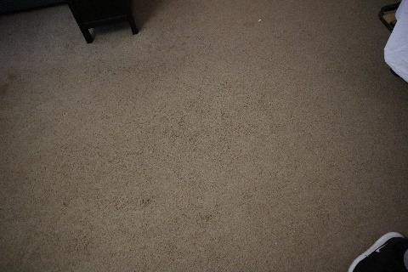  Figure 190. Soft rolled-material flooring
 |  | 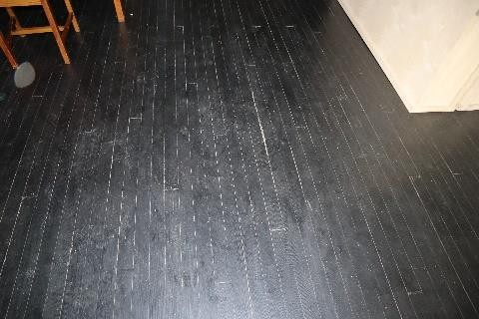  Figure 191. Wooden plank floor | 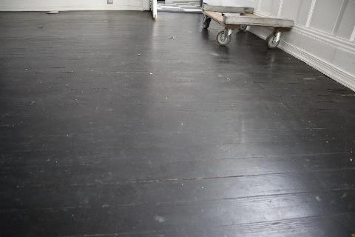  Figure 192. Wooden plank floor
4.13. | objects filling openings: gates, exterior doors, interior doors, windows, hatches |  |  |  | 50
4.13.1. windows, shutters, balcony doors: material, type, and structures | C.49 Window and balcony door units, timber;  C.49b Filling of openings with glass tiles;  C.50a Window and balcony door units, plastic;  The building has timber-framed windows and PVC-framed windows with single glazing units (see Figures 193–203). Glass tiles were also found in some places (see Figure 196). Most windows can be opened by raising the sash with a roller-and-counterweight mechanism. Wooden windows are preserved on the first floor and on the doors of the balcony and terrace (see Figures 201, 203). The basement windows have metal grilles installed on the street facade as burglary protection (see Figure 195). Metal corrosion was detected in the grilles. The structures filling window openings in the building not properly sealed (infiltration of air through gaps along the perimeter is noticeable). An exposed inspection area on the street facade revealed non-sealed window casement covered with exterior finish plates (see Figure 197). Moisture infiltration and rotten jamb were found around the balcony door (see Figure 204). As a result of the uneven settlement of the foundation, the casements in the window openings deformed with the brick walls. The basement openings facing the courtyard side have timber-frame structures lined with plywood and plastered (see Figures 205–206). Infiltration of moisture and moisture damage were detected along the joint with the masonry. The frame was probably built to incorporate a rectangular window profile without preserving the historic window opening. The structures in the window openings are obsolete, are not properly sealed, and do not meet the requirements of LBN 002-19 for maximum thermal conductivity (U≤1.1 W/(m²K)).  The condition of the window and balcony door is unsatisfactory (wear 60%). |  |  |  | 60

 |  | 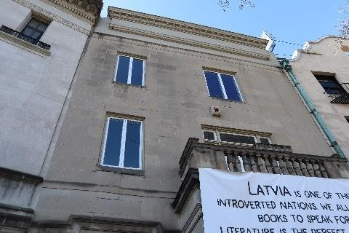  Figure 193. Street facade windows | 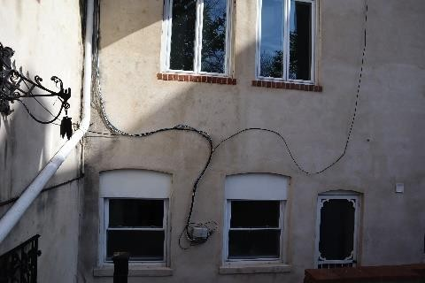  Figure 194. Courtyard facade windows
 |  | 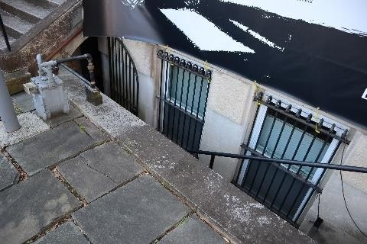  Figure 195. Protective metal grilles | 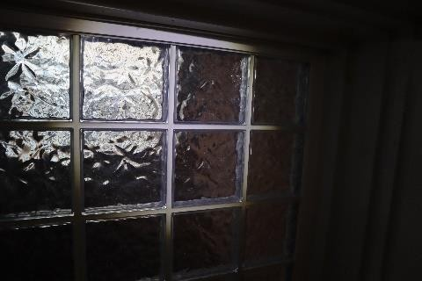  Figure 196. Glass tiles
 |  | 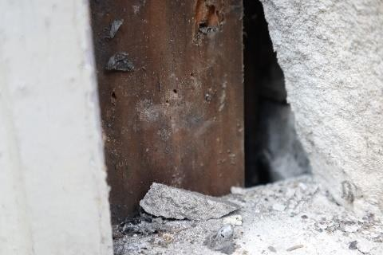  Figure 197. Window casement installation method | 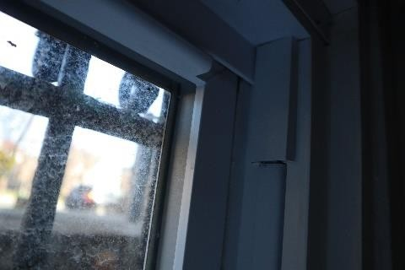  Figure 198. PVC windows
 |  | 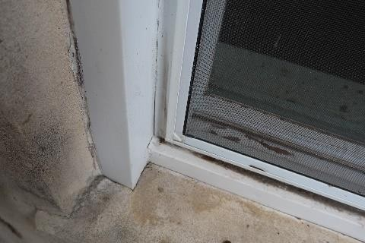  Figure 199. PVC windows | 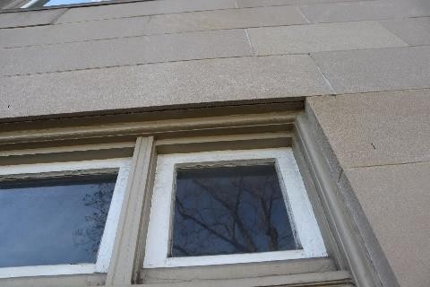  Figure 200. PVC windows
 |  | 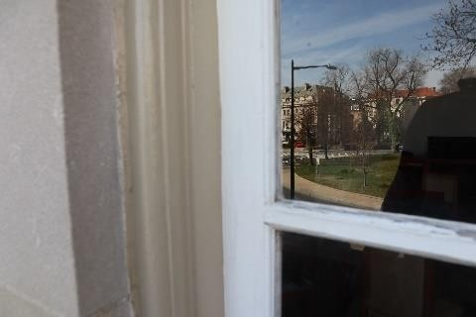  Figure 201. Wooden balcony door | 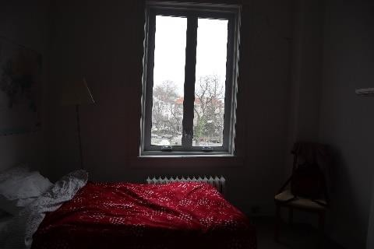  Figure 202. Window case tilt

 |  | 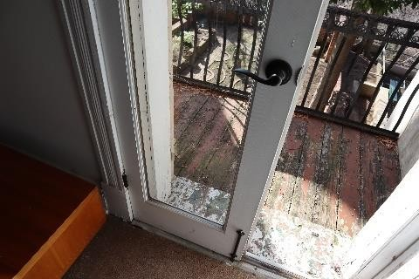  Figure 203. Wooden balcony door | 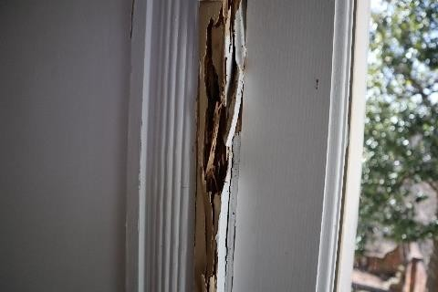  Figure 204. Balcony door jamb
 |  | 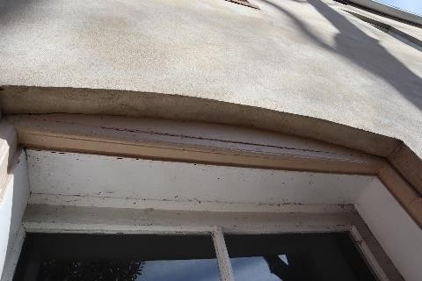  Figure 205. Opening of basement window facing the courtyard | Figure 206. Timber frame structure  for the opening of the basement window
4.13.2. external doors, internal doors, and gates: material, type, and structures | C.51 Wooden doors;  C.51a Glazed and glass doors;  C.52 Metal doors; C.52a Metal gates;  The main external door of the building is a solid timber structure with a glazed section (see Figures 207–209). A metal gate is installed in front of the entrance. The gate frame has corrosion damage and warping beyond its normal plane (see Figures 210–211). The street-side doors to the courtyard and basement are wooden structures with no cultural historic value (see Figures 215–216).  Inside the building, there are simple panelled doors, glazed wooden doors, and wooden doors (see Figure 217). The door openings were significantly deformed by the uneven settlement of the foundation (see Figure 218). Glass doors are installed in the stairwells of Floor 1 and 2 (see Figure 219).  The exterior doors are not properly sealed and do not meet the maximum thermal conductivity requirements set in LBN 002-19 (U≤1.8 W/(m²K)). The design of the attic hatch is not fire-safe (see Figure 220). |  |  |  | 40
 |  | 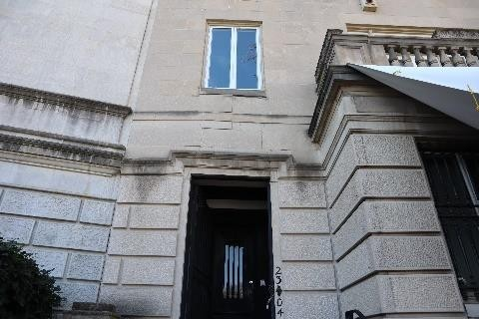  Figure 207. Main external entrance door | 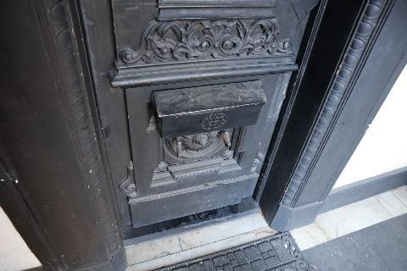  Figure 208. Main external entrance door |  | 40

 |  | 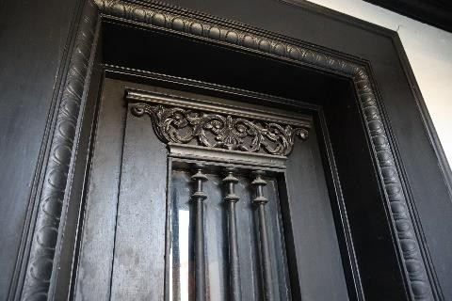  Figure 209. Main external entrance door | 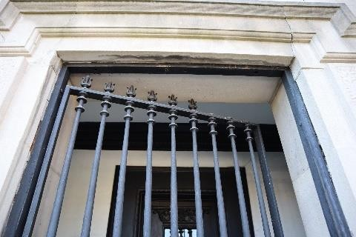  Figure 210. Metal gate
 |  | 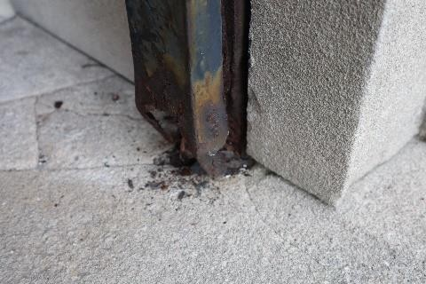  Figure 211. Corrosion in metal gate frame | 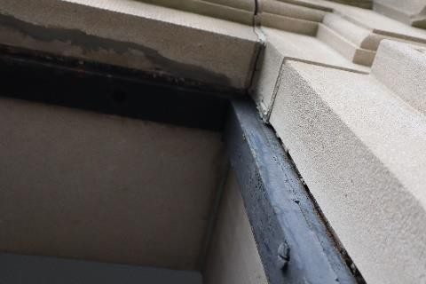  Figure 212. Corrosion in metal gate frame
 |  | 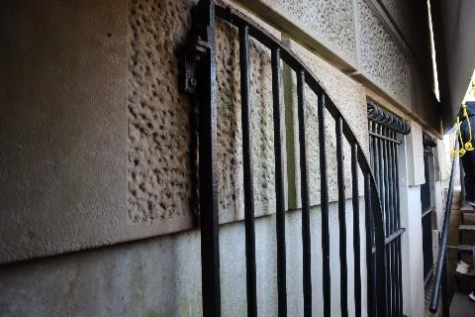  Figure 213. Basement-access metal gate | 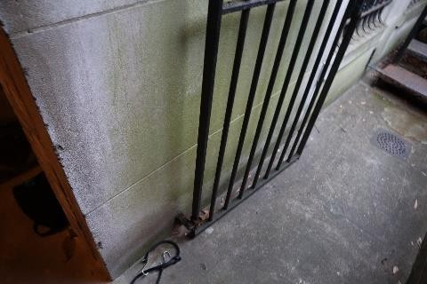  Figure 214. Basement-access metal gate
 |  | 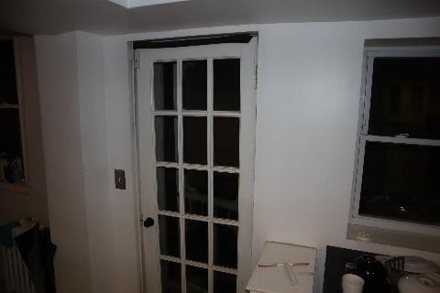  Figure 215. Wooden door to the courtyard (from the basement) | 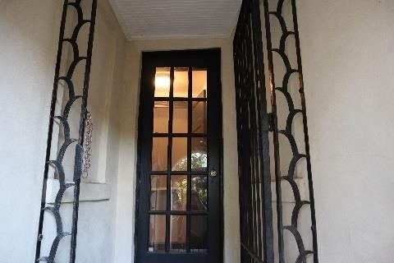  Figure 216. Wooden door to the courtyard (from the first floor)
 |  | 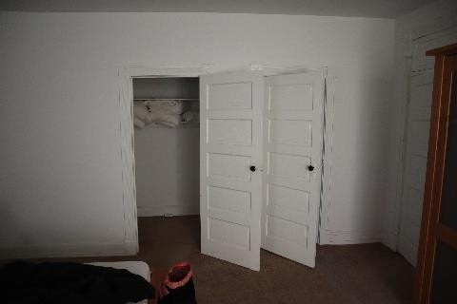  Figure 217. Wood-panel interior door | 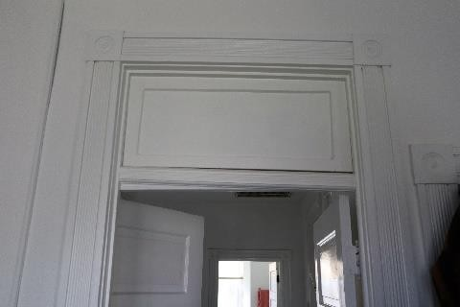  Figure 218. Tilted wooden case

 |  | 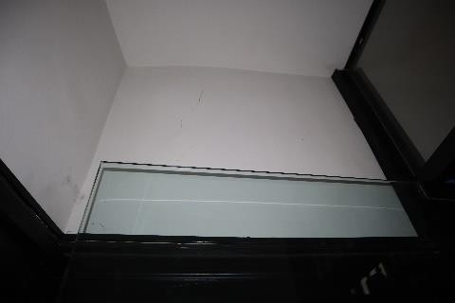  Figure 219. Staircase glazed door | 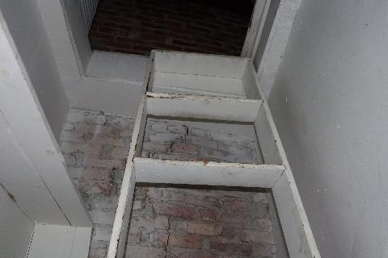  Figure 220. Wooden hatch leading to the attic
4.14. | heating stoves, kitchen stoves, chimneys |  |  |  | 40
4.14.1. types, structures, materials and finish of heating stoves, fireplaces, kitchen stoves and chimneys; compliance with fire safety | The building has fireplaces. The fireplaces are currently used decoratively only and not according to their primary purpose (see Figures 221–222). The building still has two historic chimneys made of clay bricks, which appear not to have defects (see Figures 223–224). There is a gas-fired central heating boiler in the basement; the smoke exhaust of the boiler is connected to the chimney in the NW wall. The concrete joints at the top of the chimneys were found to have begun crumbling since the previous technical inspection in 2014.  The condition of the fireplaces and chimneys is satisfactory (wear 40%). |  |  |  | 40
 |  | 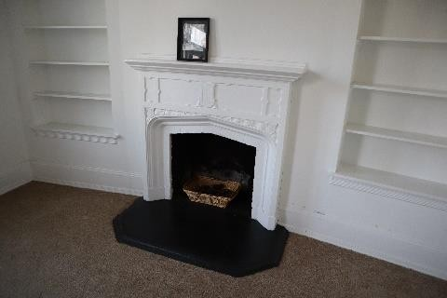  Figure 221. Heating fireplace | 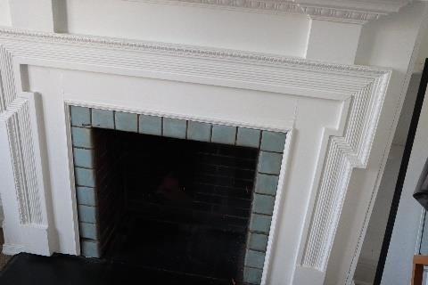  Figure 222. Heating fireplace |  | 40
 |  | 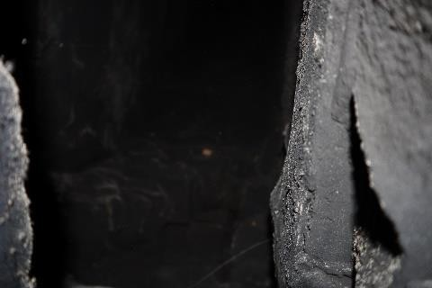  Figure 223. Chimney outlet | 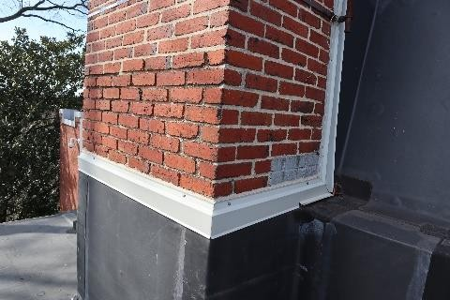  Figure 224. Brick chimney |  | 40
4.15. | Fire resistance of structures and materials |  |  |  | 40
4.15.1. concrete, metal, wood, plastic, fabric fire extinguishing equipment, conformity to standards | The main structures of the building are made of brick masonry, plastered on the inside. The building has timber slabs between the floors and a load-bearing timber roof slab. The wooden slab ceilings in the building are mostly plastered (in some places, the structure is exposed or the plaster is damaged). It is recommended to conduct a new treatment of the timber supporting structures of the roof with fire retardant and to restore or replace the internal plaster finish.  Technical condition of the fire protection of structures and materials: satisfactory  (wear 40%). |  |  |  | 40
4.15.2. compliance of fire resistance measures with laws and regulations; assessment of structures and materials from the viewpoint of fire resistance levels and smoke protection | Total area of the building: 410.3 m² (one fire zone), with the highest floor level mark <8 m. According to LBN 201-15 ‘Fire safety of structures’, the building has use type I, and according to LBN 201-15 Annex 3, it has fire resistance level U3 (see Table 1). |  |  |  | 40

Table 1

Fire resistance of building structures
No | Building structure | Minimum fire performance of the building structures according to the fire resistance ratings of the building
No | Building structure | U1 |  | U2 |  | U3
 |  | U1a | U1b | U2a | U2b | U3
1. | Load-bearing walls and staircase walls | REI 120* | REI 60 | REI 60 | REI 30 | not regulated
2. | Perimeter structure of other fire-separated rooms***** | EI 60 | EI 30 | EI 60 | EI 30 | not regulated
3. | Columns | REI 120* | R60** | R 60****** | R 30** | not regulated
4. | Stair landings, beams, spans, and steps in the escape route | R 60 | R 30 | R 60 | R 30 | not regulated
5. | Horizontal perimeter structure of a stairwell | R 60 | R 30 | R 60 | R 30 | not regulated
6. | Slabs, including in the bay windows | REI 60 | REI 30 | REI 60****** | REI 30 | not regulated
7. | Joined roof*** | R 60 | R 30 | R 60 | R 30 | not regulated
8. | Roof load-bearing structures*** | R 30 | R 15 | R 15 | R 15 | not regulated
9. | Fire-resistant wall | REI 180-M | REI 120-M | REI 60-M | REI 60-M | REI 60-M
10. | Fire safety section perimeter structure | REI 180 | REI 120 | REI 60 | REI 60 | REI 60-M
11. | Doors, windows, gates, hatches, and valves in fire walls and fire zone perimeter structures**** | EI 60 | EI 60 | EI 30 | EI 30 | EI 30
12. | Elements filling openings in the perimeter structures of fire-separated rooms***** | EI 30 | EI 30 | EI 30 | EI 30 | not regulated
13. | Stairwell doors***** | EI 30 | EI 30 | EI 30 | EI 30 | not regulated
14. | Balcony, terrace, gallery load-bearing structures | R 30 | R 15 | R 30 | R 15 | not regulated

Smoke detectors are installed in the building.
The technical condition of the structures and materials in terms of fire resistance and smoke protection is satisfactory (wear 40%).
4.16. | Ventilation shafts and ducts | 40
4.16.1. type, material; circulation of air, temperature and air humidity in the attic | The building is equipped with a recirculation ventilation system, but it is not in use. Natural air supply to the building is through open windows and from parts of windows and doors that lack proper seal. Natural air extraction is through the chimney flues of the fireplaces. The concrete joints at the top of the chimneys were found to have begun crumbling since the previous technical inspection. Indoors, the circulation of air seems to be sufficient under current conditions. No mould damage due to insufficient circulation of air found. | 40
Condition of ventilation shafts and ducts: satisfactory (wear
40%).
4.17. | Lift shafts | ---
4.17.1. Type, material | The building has no lift shafts. | ---
4.18. | External finish and architectural details | 50
4.18.1. indoor surface  finish types | C.54 Water-based paints; C.55a Emulsion paints; | 50
 | C.57 Ceramic tiles;
 | C.57b Brickwork seams;
 | C.58 Plaster;
 | C.58a Plasterboard and other finish panels;
 | C.59 Top finish of walls and ceilings with boards and other timber materials

The interior finish (on the walls, ceilings) is mostly painted lime plaster (see Figure 225) on a layer of wooden planks (lathing). There is a metal plaster mesh (see Figure 226) with a thick layer of plaster (2–3 cm) on the brick walls. There is also a plasterboard ceiling finish and wood panelling in a room on Floor 1 (groin ceiling) and an exposed brick wall (see Figures 227–228). There are ceramic tiles in the kitchen and bathrooms (see Figure 229). Ceramic brick tiles were found on the stairs of Floor 2. The hallways of the building have wood panelling (see Figure 230).
Rooms were found with detached plaster or even missing wooden lathing, not meeting hygiene requirements (it is impossible to clean and disinfect the surface) (see Figure 231). The finish needs to be restored in some rooms, where indoor wood damage and moisture infiltration were detected. The locations of cracks in the openings and historic leaks require renovation of the finish (see Figures 232–236). Historic architectural details such as alcove ornaments, metal and wood ornaments of the main staircase, door detail ornaments, groin ceiling ornament, beam support ornaments, heating elements were found in the interiors (see Figure 237–242).
Overall, the interior finish needs to be renovated in line to match the status of the embassy, its purpose, and to preserve the historic architectural details as much as possible.

The condition of the interior finish is unsatisfactory (wear 60%).
 |  | 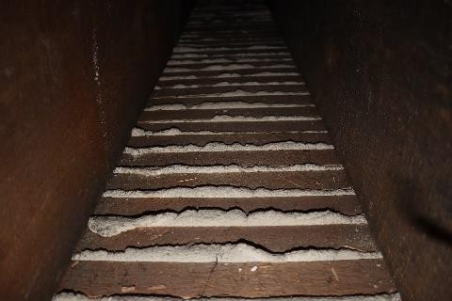  Figure 225. Wooden lathing with plaster | 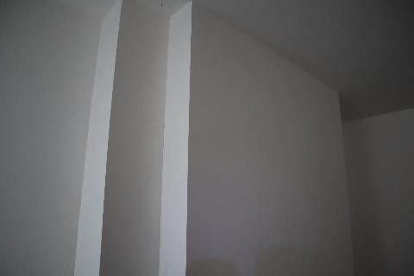  Figure 226. Plastered brickwork
 |  | 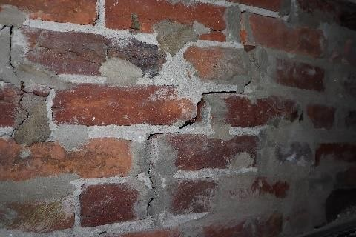  Figure 227. Exposed brickwork | 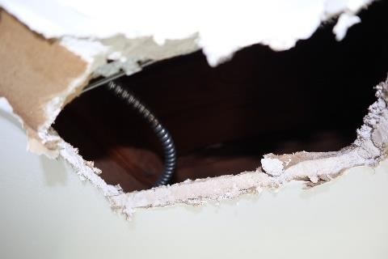  Figure 228. Plasterboard finish
 |  | 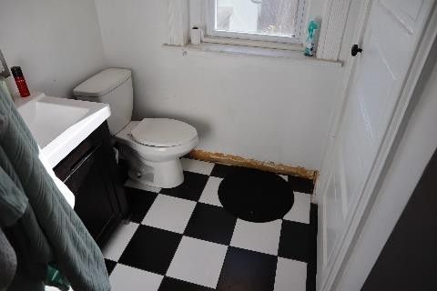  Figure 229. Ceramic tile finish | 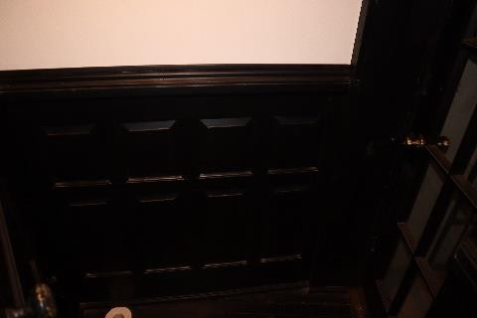  Figure 230. Wooden panel finish

 |  | 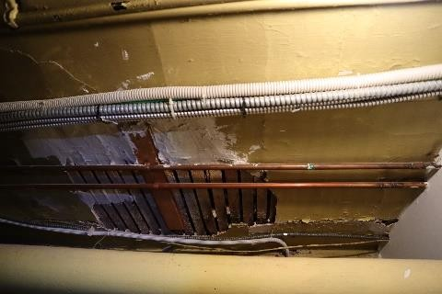  Figure 231. Detaching plaster indoors | Figure 232. Historical water leaks  on ceiling finish
 |  | 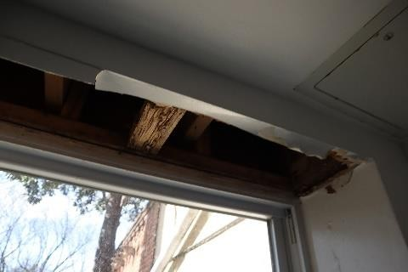  Figure 233. Damaged interior finish with rotten wood | Figure 234. Damaged interior finish with rotten wood
 |  | 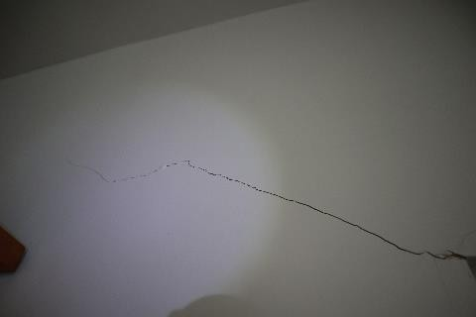  Figure 235. Crack openings in the interior finish | 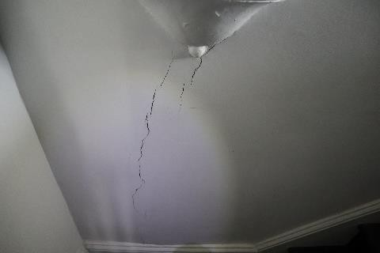  Figure 236. Crack openings in the interior finish
 |  | 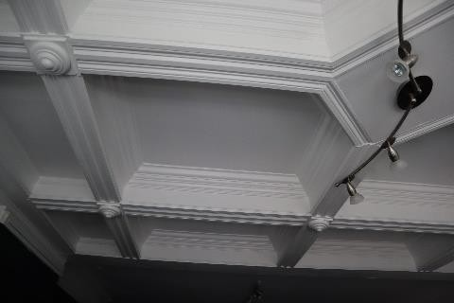  Figure 237. Caisson ceiling | 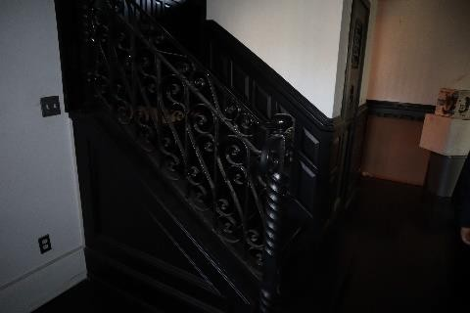  Figure 238. Historic metal railings
 |  | 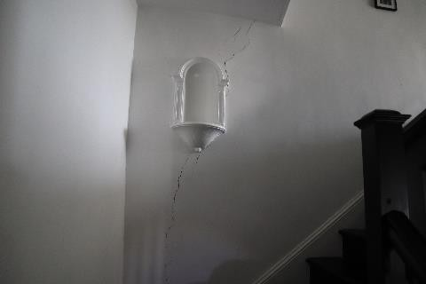  Figure 239. Alcove ornaments | 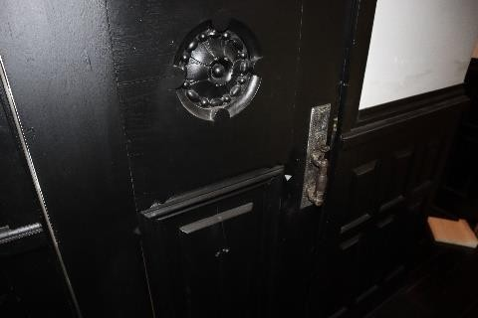  Figure 240. Wooden door ornaments

 |  | 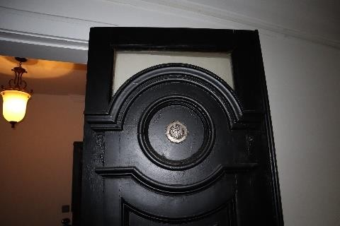  Figure 241. Wooden door ornaments | 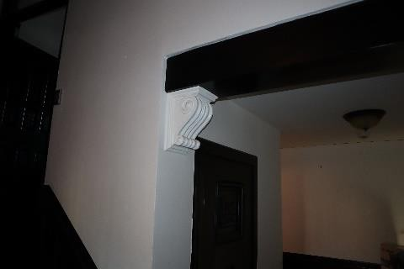  Figure 242. Slab support ornaments
4.19. | External finish and architectural details |  |  |  | 50
4.19.1. facade surface finish; facade details, their material | C.57b-f Seamed brick masonry;  C.58f Plaster;  C.58bf Stone chippings and other mineral-based finishes; C.59f Top finish of walls with boards and other timber materials  The building has two facades facing NE and SW. The street facade (facing NE) has stone plates (see Figures 243–245). Stone plate thickness: 10 cm. As a result of uneven settlement in the foundation, some plates have been crushed and cracked (approximately 10–20% of the street facade). A decorative cantilever element is missing from the street facade (see Fig. 244). The basement entrance has a seamed brick wall with significant surface salt accretion due to non-functioning or non-existent waterproofing (see Figure 246).  The facade of the courtyard was plastered and painted over time, thus losing its original historic appearance (see Figure 247–248). Vegetation growth and leakage stains were found on the plaster. Plaster thickness: <10 mm. The annex between Floors 2 and 3 is lined with wooden planks.  The exterior facade has notable architectural details such as the wooden elements in the ceiling of the entrance portal, the solid wooden door, the obelisk, the lantern, the metal gate of the main entrance (corrosion damage detected), the metal window grilles (corrosion damage detected), see Figures 249–254.  The condition of the exterior finish is unsatisfactory (wear 50%). |  |  |  | 50
 |  | 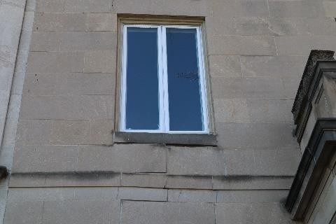  Figure 243. Stone plate finish | 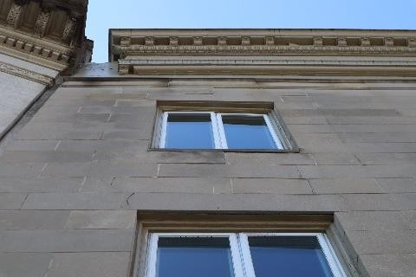  Figure 244. External facade defect |  | 50
 |  | 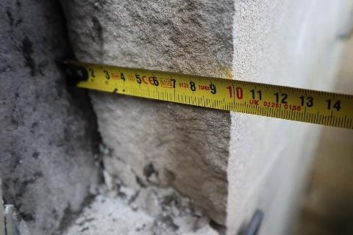  Figure 245. Stone plate finish (10  cm) | Figure 246. Accretion of salt on brick |  | 50

 |  | Figure 247. Plaster finish in the courtyard part of the building | 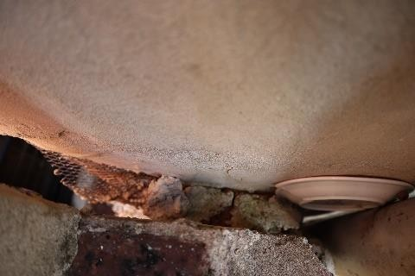  Figure 248. Plaster mesh and finish
 |  | 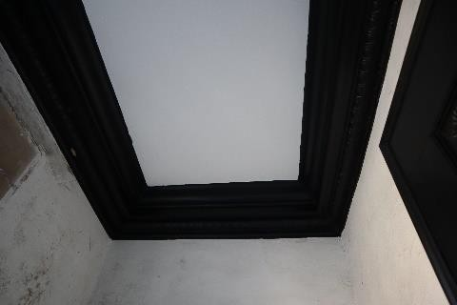  Figure 249. Wooden ceiling elements above  the entrance portal | Figure 250. Wooden ornaments for the main  entrance door
 |  | Figure 251. Wooden ornaments for the main entrance door |   Figure 252. Obelisk
 |  | 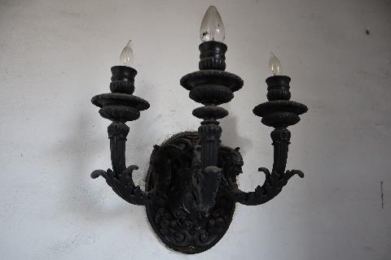  Figure 253. Lantern | Figure 254. Metal grilles for window openings
4.20. | Other parts of the building |  |  |  | ---
4.20.1. Other parts of the building | No other parts of the building. |  |  |  | ---

5. Internal utility lines and equipment
(Includes only those utility lines and equipment surveyed in accordance with the inspection statement of work)

- water inlet with meter
- gas inlet with meter
- power input connection with meter
- sewer outlet
- rainwater drains

Figure 255. Building utility input/output connections
Inspection site or object  name | Brief description of damage/defects found and of their causes; assessment of the technical condition of individual structural elements, types of structures and parts of the structure. Compliance with laws and regulations | Technical wear, %
1 | 2 | 3
5.1. | Cold water supply and sewer lines, valves, taps, plumbing equipment, water meters | 50
5.1.1. lead-in indoor water supply pipes, water meter, water supply line diagram, pipes and fittings, line pressure and other parameters; hydraulic testing and compliance with laws and regulations; | C.60 Cold water supply;  The cold water supply system for the building is made of metal (sometimes copper) pipes with a diameter of ~25 mm (1 inch). The water inlet is on the street facade of the building, with an underground gate valve (see Figure 256–261). The water meter is located in a manhole in the street. No proofing against condensation is installed on cold water pipes. Virtually all the pipes are concealed. No diagram of the system was prepared as it would require extensive, unnecessary dismantling work. The existing system is worn-out and outdated, although no water leaks were detected. | 50
 | The technical condition of the cold water line is unsatisfactory (wear 50%).
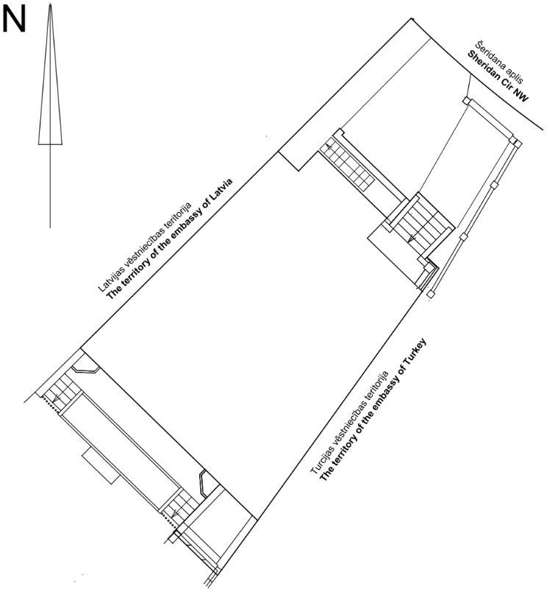

 |  | 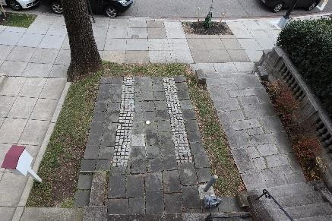  Figure 256. Cold water inlet | 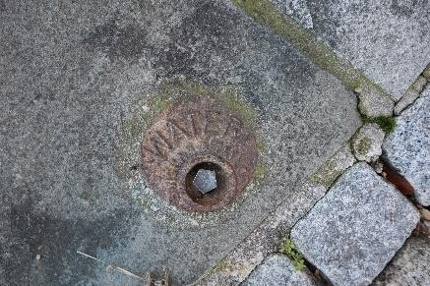  Figure 257. Shut-off valve access
 |  |   Figure 258. Water meter manhole | 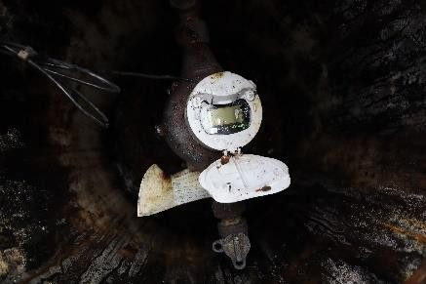  Figure 259. Water meter
 |  | 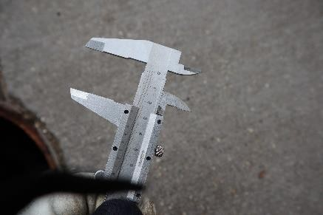  Figure 260. Water pipe diameter  (~25 mm) | 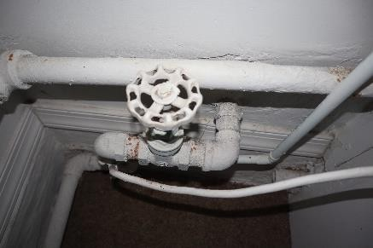  Figure 261. Water inlet in the building with a shut-off valve
5.1.2. Wastewater drainage and treatment | C.62 Household and industrial wastewater drainage; C.62a Rainwater drains and rainwater sewer; |  |  |  | 50
 | The household sewer system in the building is built of cast iron and PVC pipes, DN 100, 50. The household sewer system is connected to the general municipal system. The system’s pipes are mostly concealed and embedded in structures (see Figures 262–264). No video inspection of the pipelines has been carried out, so it is not possible to verify the technical condition of the pipes in the ground. In the basement bathroom, a small quantity of wastewater is pushed into the adjacent sink when using the shower, indicating a possible connection that is not hermetic and insufficient diameter or incline for draining the water. The riser of the sewer system is built up to the roof of the building, but does not have a top cover element (see Figure 265). The system is outdated and worn-out in general.
 | Rainwater drains are built on the street front side of the building and on its courtyard side. The street-side drainpipe has a lot of free play and does not ensure that rainwater is discharged into the centralised drainage system (see Figures 265–266). The current drains in the courtyard are built along the edges of the building, moving the rainwater into the municipal sewer system. The rainwater drain pipes in the courtyard are built into the basement floor volume (see Figures 267–268). A leaf trap was installed in the horizontal gutter in the courtyard, and not installed in the annex below it (see Figures 269ܺ–270). Rainwater drains were found to have high free play. An inspection hatch unit has been installed for only one drainpipe on the courtyard side (see Figure 271). A rainwater drainpipe whose function is unclear is installed in the courtyard of the building (see Figure 272).
 | The household wastewater and rainwater system drains into the overall system of the city.
 | The technical condition of the wastewater system is unsatisfactory (wear 50%).

 |  |   Figure 262. Sewer system access | 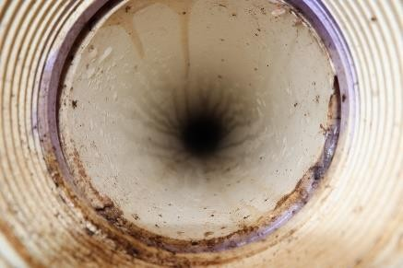  Figure 263. PVC sewer pipe
 |  | 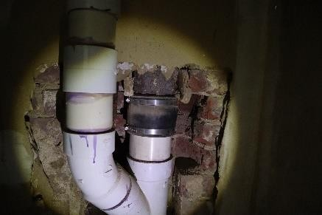  Figure 264. PVC and cast iron sewer pipes | 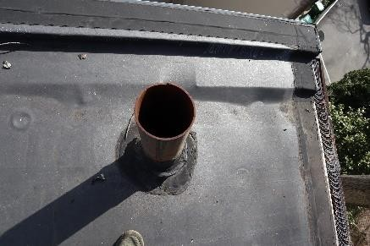  Figure 265. Household sewer outlet  on the roof
 |  | 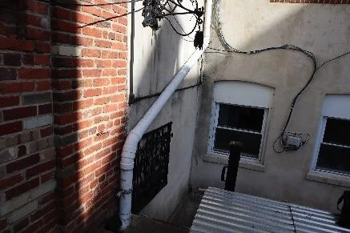  Figure 265. Rainwater gutters | Figure 266. Inadequate rainwater drainage solution
 |  | 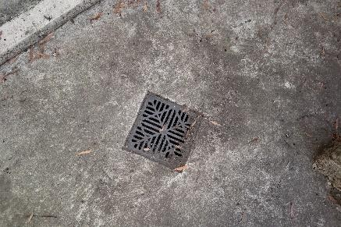  Figure 267. Rainwater system gully | 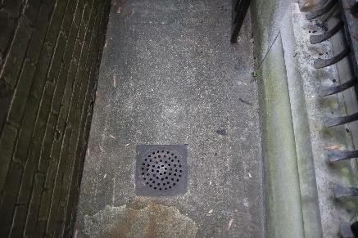  Figure 268. Rainwater system gully
 |  | Figure 269. Leaf trap on a drain | Figure 270. Open rainwater drain

 |  | 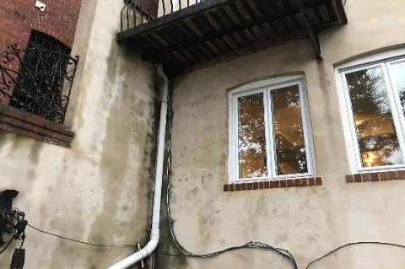  Figure 271. Rainwater drain in the  balcony surface | 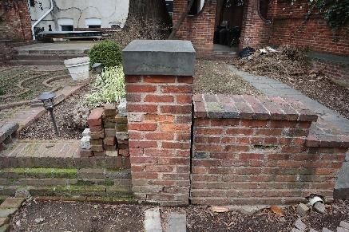  Figure 272. Rainwater outlet in the courtyard
5.2. | Hot water pipes and their heat insulation, valves, taps, mixers, driers, solid-fuel water heaters, water and heat meters, and other  elements |  |  |  | 40
5.2.1 Indoor hot water supply system; system diagram, pipes, pumps; consumption of heat for producing hot water;  location of the water heater | C.61 Hot water supply;  Hot water for the building is produced by a gas boiler and kept in a storage tank (water volume heater), see Figures 273–276. The hot water system is mostly concealed and embedded into structures. The system is made of copper piping, without insulation or a recirculation system. The system is outdated and worn-out in general.  The technical condition of the hot water system is satisfactory (wear 50%). |  |  |  | 40
 |  | 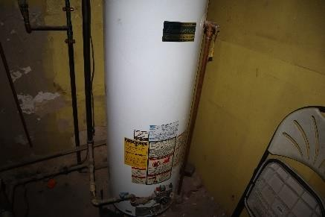  Figure 273. Hot water storage  tank | 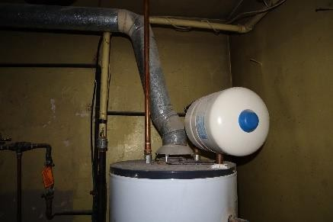  Figure 274. Hot water storage tank with expansion tank |  | 40
 |  | 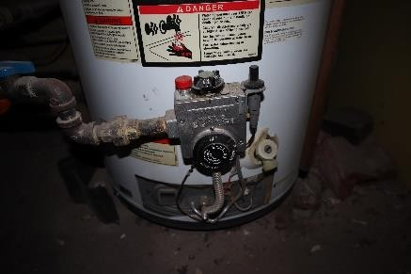  Figure 275. Hot water storage  tank | 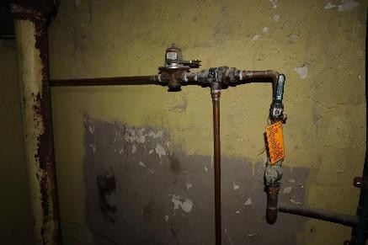  Figure 276. Hot water copper pipes |  | 40
5.3. | fire water supply, automatic fire suppression systems and smoke protection solutions |  |  |  | ---
5.3.1. indoor fire suppression system type; system diagram, pipes, pumps, fire hydrants, hoses, nozzles; hydraulic check;  hydraulic test | The building does not have a fire water supply system. According to the type of use of the building and the level of fire safety, an internal fire extinguishing (sprinkler) system is not required under the laws and regulations of Latvia and the United States of America. |  |  |  | ---
5.3.2. type of automatic fire suppression system; substances used for fire suppression;  water mains inlets; system | The building does not have a fire water supply system. According to the type of use of the building and the level of fire safety, an internal fire extinguishing (sprinkler) system is not required under the laws and regulations of Latvia and the United States of America. |  |  |  | ---

diagram, pipes, fittings and pumping equipment; automatic control equipment, back-up power supply; system service life; types of smoke protection solutions; air ducts, devices, and systems, back-up power supply; automatic control, interlocks with other systems; system service life
5.4. | Heating system, its pipelines, risers, valves, insulation, heating boilers, heat exchangers, measuring instruments, automation and other elements |  |  |  | 60
5.4.1. heating unit; heating system type; pipelines; expansion tank; system service life; main defects; compliance with laws and regulations; heat loss in the structure; local boiler house system, approximate maximum output | C.63a Centralised heating from local source of heating (natural gas boilers);  The building has a centralised system connected to a local natural gas boiler (see Figures 277–282). The boiler is located in the basement of the building and does not have a separate air supply duct (it uses indoor air). The heat medium is water. Indoor temperature controllers are installed. The heating system is constructed with a two-pipe bottom distribution system and a forced circulation pump. The system’s pipelines are mostly concealed and embedded in structures. No diagram of the system was prepared as it would require extensive dismantling work. Old steel pipes without thermal insulation were found in the basement. The heating system has a low degree of automation. The boiler is inefficient, uneconomical, and obsolete.  The technical condition of the heating system is unsatisfactory (wear 60%). |  |  |  | 60
 |  | 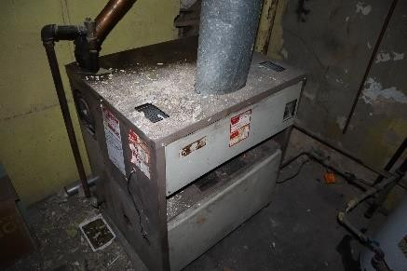  Figure 277. Gas boiler | 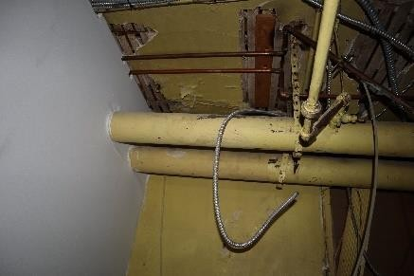  Figure 278. Uninsulated steel pipes |  | 60
 |  | 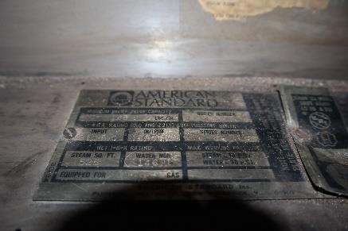  Figure 279. Gas boiler specifications | 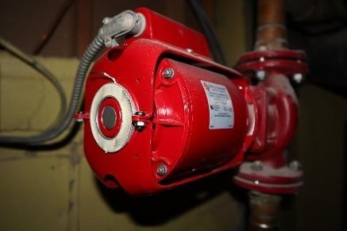  Figure 280. Heating system circulation pump |  | 60
 |  | 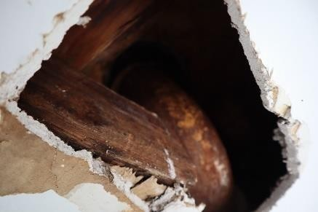  Figure 281. Heating system steel | 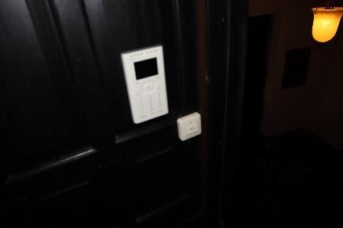  Figure 282. Heating system temperature |  | 60

 |  | pipes | controller
5.5. | central heating radiators, heaters, convectors and their feed lines,  heat regulators |  |  |  | 50
5.5.1. Heating bodies of the central heating system; their service life | C63.b Central heating bodies;  The building has cast-iron heating bodies (see Figures 283–286) that are not fitted with thermostatic and non-return shut-off valves. An imbalance was detected in the heating system. The heating elements are installed indoors, in an open and enclosed manner. Heating elements installed in an enclosed manner do not transfer heat into the room efficiently. The heating elements have historical value.  The condition of the central heating bodies is unsatisfactory (wear  50%). |  |  |  | 50
 |  | 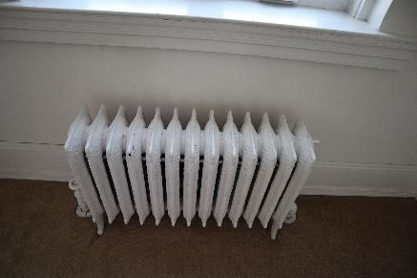  Figure 283. Cast iron heating bodies | 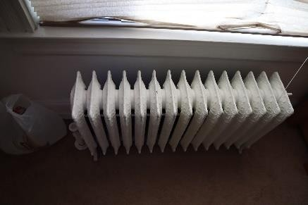  Figure 284. Cast iron heating bodies |  | 50
 |  | 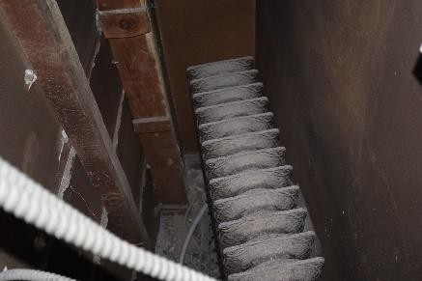  Figure 285. Cast iron heating bodies | 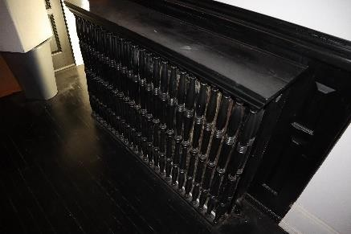  Figure 286. Cast iron heating bodies |  | 50
5.6. | Ventilation and air conditioning equipment |  |  |  | 50
5.6.1. Ventilation and air conditioning system, equipment and other elements | 66. Natural ventilation  66a. Forced ventilation  The building is equipped with a recirculation ventilation system, but it is not in use. Natural air supply to the building is through open windows and from parts of windows and doors that lack proper seal. Natural air extraction is through the chimney flues of the fireplaces.  Forced ventilation units are located in the basement (exchanging the air in the basement and on Floor 1) and in the attic (exchanging the air of Floor 2 and Floor 3), see Figures 287–292. The ducts are built in a chaotic manner. Air supply diffusers are locally embedded in the floor.  The forced ventilation units are equipped with a cooling function (see Figure 293–296) via outdoor condenser units (refrigerant: Freon). A control panel is installed indoors.  Condition of the ventilation and air conditioning equipment: unsatisfactory  (wear 50%). |  |  |  | 50
 |  | 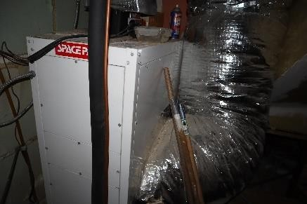  Figure 287. Forced ventilation unit | 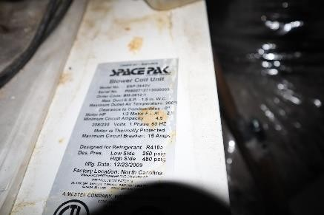  Figure 288. Unit specifications |  | 50

 |  | 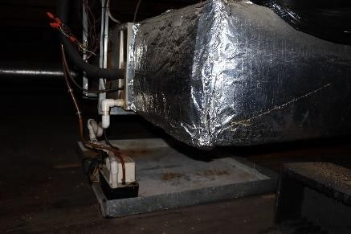  Figure 289. Forced ventilation unit | 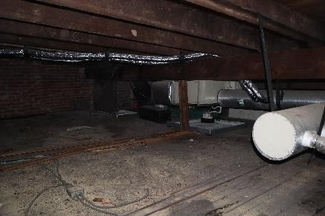  Figure 290. Forced ventilation unit
 |  | 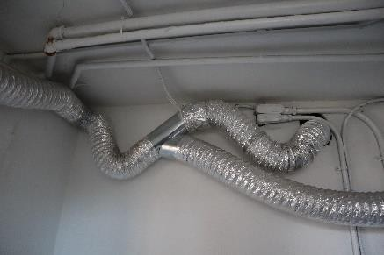  Figure 291. Recirculation system pipes | 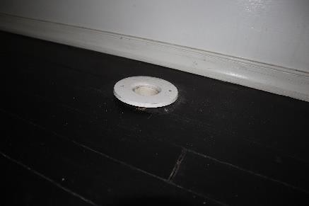  Figure 292. Air supply diffuser
 |  | 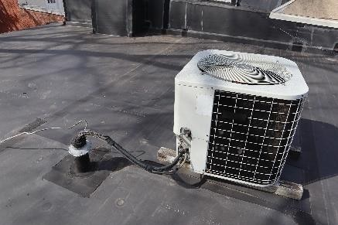  Figure 293. Cooling system outdoor unit | 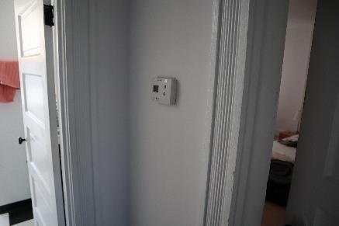  Figure 294. Cooling system control  panel
 |  | 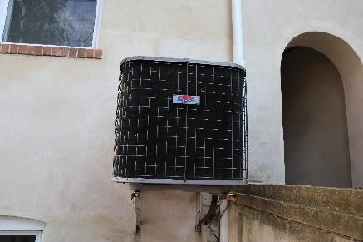  Figure 295. Cooling system outdoor unit | 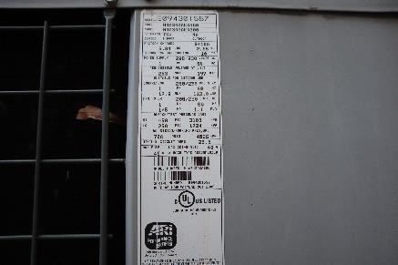  Figure 296. Technical specifications of the cooling system
5.7. | Waste chutes and chambers |  |  |  | ---
5.7.1. waste chutes and chambers | The building has no waste chutes or chambers. |  |  |  | ---
5.8. | Gas lines and facilities; gas water heaters; gas heating boilers;  gas meters |  |  |  | 60
5.8.1. Lead-in gas line, other gas lines, gas facilities installed | 67. Gas supply: external mains gas supply;  The building is connected to (low-pressure) gas mains; the gas is used to produce heat for heating and hot water (see Figures 297–298). The gas meter is installed openly with the meter on the street facade (see Figure 299). The gas pipes are worn out and have improper pipe fastening elements (see Figure 230). There is a noticeable smell of gas (leak) at the basement entrance.  The technical condition of the gas pipeline system is unsatisfactory (wear 60%). |  |  |  | 60

 |  |   Figure 297. Gas meter specifications | 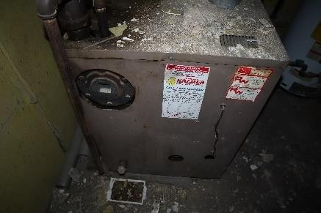  Figure 298. Gas boiler
 |  | 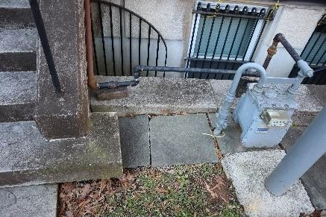  Figure 299. Gas meter in the front yard | 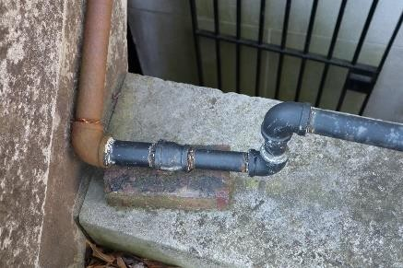  Figure 300. Inadequate support solutions for the gas pipe
5.9. | Electric power supply system and electrical engineering equipment |  |  |  | 60
5.9.1. power supply source, mains voltage, power supply and distribution facilities, power supply for the lift, heating unit, emergency lighting, smoke protection, other equipment and installations; power consumers, their capacity; results of cable and wire insulation resistance measurements, emergency and rescue lighting and the type of its back-up power supply; earthing and lightning protection devices; results of resistance measurements; provision of back-up power supply to the heating unit | C.64. Electrical facilities; C.64a. Electrical lines;  The building is connected to the municipal power supply grid: 400 A (see Figure 301). The meter is located at the basement entrance, on the courtyard side (see Figure 302). The electrical switchboards are located in the basement (see Figures 303–304). Electricity wires were found to have been modified in some places, but mostly the historic ones remained. The electrical cables in the building are installed in a chaotic manner, going through floor slab structures (see Figures 305–306). No resistance measurements are available. The building’s lighting system is not energy efficient and is worn out. No additional inspection was carried out as the existing system is to be dismantled and built from scratch.  The technical condition of the electrical equipment and lines: unsatisfactory (wear 60%). |  |  |  | 60
 |  | 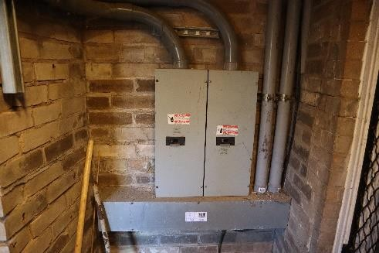  Figure 301. Electrical inputs to the building (2x200 A) | 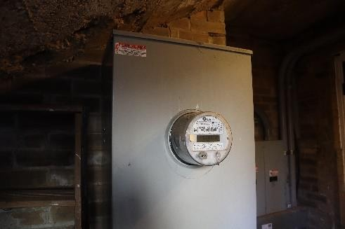  Figure 302. Power meter |  | 60
 |  | 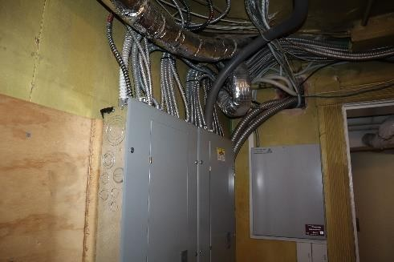  Figure 303. Electrical switchboard | 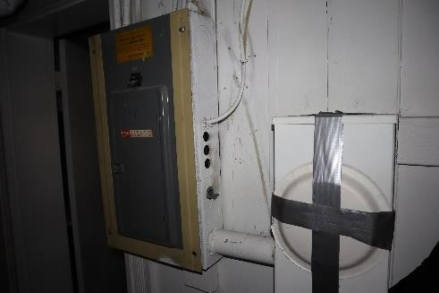  Figure 304. Electrical switchboard |  | 60

 |  | 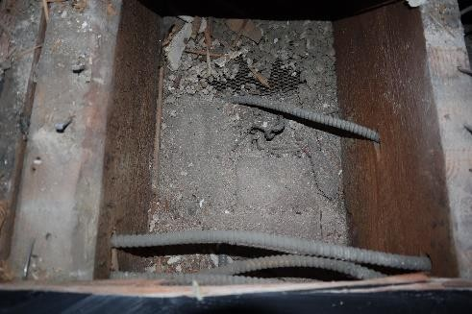  Figure 305. Electrical cables in a slab between floors | 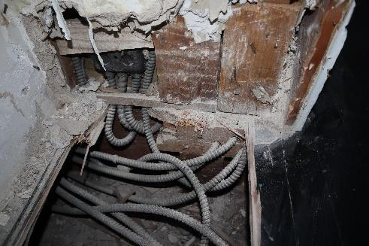  Figure 306. Electrical cables in a slab between floors
5.10. | Security, alarm, communication and other systems |  |  |  | 25
5.10.1. type of security alarm system, its back-up power supply | 68. Security alarm system;  The building has an alarm system with motion sensors (see Figures 307–308).  The level of technical wear of the security alarm system is satisfactory (wear 25%). |  |  |  | 25
 |  | 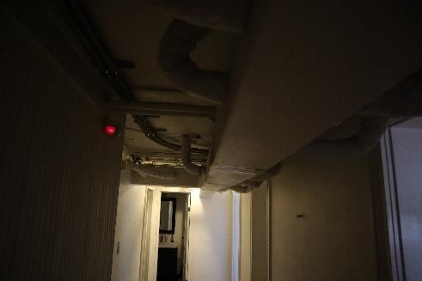  Figure 307. Alarm motion sensors | 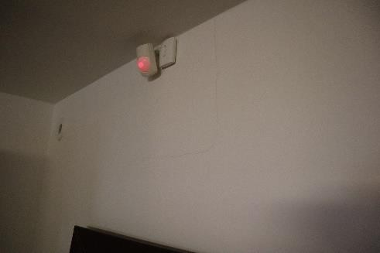  Figure 308. Alarm motion sensors |  | 25
5.11. | Low-current lines and devices |  |  |  | ---
5.11.1. list of telephony systems, centralised announcement systems, their types, and their back-up power supply | 69. Telephony, including telephone exchanges. The building has a telephone system. |  |  |  | ---
5.11.2. list of TV devices, their types, provision of back-up power supply | There are no TV devices in the building. |  |  |  | ---
5.11.3. list of computer devices, their types, provision of back-up power supply | 71. Computer system with an internal distribution network;  The computer systems are built individually in line with the needs of the building user. |  |  |  | ---
5.11.4. list of video surveillance devices, their types, provision of back-up power supply | The building has no video surveillance devices. |  |  |  | ---
5.12. | Lift equipment |  |  |  | ---
5.12.1. number and uses of lifts, their capacity and location; lift cage and the space in front of the shaft; year of construction; special features, technical condition of the electric wiring | There are no lifts in the building. |  |  |  | ---
5.13. | Other equipment and systems |  |  |  | ---
5.13.1. other equipment and  facilities | There are no other equipment or facilities in the building. |  |  |  | ---

Outdoor utilities
(Includes only those outdoor utility lines surveyed in accordance with the inspection statement of work)

Inspection site or object  name | Brief description of damage/defects found and of their causes; assessment of the technical condition of individual structural elements, types of structures and parts of the structure. Compliance with laws and regulations | Technical wear, %
1 | 2 | 3
6.1. | water supply | 35
6.1.1. Source of water supply, water quality, type of external fire water supply, system diagram, water lines, hydrants | The building is connected to the city water supply system. No failures or defects were detected.  The technical condition of the water supply system is satisfactory (wear 35%). | 35
6.2. | Sewer system | 40
6.2.1. outdoor sewer  system. Courtyard sewer network, its connection point or  outlets, local sewer treatment devices. Rainwater drainage and rainwater outlets, pipelines, local devices. Installed bathroom appliances | Household and rainwater sewer systems connected to the general municipal sewer system
(drained into the same system)
The technical condition of the sewer system is satisfactory (wear 40%).
 |  | 40
6.3. | Drainage systems | ---
6.3.1. drainage systems | The building has no drainage systems. | ---
6.4. | heating supply | ---
6.4.1. heating supply  source, heating lines,  connection location | The building is not connected to district heating. | ---
6.5. | Gas supply | 60
6.5.1. source of gas supply, layout of the gas line in the courtyard, its connection point | The building is connected to gas mains (low-pressure); gas is used for heating and hot water. The only gas consumer in the building is the gas boiler. When replacing the gas piping system and the gas boiler, the gas inlet must be connected to a higher pressure system to enable the operation of the equipment. The gas inlet is located in the street front yard. There is a noticeable smell of gas (leak) at the basement entrance. | 60
 | The technical condition of the gas supply system is unsatisfactory (wear 60%).
6.6. | lightning protection | 50
6.6.1. lightning protection | The building has a local lightning protection circuit with an outdoor lightning drainage unit on the roof (see Figures 309–310). The circuit is in direct contact with the roof of the building. No data on earthing or resistance measurements are available. Based on the use of the building and the information provided by local engineers (MEP), no new lightning protection system is required.  Lightning protection technical condition: unsatisfactory (wear 50%). | 50

 | 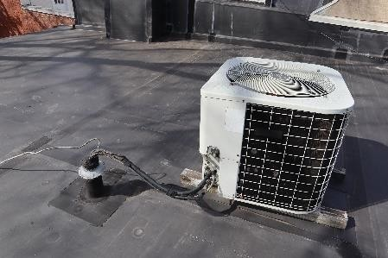  Figure 309. Outdoor unit with earthing | 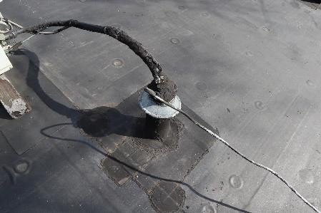  Figure 310. Earthing
6.7. | other systems |  |  | ---
6.7.1. other systems | The building has no other systems. |  |  | ---

Summary

overall visual and technical wear of the building.
Table 4

Name of structure/building part or finish | Structure element or finish share |  | Overall visual  wear  in proportion to the entire building, %
Name of structure/building part or finish | Share of structure/building part, % (e.g. Cabinet Regulation 48 of  10 January 2012, Annex 5) | Visual wear, %
1 | 2 | 3 | 4
Bases | 19 | 40 | 8
Walls | 41 | 40 | 16
Slabs | 20 | 55 | 11
Load-bearing roof structure | 10 | 40 | 4
Roofing | 10 | 40 | 4
Total | 100 |  | 43

description of the wear of the structure.

The level of deterioration of the technical parameters of the structure and related other indicators over time, as compared to a new structure, due to natural, climatic and weather factors, as well as human activity, is 43% (unsatisfactory).
The building has been in use since 1910 (110 years). The building is located in a historically significant area (Sheridan-Kalorama Historic District and Massachusetts Avenue Historic District). The building and its courtyard have objects and structures of cultural and historic value in need of careful restoration and reinforcement. The building has been reconstructed in some places and undergone various types of decorative repairs over the years, with the result that the original features of the building no longer remain.
The layout and arrangement of the building, as well as the conditions of its use, do not fully meet the requirements of modern development, and it requires a comprehensive reconstruction, taking into account the deficiencies identified during the technical inspection, as well as the requirements for the performance of its basic functions set by the owner and the users of the building .
Overall, the building does not currently meet all the requirements of Section 9 of the Construction Law, but it does meet the requirement for mechanical strength and stability. No elements of the main load-bearing structural components of the building were identified as being in a failure or pre-failure condition (with the exception of certain slab beams, certain load-bearing structural elements of the roof, and stairs 1 and 9); however, a number of signs of progressive deterioration in the main load-bearing structural components were indeed identified, which may lead too the building reaching a pre-failure or failure condition. The building has worn-out, outdated, inefficient, and uneconomic indoor utility lines, which are in need of a complete overhaul. For the future operation of the building, a construction design must be developed and appropriate construction must be carried out to enable the building to be operated in accordance with all the requirements of Section 9 of the Construction Law.
Overall visual deterioration: 43% (unsatisfactory).

conclusions and recommendations.

Conclusions:

    - The existing layout of the structure is in line with the use of the structure.
    - The foundations of the building have a history of uneven settlement, which has led to vertical cracks in the load-bearing brick masonry, and significant tilting of the floor slabs. The 2007 technical inspection by T. Cave recorded the reinforcement of the soil under the basement brick masonry in 2000–2004. The base reinforcement work involved the use of ~ 88 m³ of grout mix, retaining several metal grouting pipes in the base. See Annex 2 for the foundation reinforcement diagram and a statement issued by the building contractor.
    - The building has a concrete perimeter foundation supporting load-bearing brick walls. The thickness of the load-bearing brick external walls is ~0.32 m. It is not possible to identify the structural design of the foundations without exposing them, but given the historical construction patterns observed in the adjacent building (2306 Massachusetts Avenue, NW, Washington DC 20008), and the 2018 Geotechnical Engineering Report (by Schnabel Engineering DC, Reference No 17C41025), it is increased-thickness, multi-tier brick masonry resting on a concrete perimeter base. The concrete foundation base has an approximate depth of 0.5–0.7 m.
    - The settlement of the foundation did not progress after the reinforcement of the substructure and, based on the findings of the previous technical inspections, there are no indications of further development of the cracks. The visual inspection of the foundations of the building did not reveal any crack openings, increased deformations, or any other signs indicating a loss of bearing capacity of the foundations or base, or a rapid deterioration of their technical condition. The building’s foundations have so far been able to withstand the load.
    - Seismic activity was recorded in 2011, resulting in a tilting of brick supporting walls and fences, cracks opening and even masonry walls detaching from the main volume of the structure.
    - No horizontal or vertical waterproofing of the foundations was found at the time of the inspection. Brick masonry planes with 100% relative humidity saturation were found in some basement areas. The external planes of the brick exterior walls also showed high relative humidity levels (>60%) and salt residue, indicating poor or even no horizontal waterproofing. No moisture damage to the brickwork was found on the upper floors.
    - The load-bearing external perimeter walls are built of clay brick, with a thickness of ~32 cm (full brick dimensions ±1 cm: 20x10x6 cm). The perimeter brick walls are built up to the level of the roof structures. The internal load-bearing wall structure is constructed in the middle (longitudinally) of the basement, of clay brick ~21 cm thick. The internal load-bearing brick wall is built up to the floor level of Floor 2, supporting the basement slab and Floor 1 slab.
    - Uneven settlement of the foundation resulted in through open cracks (some even going through the entire height of the structure, see Annex 1 for crack mapping), which have not grown after reinforcement of the foundation. The settlement of the foundation also resulted in the settlement of the external load-bearing brick walls above it with a tilt to the SW and NW, resulting in changes in the level of the slab between the floors of up to 200 mm. No plane buckling or dislocations in the brick walls were found.
    - The brick masonry of the basement is saturated with capillary moisture, suggesting non-functional horizontal waterproofing.
    - As part of the technical inspection report, inspection areas were exposed at Floor 1 and 2 levels, confirming the existence of the internal load-bearing brick wall. The upper layer of the masonry wall (the bearing location of Floor 2 mezzanine slab) has unsatisfactory bonding among the bricks.
    - The structural arrangement of the middle (longitudinally) part of the building on Floors 3 and 4 is based on timber frame structures (50x100 mm base elements, ~450 mm interval). The wooden structures are constructed with an offset (eccentricity) from the centre axis of the brick masonry below. The eccentricity of Floor 2 with respect to the middle axis of the brick masonry reaches e~0.07–0.21 m.
    - The eccentricity of the load-bearing plane of Floor 3 load-bearing wall with respect to the middle axis of the brick masonry reaches e~0.7 m. The wooden load-bearing wall structures have not been treated with any protective agents (antiseptics). The load-bearing solutions of the load-bearing timber frame walls are inadequately constructed and do not ensure the symmetrical transfer of loads to the load-bearing elements below.
    - The steel lintels in the NE part of the basement are visually curved at the entrance and have insufficient support location areas. The brick vault between Floor 1 and 2 has deformed due to foundation settling. Some brick crumbling was found in the opening of the basement window facing the courtyard. No new deformations in the brick vaults were detected.
    - The building was found to have thermal insulation in the attic slab consisting of loose cellulose wool with an average thickness of 200 mm under the plank cover. It is recommended to add a thermal insulation layer in accordance with the requirements of LBN 002-19, to achieve U≤0.20 W/(m²K).
    - The building’s other external envelope structures are not insulated. It is recommended to design comprehensive measures for improving the energy efficiency of the building, taking into account the heritage status of the building and its area.
    - The basement and inter-floor slab wooden beam cross-section dimensions are: (±5 mm) 50x290 mm, with an interval of 310–420 mm, max. free span ~5 m. In some places, the beam slabs installed have double cross-section. Some beams have a cross-section of (±5 mm) 70x290 mm. Above Room 201 on Floor 2, there are two beams with a cross-section of (±5 mm) 2x75x290 mm oriented along the longitudinal axis of the building. In some places, the beam slabs installed have double cross-section. The beams above the middle load-bearing wall are tied with an overlap. The slab structures on the ceiling side of the lower floor are lined with 20 mm thick lathing with 20 mm lime mortar plaster (the ceiling is exposed in certain areas). The top of the slab is covered with a 22 mm plank floor. No sound insulation was found in the slab. The saturation of moisture in the wooden beams near the brick masonry is 15% RH. In the exposed areas in the middle load-bearing wall, the moisture content of the wood was low, at <5% RH. Overall, the condition of the beam bearings is satisfactory. Waterproofing under the wooden beams was found only in some areas.
    - Following an on-site recalculation of the load-bearing capacity of the inter-floor slab beams together with the designer of building structures, some slab beams were found not to meet the load capacity requirements, and their reinforcements must be included in the building structure part of the construction design.
    - Some wooden beams have biological damage due to moisture (on the courtyard side of the building). Water infiltrates into the interior of the building along the timber frame and contributes to the deterioration of the wood.
    - Slab beams in the basement (~4) on the inner side of the courtyard show increased vibration, indicating loose movement of the beam support locations. Slab beams between floors (~4) on the inner side of the courtyard show increased vibration, indicating loose movement of the beam support locations. Some beams were out of plane and tilted towards the longitudinal axis of the element. Local openings were made in the beams for intersections with electric lines. The attic floor space is used inexpediently as storage for household items.
    - No deformations exceeding standard values were detected in the existing wooden beams, but due to the settlement of the load-bearing walls caused by historical, uneven deformations in the foundation, the slab is tilted in the transverse direction of the building by approximately ~200 mm.
    - The attic slab is constructed of timber beams supported by load-bearing brick walls and timber frame load-bearing walls. Cross-section dimensions (±5 mm) 50x200 mm, with an interval of 310–420 mm, max. free span ~5 m. The beams above the middle load-bearing wall are tied with an overlap. The slab structures on the ceiling side of the lower floor are lined with 20 mm thick lathing with 20 mm lime mortar plaster (the ceiling is exposed in certain areas). The top of the slab is covered with a 22 mm plank floor. In the attic slab, ~200 mm thick cellulose wool thermal insulation was found. Historical water leaks were found on the attic ceiling.
    - Following an on-site recalculation of the load-bearing capacity of the attic slab beams together with the designer of building structures, some slab beams were found not to meet the load capacity requirements, and their reinforcements must be included in the building structure part of the construction design. A calculation report for the Building Structure (BS) part of the design will be prepared based on the results.
    - The spatial stability of the building is achieved via load-bearing brick masonry walls and load-bearing timber-frame walls, built with an offset from the centre axis of the load-bearing brick masonry inner wall.
    - The roof load-bearing structures consist of 50x190 mm (±5 mm) timber rafters with a 3° incline towards the courtyard of the building. The rafters are supported on brick lath and two 2x50x305 mm (±5 mm) tie beams oriented transversely relative to the building. The tie beams are supported by the brick wall and a 2x50x90 wooden post (±5 mm) covering a span of ~8.8–9.2 m. The spans of the rafters are 4.1, 3.3, and 4.1 m, respectively along the longitudinal axis of the building, forming a beam slab with fixed spans. The post support locations are offset and supported on timber-frame load-bearing walls. One supporting truss was reinforced with 2x45x265 mm wooden beams. The load-bearing structures of the roof have so far been able to withstand the current load.
    - Following an on-site recalculation of the load-bearing capacity of the load-bearing structures of the roof together with the designer of building structures, some wooden load-bearing elements were found not to meet the load capacity requirements, and their reinforcement must be included in the building structure part of the construction design.
    - The supporting units of the wooden rafters and supporting roof trusses are in a satisfactory technical condition. Historical leaks were found in the wooden load-bearing elements, caused by the previously installed metal sheet roofing and the absence of anti-condensation film, and the poor installation of the previous roofing (previously identified). The roof hatch structures were restored. A freestanding outdoor condenser is mounted on the roof structure.
    - The building has rolled-material roofing (PVC membrane) on timber lathing. Historical leaks and moisture damage were found on the lathing. Holes were found in the roofing, but no moisture damage was observed in the attic space below. No vapour barrier was found. The roof is covered in various types of patches and putty at plane junctions. A parapet of 0.83 m height is built on the street side of the building. Along the SE and NW sides of the building, there is the wall of an adjacent building, >2.23 m tall.
    - The air circulation solution in the attic space is sufficient and in good condition.
    - A steel-structure balcony is built on the side of the courtyard, with minimal corrosion damage. The wooden structures are overgrown with vegetation, soaked with moisture, and have started to rot. The balcony flooring has tilted along with the building, directing all water onto the nearby wall and wall corner, saturating the facade with moisture, leading to moisture infiltration along the timber casement of the window opening. The balcony currently cannot be used.
    - The rainwater drain in the terrace is clogged with leaves. No water leaks were found in the ceiling of the first floor.
    - The indoor staircase is built of wood with carved steps propped by trusses under the flights. Central indoor staircase 1 connects all the floors of the building with two and three-flight stairs with a half-landing. The flight trusses are constructed of beams with a cross-section of 50x290 mm. The flight trusses are attached along the edges of the steps and in the middle of the steps. At the step edges, the flight trusses have double cross-section. The half-landing structure is built using beams with a cross-section of 50x200, supported by a brick wall and functioning as a cantilever structure. The central staircase has tilted considerably and the cantilever supports have been displaced out of their original clamping positions in the load-bearing walls. No free movement was detected in the handrails.
    - Indoor staircase 2 is built of wood (see Section 4.10), historically intended to connect the basement kitchen with the first-floor dining room. Currently, one of the entrances to the stairwell is bricked up, and the stairwell is used as a utility room. The historic staircase between the first and second floors has been partially rebuilt and has no entrances.
    - Staircase 4 connects Floor 3 to the attic floor (see Section 4.10). The staircase does not comply with occupational safety and fire safety requirements.
    - Staircase 5 is made of metal, heavily corroded, with free play in the steps (see Section 4.10). The stair fastening elements are of poor quality, locally attached to external finish plates.
    - Staircases 6 and 7 (see Section 4.10) are built of stone steps, without significant defects It is recommended to install handrails for the stairs.
    - Staircase 9 is made of stone steps supported by a reinforced concrete slab (see Section 4.10). The slab shows significant crumbling in the concrete protective layer below and significant corrosion in the metal reinforcement, reducing the load-bearing capacity of the slab.
    - Some wooden partition structures were found to have rot and termite damage. In general, there are no signs of lacking load capacity or loss of stability in the partitions.
    - There is no soundproofing or step insulation under the wooden floorboards.
    - The structures filling window openings in the building not properly sealed (infiltration of air through gaps along the perimeter is noticeable). An exposed inspection area on the street facade revealed non-sealed window casement covered with exterior finish plates. Moisture infiltration and rotten jamb were found around the balcony door. As a result of the uneven settlement of the foundation, the casements of the window openings deformed with the brick walls. The basement openings facing the courtyard side have timber-frame structures lined with plywood and plastered. Infiltration of moisture and moisture damage were detected along the joint with the masonry. The frame was probably built to incorporate a rectangular window profile without preserving the historic window opening. The structures in the window openings are obsolete, are not properly sealed, and do not meet the requirements of LBN 002-19 for maximum thermal conductivity (U≤1.1 W/(m2K)).
    - The main external door of the building is a solid timber structure with a glazed section. A metal gate is installed in front of the entrance. The gate frame has corrosion damage and warping beyond its normal plane. The street-side doors to the courtyard and basement are wooden structures with no cultural historic value.
    - Inside the building, there are simple panelled doors, glazed wooden doors, and wooden doors. The door openings were significantly deformed by the uneven settlement of the foundation.
    - The exterior doors are not properly sealed and do not meet the maximum thermal conductivity requirements set in LBN 002-19 (U≤1.8 W/(m2K)). The design of the attic hatch is not fire-safe.
    - Two chimneys are built in the building. The concrete joints at the top of the chimneys were found to crumble.
    - The main structures of the building are made of brick masonry, plastered on the inside. The building has timber slabs between the floors and a load-bearing timber roof slab. The wooden slab ceilings in the building are mostly plastered (in some places, the structure is exposed or the plaster is damaged).
    - Total area of the building: 410.3 m2 (one fire zone), with the highest floor level mark <8 m. According to LBN 201-15 ‘Fire safety of structures’, the building has use type I, and according to LBN 201-15 Annex 3, it has fire resistance level U3.
    - The building does not have a fire water supply system. According to the type of use of the building and the level of fire safety, an internal fire extinguishing (sprinkler) system is not required under the laws and regulations of Latvia and the United States of America.
    - The building is equipped with a recirculation ventilation system, but it is not in use. Natural air supply to the building is through open windows and from parts of windows and doors that lack proper seal. Natural air extraction is through the chimney flues of the fireplaces.
    - Rooms were found with detached plaster or even missing wooden lathing, not meeting hygiene requirements (it is impossible to clean and disinfect the surface). The finish needs to be restored in some rooms, where indoor wood damage and moisture infiltration were detected. The locations of cracks in the openings and historic leaks require renovation of the finish.
    - Historic architectural details such as alcove ornaments, metal and wood ornaments of the main staircase, door detail ornaments, groin ceiling ornament, beam support ornaments, heating elements were found in the interiors.
    - The facade of the courtyard was plastered and painted over time, thus losing its original historic appearance. Vegetation growth and leakage stains were found on the plaster. The annex between Floors 2 and 3 is lined with wooden planks.
    - As a result of uneven settlement in the foundation, some plates of the outer facade were crushed and cracked (approximately 10–20% of the street facade). A decorative cantilever element is missing from the street facade (see Fig. 244).
    - The exterior facade has notable architectural details such as the wooden elements in the ceiling of the entrance portal, the solid wooden door, the obelisk, the lantern, the metal gate of the main entrance (corrosion damage detected), the metal window grilles (corrosion damage detected).
    - No proofing against condensation is installed on cold water pipes. Virtually all the pipes are concealed. The existing system is worn-out and outdated, although no water leaks were detected.
    - No video inspection of the pipelines has been carried out for the household sewer pipes, so it is not possible to verify the technical condition of the pipes in the ground. In the basement bathroom, a small quantity of wastewater is pushed into the adjacent sink when using the shower, indicating a possible connection that is not hermetic and insufficient diameter or incline for draining the water. The riser of the sewer system is built up to the roof of the building, but does not have a top cover element. The system is outdated and worn-out in general.
    - Rainwater drains are built on the street front side of the building and on its courtyard side. The street-side drainpipe has a lot of free play and does not ensure that rainwater is discharged into the centralised drainage system. The current drains in the courtyard are built along the edges of the building, moving the rainwater into the municipal sewer system. The rainwater drain pipes in the courtyard are built into the basement floor volume. A leaf trap was installed in the horizontal gutter in the courtyard, and not installed in the annex below it. The drains are not regularly cleaned.
    - The household wastewater and rainwater system drains into the overall system of the city.
    - The hot water system is mostly concealed and embedded into structures. The system is made of copper piping, without insulation or a recirculation system. The system is outdated and worn-out in general.
    - The building has a centralised system connected to a local natural gas boiler. The boiler is located in the basement of the building and does not have a separate air supply duct (it uses indoor air). The heat medium is water. The system’s pipelines are mostly concealed and embedded in structures. Old steel pipes without thermal insulation were found in the basement. The heating system has a low degree of automation. The boiler is inefficient, uneconomical, and obsolete.
    - The building has cast-iron heating bodies that are not fitted with thermostatic and non-return shut-off valves. An imbalance was detected in the heating system. The heating elements are installed indoors, in an open and enclosed manner. Heating elements installed in an enclosed manner do not transfer heat into the room efficiently. The heating elements have historical value.
    - The building is equipped with a recirculation ventilation system, but it is not in use. Natural air supply to the building is through open windows and from parts of windows and doors that lack proper seal. Natural air extraction is through the chimney flues of the fireplaces.
    - Forced ventilation units are located in the basement (exchanging the air in the basement and on Floor 1) and in the attic (exchanging the air of Floor 2 and Floor 3). The ducts are built in a chaotic manner. Air supply diffusers are locally embedded in the floor.
    - The building is connected to (low-pressure) gas mains; the gas is used to produce heat for heating and hot water. The gas meter is installed openly with the meter on the street facade. The gas pipes are worn out and have improper pipe fastening elements. There is a noticeable smell of gas (leak) at the basement entrance.
    - The building is connected to the municipal power supply grid: 400 A. The meter is located at the basement entrance, on the courtyard side. The electrical switchboards are located in the basement. Electricity wires were found to have been modified in some places, but mostly the historic ones remained. The electrical cables in the building are installed in a chaotic manner, going through floor slab structures. No resistance measurements are available. The building’s lighting system is not energy efficient and is worn out.
    - The building is connected to gas mains (low-pressure); gas is used for heating and hot water. The only gas consumer in the building is the gas boiler. When replacing the gas piping system and the gas boiler, the gas inlet must be connected to a higher pressure system to enable the operation of the equipment. The gas inlet is located in the street front yard.
    - The building has a local lightning protection circuit with an outdoor lightning drainage unit on the roof. The circuit is in direct contact with the roof of the building. No data on earthing or resistance measurements are available. Based on the use of the building and the information provided by local engineers (MEP), no new lightning protection system is required.
    - The courtyard of the building requires to comprehensive landscaping, renovation, reinforcement, and restoration work (see Section 3 for details).

Taking into account the location of the building (the United States of America, hereinafter referred to as the USA), its cultural and historic status, and the operational status of the building in terms of its main function as the Embassy of the Republic of Latvia in the United States of America, the technical solutions for the construction design of the building must be in accordance with the laws and regulations of the Republic of Latvia and the USA. The technical solutions must be designed to the extent that they are acceptable under USA laws and regulations, and these must get the necessary approvals by local authorities before the construction begins.
The technical inspection report has been prepared by independent construction specialists from the Republic of Latvia. The technical inspection report may be used as an input document for the construction design. The actual technical solutions for the construction design may differ from the technical inspection report due to assessments by USA construction specialists and local regulations.

Recommendations (for parts of the building):

- The building must be equipped with a vertical and horizontal layer of foundation waterproofing for the external perimeter load-bearing brick wall. A horizontal waterproofing layer must also be provided for the internal load-bearing brick wall (oriented along the longitudinal axis of the building).

- Existing cracks in the load-bearing brick walls must be milled out and filled with repair mortar or reinforced using another solution.

- Reinforce the steel lintels of the entrance door and window openings in the NE part of the basement. The brick masonry of the basement window opening facing the courtyard must be renovated.

- The internal brick wall (oriented on the longitudinal axis of the building) requires renovation of the upper brick layer (at the level of Floor 2 slab) or filling the upper section with cast reinforced concrete, preceded by the dismantling of the brick layers and the installation of temporary supports for the inter-floor slab. Waterproofing must be installed under the wooden beams.
- The load-bearing timber walls on Floor 2 and 3, as well as the load-bearing roof posts, are constructed with an offset to the brick load-bearing wall of the floor below. Rebuild the load-bearing timber wall structures with as little or no offset to the brick wall of the floor below them. When changing the structural arrangement of the load-bearing timber frame, take into account the calculations of load-bearing capacity and operability limits of the structural elements supported by it (timber load-bearing wall structure). Reinforce any appropriate structural elements as necessary.

- The load-bearing solutions of the load-bearing timber frame walls must ensure the transfer of loads to the load-bearing elements below.
- Replace the existing beams (~ 4 pcs on the SW plane of the external wall) for the basement slab and inter-floor slabs in the SW part of the building (facing the courtyard). If necessary, renovate the support points of the replaced beams. Install waterproofing under the new timber beams at the brick support locations.

- Some floor slab beams must be installed on a straight plane relative to the inter-floor slab, and it must be ensured that they are stable on the operating plane.

- When levelling the existing floor slabs in the building, in order to eliminate the tilt in the rooms (up to 200 mm), it is recommended to reinforce the existing wooden beams by installing a new wooden beam (or beams) supported on the brick and timber structures, or to provide other structural solutions to level the floor. In places where the tilting is minimal, level the cross-section of the beams by adding timber elements.

- To level the basement floor, the existing flooring must be removed, and a new levelling layer is to be laid.

- The new inter-floor slabs must be provided with sound insulation in the inter-floor slabs, and/or step insulation must be installed under the flooring.

- The composition of the inter-floor slabs must be such that there is no or very minimal load increase on the load-bearing structures (in this case, the solutions must be approved by the designer of the building structures).

- If ventilation, cooling or other units are to be placed on the supporting structures of the attic or roof, this must be approved by the designer of the building structures. The existing outdoor cooling unit on the roof must be dismantled or fastened (the current structure is free-standing).

- Remove household objects from the attic floor.

- The roofing needs to be renovated, with the dismantling of the existing roofing. The new roofing must be designed according to the slant roof (3°). A replacement of some or all lathing must be included, in line with the construction design solutions. If necessary, the installation of an anti-condensation film to drain condensate into rainwater drainpipes must be included. Build airtight joints at existing building volumes and at roof intersections.

- It is recommended to conduct a new treatment of the timber supporting structures of the roof with fire retardant and to restore or replace the internal plaster finish for the existing slabs.

- The steel structures of the balcony must undergo corrosion removal and protective paint treatment. Dismantle the wooden structures of the balcony and replace them with impregnated timber intended for outdoor use. The design of the rainwater drainage system in the balcony flooring must be such that there is no water leakage onto the corner of the building.

- The central wooden staircase (connecting all the floors of the building) must be dismantled. The new staircase must be provided with new cantilevered fastening elements in the brick masonry, and the historic architectural elements must preserved as much as possible. Use existing timber elements for the purposes of sustainable material use whenever possible.

- It is recommended to dismantle indoor Staircase 2 (see Section 4.10), i.e. the servant staircase.

- Staircase 4 (see Section 4.10) between Floor 3 and the attic floor must be dismantled and proper metal stairs must be installed.

- Dismantle Staircase 5 (see section 4.10) for the basement. Provide new steel stairs in line with the architectural style of the existing stairs.
- Staircases 6 and 7 (see Section 4.10) between the basement and the courtyard of the building are recommended to be equipped
with railings.

- The design of the attic hatch must be fire-resistant.

- Provide a new stair between the attic and the roof exit.

- The concrete slab at Staircase 9 (see Section 4.10) leading to the main entrance of the building must be reinforced or renovated. It is recommended to build a waterproofing layer under the steps.

- The damaged timber pieces in the partition walls must be dismantled and replaced with new timber pieces.

- Windows must be replaced in accordance with the LBN 002-19 requirement for maximum thermal conductivity (U≤1.1 W/(m²K)). For the basement window openings on the SW (courtyard) side, dismantle the existing frame structure and provide windows of the original opening size. Windows of cultural historic value must be restored, or new windows must be provided.

- External doors must be replaced in accordance with the LBN 002-19 requirement for maximum thermal conductivity (U≤1.8 W/(m²K)).
Doors of cultural historic value must be restored, or new doors must be provided.

- Waterproofing and vapour barrier tape must be installed on windows and doors.

- Renovate the seams of the chimneys. If the chimneys are to be operated, they need cleaning.
- Dismantle areas of moisture damage in the building (wooden structures, shelf structures). Provide new interior finish (floor, walls, ceiling) in all indoor areas of the building, according to the function of each room.

- When redecorating the indoor finish of the building, historic architectural details such as alcove ornaments, metal and wood ornaments of the main staircase, door detail ornaments, groin ceiling ornament, beam support ornaments, heating bodies must be preserved and renovated. Overall, the interior finish needs to be renovated in line to match the status of the Latvian embassy, its purpose, and to preserve the historic architectural details as much as possible.

- For the external facade in the NE part of the building (street side), conduct renovation of damaged stone plates and surface cleaning. For the courtyard facade, consider restoring the original appearance (seamed brickwork) of the facade or repainting the existing plaster.

- In the exterior facade, keep and renovate its architectural details such as the wooden elements in the ceiling of the entrance portal, the solid wooden door, the obelisk, the lantern, the terrace railing, the metal gate of the main entrance (corrosion damage detected), the metal window grilles (corrosion damage detected).

- Implement comprehensive energy efficiency improvement measures for the building envelope (taking into account the requirements of LBN 002-19), in line with the cultural and historical status of the building and the possibilities of what is technically feasible (functional). It is recommended to insulate the external walls of the building (50 mm) from the inside, with the construction of a frame.

Recommendations (for utilities):

- Dismantle the existing cold water system and build a new one with anti-condensation insulation. The system must be designed to suit the functions of the premises included in the design.

- Dismantle the existing and provide a new household sewer system with inspection hatches on each floor, adapting them to the functions of the premises included in the design. Provide a cover element for the roof outlet.

- Plan for a video inspection of the existing outdoor rainwater drainage system, with its cleaning during the construction. Plan for the replacement of the open (above-ground) rainwater system. All drainpipes must be equipped with leaf traps, which must be regularly cleaned.

- Dismantle the existing hot water system and provide a new one with recirculation and automatic control. Provide thermal insulation for hot water pipes (in utility areas).

- Dismantle the existing natural gas boiler. Provide a new high-efficiency boiler (consider a condensation boiler), with the air intake using outdoor air. The boiler must be equipped with automated control and forced circulation. The boiler should also be used to produce hot water for the building. Provide temperature sensors on the facades of the building and indoor temperature control units.

- Dismantle the existing heating system. Provide a new two-pipe system with automatic balancing valves on the risers. Pipes in the utility rooms must be insulated. The existing heating bodies must be flushed and kept in use. Install thermal valves on the heating bodies.

- Dismantle the existing forced ventilation system. Install a new forced ventilation system with a heat recovery function and automated control.

- Dismantle the existing cooling system. Provide a new cooling system with automated control and indoor temperature control units. The location of the outdoor cooling units must be approved by the architect (if they are to be installed on load-bearing structures, this must also be approved by the building structure engineer).

- Dismantle the existing power supply lines and lighting. Install a new power supply system in line with the functions of the premises included in the design. Replace the lighting with LED lights as appropriate for the premises included in the design.

- Immediately call the emergency services and repair the gas leak at the main entrance. Dismantle the existing gas pipe system and build a new one. The building must be provided with a new gas pipe with a higher working pressure to enable the operation of the new boiler plant.

- The utility systems must be equipped with a BMS system.

Recommendations (for grounds improvements):

- In the courtyard of the building, clean the surfacing of the walkways, conduct local repairs (and, if necessary, replace the plates). Keep the concrete surface in the courtyard of the building.

- The metal elements of the brick garden awning in the courtyard need renovation or replacement. The vertical supports of the awning need to be removed and restored to their original appearance. The vertical brick structures need to undergo surface restoration or complete renovation.

- The decorative elements of the metal structures of the courtyard of the building need renovation or replacement.

- Two sculptures are on display in the courtyard. Elements of the sculptures have local damage, with a need for treating the surface and conducting careful restoration. There is a fountain embedded into the brick wall on the NE side of the adjacent plots, not used for a long time, and it is recommended to renovate it in the long run.

- The courtyard greenery and improvements require regular maintenance.

- The fencing of the courtyard of the building has mostly lost its vertical orientation and is tilting. Some volumes have become detached from the main volume. Completely dismantle and restore the elements to their original condition or reinforce the existing structures.

- The perimeter wall at the outdoor canopy is tilting towards the adjacent plot (Turkish embassy side) and needs to be reinforced (only possible from the Turkish embassy side).

- The tilting supporting walls in the courtyard of the building need to be dismantled and restored to their original condition. The bricks around the existing large tree need to be dismantled.

Future operation of the building:

- Consider the possibility of regular geodetic monitoring of the slope during the future operation of the building.

- Regularly maintain the building grounds improvements and greenery in the front yard and the courtyard. Regularly visually inspect the rainwater system, clean it as necessary.

- Immediately call the emergency services and repair the gas leak at the main entrance.

- Do not operate the balcony facing the courtyard of the building.

The technical inspection was carried out on 17–25 February 2020.
Documents enclosed with the inspection report: Annex 1 — Mapping of cracks;
Annex 2 — Foundation reinforcement diagram provided in the building contractor statement
Annex 3 — List of codes for individual parts (structural elements) and utility systems of buildings (structures) to be included in the technical inspection report of the building (structure)

EDGARS STURMOVIČS, cert. No 4-03199; 5-02273; 20-7801
(contractor signature (name, surname, certificate number)) MĀRTIŅŠ PĒTERSONS (licensed construction engineer) (contractor signature (name, surname))
EDGARS STURMOVIČS
(name, surname, and signature of the head of the legal entity)



Reg. No 40103680902, Duntes iela 28-3, Riga. LV-1005 Construction merchant reg. No 11096-R
Phone: +371 26451630
info@jaunriga-eco.lv

ANNEX 1.

Mapping of cracks

Residential building, 2304 Massachusetts Avenue, NW, Washington, DC 20008, United States of America, cadastral No 20008 2810

Riga, 2020

No 1.

No 2.

No 5.
No 4.
No 7.
No 3.
No 6.

No 8.

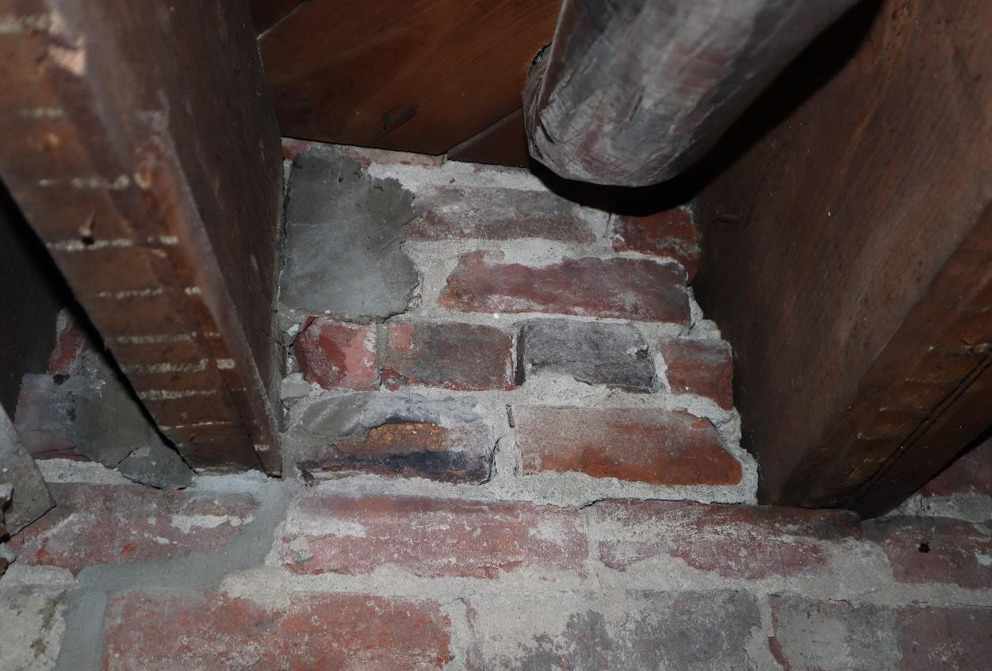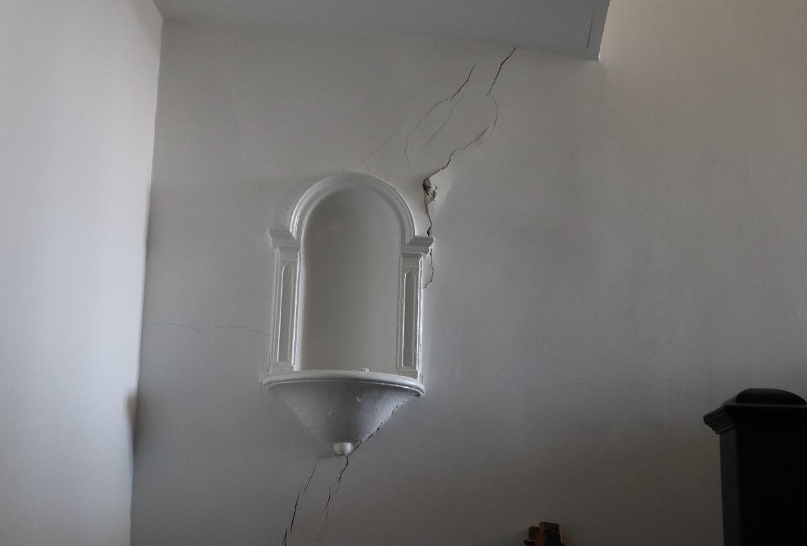Photographic records of crack openings

  - figure. Crack 1.

  - figure. Crack 2.

  - 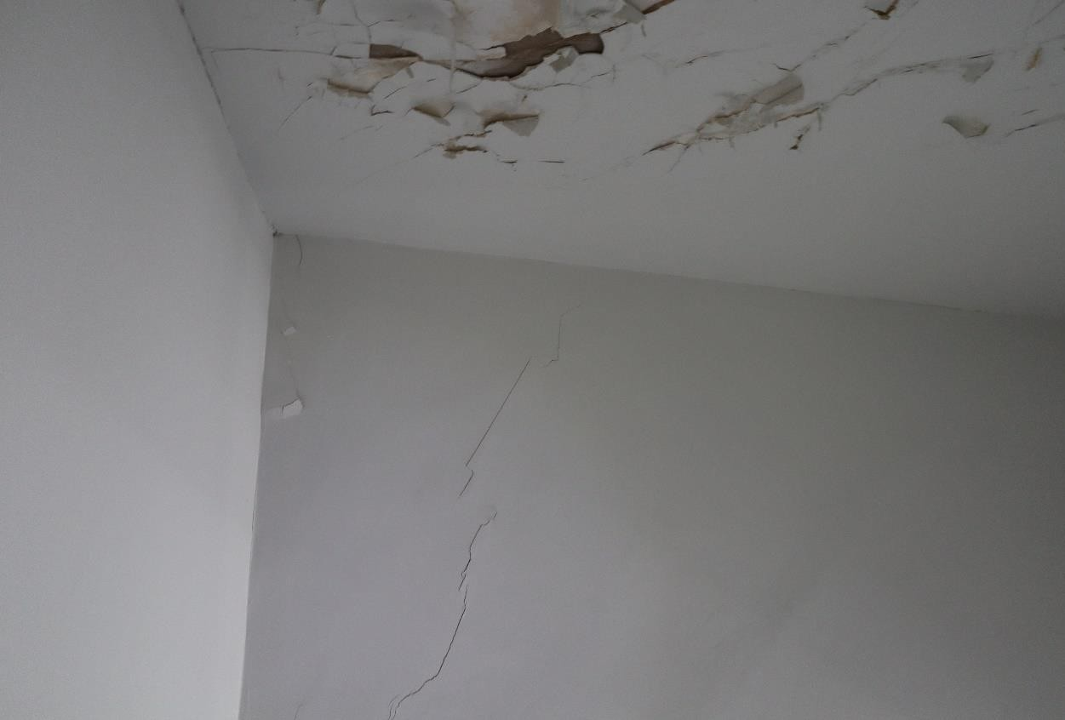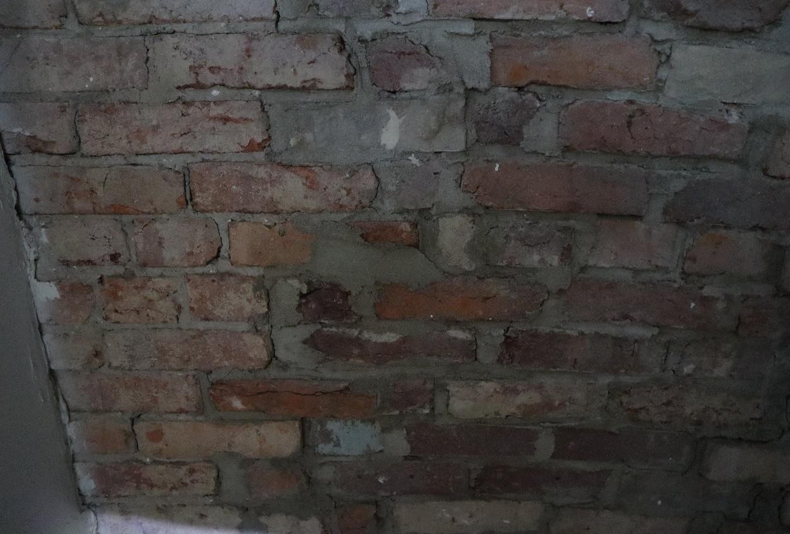figure. Crack 3.

  - figure. Crack 4.

  - 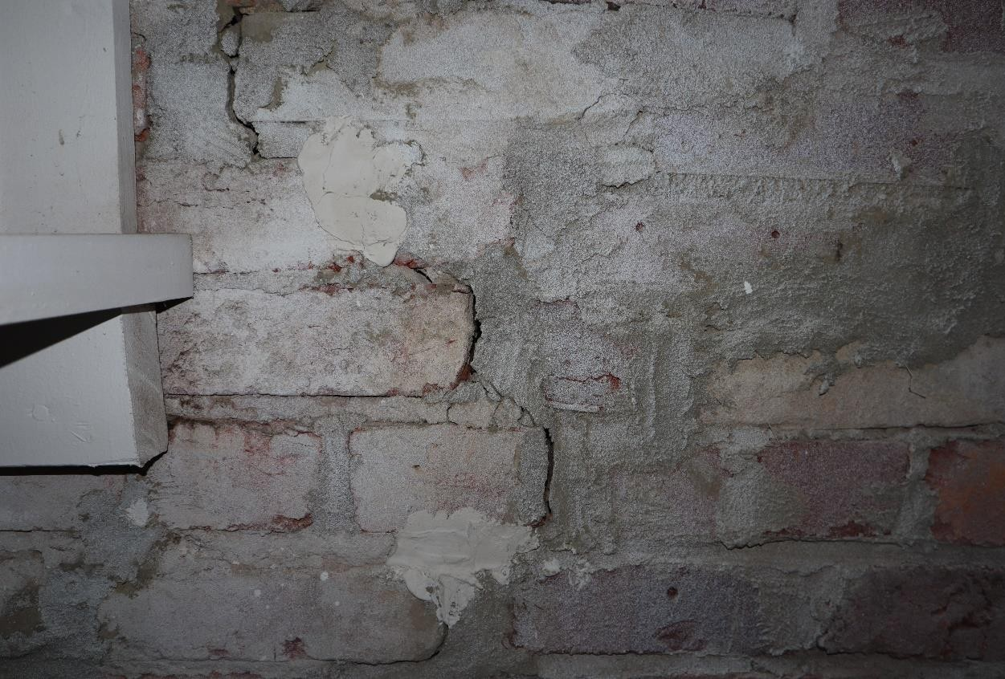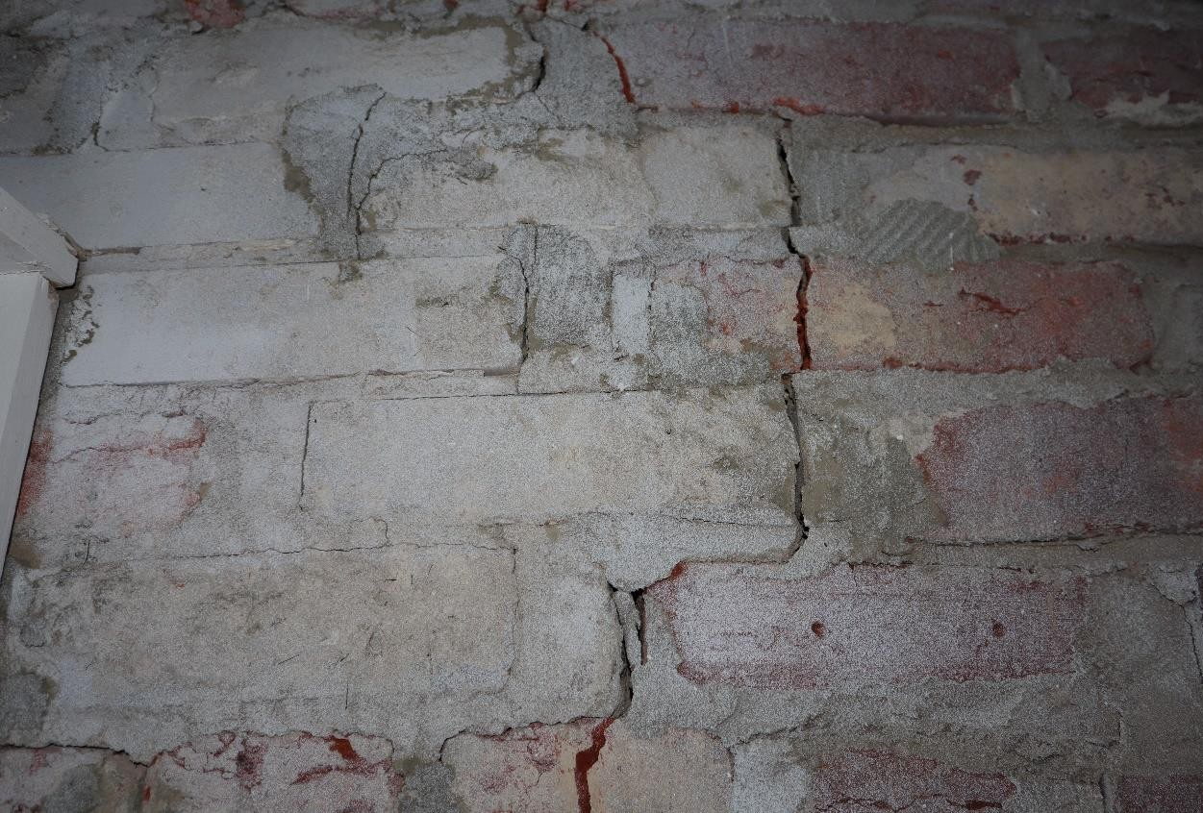figure. Crack 4.

  - figure. Crack 4.

  - 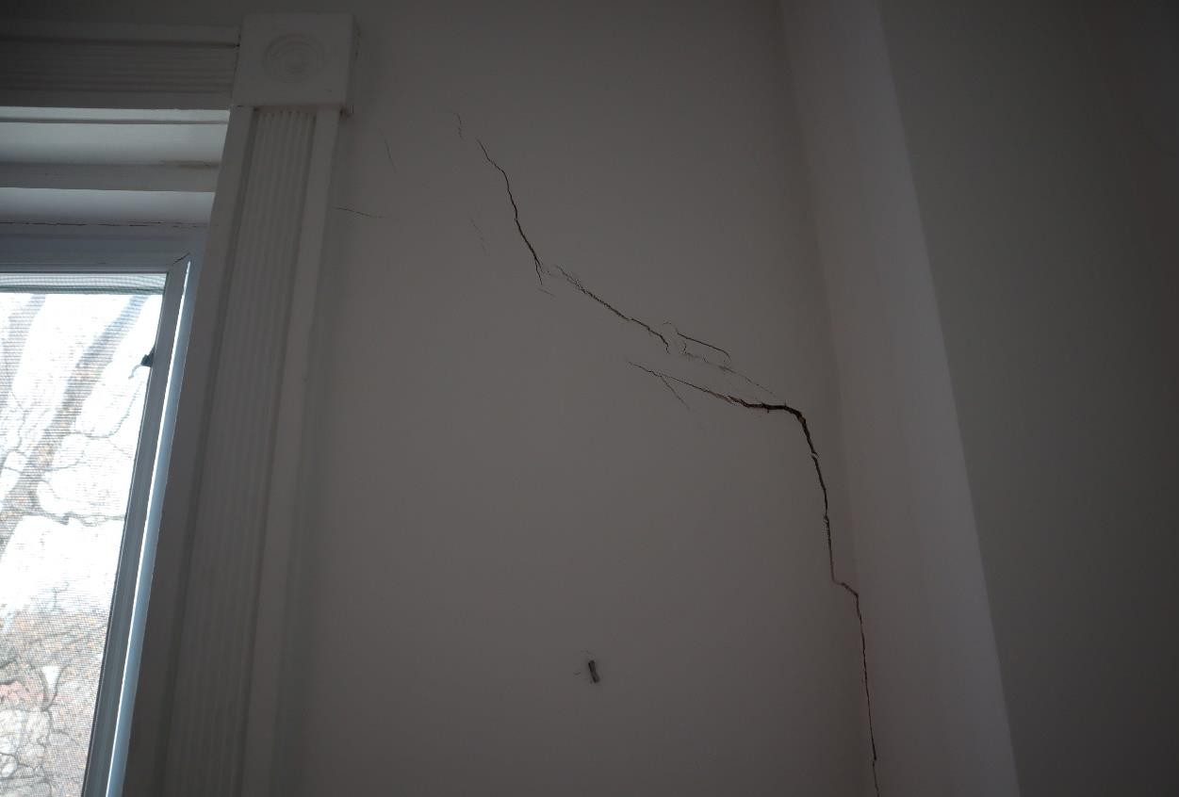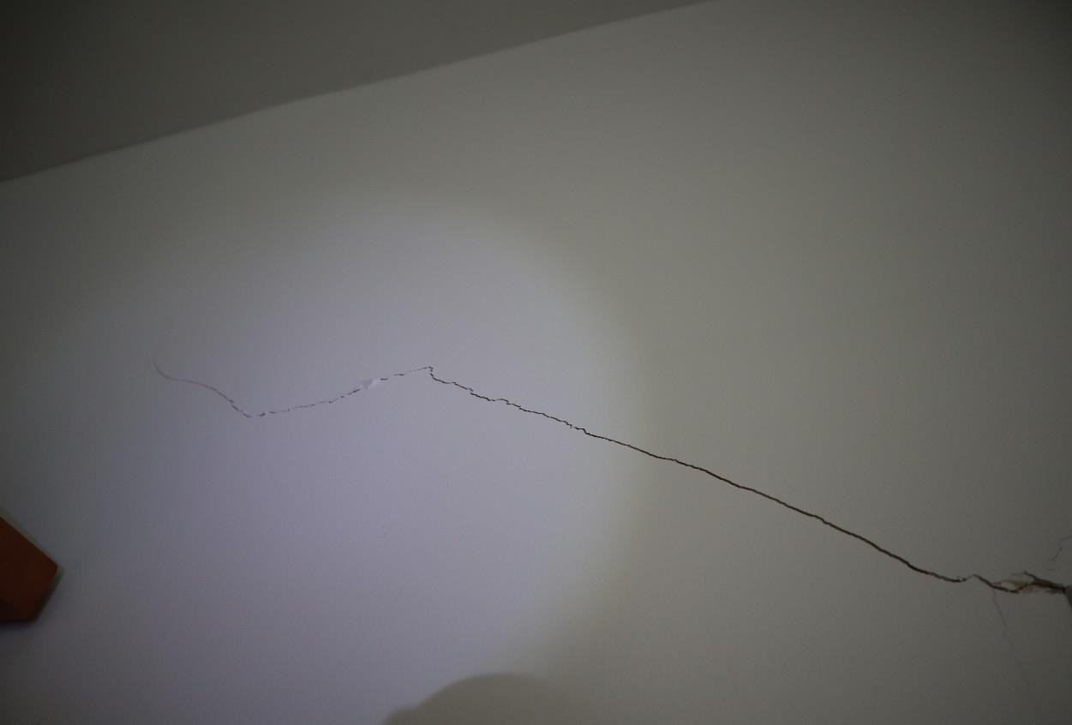figure. Crack 5.

  - figure. Crack 6.

  - 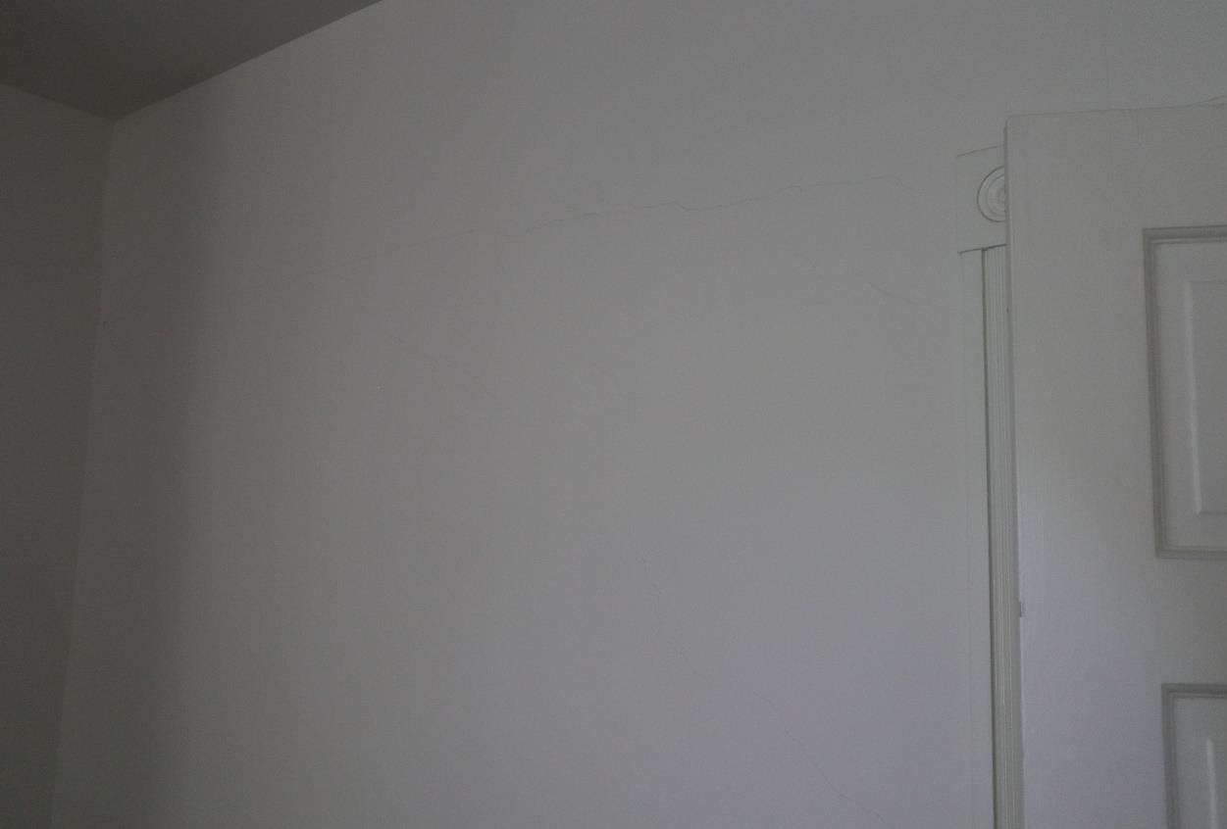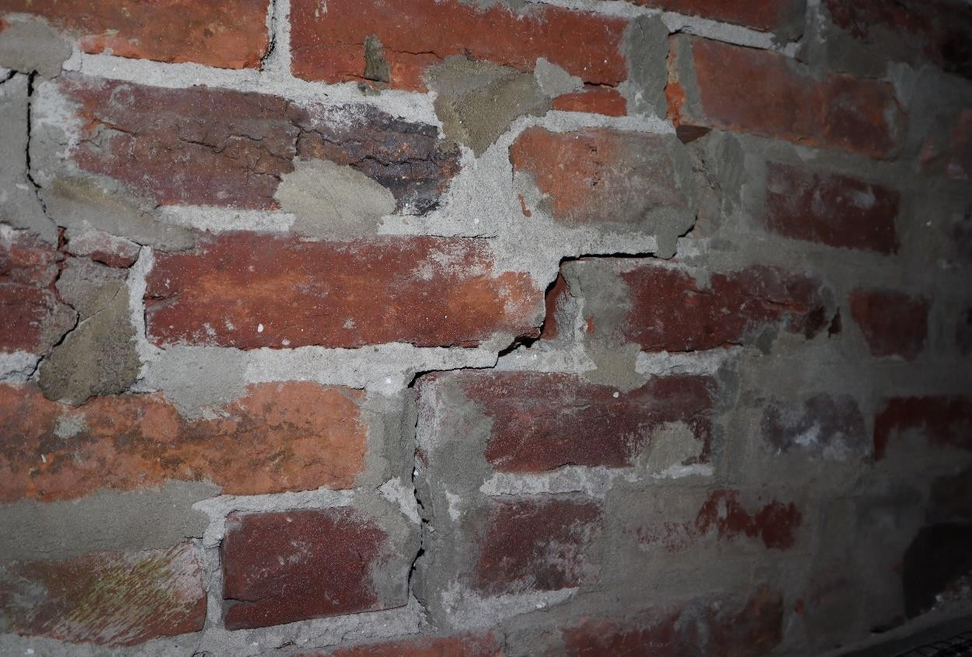figure. Crack 7.

  - figure. Crack 8.

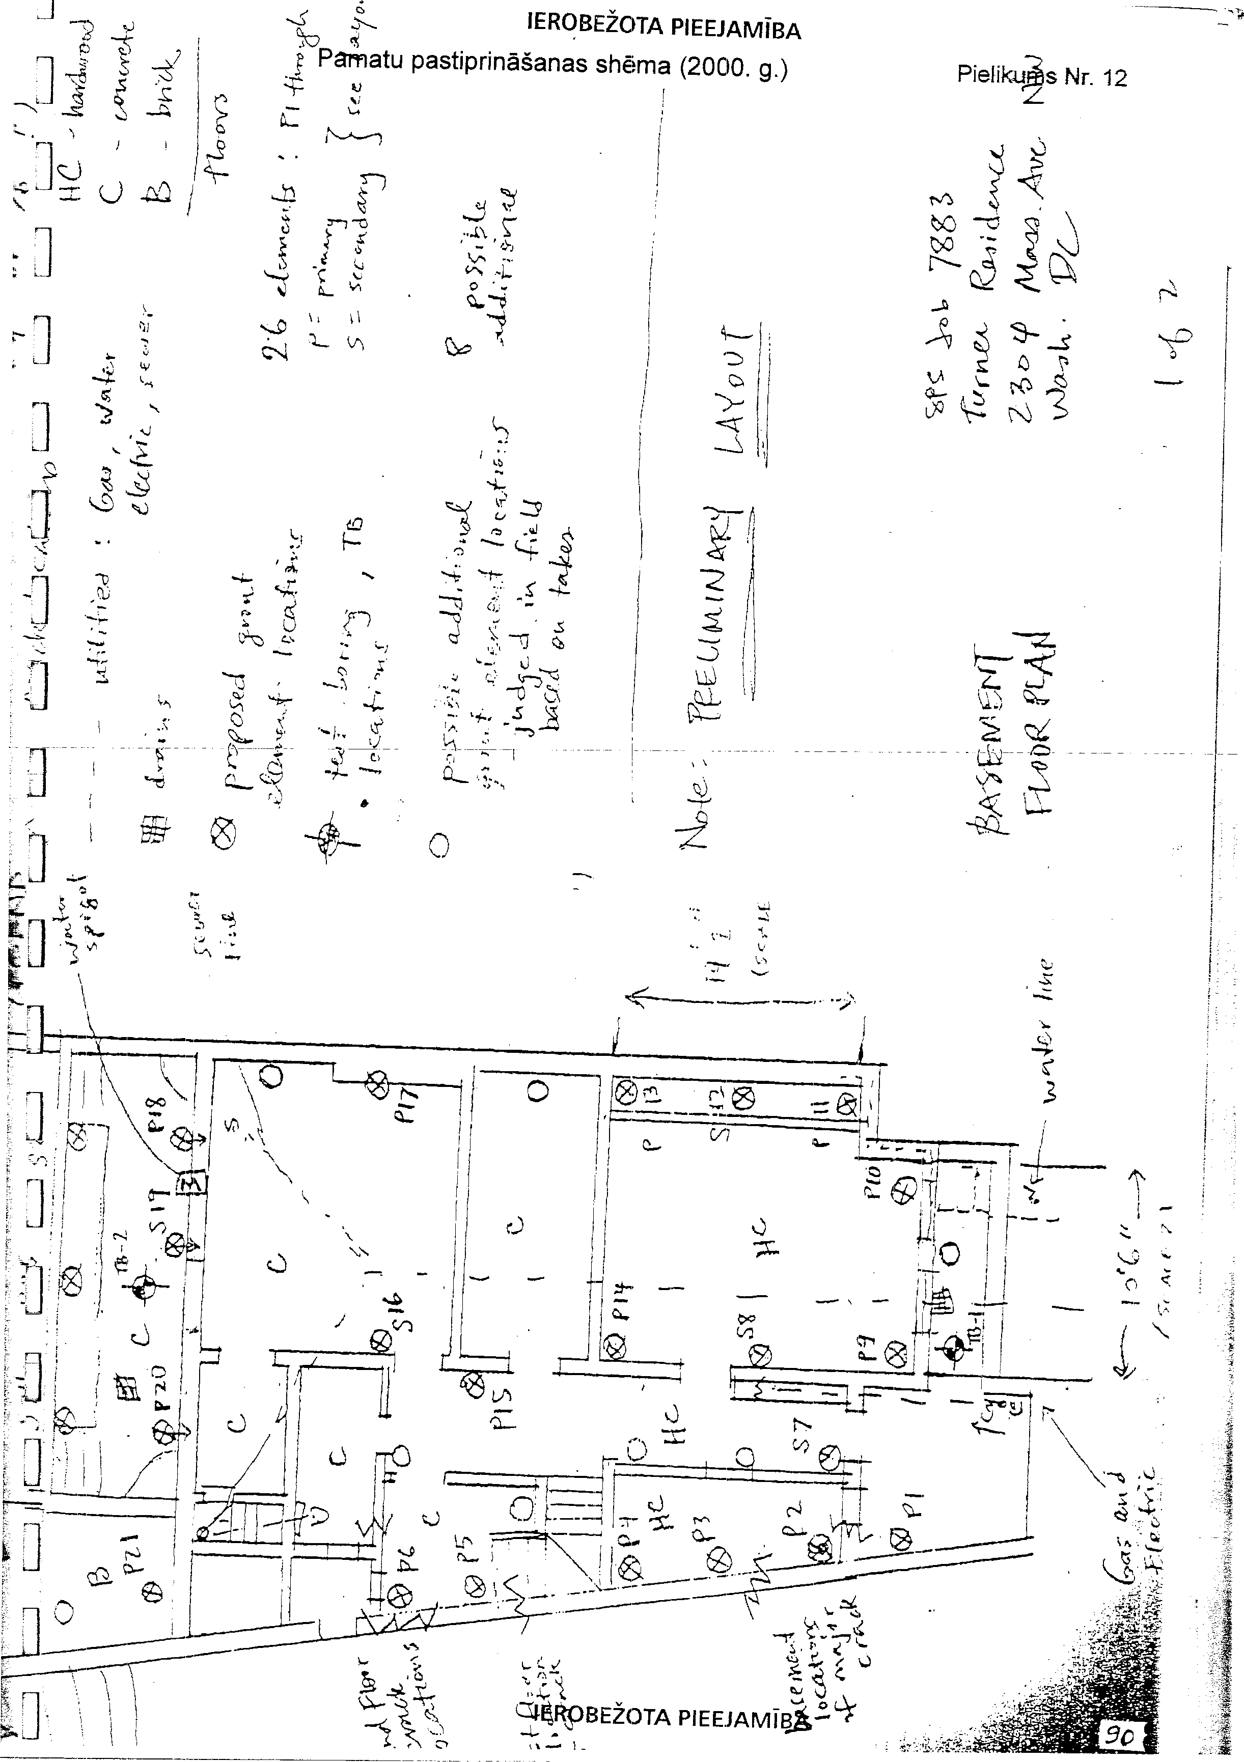

RESTRICTED ACCESS
STRUCTURAL PRESERVATION SYSTEMS, INC /Seal: Annex 13/
GeoStructural Division
Mr Richard Turner
2034 Massachusetts AY NW
Washington, DC 20008
SPS. On behalf of INC, I would like to thank you for the opportunity to perform the compaction grouting work at 2304 Massachusetts Avenue, Washington DC. The following is a final report and summary of operations for the project.
The grouting program explained in SPS Proposal No 20001113041 illustrates the methodology used for this project. As described in the proposal, Schnabel Engineering Associates performed soil sampling tests on-site to determine subsurface conditions. A Geotechnical Engineering Report containing these data was provided to you dated 10 January 2000. It was determined from this investigation that the depth of the overlying fill material was deeper than originally anticipated based upon available information. Specifically, the fill was found to extend down to 29.5 ft (8.99 m) versus the 8 to 10 ft ( 2.74–3.05 m) original estimates. As we discussed at the time, due to the limited financial resources, it was agreed that the compaction grouting program should proceed as submitted. Thus approach to arresting the structure's immediate settlement problems provides a higher chance for success at the least possible cost.
The final scope of work for the project included driving and grouting 28 compaction grout elements. The elements were located around the perimeter footings of the building, along the central foundation wall, outside the structure where future work is anticipated, and in areas of severe stress and cracking within the building. A plan-view schematic drawing of the compaction grout element layout and their relative grout volumes is included in this report. Additionally, a summary of die driven depths and grout volumes for each compaction grout element has been enclosed for your reference.
Twenty-eight (28) injection casing elements were driven to refusal. Fifteen elements were driven into the underlying fill to a depth of 10 feet ( 3.05 m) or less. All but one reached depths of 8 to 12 feet ( 2.74 to 3./illegible/ m). This depth appears to correlate with a higher-density layer shown in the borings done by Schnabel Engineering. The remaining 13 elements encountered less resistance and were driven deeper into the fill material. In fact, 3 elements reached a depth of 15 to 16 feet ( 4.5 to 4.88 m). The average depth of the elements was 11 feet ( 3.35 m). Total linear footage of driven casing was 308 LF (93.9 m), or 110 % of the base bid amount of 280 LF ( 85.3 m). Generally, this part of the project was more difficult than anticipated due the numerous obstructions within the variable fill material below the structure.
Twenty-seven of the 28 elements were grouted to refusal. The refusal was determined according to one of the following criteria: Refusal was defined by one of the following criteria: 1/8- inch (3.2 mm) ground heave, pressure exceeding 10 psi per foot of depth (2.25 bar/m) (adjusted for backpressure), or refusal of grout (i.c. ground pressure exceeds annular pipe pressure). Due to the variable nature in soil behaviour, a grout volume cut-off criterion was used only in a few instances In some locations, very weak zones within the fill required a substantial volume of grout to achieve refusal, others, less volume. In other words, the pressurized grout went where it needed to go. The easiest way to understand the results of the grouting operation is to look at the schematic drawing mentioned earlier. The grout takes in each hole can be categorized as such (an incrementally larger circle represents each category): From 0 to 5 cubic feet (CF) ( 0.14 m3): 5 elements; 5 to 10 CF ( 0.14 –0.28 m3): 7 elements; 10 to 15 CF ( 0.28–0.42 m3): 3 elements; 15 to 20 CF ( 0.43– 0.56 m3): 5 elements; 20 to 25 CF ( 0.56–0.7 m3): 3 elements; 25 to 50 CF ( 0.7–1.4 m3): 1 element; 50 to 100 CF ( 1.4–2.8 m3): 3 elements; more than 100 CF ( 2.8 m3): 1 element. The total volume of grout utilized for the project was 628.75 CF, or 124% of the base bid amount of 500 CF. The average volume of grout per element was 22.45 CF, which represents an average volume replacement per linear foot of over 40 times the original volume of the hole. It should be noted that even under these conditions, extreme care was exercised to not over-pressurize the holes and create excessive heave within the structure. Generally, this phase of the project ran smoothly, with each compaction grout element exhibiting normal behaviour. Isolated elements posed a bit of a challenge to the crewmembers, and some steel injection pipes were grouted in place to act as additional support in this case. Grout logs for these and all elements are included in this report for your reference.
In summary, SPS feels that along with achieving the limited technical goals of the project, we have more than fulfilled the scope of work described in our proposal. As we have discussed in length, there may be additional settlement of the building in the future due to a deeper problem than what we were able to address at this time within the structure of this contract. For your files, I have included a letter from Schnabel Engineering Associates attesting to the as-built conditions of the site and the methodology of our grouting operations. As mentioned in the letter, if future settlement occurs, please contact our office so that we can consider and discuss additional and alternative remediation methods.
Thank you for your availability for the final walk-through of the site with SPS crewmembers after our most recent site visit. You subsequently confirmed with us that you are satisfied with the clean-up phase of the project. This final report represents the last portion of work that remains for completion of the project. Therefore, upon receipt of this report, our work shall be considered complete. As per our contract conditions, please submit the outstanding portion of your balance as soon as possible. SPS invoice 7883-02 in the full and final amount $21,167.00 is attached to this report for payment. Thank you for your patronage. If I can be of any further assistance, please do not hesitate to contact me.
Steven J. Van Dorpe, Project Manager Translated by T. Cave
p.s Drilling results (at a depth of, from basement floor level):
3 ft. (0.9 m) — sandy lean clay, backfilled, water-saturated, filled with pieces of concrete and brick, brown;
5 ft. (1.5 m) — silty sand, backfilled, fine gravel, water-saturated, reddish-brown, grey;
10 ft. (3.0 m) — sandy lean clay, possibly backfilled, water-saturated, soft, brownish;
30 ft. (9.1 m) — sand with gravel, water-saturated, brown.

RESTRICTED ACCESS

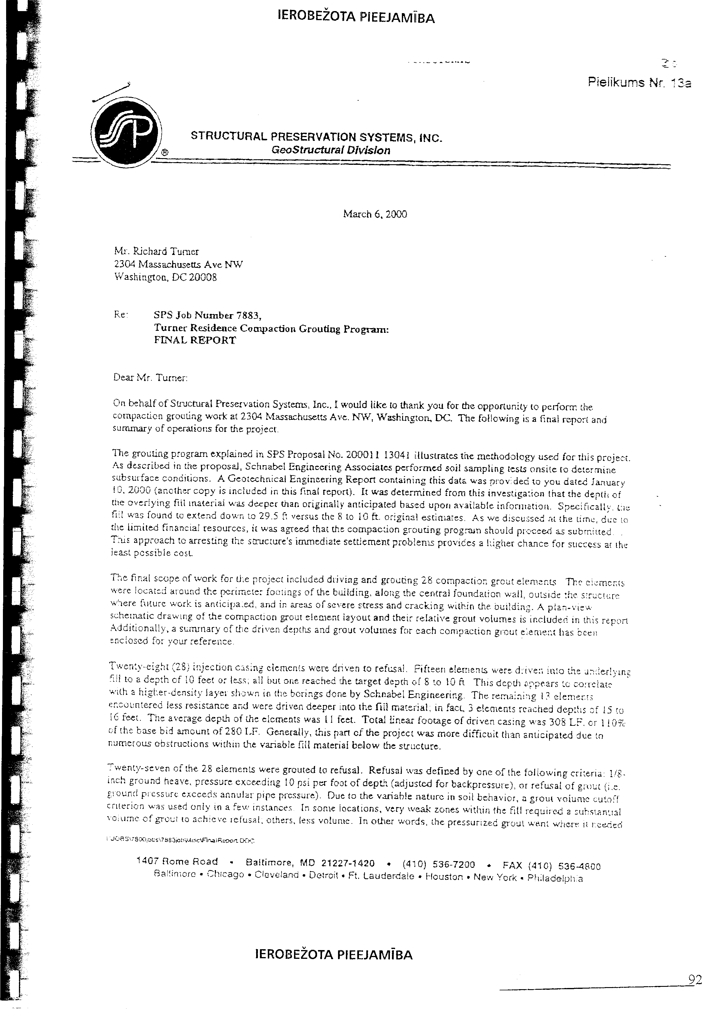

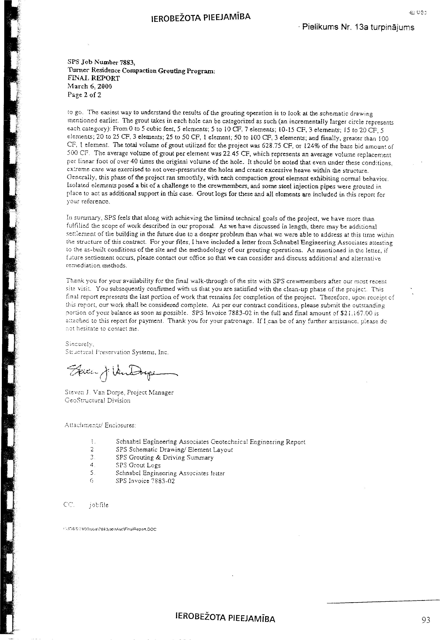

Annex 3
1

List of codes for individual parts (structural elements) and utility systems of buildings (structures) to be included in the technical inspection report of the building (structure)

Structure  code | Part or structural element of the building (structure)
I | Foundations for external load-bearing walls
C.1 | Cast concrete, natural stone, and brickwork perimeter foundations
I-1 | Foundations for internal load-bearing walls
C.1b | Cast concrete, natural stone, and brickwork perimeter foundations
II | Load-bearing external walls, columns, poles, posts
C.5 | Brick walls
II-1 | Load-bearing interior walls, columns, poles, posts
C.5b | Load-bearing interior brick walls
C.11b | Timber-frame (pile) walls
III | Basement slabs
C.19 | Non-plastered timber beam slabs
C.20 | Plastered timber beam slabs
III-1 | Slabs between floors and in the attic
C.19b | Non-plastered timber beam slabs
C.20b | Plastered timber beam slabs
III-2 | Balconies, loggias, porches, canopies
C.17 | Balconies, porches, and canopies
C.18 | Loggias, bay windows, avant-corps, and awnings
IV | Roof structures
C.25 | Wooden roofs (load-bearing structure)
IV-1 | Roof coverings
C.28 | Rolled-material surfaces
V | Stairs
C.34 | Wooden stairs
C.34a | Metal stairs
VI | Partition walls
C.38 | Brick partitions
C.39 | Non-plastered timber partitions
C.40 | Plastered timber partitions
VII | Floors
C.42 | Sand-cement, concrete screed floors
C.43 | Ceramic tile floors
C.45 | Wooden plank floors
C.47 | Soft rolled-material flooring
VIII | Structures filling window and balcony door openings
C.49 | Window and balcony door units, timber
C.49b | Filling of openings with glass tiles
C.50a | Window and balcony door units, plastic
VIII-1 | Structures filling doors and gate openings
C.51 | Wooden doors
C.51a | Glazed and glass doors
C.52 | Metal doors
C.52a | Metal gates
IX | Stationary heating devices
C.53 | Stoves, fireplaces, chimneys
X | Interior finish
C.54 | Water-based paint
C.55a | Emulsion paints
C.57 | Ceramic tiles
C.57b | Seamed brick masonry
C.58 | Plaster

C.58a | Plasterboard and other finish panels
C.59 | Top finish of walls and ceilings with boards and other timber materials
XI | Exterior finish
C.57b-f | Seamed brick masonry
C.58-f | Plaster
C.58bf | Stone chippings and other mineral-based finishes
C.59f | Top finish of walls with boards and other timber materials
XII-1 | Cold water supply
C.60 | Cold water supply
XII-3 | Hot water supply
C.61 | Hot water supply
XII-4 | Sewer and rainwater drains
C.62 | Household and industrial wastewater sewer
C.62a | Rainwater drains and rainwater sewer
XII-5 | Centralised heating (heating supply)
C.63a | Centralised heating from a local heat source
C.63b | Centralised heating bodies
XII | Electrical equipment and lines
C.64 | Electrical equipment
C.64a | Electrical lines
 | In addition to LVS 412
XIII-1 | Ventilation
66 | Natural ventilation
66a | Forced ventilation
XIII-2 | Gas supply
67 | Gas supply: external mains gas supply;
XIII-3 | Security alarm system
68 | Security alarm system
XII-5 | Telephony
69 | Telephony, including telephone exchanges
XIII-7 | Computer networks
71 | Computer system with an internal distribution network
XIV | Grounds improvements: fences
74 | Fences
XIV-1 | Grounds improvements: roads and open areas
75 | Walkways, roads, and surfaced areas
75a | Playgrounds, recreation and sports grounds
XIV-2 | Grounds improvements: greenery, small architectural forms
76 | Greenery
76a | Small architectural forms
XV | Signs of unauthorised construction
78 | No signs of unauthorised construction

2

