EMPLOYER’S INFORMATION REQUIREMENTS (EIR)
Version 1.0
SJSC "RIGA INTERNATIONAL
AIRPORT"

Contents
Contents
1. Introduction 3
1.1. Purpose and application 3
1.2. References and standards 4
1.3. used in manual 4
2. Business requirements 5
2.1. Competence of the supplier 5
2.2. Control points and expected results 6
2.3. BIM deliverables 10
2.4. Application of BIM during management 10
3. Information exchange requirements 11
3.1. Roles and responsibilities 11
3.2. BIM Execution Plan 16
3.2.1. Pre-Contract BIM Execution Plan 17
3.2.2. Post-Contract BIM Execution Plan 17
3.3. Workflow during design work 18
3.4. BIM process during construction works 20
3.4.1. Exchange of information using the "design and build" principle 21
3.5. Common Data Environment 23
3.5.1. Requirements for a Common Data Environment 24
3.5.2. Shared-cycle Common Data Environment 25
3.6. Collaborative process 28
3.6.1. Client's participation in BIM meetings 29
3.7. Coordination and quality control 29
3.7.1 Types of verification 30
3.7.2. Coordination and scheduling of collision checks 31
3.7.3. Collision detection matrix 33
3.8. Construction supervision 33
4. Technical requirements 34
4.1. Software 34
4.1.1. Software for creating 2D drawings 34
4.2. Computer support 35
4.3. Data exchange formats 36
4.3.1. Original format files 37
4.4. Generating file names 37
4.5. Model development 38
4.5.1. Level of detail 38
4.5.2. The level of graphic detail 38
4.5.3. Level of information detail 41
4.5.4. Coordinates 44
4.5.5. Classification 44
4.5.6. Modeling 45
4.5.7. Unique identification number 47
4.5.8. The connected model 48
4.6. Analyses and simulations 48
4.6.1. 4D simulation 48
4.6.2. 4.5.3. 4D recovery and status management: 50
4.6.3. Constructability analysis 50
4.6.4. Analysis of environmental availability 51
4.6.5. Other simulations 52
4.7. Laser scanning and photogrammetry 53
4.7.1. Photogrammetry 53
4.7.2. General instructions 54
4.7.3. Instructions on how the supplier should carry out laser scanning: 54
4.8. Visual aids 55
4.8.1. Visualizations 55
4.8.2. Virtual reality 56
4.9. 2D documentation 57
4.10. Sample models for maintenance phase 57
4.11. As-build model 58
4.12. Asset Information Model 59
5. Annexes: 60

Introduction

Purpose and application
The document is designed to set out clear and understandable conditions and processes for the commissioning, development and delivery of BIM within a real estate development project, including requirements for quality, capacity and information exchange.
These Client Information Requirements are intended for use as part of the design and construction process and take the approach that the design team that created the BIM retains responsibility for updating and updating the BIM during the construction phase. Accordingly, BIM requirements can be used both in the context of a combined design-build contract (design-build), with the Client's Information Requirements applying to the designer and the builder, and, if necessary, the Client's Information Requirements can also be used only in the design stage.
BIM requirements are to be used as Client Information Requirements (including information exchange requirements) in the context of BIM and are to be included in procurement contracts as an annex. BIM requirements do not replace the technical specifications of the specific service but serve as a part of the work assignment.
The BIM requirements specify the conditions for information exchange and collaboration processes, as well as the technical requirements for BIM deliverables. At the same time, BIM requirements do not exclude the need to develop and coordinate construction planning documents in accordance with the requirements of regulatory acts.
BIM requirements are adaptable to the needs and specifics of a given project. The use of all or part of the BIM requirement documents remains at the discretion of the Client. For ease of use, a Project Specific Requirements Template (Annex No. 6) is attached to the Requirements Annex, which can be used to define project-specific BIM deliverables, timelines and other conditions.
BIM will be used in the management of Riga Airport to create detailed building models and improve efficiency, safety and sustainability. It will help to plan projects, coordinate construction, maintain up-to-date information and create safety plans.
To improve quality and ensure that all BIM requirements are met as requested by the Client, the construction supervisor has undertaken to provide verification that the Supplier meets all Client Information Requirements as agreed by both parties following the contract BIP.

References and standards
LVS EN ISO 19650-1:2019 "Information on buildings and engineering works
organization and digitization, including building information modeling (BIM).
Information management using building information modeling. Part 1:
Concepts and principles"
▪ LVS EN ISO 19650-2:2019 "Information on buildings and engineering works
organization and digitization, including building information modeling (BIM).
Information management using building information modeling. Part 2: Asset
delivery stage"
▪ LVS 1052:2018 "Building information modeling (BIM) terminology"
▪ BS 1192:2007 “Collaborative production of architectural, engineering and construction
information – Code of practice”
▪ BSI PAS 1192-2:2013 “Specification for information management for the
capital/delivery phase of construction designs using building information modelling”
▪ BSI PAS 91:2010 “Construction related procurement. Prequalification questionnaires”
▪ BIM Forum “Level of Development Specification" 2021
▪ COBIM 2012 "Common BIM Requirements" terms and abbreviations

Terms and abbreviations used
Client Information Requirements – Building Information Modeling Requirements, this document.
Client – the client specified in the specific procurement tender and procurement contract.
Supplier – the applicant specified in a specific procurement proposal or the contractor specified in a specific procurement contract.
Project – the client's real estate development project in the planning or implementation phase.
CDE – Common Data Environment.
EIR – Employer’s Information Requirements.
BIM – Building Information Modelling
LOD – Level of Detail
LoI – Level of Information
LoG – Level of Geometry (level of geometric detail)
RIX – SJSC Riga International Airport
AIR – Asset Information Requirements
BEP – BIM Execution Plan
Note: this document does not decipher the terms used in accordance with the standard LVS 1052:2018

Business requirements

Competence of the supplier
The client must be sure of the supplier's ability to implement the project in a BIM environment and meet BIM requirements. The evaluation of the supplier's competence is carried out during the procurement procedure.
The supplier's ability to deliver a BIM project is demonstrated by the level of knowledge and skills, previous experience, information technology and staff resources.
In order to verify the supplier's compliance with BIM requirements, during the procurement procedure, the Client may request to submit the following materials:

Materials to be submitted
Name | Objective
Sample models | Demonstrates the supplier's ability to meet the Client's technical requirements in a real and tangible way.
Responsibility matrix | In Annex No. 8, the responsible person and LOD are added to each discipline.
BIM specialist CV and supporting documents | Provides information on the CV of a BIM specialist, basic BIM certificates, education, experience and documents certifying this experience.
Pre-Contract BIM Execution Plan | Ensures that the requirements of the Client are known and that the Client agrees to perform a specific service to the full extent, to the quality and within the time limits specified.  Provides information on the supplier's approach to delivering the project in a BIM environment (including resources and methods).

Control points and expected results
The control points and expected results are specified to clearly define the conditions that lead to the approval of the current BIM handover and the transition to the next phase of BIM development.
Deadlines for control points are determined individually using the Project's special requirements template.
The following BIM control points and expected results are planned within the project:

Project stage | Control point | Expected result
Project planning | N/A | N/A
Research | N/A or  Conceptual BIM | - Models (and other deliverables, if applicable) are fully developed, tested and  approved by the Client.  - The included solutions are coordinated with the user of the building.
Design (DSG) | Conceptual BIM | - Models (and other deliverables, if applicable)  are designed to the level of detail specified in the project  specific requirements template, checked and approved by the Client.  - Construction design in minimum form developed and agreed with Client, building user  and the construction board.  - Building permit with conditions received.
Design (DSG) | Interim BIM | - BIM models are developed to the level of detail specified  in the project specific requirements template, checked and approved by the Client.  - No collisions are found in the matched model that are not listed as collisions  in the report.
Design (DSG) | Detailed BIM | - BIM development is complete.  - Models (and other deliverables, if applicable) are fully developed, tested and  approved by the Client.

- Specifications of material volumes read from BIM models have been submitted
- The construction design is coordinated with the user of the building.
- The construction design is ready for submission for expertise.
 | Approved BIM | - Specified models (and other deliverables, if applicable) have been tested and approved  by the Client.  - Specifications of material volumes read from BIM models have been submitted  - A positive expert opinion has been received.  - The construction design is coordinated with the user of the building and Client.  - The construction design has been coordinated with the construction board.
Construction (CON) | BIM renewal (changes and deviations from the construction design):  permanently | - Models (and other deliverables, if applicable) with changes during construction works and/or  Deviations from the construction design have been fully developed, checked and approved by the Client.*  - Changes, incl. changes in the scope of construction works, is approved in accordance with  the procedures laid down in the procurement contract (i.e. legally approved, e.g. by signing the relevant deed of variation or contractual agreement). **
Construction (CON) | Supplementing BIM (information about equipment and elements):  within 10 days after receiving the information | - The models have been supplemented with information obtained during the construction works after  assembly of equipment/elements, checked and approved by the Client.

As-built (ASB) | As-built model | - Models (and other deliverables, if applicable) are fully developed, tested and approved by the Client.  - The facility has been put into operation.
As-built (ASB) | Asset Information Model | - Models (and other deliverables, if applicable) are modified according to requirements. Asset Information Model has been checked and approved by the Client.  - The construction works and/or the facility have been handed over to the Client.

Below is the basic process diagram:
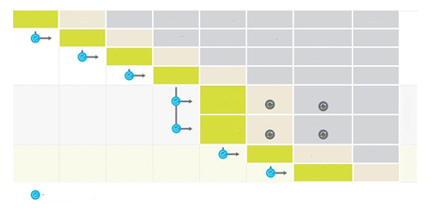
Result achieved
Planning
Construction
Transfer
Archived
Archived
Archived
Archived
Archived
Archived
Archived
Archived
Archived
Archived
Published
Published
Published
Published
Published
Published
Conceptual BIM
Interim BIM
Detailed BIM
Approved BIM
BIM renewal
BIM addition
Executive model
Archived
Archived
Archived
Archived
Archived
Archived
Archived
Archived
Archived
Archived
Archived
Archived
Archived
Published
Published
Asset Information Model

BIM deliverables
Within each project, BIM deliverables are required, see Annex No. 6 "Project Specific Requirements Template" for a list of deliverables

Within each project, a unique list of deliverables is requested, which depends on the specifics, content and objectives of the given project.
The minimum list of BIM deliverables when implementing a project in a BIM environment may be limited to the development of 3D BIM models and the non-graphical information to be added to 3D BIM models.

Application of BIM during management
The following potential uses of BIM are envisaged once the projects are completed:

Application | Description
Asset maintenance | Use of models to maintain asset information by linking objects/elements to external databases using dedicated middleware. Asset maintenance is part of the asset management process.
Asset purchase | Use of models as part of an asset procurement process (e.g. for furniture, spare parts or equipment). The process also includes updating/supplementing the models with information about replaced, new or used assets.
Asset tracking | Using models to track the locations of static or movable assets. Asset tracking is part of the asset management process and may include the use of radio frequency identification (RFID) or other tracking/tagging technologies.
Building inspection | The models are used for inspection and reporting on the technical condition of the building, compliance with legislation, standards, etc.
Asset transfer | Using models to plan and manage the movement of movable property (assets) within a facility.
Premises management | Using models to plan and manage occupancy/use of the premises.
Building automation | Using models to monitor and control the facility through a Building Management and Automation System (BMS).
Real time information | Using models to represent information received in real time from sensors located in a building or facility. Information may include premises occupancy, temperature, humidity, energy consumption, etc. The process also covers Building Management and Automation System (BMS) and Internet of Things (IoT).

Information exchange requirements

Roles and responsibilities
This section specifies the minimum requirements for the division of roles of the parties involved in the BIM process.
Roles cannot be combined, except in the cases indicated in the table.

Role |  | Responsibility
 | Project Manager | - Represent the Client;  - Ensure verification of control point results and conditions.
 | Information Manager | - Verify the BIM Execution Plan;  - Check BIM deliverables for compliance with the Client's information requirements and the BIM Execution Plan;  - Participate in meetings related to the BIM process;  - Check and monitor compliance with BIM processes and procedures;  - Publish and archive BIM deliverables.
 | BIM Coordinator  Client | - Perform model quality control, incl. model coordination and compatibility checks, collision  checks (both by visual and automated methods), document it and follow up on the resolution of these problem areas;  - Participate in meetings related to the BIM process.
 | CDE Manager | - Manage , incl. provide access to the persons involved, provide correct data deployment and structuring.

 | Project Manager | - Represent the supplier. The obligations are based on the conditions of the specific contract and technical specifications;  - Organize and/or participate (if the responsibility to organize is delegated to the Information Manager) with BIM processes related meetings.
 | Information Manager  Supplier | - Develop a Post-Contract BIM Execution Plan;  - From designer teams to suppliers Task information deliveries for plans to develop the main information delivery plan and update it in case of changes;  - Participate and/or organize (if the responsibility to organize is delegated to the Information Manager) with BIM processes related meetings;  - Determination of responsibility for providing information and its level of detail for each stage of the project (based on Client's BIM requirements);  - To supply in Client Information Requirements specified information within the specified deadlines and at the appropriate level of detail.
 | BIM Coordinator | - Provide information to Information Manager, that is necessary for drawing up a BIM Execution Plan;  - Perform model quality control, incl. model coordination and compatibility checks, collision inspections (both with visual and automated methods), document it and follow up on the resolution of these problem areas (including preparing minutes of collision reports and coordination meetings);  - Lead project coordination meetings, as well as participate in other BIM-related meetings (if necessary or  participation is requested by the Client);  - Provide support to stakeholders in relation to BIM processes within the project;  - 4D creation.
 | Head of the Architectural Part of the Construction Design*  Supplier | - Provide information to Information Manager, that is necessary for drawing up a BIM Execution Plan;  - To develop and restore in case of changes Task information delivery plan;  - Ensure the creation of the building information model in the agreed coordinate system and location, which is then required to be delivered to all participants of the project;  - Provide architectural BIM model(s) development;  - Provide self-testing of models;  - Participate in meetings related to BIM processes;  - Ensure that all information meets the required level of detail (LOD, non-graphic information);  - Ensure the uploading of models to the Common data environment in accordance with the schedule established in the BIM Execution Plan;  - Ensure the elimination of problem areas discovered during coordination within the framework of the AR part.

 | Head of the Engineering Solutions Department of the construction design* (BK, AVK, UK, etc.)  Supplier | - Provide information to Information Manager, that is necessary for drawing up a BIM Execution Plan;  - To develop and restore in case of changes Task information delivery plan;  - Provide development of BIM model(s) of engineering solutions;  - Provide self-testing of models;  - Participate in meetings related to BIM processes;  - Ensure that all information meets the required level of detail (LOD, non-graphic information);  - Ensure the uploading of models to the Common data environment in accordance with the schedule established in the BIM Execution Plan;  - Ensure the elimination of problem areas discovered during coordination within the framework of the his/her part.
 | CDE manager, (possible to combine with BIM coordinator or information manager) | - Manage CDE, incl. provide access to the persons involved, provide correct data deployment and structuring.
 | Cost Consultant  (recommended) | - Provide information and data to the project team on budget and costs related to the construction design and related to its changes.

- The responsibilities of these BIM actors within a part of the project may be further detailed by the supplier (e.g. project manager, BIM technician/designer, etc.).

BIM Execution Plan
The supplier develops a BIM Execution Plan as a response to the BIM requirements. The BIM Execution Plan describes the supplier's approach to implementing the project and meeting the Client's requirements. During the procurement procedure, the supplier submits a Pre-Contract BIM Execution Plan, with the supplier's responsibility matrix attached to it. After the conclusion of the contract, the supplier shall develop a Post-Contract BIM Execution Plan together with a Master information delivery plan and Task information delivery plans.

Pre-Contract BIM Execution Plan
The Pre-Contract BIM Execution Plan Template provides requirements and explanations for preparing a Pre-Contract BIM Execution Plan. (See Annex No. 1)
The supplier responsibility matrix (See Annex No. 8) determines the responsibility of the parties involved in the project for parts of the construction design and other BIM deliverables. According to the BIM development phase, it is also necessary to indicate the detail levels of graphic information (if they are applicable to the deliverables).

Post-Contract BIM Execution Plan
Once the contract with the selected supplier has been signed, the supplier is required to draw up a detailed BIM Execution Plan, or Post-Contract BIM Execution Plan. The Post-Contract BIM Execution Plan shall incorporate the information from the Pre-Contract BIM Execution Plan with changes that are agreed with all parties involved in the project (if changes have occurred) and shall be supplemented with information as specified in the Post-Contract BIM Execution Plan template. The supplier has the option to provide an in-depth and detailed description of the BIM processes, inviting the contractor to describe them in such detail that the project participants have no doubts about the outcome, even if this goes beyond the scope of the contract's BIM Execution Plan.
The Post-contract BIM Execution Plan must be submitted to the Client within 4 weeks after the conclusion of the contract. The Client examines and approves it within 4 weeks from the date of submission.
During the construction stage, the Post-Contract BIM Execution Plan needs to be updated and agreed with the Client by the end of the next relevant control point. The Post-Contract BIM Execution Plan, together with the updated Task information delivery plans and the Master information delivery plan, shall be submitted at the same time as the deliverables for each control point.
The Post-Contract BIM Execution Plan can also be updated more frequently, as well as during construction, if the need arises during the project. The updated Post-Contract BIM Execution Plan can only be used after coordination with the Client.
The Post-Contract BIM Execution Plan is an integral part of the contract subject to the terms of the design/construction contract, which is agreed upon when it is mutually signed. Only the Post-Contract BIM Execution Plan signed by the Client and the supplier is considered to be agreed.
The Post-Contract BIM Execution Plan can also be updated more frequently, as well as during construction, if the need arises during the project. The Client's agreement to the BIM Execution Plan shall not create additional obligations for the Client and shall not alter or modify the terms and conditions of the contract, nor shall the Client's agreement to it create any obligations other than those imposed on the Client in the contract.

Task information delivery plan
Each construction design manager or other BIM delivery author is obliged to describe the files to be delivered at each of the project phases and control points in the Task information delivery plan after the conclusion of the contract.
The Task information delivery plan shall specify the exact details of the files (BIM deliverables, 2D documentation, etc.) to be submitted at the next (following) control point and approximate details of the files to be submitted at the subsequent control points.

Master information delivery plan
The Master information delivery plan (GIPP) is made up of individual Task information delivery plans (UIPP). This plan serves as a schedule for the delivery of information during the implementation of the project. (Annex No. 9 and No. 10.)
An updated Master information delivery plan is required at each control point, which is based on each separately updated Task information delivery plan.

Workflow during design work
This section describes the minimum requirements and terms and conditions for the BIM workflow regarding the creation of BIM and the use of during design works. The requirements apply to design works (including works to modify the designed solutions) both during the design phase and during the construction phase.

- Each model developer is obliged to regularly coordinate their activities with the developers of other models, including sharing their models and making comparisons of models with current versions of other models. The models must also be self-tested for consistency, completeness, coherence and compliance with the client's information requirements.
- The supplier needs to determine the frequency of information exchange depending on the design stage. Information exchange means uploading the information developed during the project to (in the "Shared" stage). Since the completion of the control point "Interim BIM", the minimum frequency of information exchange and coordination meetings is once every two weeks.
- BIM deliverables must be submitted to the Client in a timely manner according to the relevant control points.
- BIM deliverables are submitted to the Client by the supplier's information manager. The supplier's information manager shall immediately inform the Client's information manager that the transfers have been submitted.
- The Client's information manager will, within 10 working days, accept or reject the information supplied, commenting on any deficiencies or shortcomings in the information supplied.
- The supplier shall have 10 working days to remedy any deficiencies or shortcomings and to resubmit the rejected information for reconsideration.
- The approved BIM deliverables under the relevant control point are published for future use by the project stakeholders. Only approved information will be included in the "Published" stage, which will be available to all parties involved in the project.
- BIM deliverables are published only after all deliverables for the respective control point have been met.
- After the publication of the next BIM-approved version, the previous BIM-approved version is transferred to the archive stage.

Below is the basic process diagram.

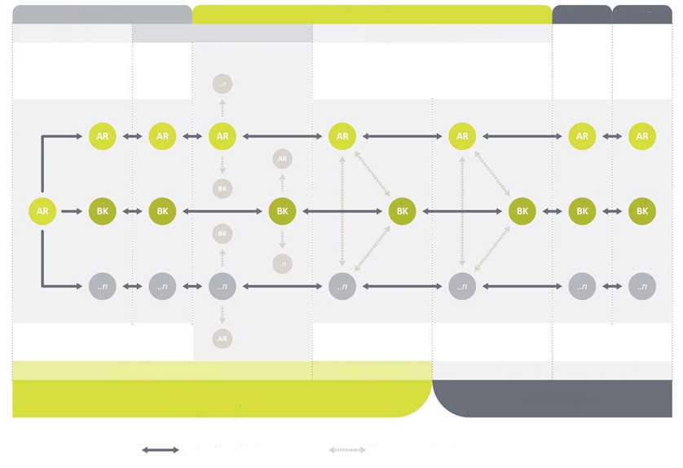
Shared
Self-check
Work files
Published
Archived
Client
Development
Coordination and inspection
Compliance with requirements
Compliance with other models
Interoperability (According to BIM coordination matrix) and compliance with requirements
Head of Construction Design
BIM Coordinator
BIM Coordinator (optional)
Information Manager
Supplier
Workflow/change of workstream
Model matching/comparison with other models

BIM process during construction works
During construction works, the 3D BIM models must be continuously updated and updated to take account of changes and emerging information on building elements and assets, so that when the project is complete, the BIM is fully relevant to the actual building (facility) and ready for the management process and the Asset Information Model.
The process of information exchange during construction works depends on the chosen BIM delivery method or procurement principle, i.e. when the design and construction works are carried out under one contract, or when the design and construction works are carried out by different suppliers under different contracts.
Procedure for making changes (general instructions):
- The proposed changes shall be reflected in the 3D BIM models (maintaining the specified level of detail) by the supplier and submitted to the Client for review and approval.
- 3D BIM models shall be submitted on time, with changes during construction and with deviations from the construction design, including drawings for changes.
- All changes and deviations from the construction design must be included in the 3D BIM models and reflect the actual planned construction solutions.
- Changes to 3D BIM models must comply with the work flow description as well as all relevant sections of the BIM requirements, such as modelling requirements, coordination and quality control requirements, etc.
- The Client performs an inspection according to the conditions of the control point, and accordingly rejects or publishes the proposed changes.
- After the proposed changes are published, they are considered to have been handed over for the respective construction works.
- The BIM requirements do not regulate the financial and legal liability for proposed changes within a procurement contract, as these are a matter of a specific technical specification, procurement contract or regulatory requirement.
BIM preparation for management (general instructions):
- During construction works, 3D BIM models need to be updated with information obtained during construction works after installation of equipment/elements. The 3D BIM models need to be updated within 10 days of receipt of the information.
- The information that needs to be added to 3D BIM models is described in the "Information Detail Requirements" section.
- The supplier provides records of BIM additions and updates during construction works.

Exchange of information using the "design and build" principle
Under the "design and build" principle, the supplier assumes full responsibility for receiving information from the construction site for 3D BIM models during renovation and addition construction works.
Making changes:
      - The supplier shall ensure timely exchange of information on proposed changes between the contractor and the design team.
      - Below is a schematic representation of the change workflow.

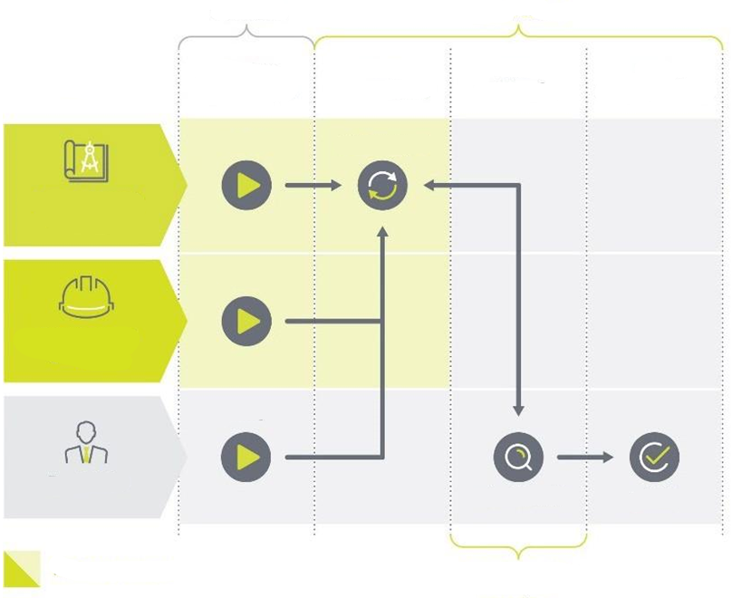
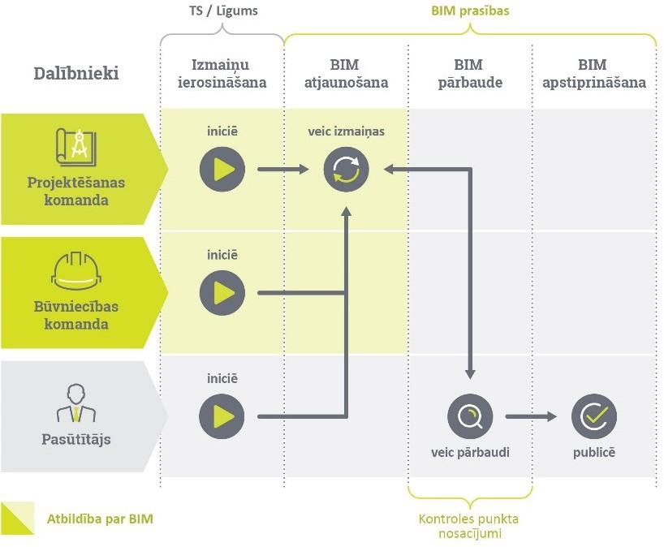
TS / Contract
BIM requirements
Participants
Information on assets
BIM completion
BIM inspection
BIM validation
Project team
Construction team
Client
adds information
delivers information
evaluates
does inspection
publishes
Responsibility for BIM
Control point conditions

Adding information:

      - The installer of the equipment/elements is required to provide this information to the BIM manager of the relevant project unit after the equipment has been installed.
      - BIM models are uploaded to the Common data environment at least once a month.
      - Complementing BIM with asset information is shown schematically below.
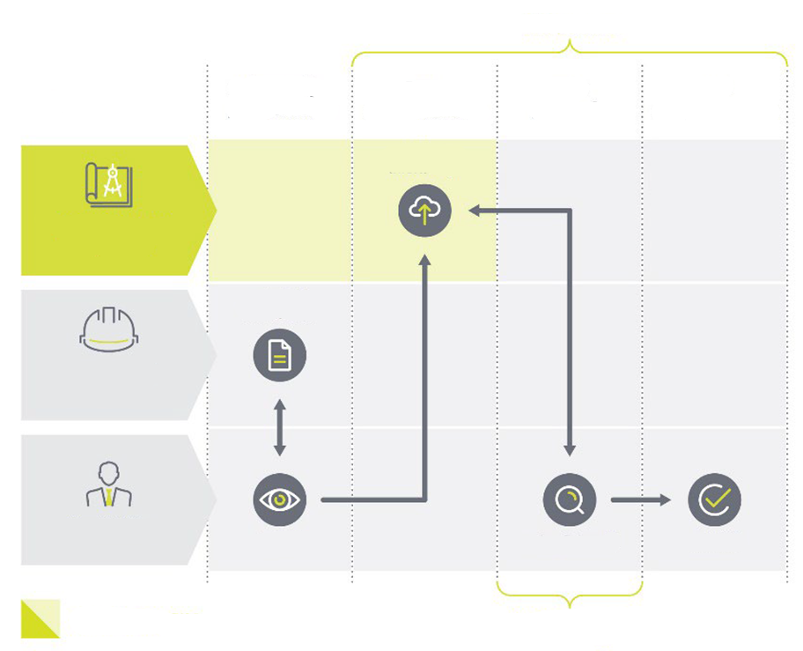
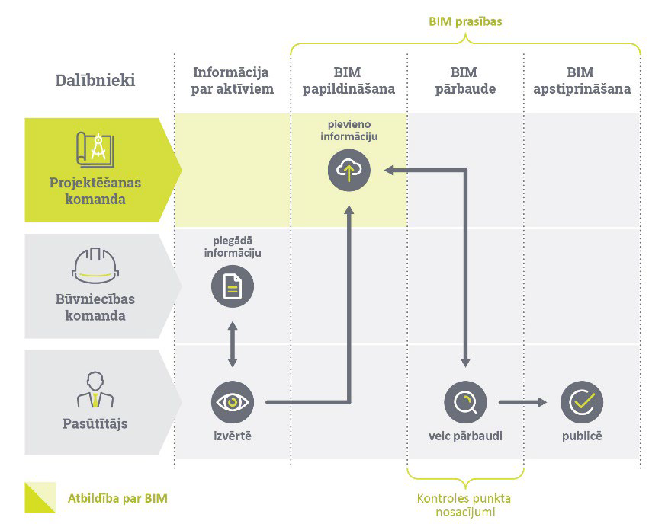
Control point conditions
Responsibility for BIM
BIM requirements
adds information
publishes
does inspection
evaluates
delivers information
BIM validation
BIM inspection
BIM completion
Information on assets
Client
Construction team
Project team
Participants

Common Data Environment
This section includes the minimum requirements for CDE functionality, and also describes how to provide CDE.
The type of CDE provision chosen for the specific project is indicated using 2.3. BIM deliverables "Annex No. 6 – Project Special Requirements Template”.
The party that maintains and manages the CDE within the framework of the project is obliged to ensure the existence of the terms and conditions of use of the CDE, and it is also recommended to develop the instructions for use of the CDE.
Regardless of the type of CDE provision, the supplier must define and describe in the BIM Execution Plan how the project information will be structured, what information will be shared with all parties involved in the project, and set file size limits for project information, if this is deemed necessary.

Requirements for a Common Data Environment
CDE is a file management solution that ensures the storage, sharing and exchange of information developed during the project. The main purpose of the Common Data Environment is to maintain a centralised source of information to disseminate all project-related information to the relevant teams and project participants.
stores and manages information, which is called information containers. Information containers are 3D BIM models, databases, documents and other files that contain information. After creating/inserting an information container in, it needs to save the following information in order to be able to track the development progress of information containers:
    - Information about the author and time (when the change was made), who created/inserted this information container;
    - Information about who has updated this information container, keeping the possibility of viewing old versions.
Information containers are organized by stages according to information readiness. Information containers must be able to move from one stage to another depending on the readiness of the information, the stage of the project and the expected deliverables. Changing the stages of information containers shall be done by creating a request or submitting a referral to the relevant stage, which shall be further verified and approved or rejected by the relevant person specified in the roles and responsibilities.
Schematic representation of the Common Data Environment work flow:
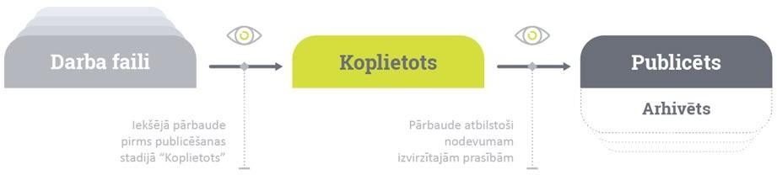
Inspection against the requirements of the referral
Internal check before publishing at “Shared” stage
Work files
Shared
Published
Archived
Common Data Environment safety and access solutions:

- must provide the possibility to assign usage rights (view, download and change) at the level of stages and information containers;
- The possibility to define the rights of users of the to submit and approve the transition of information containers from one stage to another based on the roles and responsibilities of the parties involved, recording the time and the person who performs these actions.

Shared-cycle Common Data Environment
The split-cycle approach is that the technical solution for the sharing of models, other contributions and information between supplier members at the "Shared" stage is provided by the supplier (making sure that file names remain unchanged and overwriting previous versions), while the technical solution for the submission of contributions to the Client at the "Shared" stage as well as for all activities at the "Published" and "Archived" stages is provided by the Client.

The split-cycle approach can be used where the Client wishes to retain responsibility for the provision and maintenance of within the project, but does not have sufficient IT or administrative resources to provide full-cycle , i.e. maintenance of the during its most active phase of use when multiple models and other contributions are shared and coordinated between members of the supplier's team.

Split can also be used in cases where the Client does not need to follow the contractor's activities at the "Shared" stage before models or other deliverables are advanced to the Client for approval (e.g. especially in large projects involving multiple teams of suppliers).

Within the framework of the split-cycle BIM approach, the BIM created by the Client is the only reliable source of BIM.

Below is a schematic representation of a split-cycle work flow.

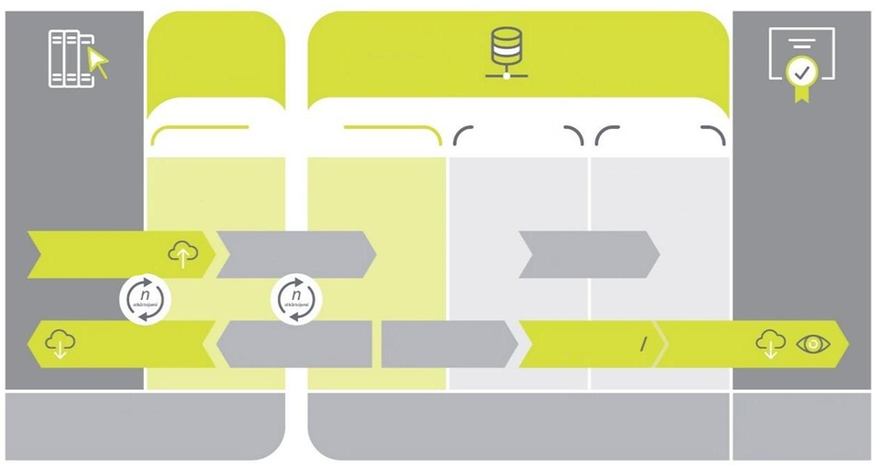The following management and access rights are foreseen in the framework of a split-cycle , according to the roles of the parties involved:
Views
Downloads
Downloads current version of models
Uploaded by the autorhir of each model
Storage of previously approved versions
Maintenance of Actual Information
Inspection of deliverables
Model cross-checking and coordination quality control
Archived
Published
Shared
To be approved incl. Incl. Achieved control point result
Not approvable
Notifies the handover according to the control point
Next approved version published
BIM exchange / storage / management
UNIFIED DATA ENVIRONMENT
UNIFIED DATA ENVIRONMENT
CLIENT
All participants involved in the project
SUPPLIER
APPROVED DELIVERABLES
WORK FILES
(BIM development)
Supplier :
- Manager – manages the Common Data Environment, assigns access rights to project participants;
- Supplier Information Manager – can manage all shared project deliverables and view/download published and archived deliverables, as well as submit deliverables to the Client Information Manager;
- Supplier BIM Coordinator – can manage model quality control information at shared stage, and can also view/download other shared, published and archived deliverables;
- Architect, designer of engineering solutions (author) – can manage information shared at the stage within the relevant section of the construction design, and can also view/download other shared, published and archived deliverables;
- Client Information Manager – at the request of the Client, the right to view/download shared deliveries is granted.

Client :
The Client will use MS Sharepoint for storing documents (protocols, contracts, MAF, etc.) and Trimble Connect for storing the technical project (drawings, models).
- Manager – manages the Common Data Environment, assigns access rights to project participants;
- Client Information Manager – can view/download shared, published, and archived deliverables. Publish, archive or reject project deliverables;
- Client BIM Coordinator – can view/download shared, published and archived deliverables;
- Project Manager – can view/download shared, published and archived deliverables;
- Supplier Information Manager – submits (uploads) deliverables to the Client's Information Manager at the shared stage, published and archived deliverables can be viewed/downloaded;
- Supplier BIM Coordinator – can view/download published and archived deliverables;
- Architect, designer of engineering solutions (author) – published and archived deliverables can be viewed/downloaded;
- The other participants involved in the implementation of the project – can view/download only the published and archived deliverables (rights may be specified during the implementation of the project).

In case a split-cycle solution is selected, this is specified in the Project Special Requirements Template.
Both the supplier's and the Client’s shall comply with the requirements set out in clause 3.5.1.

Collaborative process
All parties involved in the implementation of a project have a role to contribute and share project information. Sharing of 3D BIM models and other transfers and information should be done using. This should promote cooperation and exchange of information between the parties involved in the implementation of the project.
The BIM Execution Plan needs to describe the frequency of information exchange as well as the definition of joint meetings within the project. As a minimum, the supplier shall organize the following meetings:

Type of meeting | Activities and objectives | Frequency of meetings (recommended) | Frequency of meetings (minimum)
BIM  kick-off meeting | (BIM kick-off meeting) is organised to introduce the team to the BIM execution plan and the set requirements for models, information delivery, outputs, detailing, timing of coordination meetings, etc. | At the beginning of the project stage | At least once
Model review meeting | Model review meetings should be organized during the design stage. Topics to be discussed at the meeting include: the adequacy of the models and the construction design to the project objectives and requirements, including detail and completeness according to the project phase, the appropriateness of the solutions applied, compliance with standards and guidelines. These activities are expected to be carried out in design meetings | Once in two weeks | Once per month
Coordination meeting | BIM coordination meetings need to be organized at the design stage and, if changes are made to the geometry of the models during construction, also at the construction stage. The purpose of the meetings is to identify and eliminate design errors before they are discovered during construction. | Once per week | Once in two weeks
Constructability analysis meeting* | Constructability analysis meetings need to be organised during the design phase to identify and modify potentially complex and inconvenient solutions that could have a negative impact on the construction process. The purpose of the meetings is to identify risks that might arise during construction, to help plan construction work more efficiently, and to assess opportunities to save money by suggesting alternative solutions.* | Three times* | At least once*
*Applicable if the delivery of the constructability analysis is requested in the Annex of the Project's special requirements.

Client's participation in BIM meetings
At the request of the Client, the supplier is obliged to include the Client's representatives (e.g. project manager, information manager, BIM coordinator) in BIM-related meetings. The purpose of the Client's representatives attending these meetings is to make sure that the BIM requirements, incl. procedures, workflows and quality control processes defined in the BIM requirements. The Client's representatives shall have the right to point out non-conformities with the BIM requirements and the supplier shall be obliged to remedy the deficiencies identified by the Client.

Coordination and quality control
Project quality and risk reduction through 3D BIM models and information coordination is one of the main objectives and requirements of the client during the project implementation. The parties involved in the implementation of the project need to agree on how the 3D BIM models of the relevant sections will be coordinated and how quality control will be ensured, documenting it in the Post-Contract BIM execution plan.

3.7.1 Types of verification
In order to ensure that the construction design meets the geometric and information requirements set for it, as well as to ensure the overall quality of the construction design and compliance with the standards, quality control must be continuously carried out during the development of the construction design. Quality control must ensure at least the following verifications:

Type of control | Objective | Control frequency | Responsible party
Self-check | Ensure that the model meets the design concept and technical requirements, contains the necessary information for the project phase/stage and that the graphical representation of the model meets the detail requirements. | At least before uploading models to the "Shared" stage of the | The manager of the relevant part of the construction design
Visual inspection | Make sure the model does not contain unnecessary elements and that the information is relevant to the project section.  Comply with the spatial requirements of the facility (e.g. areas needed to open doors or windows). | At least at the interval of the project coordination meetings | BIM coordinator, BIM author before each model upload
Collision check | Unwanted crossing of elements within one or several models is determined. Collision checks are carried out both | At least as often as project coordination | BIM Coordinator
 | by automated and manual methods. | interval of meetings
Model data/integrity check | Check that the elements of the model meet its detail and information requirements. Both by automated checks and by manually examining the information tables. | Before submitting the deliverables to the Client. And also checked at least for each coordination meeting | BIM Coordinator

3.7.2. Coordination and scheduling of collision checks
No later than the day before the Coordination Meeting, the supplier is required to upload a collision report containing the following information:
    - a picture with the detected collision or problem area;
    - an indication of which sections of the construction design collide or conflict (it is not permissible to indicate all or other sections of the construction design that do not collide or conflict);
    - location;
    - the date of the collision or problem area.
No later than two days after the Coordination Meeting, the supplier shall upload the minutes of the Coordination Meeting to the , based on the collision report and supplemented with the following information:
    - the party responsible for avoiding the collision or problem area;
    - the expected deadline in which the collision or problem area must be resolved;
    - date of resolution of conflicts identified in previous meetings (if applicable).
The supplier is required to use a BCF server (BIMcollab, Catenda or similar) to manage problem areas. Significantly more transparent, no local file volumes, all parties always working with up-to-date information. If needed, you can export the report in pdf or xlsx format, both as a list of problem areas and as graphs.
Note: During collision tests, collisions that are deliberate and do not affect the constructability of the elements are permissible. It is permissible not to prevent these collisions. Such collisions can include:
- perpendicular collisions of engineered model pipes, ventilation ducts and cable ladders no larger than d150 mm against non-load-bearing structures;
- perpendicular collisions of engineered model pipes, ventilation ducts and cables no larger than d50 mm with load-bearing structures;
- perpendicular crossing of pipelines, if the diameter of both pipelines is less than 18 mm;
- intersection of elements with pipeline and duct insulation of less than 1/2 the insulation thickness;
- intersection of light fittings, utility outlets and inlets with suspended ceilings;
- other minor collisions, in agreement with the parties involved in the project.
In the BIM Execution Plan, the supplier needs to describe the coordination and collision checking processes, including the following information:
    - coordination and collision detection process;
    - software;
    - creating a collision report;
    - conduct of coordination meetings;
    - creation of minutes of the coordination meeting;
    - collision avoidance process.

In order to track the supplier's quality control, the BCF server needs to show the results of the collision control according to the schedule of meetings specified in the BIM Execution Plan.

3.7.3. Collision detection matrix
It is necessary to include the Collision detection matrix in the BIM Execution Plan. The Collision detection matrix should show the distribution of priorities among all sections of the construction design for which BIM models are developed. The purpose of the Collision detection matrix is to determine the priorities of the procedure for the prevention of collisions and problem areas in the sections of the construction design, based on which the parties responsible for the prevention of the detected collisions or problem areas are determined. The Collision detection matrix should be created as a table in which the sections of the construction design are indicated in priority order, starting from the highest priority to the lowest priority.
Note: The collision matrix serves as a general principle for determining the responsible party for resolving collisions and problems, but exceptions may be made where a collision or problem in a lower priority section is resolved by changes or corrections in a higher priority section.

Construction supervision
The construction supervision team plays a vital role in ensuring that BIM is effectively integrated into the construction process. The construction supervisor will need to integrate BIM requirements into the BIM construction supervision plan. This integration involves routine procedures that include regular checking of the BIM model to guarantee its consistency and up-to-date relevance to the construction phase.
Training and performance requirements:
The construction supervisor is trained in BIM technologies and must ensure that any training gaps are addressed in daily inspections and additional training is provided where necessary.
Establishes performance criteria for checking and assessing the accuracy of the BIM model, ensuring that the construction manager meets the performance requirements and ensures the integrity of the BIM model throughout the life cycle of the construction design.
BIM model and daily check:
The construction supervisor is responsible for the daily check of the BIM model, ensuring that it reflects the geometric and actual construction object on the construction site. This check can be done using laser scanning and compared to BIM models. Use Annex 5 – Permissible deviations between the BIM model and the point cloud as tolerance between BIM and Point Cloud.
Coordination and error resolution:
The construction supervisor shall identify and inform the supplier and the client of any discrepancies between the BIM model and the on-site constructed facility. The supplier shall carry out a coordination check to ensure that all elements of the model are correctly aligned and that there are no collisions between them.
Information flow and data compatibility:
The construction supervisor ensures that he is fully aware of the data contained in the BIM model and uses it effectively in his daily work.
Monitors data compatibility, LoI completion and change monitoring to ensure all data conforms to current construction plans, specifications and models.
At the monthly execution reconciliation, the construction supervisor shall check that the execution matches the as-built execution. In addition, a "Progress Report – 4D Progress Report Component" is provided by the supplier, comparing what has actually been built with what was planned. It is convenient to use the execution status attribute in the model with the value "Planned", "Built", etc.
These points serve as a basis, but it is important to adapt them to the specific project, taking into account the specifics of the project and the objectives of using BIM.

Technical requirements

Software
The supplier is obliged to specify the software used for the project, its version and file formats. During the design process, software versions must not be changed in an uncoordinated way to avoid compatibility problems. Version changes shall only be made in coordination with the Client and all parties involved in the design process, and by testing with test models to prevent potential loss of information and inaccuracies during the transition process.
In the development of BIM models, it is necessary to use "BUILDING SMART" certified computer programs (https://www.buildingsmart.org/compliance/certified-software/).

Software for creating 2D drawings
The construction drawings shall be produced in the same authoring software as the BIM models, using the geometry of the models to produce views of the drawings. In this way, identical geometry of models and drawings is ensured.
This requirement does not apply to the following exceptions:
    - for displaying assemblies, schematics and high-detail elements with a scale greater than M1:20. In certain cases, upon agreement with the Client, it is permissible to reduce the scale to M1:50;
    - tables, specifications, if this information is not available or readable in BIM models;
    - development of geotechnical, topographic and master plan section drawings;
Drawings (or their parts, if applicable) developed in BIM authoring software may not be modified or extended in other authoring software.
The contractor is obliged to inform the Client about all drawings that are planned to be developed outside BIM authoring programs. The information must be submitted before the drawings are developed.
The creation and presentation of the construction drawings in the BIM authoring software shall be evidenced by the drawings displayed in the original BIM authoring software file.

Computer support
The supplier is obliged to use BIM models in the construction work and to ensure that its subcontractors also undertake this obligation. The supplier shall thus ensure that the responsible personnel are sufficiently equipped with tablets connected to the internet and access to Trimble Connect software or other for on-site work. Each construction manager (including subcontractors' managers) must be equipped with tablets for on-site work.
Computers, tablets and mobile devices must meet at least the following minimum requirements:
Computer (Windows desktop, laptops and tablets):
CPU | 8-core 2.60Ghz
Memory | 16 GB RAM
Storage | 256 GB SSD
Graphics card | Discrete GPU (Nvidia, AMD)

Mobile devices:
Operating System | Android 13/ iOS 16 and above
CPU | Hexa-core
Memory | 6 GB RAM  8 GB RAM for complex projects1
Display | 1080×1920 pixels resolution
Network | Wi-Fi, 10 Mbps
*Working on site, must have internet access – must provide WiFi coverage or (better) 4G/5G connection to the equipment.
To enable the use of the BIM model in on-site meetings, the supplier shall equip its construction site meeting rooms with a minimum 65 inch screen, online meeting facilities (audio and video) and a computer station powerful enough for BIM review.

Data exchange formats
File formats used for project information exchange:

Deliverable type | Deliverable file format
3D BIM models | *.ifc and author programs in original format
Material specifications | *.xlsx
2D drawings | *.dwg and *.pdf
Information on managed assets | *.xlsx
4D simulation | *.mpeg or *.avi and author programs in original format
Other documentation | *.pdf and *.docx, if applicable

The formats of the other deliverables must be specified in the BIM Execution Plan.

Original format files
Original files are defined as authoring software files containing graphical and/or non-graphical information about the building or facility concerned. The original format files are also those files used for export from the original format of the authoring software to the *.IFC file format. The size of the original files of the authoring software to be submitted must be such as to allow re-export to *.IFC file format without loss of graphical and non-graphical information.

Generating file names
File names within the project should be created according to a uniform structure. The file name consists of 4 separate groups separated by a dash:
[Construction design section] – [Building part or area] – [Project stage] – [Name]

Name group | Description
Construction design section | The name of the section according to the information specified in LBN 202-18 "Construction design documentation preparation". Where a section is split into several parts, this should be reflected in the title of the section by placing an underscore after the title and the split part. Example AVK_V.
Building part or area | Building part or area according to the specifics of the project. The recommended length of the designation of a building part or area is 1 symbol.
Project stage | Project stage is used to describe the stage of the project in which the file is created. Project stage length – 3 symbols. See the table below for the applicable designations of the Project stage.
Name | File name, short description of what the model file contains max in 6 words

Information content designations
Building part or area
Designation | Description
A | 6. Transcript of the new terminal
B-G | Transcripts of existing airport terminals
Project stage
Designation | Description
DSG | Design or Design stage transcript
CON | Construction or Construction phase transcripts
ASB | As-Built or Commissioning (Executive model)
Where additional file types, information content designations and floor or level designations are required, these should be agreed with all project participants and specified in the post-contract BIM Execution Plan.
The file names must remain unchanged when updating the file version in order to be correctly recognized by and other BIM software.

Model development

Level of detail
The detailing requirements set for the project can be divided into two parts – the level of graphic detailing of models (LoG) and the level of detailing information (Lol). The graphical level of detail represents only the level of geometric accuracy and detail of the elements. The level of information detail represents the amount of information that is added to the elements.

The level of graphic detail
A brief description of the graphic detail levels of the models:

LOD 100
- A model element is represented by a symbol or other generic term intended to indicate the presence of the element, but not its shape, size or exact location.
- Any information obtained from LOD 100 elements should be considered approximate.
LOD 200
- A model element is graphically represented as a generic facility or system with approximate quantities, size, shape, location and orientation. A model element can
be both recognizable in relation to the facility it represents and to serve as a volume for highlighting or booking spaces. Non-graphical information can also be added to a model element.
- The model must be sufficiently accurate to ensure that the design meets the constraints imposed (e.g. regulatory requirements for construction design
in minimum composition) before detailing the project.
- Any information obtained from LOD 200 elements should be considered approximate.
LOD 300
- A model element is a graphical representation of a specific and precise facility or system in terms of quantity, size, shape, location and orientation. Developed
amount, size, shape, location, and orientation of an element can be measured directly from the model without using non-model information (such as annotations). Non-graphical information can also be added to a model element.
- The model can be used to check all regulatory requirements (e.g. statutory requirements for building design), as long as they are not related to a specific brand,
model or material (this also applies to subsequent LOD levels).

LOD 350
- A model element is graphically represented as a specific and precise facility or system in terms of its specified quantity, size, shape, location, orientation and interfaces with
other building systems. The details necessary for the coordination of the element with nearby or attached elements are modelled (e.g. supports and joints are modelled).
- Developed amount, size, shape, location, and orientation of an element can be measured directly from the model without using non-model information (such as annotations).
Non-graphical information can also be added to a model element.
LOD 400
- A model element is a graphical representation of a specific and precise facility or system in terms of quantity, size, shape, location and orientation with detail,
manufacturing, assembly and installation information. Developed amount, size, shape, location, and orientation of an element can be measured directly from the model without using non-model information (such as annotations). Non-graphical information can also be added to a model element.
- The model element shall be modelled with sufficient detail and accuracy for the manufacture and installation of the component depicted. This is the highest in graphical
level of detail.
- In case LOD 400 is requested at the design stage, the manufacturer or model may not be specified, so the information at the construction stage must be supplemented with
the brand or model finally selected.
LOD 500
- A model element has been verified by construction to a certain quantity, size, shape, location and orientation.
- LOD 500 refers to inspection by construction and is not associated with an even higher level of graphical or non-graphical detail.

A detailed description of the detail levels of the models can be found in the document "Level of Development Specification 2021 (Part I)" developed by the BIM Forum (available at https://bimforum.org/lod/).

In BIM models, it is necessary to model all the elements specified in the construction design. The supplier has the right to submit a proposal for those elements that are not depicted in the BIM model, provided that this does not hinder the achievement of the objectives set by the Client regarding the application of BIM.

The list of exceptions may be supplemented during the project by agreement between the client and the supplier and by describing each specific exception in the Post-Contract BIM Execution Plan.

Level of information detail
Building construction and management needs require specific information to be specified in 3D BIM models.Attributes must use the correct value type. RIX-Length would be a Length parameter, RIX-Area would be an Area parameter. RIX-Classification should be exported as IfcClassification etc.It is necessary to create a Common set of attributes, "RIX-Data", so that the information added to BIM models can be easily selected.
Requirements for the information to be added to the model elements can be found in Annex 2 "Information detail requirements". The information to be added is divided into data groups (e.g. "AR, Finish") and data sets (e.g. "Wall finish").
The name of the data group is indicated on the left side of each table. The name of the data set and its brief description are given at the top of the table.
Data groups "AR, Windows and doors", "AR, Finish", "AR, Premises ID"; "AR, Building elements", "BK, Building constructions", "Engineering networks" refer to specific parts of the construction design.
Data groups "AR, Windows and doors", "AR, Finish", "AR, Premises ID"; "AR, Building elements", "BK, Building constructions", "Engineering networks" require information that can be used both during construction works and in the framework of the building management and maintenance process.
Depending on the needs and purposes of information use, the Client determines the amount of non-graphical information to be added within the scope of the specific project, using Annex 2 "Information detail requirements". Instructions for adding information:
- The structure of the tables must be respected, and it is not permitted to merge, relocate or modify attribute names.
- Data set information fields should be added as soon as model elements are created, while attribute information should be added as soon as it is available.
- In some authoring software it is acceptable to omit the data set name for technical reasons, but it must appear when exporting the model in *.IFC file format.
- Adding information to attribute "RIX_Name or Name" (description), the element name must be clearly defined, specific to the intended element. A generic or ambiguous name is not allowed.
- In case an element consisting of several layers is modelled by a single model element, all layers and their thicknesses need to be specified under the "RIX-Material or Material" attribute.
- When adding information to the "RIX_Type or Type" attribute, you must specify the element type as presented in the construction design. If a specific element is not assigned a specific type in the construction design, it needs to be assigned separately in BIM models. The same type names for different elements are not allowed.
- Attribute names must appear in the exact order as they appear in the detail tables, and all attribute names must be created, even if it is known that an attribute will not be filled in.
- Attribute information must be filled in English.
- All attributes that apply to add a "relative link". The link is created and stored in the specified by the Client.
- The "Project stage" column indicates the control point at which the required information must be presented to the model elements. It is only possible to withhold information at the relevant control point when that information is not available and needs to be displayed until it becomes available.
- It is not allowed to indicate a link to a website found on the Internet in the attributes in which it is necessary to indicate a link to an external document. The purpose is to indicate the web version link to the specific document. As an exception, the website is saved as a copy in .HTML format and then linked to this saved version.
- Files attached to BIM models should be saved in a separate folder and submitted with the BIM models so that the relative link between the models and the attached files is not lost.
- The Post-Contract BIM Execution Plan needs to describe in detail the procedure for adding non-graphical information to the original format files of the authoring software (description of the correspondence of the attributes in Annex 2 "Information detail requirements" to the built-in attributes of the authoring software and to the newly created attributes, their naming) and the export of this information to *.IFC file format (description of the steps to be taken, the auxiliary files to be used and the attachment of these auxiliary files to the annex).
Note: When developing the Post-Contract BIP, agree with the supplier which possible attributes can be included in the MAF to avoid duplicate information.
Explanation of control point abbreviations:

Abbreviation | Transcript
DSG | Design or Design stage transcript
CON | Construction or Construction phase transcripts
ASB | As-Built or Commissioning (Executive model)

Coordinates
Each 3D BIM model of a building project must be located in a Common coordinate system that corresponds to the true coordinates of the building according to the coordinate system LKS-92 and LAS-2000.5. The models must be correctly oriented towards the north of the construction design.
Guidelines for ensuring uniform coordinates when starting design:
- The architect will share a model containing the axes and levels of the project as early as possible. This model should be used to achieve uniform project coordinates.
- Each party involved in the design will use this model to ensure the project is in the exact location without modification.
- If the facility is divided into several parts (e.g. buildings or blocks) and therefore models, it is necessary to define a zero point for each model.

Classification
The elements of the 3D BIM models to be developed for the project shall be classified in accordance with ISO 12006-2:2015 Construction Information Management Part 2 – Basic Principles of Classification.
It is necessary to use the classification UniClass 2015 using the Products, Systems and Spaces tables (Information is available on the NBS website https://www.thenbs.com/our-tools/uniclass-2015#classificationtables). The Products and Systems tables can be used simultaneously for each specific building element or facility.
The classification needs to be presented in models under a separate data set. The data set name as well as the attribute names must be identical in all models. For each specific classification table, it is necessary to present both the description and number attributes.
To use a separate data set for classification, it is recommended to immediately indicate its name and the names of the classification attributes. This will help keep information consistent across projects. E.g. dataset RIX-Classification, attributes RIX-PrCode, RIX-SsCode, etc.
Model elements must be graded with model detail reaching LOD300 graphical detail level.
Latvian national classification, standard No. LVS 1078m publication, which will need to be included in the project.

Modeling
The following minimum requirements are set for the modeling process:
- Elements should be modeled as they are intended to be built. That is, not to lay pipelines several tens of meters long, but to foresee the connections where they will actually be installed. Also – do not divide risers at storey levels if no riser divisions are to be made at these heights during construction.
- The model elements must meet the data detail requirements for the specific project phase, be clearly understandable and contain information on the required parameters and attributes.
- It is essential to ensure that model element data can be transferred in IFC format.
- Model coordinate systems must be consistent between all sections of the construction design. The BIM models of each section of the construction design, as well as the exported IFC models, must be located in the same coordinates. When importing IFC models of other sections into BIM authoring software, they must overlap with the BIM model developed in the specific authoring software without manual repositioning. In the case of a project using the same developer's authoring software in several sections of the project, when the authoring software files are merged, they must also overlap in the correct coordinates without manual correction of the position of the models.
- In the model, element contradictions (crossing, overlapping and cross-overs) are not allowed, except in section 3.7.2. "Coordination and scheduling of collision checks" in the stipulated cases. It is the responsibility of the BIM coordinator and the 3D BIM modelers (architect, civil engineers) to ensure that the models of the different parts of the project are consistent, have the correct element heights and do not conflict with the models of other parts.
- All three geometric indicators (3D) of the model elements are equally important. The accuracy and required reliability of placement of elements in space are equal in three directions.
- Model elements must be modeled in layers. The breakdown by floors allows better management of the design of the model and facilitates the estimation and planning of construction based on the model.
- The elements of the model must be modeled according to their phases – demountable, existing or designed element. All volumes to be dismantled need to be modeled for AR and BK sections.
- Models must remove redundant model element types, known as clusters, that have been uploaded to the project. The model must be a single entity and the elements of the model must be modelled as a coherent and continuous system. All the elements that are necessary for the system to work according to the project solution must be modeled.
- All elements must be modeled with a tool (function) provided for this in the selected BIM software. However, if different tools are used or new elements are created with generic modelling tools, when exporting IFCs it is important to ensure that they are correctly associated with the IFC classes and types and that they are correctly represented.
- If model elements are changed, existing model elements should be edited first, not deleted and new ones created. In this way, elements retain a single GUID identifier and can track actions related to them.
- Space elements (IfcSpace) must be modeled at all stages of the construction life cycle. The premises must conform to their boundaries and there should be no contradictions between them. All floor surfaces of the building must be covered with room elements.
- 2D drawings must be derived from 3D BIM models. Inconsistency of information between 2D drawings and 3D BIM models is not allowed.
- If there are changes to the construction design, they are first implemented in the model and then the updated drawings are sent out.
- Annotations (references, indications, height marks, measuring lines) attached to the drawings and reproduced on the 2D drawings shall be based on the models (shall comply with
- model), i.e. parameters must be related to model elements.
- It is necessary to add correct material graphic information (color, pattern, etc.) to decoration and interior elements. It is not allowed to use generic materials as finishing for these elements. It is necessary to ensure that the material information in the model is the same as that specified in the construction design documents.
- Where a part (or parts) of a construction design has a restricted access status in the technical specification, a "Restricted Information" marking shall be provided visually in the model for that part of the construction design. The designation shall be clarified during the project kick-off meeting and described in the Post-Contract BIM Execution Plan.

In case the Project Specific Requirements Template requires models to add non-graphical information to the data group "AR, Finish", the finish elements shall be designed according to the following principles:

- In order to meet the detail requirements for interior and exterior finishes in AR models, it is acceptable to model the finishes in a separate finishes model with all individual interior and exterior finishes modelled with their associated information, or it is possible to model the finishes in the main architectural model by dividing the finishes as individual elements and adding their associated information while maintaining the intended geometry of the interior and exterior spaces. Intersection of finishing elements with building elements of the model is not allowed. The thickness of the finishing layer must be subtracted from the thickness of the building element, modeling it so that it fits the building elements.
- Floor and ceiling finishing layers need to be created for each room separately. It is not permissible to use the same finishing element for several rooms separated by partitioning structures.

Unique identification number
In case the project specific requirements require the addition of a non-graphical information dataset "Asset Information", a unique identification number must be added to specific model elements, which must not be repeated for any other element within the project. The unique identification code assignment methodology consists of the following parts:
- Numberings of LBN 501-17, Annex 2 "Types of construction works and constructive elements";
- Attaching the element to the floor;
- Attachment of the element to the room;
- Element number in sequence.
Example:

- Unique identification number: 20.3_02_213_001
- Transcript: Lighting body, building 2nd floor, room 213, first in its UID group.

The connected model
The individual 3D BIM models in *.IFC format from all authors need to be merged into a single integrated model. In the combined model, it should be possible to view each model separately.
When merging 3D BIM models, the supplier shall ensure that the location of the 3D BIM models is correct, i.e. the models imported into the model matching software shall be shown in the appropriate coordinates as defined in the Post-Contract BIM Execution Plan. Manual adjustment of the location of the models in the 3D BIM model matching software is not allowed.
The integrated model shall display the graphical and non-graphical information attached to the 3D BIM models in accordance with the criteria set out in the BIM requirements. It is necessary to submit the results of collisions saved in the combined model in order to view the performed tests and their results.
When providing the combined model to the Client, suppliers shall additionally provide a report in excel format showing all listed elements with completed attributes in an easy and convenient to view format.

Analyses and simulations

4D simulation
4D simulation involves visualization and analysis of the construction process using 3D models and adding a time dimension to them. (4D creation i uses the models created in the Design stage)
When developing a 4D simulation or performing construction activities and the time schedule WBS (Word breakdown structures) must be created so that it is in accordance with the estimate, connection with model components or elements, it is necessary to provide sufficient detail so that the simulation is transparent, the suggestion would be to create an ID number for elements e.g. RIX-WBS_No would allow the automatic creation of the WBS structure in the BIM software, as well as significantly speed up and facilitate the creation of 4D simulations. The minimum detail for the model components shall be as follows: models, floors, types of work (volume to be demolished, volume to be retained, new volume), zones, essential equipment. The level of detail for the 4D simulation time is 1 calendar day. For certain types of work, the level of detail may be reduced to 1 week by agreement between the parties.
Technical requirements for 4D video:
- Video resolution: min 1920x1080 pixels;
- Video format: *.mpeg or *.avi;
- Not less than 30 frames per second.
4D simulations are delivered in video file format and in the original format of the 4D simulation author program.
Simultaneously with the 4D simulation of the planned construction process, within the project, making a mark in the section'' 2.3. BIM deliverables'' in the Project Specific Requirements, additional information and analyses may also be required, namely 4D simulation extension, 4D simulation update during construction and constructability analysis.
4D extension
Construction logistics:
- Construction site organisation planning and simulation, including workforce, equipment, heavy machinery deployment/movement planning, temporary structures deployment/movement planning, construction materials supply, deployment and storage planning, etc. It also includes checking the availability of resources.
Construction waste management:
- Planning and simulation/modelling of construction and other waste from construction activities, including planning for storage and transport of construction waste, identification of potential construction waste and its volume, identification of factors, technologies and materials influencing the generation of construction waste and reducing its use, and identification of materials that can be reused.
Analysis of construction intensity by zone:
        - Analyses of whether there are overlapping construction activities in the areas concerned during the same time period that may interfere with or delay each other.
A 4D extension can be requested on the condition that the development of a basic 4D simulation is envisaged within the project.

4D recovery and status management:
Continuous updating of the 4D simulation during construction in accordance with the actual works carried out on site, as well as planned changes to the original construction schedule (if any).
When renewing a 4D simulation, it should clearly separate completed and planned construction works. Reporting the status of construction works and updating the 4D simulation should be done once per month.
The 4D simulation renewal requirements apply to both the basic 4D simulation and the 4D extended simulation (if requested in the Project's Special Requirements).
4D renewal and status management can be requested conditionally if the project includes the development of a basic 4D simulation.

Constructability analysis
Constructability analysis includes specific operations and assemblies simulation the creation of an animation in order to make sure before the construction about the feasibility of the implementation of the works envisaged in the project and the prevention or reduction of risks. Constructability analysis can be done for specific stages of construction or rounds, where detailed information is presented on the activities to be performed at the specific stage, the materials and equipment used. Listed below are the main principles that should be followed when developing a constructability analysis:

        - Installation of large and/or heavy equipment or elements (length over 5m/ weight over 200kg/ volume over 1m³) in the facility. The constructability analysis should indicate where the elements are stored in facility prior to installation, the method and technique used to install the element, and the planned installation.
Note: In certain cases it is possible to reduce the scope of the constructability analysis by agreement with the client, e.g. in the case of a new building, not to carry out a monolithic slab analysis, etc.

        - Installation of equipment or elements in a limited space or territory, for example communication shafts, room ceilings, if communications occupy more than 75% of the area of the intended area, etc.
Note: When creating a constructability analysis, pay attention to the fixing elements.
        - Detailed representation of pedestrian and traffic constraints, including solutions to divert these flows, designated areas, technical solutions and guidance on flow management.
A constructability analysis may also be required where 4D simulation is not foreseen.

Analysis of environmental availability
When designing or redesigning the premises, it is necessary to take into account the requirements for accessibility of publicly accessible premises for people with mobility, visual and hearing impairments. People with reduced mobility need to be provided with adequate free movement areas in publicly accessible spaces and adapted sanitary facilities.
Objective:
- Ensure that environmental accessibility is ensured in accordance with the applicable laws and regulations.
- Ensure adequate free maneuvering areas during the development of the interior section (IS).
Requirements:
- Transparent spatial zones modelled in 3D to allow free movement.
- For environmental accessibility zones, a clash test has been carried out against the interior section (IN) or, if no interior section is foreseen, against the architectural section (AR).
- Spatial zones have been developed in accordance with the applicable laws and regulations and the technical specifications.
Environmental accessibility analyses are developed as an independent IFC model. The model includes spatial volumes of free movement, zones that ensure the movement of people and room for maneuvering with a wheelchair. This model is linked to and checked against the interior model, thus indicating areas where interior objects should not be placed.

Deliverable | Description | Who prepares
IFC file | Transparent spatial volumes mark the environmental access area for the flow and free movement of people (including in the z-axis direction). Transparent areas are located in areas where accessibility requirements need to be met, including toilets, changing rooms, lifts and shower rooms. | Responsible author of the environmental accessibility section.

Other simulations
If requested in the Project's Special Requirements (Annex No. 7) relevant deliverable, they should be used for presenting alternative technical and other solutions to the Client and the user of the building, and for choosing and developing the most optimal technical solutions during design and/or construction works. All simulations are developed in a BIM environment using 3D models.

Deliverable | Description
Acoustic analysis | Simulation and analysis, which includes sound studies and simulations, e.g. sound insulation tests and material selection tests, siting tests for sound equipment.
Analysis of people flow and evacuation options | Simulation and analysis of the behavior of individuals or groups of people using 3D models in normal and emergency situations. Simulations help to identify and improve access, relocation and exit routes.
Fire simulation | Fire and smoke propagation simulation and analysis of building ventilation systems, automatic fire detection and fire extinguishing systems, etc. for designing.
Lighting simulation | Simulation and analysis of natural and artificial lighting inside the building.
Safety analysis | Use of 3D models for conducting virtual safety audits, which include simulations and analyses of security and access control systems, access areas, video surveillance systems, etc.
Location analysis | Analysis in which BIM software or Geographical Information System (GIS) tools are used to select the optimal project site or the optimal location of a building on a given plot of land.
Insolation analysis | Analysis of the simulation of solar radiation on building surfaces (including reflectance analysis), shadow simulation, building shape and location effects on solar heat loads.
Construction site risk analysis | Use of 3D models to identify, analyse and evaluate risks and hazards during construction works. For example, a model can be created or used to identify and analyse hazards on a construction site (e.g. potential falls from height, movement of heavy machinery, location of guardrails, etc.) and then assess these hazards according to the likelihood of the risk occurring to workers and bystanders.
Energy efficiency analysis | Using 3D models to analyse the energy performance of a building, including how and how much energy a particular building consumes. Analysis of the internal temperature of the building during the selection of engineering system solutions and building materials.
Sustainability analysis | Environmental impact analysis, including, for example, life cycle analysis of the building, assessment of energy consumption and environmental pollution. If this option is chosen, the project-specific technical specification may describe more detailed requirements for the work to be carried out and its specific characteristics.
5D | 5D BIM is the addition of costs to model elements after the project timeline is associated with those model elements.

Laser scanning and photogrammetry

Photogrammetry
Automatic or semi-automatic process of creating 3D models using photographs and image analysis. The photogrammetric processing of the resulting images shall result in a dense point cloud with a minimum point spacing of no more than 10 mm and an accuracy of no less than 50 mm in the Latvian geodetic reference system. Accuracy can be adjusted for specific projects. The Client must hand over the data processing quality report together with the survey results. In addition, the Client must hand over all taken aerial photographs together with their shooting positions and orientations in the Latvian geodetic reference system. The technical specification for a particular project may describe more detailed requirements for the work to be carried out and its specific characteristics.
Laser scanning and point cloud creation using a stationary or mobile laser scanner is provided by the supplier as part of the project. The supplier must coordinate the chosen measurement method and the achievable accuracy with the Client in advance.

General instructions
        - The point cloud can be used as input data for modeling and construction design development.
        - The point cloud is considered a priority against the inventory case.
        - The accuracy of the 3D BIM models developed by the supplier will be checked against the point cloud.
        - Maximum permissible model deviations from the point cloud: See Annex 5. "Permissible deviations between the BIM model and the point cloud"

Instructions on how the supplier should carry out laser scanning:
- 3D scanning works must use a 3D laser scanner that meets the following accuracy indicators:
          - ranging error: less than 2 mm at 25 m or less than 3 mm at 100 m;
          - 3D point accuracy: less than 6.0 mm at 10 m.
- Accordingly, if a mobile scanner or drone is also envisaged as part of the project, the accuracy requirements are similar for these types of surveying:
- For mobile scanners, the accuracy is not lower than 6 mm (per 10 m),
- Mandatory point cloud tie to geodetically surveyed control points ensuring point cloud accuracy of at least 20 mm.
- The contractor must provide at least the following technical parameters of the point cloud:
- registration deviations must not exceed 15 mm, which must appear in the matching report to be submitted with the 3D point cloud.
- point cloud density (space between measured adjacent points): not greater than 20 mm.
- 3D laser scanning data to be combined into a single coordinate system (data must comply with the Latvian geodetic reference system – LKS-92 and LAS-2000.5 (which is the implementation of the European Vertical Reference System (EVRS) in the territory of Latvia).
- Laser scanning and creation of a point cloud should be done prior to the development of construction design documentation solutions.
- The supplier provides a connected, Common point cloud.
- The supplier provides the point cloud in a format compatible with the authoring programs used by the Client (.E57, .RCP, or another format).
- In addition to the merged and processed point clouds, the raw data used in their preparation – the individual raw point clouds in their original file formats as extracted from the scanning machine – must also be provided.
- The contractor must provide the opportunity to view and transfer to the Client the 360-degree pictures taken by the 3D laser scanner at each of the scanning stations.
- The technical specification for a particular project may describe more detailed requirements for the work to be carried out and its specific characteristics.
- By agreement of the parties, the Post-Contract BIM Execution Plan may adjust the accuracy requirements or specify exceptions if, for objective reasons, certain accuracy indicators cannot be achieved.

Visual aids

Visualizations
The development of 3D models to exchange information about visual, spatial or functional properties, e.g. through fly-through video.

Visualizations should be photorealistic and used to present and coordinate the design solutions with the building user. The resolution of the pictures and videos must be at least 1920x1080 pixels and the video must be at least 30 frames per second.
Types of visualizations and file formats to be delivered:

Visualization | File format
Picture | *.jpeg or .png
Video | *.mpeg or *.avi
360⁰ visualization | Specifications in the BIM Execution Plan

During the design stage, if there are changes to the appearance of the landscaping, roof, facade or interior, the Client may request 10 updated visualisations (7 visualisations from the exterior and 3 visualisations from the interior).

During the construction stage, if there are changes to the appearance of the landscaping, roof, facade or interior, the Client may request 3 updated visualisations (2 exterior and 1 interior).

During the design stage, prepare a 3D rendered model created through Enscape, which is then created as an independent .exe viewable model. It is also possible to use another program if it can provide the same result after prior coordination with the Client.

Virtual reality
A type of modeling where 3D models are part of a virtual reality where users view simulated places, objects and processes. Virtual reality is used using virtual reality glasses or other specialized equipment.
The supplier shall provide the Client with VR (Virtual Reality) tours around BIM (Building Information Modelling) model changes where visual changes have been made to the building layout, interior, facade appearance, landscaping, etc. This requirement includes, but is not limited to, other aspects of project changes where virtual reality can offer detailed and live insight.
Documentation of Visual Changes:
The supplier must provide detailed documentation of the visual changes made to the building's layout, interior, facade appearance, landscaping, etc.
BIM Model Update:
The supplier must update the BIM model to incorporate the new changes.
VR Tour Development:
The supplier must develop VR tours that allow the Client to experience and evaluate the changes made in virtual reality.
Compliance with VR Standards:
VR tours must be created with industry standards and requirements in mind to ensure high quality and usability.
Testing and Approval:
After creating the VR tour, the supplier must offer the Client the opportunity to test it and provide feedback to ensure a satisfactory result.
Data Provision:
The supplier must provide the necessary data and files to the Client so that he can fully use the VR tour.
Possibility of Additional Changes:
If additional changes occur in the future, the supplier must be prepared to update the VR Tour to ensure it is up to date.
This requirement not only provides the Client with a detailed view of the changes made, but also allows them to experience and evaluate the project in virtual reality, which can improve understanding and communication between all those involved in the project.

2D documentation
2D documentation refers to the representation of both graphical and non-graphical information:

Type | Description
Graphic information | A way of using the model, which includes obtaining (creating) 2D drawings from 3D models containing information. 2D drawings usually include 2D plans, sections, elevations, and assemblies.
Non-graphic information: | Supporting documentation on the solutions applied and the works carried out in accordance with the requirements of the regulatory enactments and the requirements specified in the project-specific technical specification.

The detailed requirements for 2D documentation, such as the construction design, are governed by the technical specification for the service. BIM requirements do not consider 2D documentation as a separate deliverable. The BIM requirements consider 2D documentation from a technical point of view, including the requirement that 2D drawings must be derived from 3D BIM models and there must be no inconsistencies between them.

Sample models for maintenance phase
- The sample management models will be used to test the ability of the management team to implement the management process in a BIM environment.
- The supplier submits sample models in accordance with the requirements that were set during the procurement procedure.
- In the case where no model was requested during the procurement procedure, the Client shall prepare the requirements for the model using Annex 3 "Sample Model Requirements" of the BIM Requirements.
- The number of sample models shall be consistent with the number of BIM models expected to be submitted at the end of the project.
- The sample models must be developed in the same authoring software as the corresponding BIM models (the versions of the respective authoring software must also match).
- Sample models must be submitted in both the original file format of the authoring program and in the IFC file format.
- Sample models for management must be submitted if requested by the project's special requirements.
- Sample models for management must be submitted six months before the planned construction completion date.
- The builder can offer management softwares.

As-build model
The as-build model at completion and handover to the Client, must represent the actual built facility at the specified level of detail and meet the following minimum requirements:
    - Include all solutions actually implemented, including all changes to the construction design made and approved during construction, as well as deviations of more than 50 mm from the construction design, if any.
    - Inconsistency of information between executive models and 2D executive drawings and schematics is not allowed.
    - Include all specific information about assets, i.e. include all equipment and element information to be added, that has been obtained during the construction works after the installation of the equipment/elements in accordance with the requirements of detailing the information.
    - The execution model should be submitted at the time of completion and acceptance of all works on site that may affect the graphical and non-graphical information included in the BIM models.

Asset Information Model
Graphical models created during the design and construction phase contain a significant amount of information that is not relevant during building management and maintenance. In order to create models suitable for the management stage, it is necessary to perform the following modifications and actions in the Project Information models:

    - Clean the BIM models in authoring software (and .ifc format if applicable) of redundant information that is not necessary for the management activities:
      - delete drawings, views, redundant tables (except if used to add or export non-graphical information), character plots, cut-outs (legends) created in the model;
      - delete unnecessary elements in the model (purge function) (objects, pictures,
families, etc.), which are not used;
      - delete files and links attached to the model (except relative links to requested non-graphical information and BIM models of other sections of the project);
      - delete the project options in the model (project options, worksets, scope boxes, design options, view templates);
      - make sure the model does not contain any warnings or notifications.
- Ensure correct relative link behavior between models and attached files. Make sure that all files that have relative links are saved in a separate folder.
- Make sure that only existing solutions are visible in the model (deleted dismantled or planned elements).
Note: Information is not lost as it remains available in the Project Information Model at the "As-build Model" stage and can be accessed if needed.

    - In case the building AR model has been split into several models (IN, IE, etc.), it is necessary to merge these models into a single model (IFC file format) at the Client's request.
    - IFC format models need to be submitted both for each specific section of the construction design and for one combined model containing all sections of the construction design.
    - Ensure that unique asset identification numbers (IDs) are used to record building assets.

Annexes:
Annex 1. Pre-Contract BIM Execution Plan Template
Annex 2. Information Detail Requirements
Annex 3. Sample Model Requirements
Annex 4. BIM Expert Questionnaire
Annex 5. Permissible deviations between the BIM model and the point cloud
Annex 6. Project Special Requirement Template

