Annex 14
Procurement ID No AST2024/91
Joint Stock Company "Augstsprieguma tīkls"
open procedure
"Supply of electrical equipment to the 110 kV substation "Līvāni""
(ID No AST2024/91)
Lot 4 "Relay protection and automation (RAA) and dispatching system (DVS) equipment for 110 kV substation"

Technical specification, technical offer (updated 01.11.2024.)

Tenderer _______
- Control System of substation "Līvāni"

The column "Description" contains description of the requirement and shall not be modified by the tenderer.
The column "Required" contains quantity or parameters of the particular requirement and shall not be modified by the tenderer.
The column "Offered" shall be filled by the tenderer only with "YES" or "NO" depending if particular requirement is fulfilled or not.
The column "Please indicate" shall be filled by the tenderer only with the required information.
The proposed equipment must meet or exceed all the requirements requested. Otherwise, the offer will not be accepted.

SCS –Substation Control System.
RTU – Remote terminal unit.
Operator terminal (HMI) – PC based set of hardware and software for monitoring and controlling substation locally at site.
IED – Intelligent electronic device (e.g. digital protection relay, another RTU, measurement transducer etc.).
GPS – Global positioning system.
PLC – Programmable logic controller.
PC – Personal computer.
SNTP – Simple Network Time Protocol.

General requirements for substation control system are specified in the Item 1.1
RTU hardware is specified in the Item 1.2
RTU functionality is specified in Item 1.3
Operator terminal hardware is specified in the Item 1.4
Operator terminal functionality is specified in the Item 1.5
Measurement transducers are specified in the Item 1.6
Other devices are specified in the Item 1.7
Necessary spare parts for SCS are specified in the Item 1.8
Necessary equipment and software for SCS testing and maintenance are specified in the Item 1.9

  - General requirements for substation control system
Description: | Please indicate: | Offered:
- The Tenderer shall include in the tender:  - Drawings of SCS cubicles (sketch showing approximate devices, interconnection terminals and cable ducts layout in the cubicle);  - SCS functional block diagram, displaying actual amount, model names and communication mediums of all to SCS connected IEDs and SCADA systems;  - List of all SCS devices (including spare parts), their manufacturer names, exact model names, ordering codes and installed firmware versions. If modular design, then model names or part numbers of modules;  - Technical brochures of the above mentioned SCS devices. | ---
- SCS shall be provided by the Supplier for real time, uninterrupted control and monitoring of the substation and it shall be integrated in the Dispatch center of "Augstsprieguma tīkls" SCADA/EMS system (AST SCADA/EMS). | ---
- SCS shall be as RTU cubicle, PC based operator terminal and other devices with tight integration between control and monitoring units. | ---
- SCS hardware shall be designed as follows:  - RTU cubicle shall contain RTU equipment and most of the SCS equipment, measurement transducers and their equipment;  - PC based Operator terminal equipment shall be designed for desktop placement in substation control room;  - GPS antenna shall be designed for outdoor mounting at substation building; | ---
- SCS shall enable AST SCADA/EMS or any other master station to retrieve real time substation disturbance information, measurements, primary equipment state and perform control operations on substation primary equipment and relay protection units. | ---
- Local operator terminal in substation control room shall enable for the Operator to retrieve real time substation disturbance information, measurements, primary equipment state and perform control operations on substation primary equipment and relay protection units. | ---
- RTU shall be able to receive, process and transmit at least 3000 data points to at least 7 independent clients/masters.  Note:  Data point – one indication, measurement or control regardless of type. | Licensed data points:
- All the software and hardware included in the tender shall be properly licensed to the customer for unlimited period of time. | ---
- Licensing information for all devices and software used in delivered SCS shall be provided. Supplier shall deliver all necessary license keys, software activation keys, certificates, files, hardware devices, dongles, etc. for correct licensing of delivered SCS.  Note:  Licensing information and hardware (e.g. dongles) shall be provided also for SCS components which are bundled in license, but are not used in particular project, for example, for PLC. | ---
- In case of any SCS hardware replacement or software reinstallation, relicensing/reactivation of any SCS component shall be possible without additional cost to customer. | ---
- Manufacturer of SCS equipment should be certificated according to Quality control system certificate ISO 9001. | ---
- All SCS devices shall have CE marking. It shall be verified by appropriate declaration of conformity. | ---
- Power supply of SCS cubicle:  - Nominal 110 VDC;  - Operative range 100 VDC to 132 VDC. | ---
- Auxiliary power supply of SCS cubicle (only for lighting and AC power sockets) and power supply of Operator terminal hardware:  Nominal 230 VAC. | ---
- SCS power supply input and output shall be galvanically isolated and isolated from ground. | ---
- After any interruption in power supply all SCS devices shall turn on automatically and SCS shall return to normal operating state. | ---
- After any interruption in communication all indications and measurements shall be updated automatically and sent spontaneously to the master stations. | ---
- All SCS devices, except GPS antenna, shall be designed for indoor operating conditions (temperature range from 0⁰C to +45⁰C). | ---
- GPS antenna, shall be designed for outdoor operating conditions. | ---
- Cooling of all SCS equipment – passive (without fans). | ---
- For SCS time synchronization GPS shall be used. Time synchronization of RTU, network switches and relay protection IEDs using SNTP shall be possible. GPS receiver shall be located in the RTU cubicle.  As backup time synchronization source AST SCADA/EMS SNTP time server shall be used.  Note: GPS specification in Item 1.7. | ---
- In case of time synchronization issues (GPS clock lost or GPS device watchdog activation), SCS shall generate a signal and send it to master stations. | ---
- GPS, RTU and operator terminal shall have internal clock to keep time and date with accuracy 180 seconds per annual. | ---
- SCS shall support any time zone setting and automatic daylight-saving time adjustments. | ---
- RTU shall operate using UTC±0 time zone, but time tags of data points on the local HMI shall be represented with local time zone.  Note. Local time can be used in RTU maintenance interface or event logs. | ---
- SCS shall operate only with time tags of signal or measurement sources.  Note. Modifying time tags, in any other case than configured to do so, is considered SCS malfunction. | ---
- The Supplier shall deliver all necessary hardware, optical, electrical data cables (including data cables between SCS and relay protection units), converters, connection units, etc. to provide integrated solution of SCS. | ---
- All in SCS configured data points and their parameters shall be noted in one main SCS data list, according to the data list template. Empty data list template in .xlsx file format will be provided on the tenderer request, after the ordering. | ---
- SCS shall support at least the following data types for IEC 60870-104 protocol:  - <1> := Single-point information M_SP_NA_1;  - <30> := Single point information with time tag CP56Time2a M_SP_TB_1;  - <3> := Double-point information M_DP_TA_1;  - <31> := Double point information with time tag CP56Time2a M_DP_TB_1;  - <9> := Measured value, normalized value M_ME_NA_1;  - <13> := Measured value, short floating point value M_ME_NC_1;  - <34> := Measured value, normalized value with time tag CP56Time2a M_ME_TD_1;  - <36> := Measured value, short floating point number with time tag CP56Time2a M_ME_TF_1;  - <46> := Double command C_DC_NA_1;  - <45> := Single command C_SC_NA_1;  - <48> := Set point command, normalized value C_SE_NA_1;  - <49>:= Set point command, scaled value C_SE_NB_1. | ---
- SCS shall support following command execution procedures for IEC 60870-104 protocol:  - Select and execute;  - Direct execute. | ---
- SCS shall support following time qualifiers of command (QU) for IEC 60870-104 protocol:  - <0> := no additional definition;  - <1> := short pulse duration;  - <2> := long pulse duration;  - <3> := persistent. | ---
- SCS shall support local development and maintenance by connecting directly to devices. | ---
- RTU and operator terminal shall support remote development and maintenance by connecting to devices through AST SCADA/EMS network. | ---
- The Supplier shall deliver all necessary software and hardware for advanced development and maintenance of SCS (if any other equipment is needed that mentioned in the Item 1.1.9 please indicate and include it in the offer). | ---
- SCS must have the latest runtime, maintenance and configuration software version. | ---

Description: | Offered
    - SCS must process amount of measurements, controls and indications from substation primary and secondary equipment that is no less than specified in the table below:

Equipment type | Number of measurements (per device) | Number of controls (per device) | Number of indications (per device)
Relay protection IED (including Setting groups) | 10 | 10 | 50
Distribution RTU | 50 | 50 | 100
Measurement transducer or Energy Meter | 14 | - | -

Description: | Offered
The Supplier shall submit the following documentation to Telecommunication Department of JSC "Augstsprieguma tīkls":
Within 60 days after the ordering (in Latvian or English):
    - SCS cubicle(s) design, wiring diagrams and tables. Block diagram of SCS architecture displaying SCS devices, connections between these devices, data transmission protocols, data transmission mediums etc.
    - List of all SCS devices (including spare parts), their model names and installed firmware versions. If modular design, then model names or part numbers of modules.
    - User manuals, Service manuals, Menu system, Interoperability tables and other description of the SCS in electronic format.
At least 7 days before SCS testing on site:
    - Supplier shall submit approved data list for each stage of commissioning including: data point descriptors, data transmission protocol addresses and parameters, data types, original tag names, IEDs addresses, communication parameters, measuring ranges and other necessary information in ".xlsx" file format according to provided data list template.
    - Necessary spare parts requested in the Item 1.8 and necessary equipment and software for SCS testing and maintenance requested in the Item 1.9.
Right after SCS testing on site:
    - Protocols of performed tests for each stage of commissioning. The protocols shall be written in Latvian and shall contain the approved SCS data list according to which testing was done.
Note: The take-over deed about the performed tests and commissioning will be signed by the Customer only after receipt of the protocols.
    - Installation packages of all software used for SCS development, maintenance and configuration in electronic format, license certificates and backups.
    - Actual configuration backups of all SCS devices in electronic format.
In the Contract Price shall be included and provided by the Supplier:
    - 2 Purchaser's engineers participation in factory acceptance tests of SCS including travel, accommodation and meal expenses.
    - 4 Purchaser's engineers 10 days training for SCS (Note: the training is not mentioned in the Price schedule but shall be provided).
    - The training shall be performed on the equipment and software provided for delivery or identical.
    - If the training of SCS are provided in any other location than "Augstsprieguma tīkls" premises in Riga, Latvia, the Supplier shall cover all travel, accommodation and meal expenses for the Purchaser's staff participated in the training.
In the training program shall be included:
    - Configuration of SCS equipment (add/remove signals, controls, measurements).
    - Configuration of data collection, processing, transfer, etc., including Ethernet connections using IEC 60870-5-104 data transmission protocol.
    - Configuration of data collection, processing, transfer, etc., using IEC 61850 data transmission protocol.
    - Configuration of data collection, processing, transfer, etc., using IEC 60870-5-103 data transmission protocol.
    - Configuration of data collection, processing, transfer, etc. from measurement transducers.
    - Configuration of GPS receiver.
    - Creation of the single line diagrams in the operator terminal, change of legends of apparatus, add/remove signals, controls, measurements, etc.
    - Operations with data bases, filtration and download of data.
    - SCS development and maintenance via Ethernet.
    - Configuration of Ethernet switches.
    - Practical workshop for all steps shall be provided.
The following scope of services for each stage of commissioning shall be included in the Contract Price:
    - Participation in the development of SCS data list.
    - Commissioning of delivered SCS according to developed data list.
    - Checking of SCS secondary wiring.
    - Testing of co-operation with AST SCADA/EMS.
    - Testing of co-operation with Operator terminal.
    - Testing of co-operation with the relay protection and automation.
    - Testing of co-operation with Distribution RTU.
    - Testing of co-operation with measurement transducers.
    - Testing of co-operation with primary equipment.
    - The actual testing and commissioning time shall be defined by the Supplier, however in case of any discrepancies after ordering the Supplier is no way released from the obligation to perform entire commissioning without the Contract Price exchanges.
  - RTU hardware
Description: | Please indicate: | Offered:
- RTU and its equipment shall be installed in a single standard cubicle. RTU and its equipment shall be equipped with flash memory and shall not contain magnetic hard disk drives, cooling fans or other moving parts to avoid the mechanical wear. RTU shall have binary input, binary output and analog input modules for supervision, control and measurements. | ---
- RTU shall be of modular design which allows upgrading binary input, analog input and binary output count. | ---
- One kit of RTU spare parts should be provided. In case of major RTU failure, the kit should enable possibility to restore the RTU main functions such as communication with substation IEDs using IEC61850, communication with SCADA and other RTUs using IEC 60870-5-104. The kit should include at least following:  - RTU main processing module(s) with valid licenses (if backup of licenses installed in the main RTU can be provided and these licenses can be independently transferred by the customer staff to the spare RTU, no additional licenses are required);  - Communication board(s) needed for communication with transducers, relay protection IEDs using IEC61850, SCADA and other RTUs using IEC60870-5-104;  - Power supply unit(s) for the RTU main processing module and communication boards. | ---
- RTU shall have time synchronization from GPS and backup SNTP server located in SCADA network. | ---
- RTU shall work as SNTP server on any Ethernet port. | ---
- If RTU operating system is based on Microsoft Windows software, then delivered RTU operating system at the date of factory acceptance tests must not have reached the end of its lifecycle and it must be officially supported by Microsoft. | ---

Ethernet interfaces of the RTU: | Required: | Please indicate: | Offered:
- Port count. | ≥5 | Port count:
- Interface. | at least IEEE 802.3u, 100BASE-Tx | Interface:
- Connector. | RJ45 | ---
- Individual MAC address (physical address) per port. | IEEE 802.3 | ---
- User definable IP address per port. | TCP/IP – IPv4 | ---
- User definable subnet mask per port. | TCP/IP – IPv4 | ---
- User definable gateway address per port. | TCP/IP – IPv4 | ---
- Ethernet ports of the RTU shall be isolated from each other. | --- | ---

RS-485 serial interface of the RTU: | Required: | Please indicate: | Offered:
- Port count. | ≥1 | Port count:
- Interface (RS-232 to RS-485 interface converters allowed to use). | RS-232/RS-485 | Converter/inbuilt:
- User definable baud rate. | 9600-115200 bps | ---
- User definable data bits count. | 7-8 | ---
- User definable parity. | Odd, Even, None | ---
- User definable stop bits. | 1-2 | ---
- User definable flow control (only for RS-232). | None, Hardware, Xon, Xoff | ---

Description: | Please indicate: | Offered:
- For communication with AST SCADA/EMS and the local operator terminal one Ethernet port (described in points 1.2.7-1.2.14) shall be used. Communication between the RTU, AST SCADA/EMS and the local operator terminal shall be organized through SCADA Ethernet switch.  Note: SCADA Ethernet switch is specified in Item 1.7 (points 1.7.32-1.7.54). | ---
- For communication with substation relay protection IEDs one Ethernet port (described in points 1.2.7-1.2.14) shall be used. Communication between the RTU and relay protection IEDs shall be organized through IEDs Ethernet switch.  Note: IEDs Ethernet switch is specified in Item 1.7 (points 1.7.55-1.7.78). | ---
- For communication with Distribution RTU one Ethernet port (described in points 1.2.7-1.2.14) shall be used. Communication between the RTU and Distribution RTU shall be organized through SCADA Ethernet switch. | ---
- One Ethernet port (described in points 1.2.7-1.2.14) – reserved for connection with Energy Meters. Communication shall be organized through SCADA Ethernet switch. | ---
- One Ethernet port (described in points 1.2.7-1.2.14) – reserved for future. Communication shall be organized through SCADA Ethernet switch. | ---
- One RS-485 port (described in points 1.2.15-1.2.21) – reserved for legacy relay protection devices. | ---
- For TCP/IP communication isolation individual physical ports of RTU as described in 1.2.22 -1.2.26 shall be used. Virtual LANs shall not be used on RTU. | ---
- Port and interface for communication with measurement transducers shall be selected according to the offered measurement transducers specification in the Item 1.6. The communication port count for communicating with measurement transducers is not included in overall port count (points 1.2.7, 1.2.15). | Protocol:  Port count:  Interface:
- All the electrical cable links that are used for communication and are designed to go outside the RTU cubicle (including spare connections) shall be equipped with surge protection. | ---
- Maximum continuous voltage of ethernet surge protection device must not exceed ±7V DC. | ---

Digital inputs of the RTU: | Required: | Please indicate: | Offered:
- Input count. | ≥96 | Input count:
- Wetting voltage. | 24-48 VDC | Wetting voltage (V):
- For wetting voltage external power supply shall be used. | --- | ---
- The wetting voltage supply shall be galvanically isolated from the power supply of the cubicle and used only for supplying the wetting voltage to the digital inputs. | --- | ---
- At least 1 common pin per 8 individual inputs. | --- | ---
- Inputs shall be optically insulated. | --- | ---
- Sampling rate. | ≤10ms | ---
- User definable input debounce time. | At least 10-1000ms | ---

Analog inputs of the RTU: | Required: | Please indicate: | Offered:
- Input count. | ≥16 | Input count:
- Input type. | ±20mA | Input type:
- Resolution of ADC. | ≥15bit | ---
- Inputs shall be isolated (no common positive or negative terminals). | --- | ---

Digital outputs of the RTU: | Required: | Please indicate: | Offered:
- Output count. | ≥16 relays | Output count:
- It shall be possible to combine outputs for Trip/Close commands. | --- | ---
- Output type. | Dry relay contact | ---
- Contact type. | NO or NO/NC | ---
- Relay maximum switching voltage. | 230V AC/DC | Max voltage:
- User definable output contact hold time. | 0.5-2s | ---

Power supply of the RTU: | Required: | Please indicate: | Offered:
- Nominal input voltage. | 110 VDC | ---
- Power supply input and output shall be galvanically isolated and isolated from ground. | --- | ---

Cubicle of the RTU: | Required: | Please indicate: | Offered:
- Metal cubicle with following outside dimensions (Width x Height x Depth). | 900 x 2200 x 600 mm | ---
- The cubicle shall be designed according to the attached Drawing 2. | --- | ---
- Operating conditions | Indoor | ---
- Cubicle's internal surfaces of the metal parts shall be Galvanized or colored. | --- | ---
- Cubicle's external surfaces of the metal parts shall be Colored (RAL 7032). | --- | ---
- Cable entry into the cubicle shall be through the floor with construction for incoming cable fixation. | --- | ---
- The cubicle shall be equipped with terminals for grounding of incoming cables shields. All equipment in the cubicle shall be grounded. | --- | ---
- Doors, side, rear and top panels of the cubicle shall be grounded with separate grounding wire. | --- | ---
- The cubicle shall have plate for floor covering. | --- | ---
- Interconnection terminals shall be used between incoming cables and cubicle internal wiring. | --- | ---
- Double level knife disconnector type interconnection terminals (Phoenix Contact UTTB 4-MT P/P or equivalent) shall be used between incoming cables and RTU binary input, analog input modules.  Note. Binary input common, analog input common and auxiliary terminals can be without knife disconnector. | Terminal socket ≥1.5mm² | ---
- Single level knife disconnector type interconnection terminals (Phoenix Contact UK 5-MTK-P/P or equivalent) shall be used between incoming cables and RTU binary output modules. | Terminal socket ≥1.5mm² | ---
- Double level interconnection terminals (Phoenix Contact UTTB 4 or equivalent) shall be used between power cables and RTU circuit breakers. | Terminal socket ≥1.5mm² | ---
- Internal wiring of the cubicle shall be organized using plastic cable ducts. | --- | ---
- Internal wiring of the cubicle shall be marked. Marking shall indicate wire remote end address. | --- | ---
- All devices in the cubicle shall be marked. | --- | ---
- Labels on all markers shall be printed with printer. | --- | ---
- Cubicle shall have internal door as swing frame with metal front plates for mounting devices. The door shall be equipped with cable ducts for internal wiring, handle and open/close position fixator. | --- | ---
- Cubicle shall have external door with clear organic glass center part. The external door shall have at least close position fixator. | --- | ---
- Cubicle shall have backside montage plate and components shall be arranged according to the suggested layout (see Drawing 2). Changes to the suggested layout must be agreed with the Customer. | --- | ---
- For illumination of cubicle switchable (ON/OFF) LED lamp(s) shall be used. The lamp shall be switched off automatically when the doors of the cubicle are closed. | luminous flux  ≥600lm | ---
- Cubicle shall contain at least two auxiliary Euro standard AC sockets. One circuit breaker shall be for auxiliary equipment (AC socket, lamps etc.). | 230VAC, CEE 7/3, 16A | ---
- The cubicle shall support DC supply from 2 independent DC power sources – primary and backup source. Both power sources shall never be coupled inside the RTU cubicle. | --- | ---
- Automatic switchover from primary to backup power source in case of power failure shall happen. During switchover all devices located inside the RTU cubicle and Measuring cubicle shall operate without interruption. Signal about switchover shall be provided. | --- | ---
- Cubicle shall contain two main safety DC circuit breakers for all RTU equipment and separate circuit breakers for each device (processor, switch, GPS receiver, etc.). DC circuit breakers shall be mounted in the internal door swing frame (see Drawing 2). | ≤B16 | ---
- All DC safety circuit breakers shall be equipped with auxiliary contacts signaling about protection status of each safety breaker. Auxiliary contact shall be closed only after automatic tripping of safety breaker. Each auxiliary contact shall have an option to test it without tripping attached safety circuit breaker. | --- | ---
- RTU cubicle shall have temperature management – ventilation openings and ventilation fan controlled by thermostat. The thermostat shall be adjustable in temperature range from +20 to +45 ⁰C or wider. | --- | ---
  - RTU functionality
Description: | Offered:
    - RTU shall support data transmission standard IEC 60870-5-104.
    - RTU shall support data transmission standard IEC 61850.
    - RTU shall support data transmission standard IEC 60870-5-103.
    - For communication with AST SCADA/EMS (4 redundant clients + 1 standalone client) IEC 60870-5-104 (server) data transmission protocol shall be used.
    - For communication with Utility RTU IEC 60870-5-104 (server and client) data transmission protocol shall be used.
    - For communication with substation relay protection devices IEC 61850 (client) data transmission protocol shall be used.
    - For communication with substation legacy relay protection devices IEC 60870-5-103 (master) data transmission protocol shall be possible to use.
    - For communication with Energy Meters IEC 60870-5-104 (client) data transmission protocol shall be possible to use.
    - Connection to the AST SCADA/EMS shall support "104-Redundancy" according to IEC 60870-5-104. Ethernet interface shall support at least five independent, simultaneous TCP/IP sessions. RTU through one Ethernet port (one individual IP address) shall have possibility to establish TCP/IP sessions to at least five different clients (masters) independently at the same time.
Note:
AST SCADA/EMS has four redundant main centers (each of them has its own IP address and one common ASDU address) and one development system center (individual IP address and ASDU address). One of the main centers is in the active monitoring state (acquires signals, measurements and sends commands). The other three main centers are online, but they send only test messages at IEC 60870-5-104 level. It means that tendered RTU must send all the needed information to the active main AST SCADA/EMS center and also has to answer to the test messages from the other main centers. For additional information look at Drawing 1.
    - The fifth TCP/IP session with IEC 60870-5-104 for the development system (different IP address and different ASDU) shall be possible through the same Ethernet port as used for the other four sessions defined above. The RTU shall have possibility to open active communication simultaneously to the active one of redundant main centers and the development system center.
    - Ethernet connection to the AST SCADA/EMS shall support IP address and ASDU address filtering allowing only user defined clients to make connection with the RTU.
    - In case active connection between the RTU and SCADA redundant client is lost, the RTU shall accept and establish new active communication with another redundant SCADA client.
    - If communication to upper-level station (server or slave mode) is interrupted, all information acquired by the RTU during communication downtime, shall be transmitted after communication restore.
Note:
Information acquired during communication downtime shall be buffered and sent through newly established communication session from the exact point where the previous active communication session broke. Double sending information that has already been sent before communication downtime is not acceptable.
    - IEC 60870-5-104 communication buffer size – at least 1000 events or measurements.
    - If communication to lower-level station (client or master mode) is interrupted, RTU shall mark all affected data points as "not topical" or "invalid" and report them to all upper-level stations spontaneously.
    - If communication to lower-level station (client or master mode) is restored, RTU shall mark all affected data points as "valid", update their value and report to all upper-level stations spontaneously.
    - RTU shall generate, process and send information to AST SCADA/EMS about losing connection with connected sub-devices as "Single point" type (Utility RTUs, IEDs, measurement transducers, etc.).
    - RTU shall support individual, independent, user definable data point set for each master station.
    - RTU shall support change of data point type ("Single point" to "Double point" or "Double point" to "Single point", etc.).
    - RTU shall support change of data point information address.
    - RTU shall support change of data point ASDU address.
    - RTU shall support inversion of data point.
    - RTU shall support conversion of event signals that come only with rising front (1) to pulse signal with rising and falling front (1 and 0).
    - RTU shall support user definable coefficient for analog measurements.
    - RTU shall support user definable offset for analog measurements.
    - RTU shall support user definable deadband for analog measurements.
    - RTU shall support user definable zero value deadband for analog measurements, to suppress small false measurements around zero value.
    - Accuracy class of all measurements transmitted via RTU to the master station at least 0,5.
    - All information (software installation files, serial numbers, etc.) required for complete RTU software, operating system or firmware reinstallation shall be provided.
    - RTU software shall accept .SCD and .IID file formats for IEC 61850 configuring according to IEC 61850-6 or provide possibility to import data model directly from device.
    - Self-supervision of RTU indicating error codes and descriptions of malfunctions.
    - Downloading configuration file(s) to RTU.
    - Uploading configuration file(s) from RTU to retrieve actual configuration for further development.
    - At least 1000 latest events/alarms storage in RTU memory and retrieval (directly from RTU).
    - RTU shall support remote maintenance connection over LAN, TCP/IP. Requirements and supported functions for remote connection are:
- Authentication on connect;
- RTU device and software status monitoring, error detection;
- Configuration change;
- Reboot the RTU.
    - RTU shall support local maintenance connection over serial, USB, LAN or fiber optic interface. Requirements and supported functions are the same as described in 1.3.35.
  - Operator terminal hardware
Description: | Please indicate: | Offered:
- Operator terminal hardware shall consist of one PC with software, designed for continuous operation. PC shall not contain cooling fans or other moving parts to avoid the mechanical wear. PC shall be connected with peripheral devices (LCD monitor, keyboard and mouse). | Model:
- PC shall be designed with long life components wherever possible. | ---
- PC should be tested for operating shock and vibration according to IEC 60068 or MIL-STD-810 standard. | ---
- Operator terminal shall have time synchronization from GPS. | ---
- All software installed on Operator terminal shall be properly licensed for unlimited period of time. | ---
- Licensing information (serial numbers) or devices (dongles) shall be provided. | ---
- All information (software installation packages, serial numbers, etc.) required for complete operator terminal reinstallation shall be provided. | ---

Operator terminal hardware: | Required: | Please indicate: | Offered:
- Long life industrial PC. | --- | ---
- PC CPU. | Intel Core i5 or better  ≥2 GHz | Model:  Frequency GHz:
- PC RAM. | DDR4 or better  ≥ 8GB | Amount GB:
- PC internal Solid-State Drive (SSD). | ≥256GB SSD | Amount GB:
- PC USB ports. | at least 4 ports | ---
- USB standard keyboard (black) and USB scroll-mouse with mouse pad (black). | 1 set. | ---
- PC Ethernet ports. | ≥2  at least IEEE 802.3u, 100BASE-Tx | ---
- LCD monitor (black). | actual LCD screen size ≥ 27" | ---
- LCD monitor resolution. | ≥ 2560×1440 | Resolution:
- LCD monitor screen refresh rate. | ≥60 Hz | ---
- Version of operating system.  Note. At the date of factory acceptance tests of delivered SCS the Version of Operating system must not have reached the end of its lifecycle and it must be officially supported by Microsoft. | Microsoft Windows | Version:
- Nominal power supply input voltage for operator terminal hardware. | 230 VAC | ---
- All the necessary cables, plugs, connection units etc. | --- | ---
  - Operator terminal functionality
Description: | Offered:
    - The operator terminal must have the latest runtime, maintenance and configuration software version.
    - The operator terminal shall have clear, intuitive and windows-based user interface. All text in the user interface should be in Latvian. Special characters shall be supported.
    - Operator terminal shall contain at least following displays:
- Substation single line diagram;
- Event list;
- Abnormal signal list;
- Real-time signal and measurement list;
- SCS communication diagram.
    - All dynamic information and list entries in displays shall be updated in real-time.
    - For navigation between displays, relatively large buttons with short labels, describing display to be opened, shall be used.
    - The displays should be displayed in fixed frame and after opening new display, previous display should be closed.
    - Substation single line diagram shall display schematic of substation primary equipment. Dynamic elements, like circuit breakers, disconnectors, various indicators, etc., shall be designed according to 1.5.8 and shall display real-time device state or measurement.
    - The commutation devices shall be depicted using the graphic symbols found in following table:
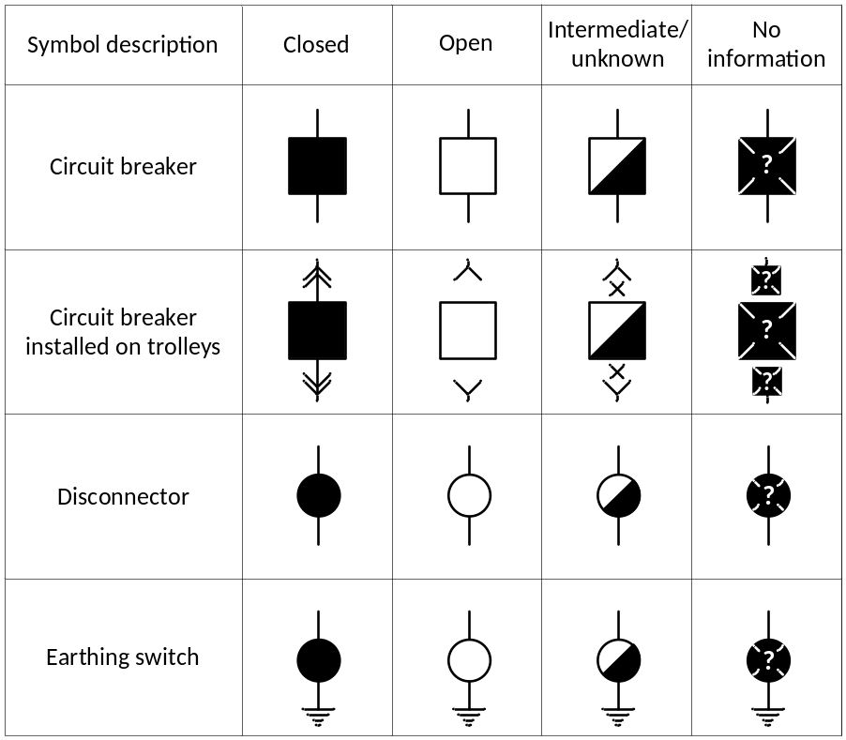
    - Single line diagram colors according to primary equipment voltage level:
- 330 kV equipment – blue;
- 110 kV equipment – red;
- 20 kV equipment – green;
- 10 kV equipment – yellow;
- 6 kV equipment – brown;
- Screen background color – gray.
    - Substation commutation devices presented by single line diagram on the operator terminal shall be controllable and the execution of all commands shall be provided in three steps:
- selection of the commutation device;
- selection of the command type (to switch on or off);
- approval of the execution.
There shall be possibility to cancel in every step before approval of the execution.
    - Operator terminal shall have zooming function for the single line diagram.
Note. As alternative option different screens for displaying different views of substation can be used. As far possible, devices from same voltage level shall be fitted in one view.
    - Operator terminal shall have maintenance and configuration software which enable at least following:
- change symbols using the graphical symbol library;
- create new symbols, change colors;
- create new displays;
- create dynamic symbols, define and attach mouse actions to symbols;
- change the layout and disposition of action buttons on the screen;
- change the design and disposition of alphanumeric information on the screen.
    - All dynamic elements in substation single line diagram should display about their invalid, not topical or otherwise bad state using "?" or symbols found in 1.5.8.
    - All entries in real-time signal and measurement list should display about their invalid, not topical or otherwise bad state.
    - Event list shall display descriptor, value label and time tag of an event.
- Descriptor (at least 64 signs) shall display event description in Latvian (including special characters).
- Value label shall display description of event value in Latvian (including special characters).
- Time tag should display date and time (including milliseconds).
    - There shall be possible to set default sorting of event list entries by time ascending or descending.
    - Operator terminal shall store at least 10 000 historical events.
    - Retrieving and filtering of historical events by time and description shall be possible.
    - There shall be possible to print (save to file) filtered event list or entire display. Printing (saving to file) should be done using only operator terminal user interface.
    - Abnormal signal list shall contain entries displaying only signals which value currently are abnormal. Abnormal list entries shall include the same fields as described in 1.5.15. For each signal there shall be possibility to define at least one abnormal value or remove abnormal value checking at all.
    - Real-time signal and measurement list shall contain all in SCS configured data points. List entries shall include the same fields as described in 1.5.15. Value field shall display current data point value. Time field shall display date and time of last value change for particular data point.
    - SCS communication diagram shall graphically display communication status between SCS devices, including interfaces to external devices (relay protection IED's, Distribution RTU, Energy Meters, etc.).
    - Remote connection over Ethernet to operator terminal using Windows Remote Desktop shall be possible. Requirements and supported functions for remote connection are:
- Authentication on connect;
- Operator terminal and software status monitoring, error detection;
- Events view or download;
- Configuration change;
- Reboot the operator terminal.
  - Measurement transducers
Description: | Required: | Please indicate: | Offered:
- Measurement transducers for measuring real-time I, U, P, Q, f (three-phase) with the accuracy class at least 0.5. | 4 pcs. | Model:
- Test blocks for transducers (one per transducer). | 4 pcs. | Model:
- Transducers shall use one of the following protocols for data transmission to RTU. | IEC 61850  IEC 60870-5-103 MODBUS | Protocol:
- Range of transducer inputs shall be selected according to ratio of the primary current and voltage transformers. | --- | ---
- Transducers without graphic display shall be DIN rail mountable or, if equipped with graphic display, shall be mounted in cut-out holes in the cubicle's internal door with display outside. | --- | ---
- Nominal transducer power supply voltage. None of the input poles shall be grounded. Measuring cubicle DC power source shall be supplied from RTU cubicle. | 110 VDC | ---
- All transducers and their equipment shall be mounted in RTU cubicle. | --- | ---
- Operating conditions. | Indoor | ---

Description | Offered:
    - For measuring current and voltage circuits Phoenix Contact URTK/S interconnection terminals or equivalent with at least 2,5mm² wire connection socket and 4mm test wire socket shall be used. For each measurement transducer at least 12 interconnection terminals shall be used – 8 for 3 phase currents and 4 for 3 phase voltages.
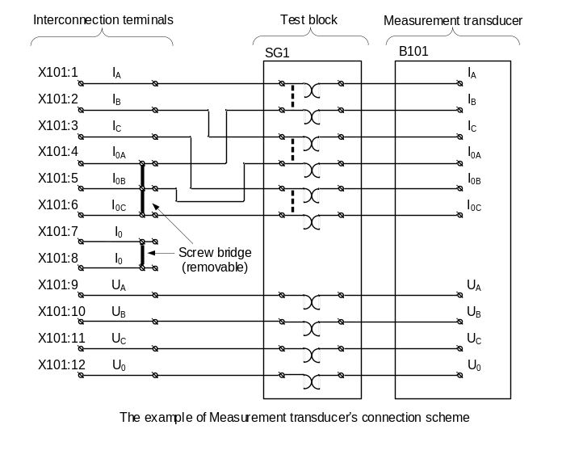
    - Transducers (if equipped with display) (point 1.6.1) and test blocks (point 1.6.2) shall be mounted in the internal door with display/front plate outside according to the suggested layout (see Drawing 2). Changes to the suggested layout must be agreed with the Customer.
    - One test block per transducer shall be mounted in the internal door for convenient shorting of currents, disconnecting of voltages and safe testing purposes. Test blocks shall be commercially manufactured.
    - Test block and test plug shall be as one integrated "plug & play" system.
    - Test blocks shall have protective cover, to protect their contacts from dust and accidental touch.
    - Test plugs shall have sockets for 4mm test wire connections.
    - Test block shall have at least 10 contact groups – 6 for 3 phase currents and 4 for 3 phase voltages.
    - Test block shall have connection terminals at the back side for connecting at least 2.5mm² wires.
    - After inserting test plug, test block shall do following:
- Shorting current measurements contacts at current transformer's side and disconnecting current contacts at measurement transducer's side;
- Current measurements' contacts shall be shorted prior to disconnecting;
- Disconnecting voltage measurements' contacts at voltage transformer and measurement transducer's sides;
- Connect all contacts to test plug sockets.

  - Other devices
GPS time receiver: | Required: | Please indicate: | Offered:
- GPS time receiver. | 1 pc. | Model:
- GPS antenna, antenna cable, lightning protection (for GPS receiver protection), mounting accessories shall be provided. | 1 set | ---
- Nominal GPS power supply voltage. No input pole shall be grounded. | 110 VDC | ---
- The GPS time receiver should work as time server. | SNTP | ---
- Ethernet port count. | ≥1 | Port count:
- Interface. | at least IEEE 802.3u, 100BASE-Tx | ---
- Connector. | RJ45 | ---
- User definable IP address per port. | TCP/IP – IPv4 | ---
- Ethernet ports shall be isolated from each other. | --- | ---
- GPS antenna's operation temperature range. | -30⁰C to +50⁰C | Range:
- GPS antenna's protection class. | ≥IP65 | Rating:
- GPS time receiver shall be DIN rail mountable or mountable into internal doors of the cubicle. | --- | ---

SCADA Ethernet switch: | Required: | Please indicate: | Offered:
- Industrial grade Layer 3 Managed Ethernet Switch.  Note. MikroTik CRS326-24G-2S+RM or other device with identical functions (described in points 1.7.33 – 1.7.54) should be delivered. | 1 pc. | Model:
- Ethernet switch shall support interface bridging to separate interfaces into different bridges. | --- | ---
- Ethernet switch shall support firewall by MAC address, IP address, port number and TCP, UDP, ICMP, IGMP protocols on each interface. | --- | ---
- Ethernet switch shall support online sniffering of ethernet packets from different interfaces, encapsulating them in TZSP protocol and streaming them over UDP through the same interface that is used for connection with SCADA without losing any functionality of this interface.  Encapsulated packets shall be recognizable by Wireshark software.  Note.  It is allowed to use different encapsulating protocol, but solution shall support all described functionality and shall be recognizable by Wireshark. Port mirroring is not acceptable for this purpose. | --- | ---
- Communication between RTU, HMI and SCADA shall be in separate interface bridge and isolated from the other interfaces by firewall. | --- | ---
- Communication between RTU and Distribution RTU shall be in separate interface bridge and isolated from the other interfaces by firewall. | --- | ---
- Communication between RTU and Energy Meters shall be in separate interface bridge and isolated from the other interfaces by firewall. | --- | ---
- Communication between SCADA Ethernet switch and IEDs Ethernet switch shall be in separate interface bridge and isolated from the other interfaces by firewall. | --- | ---
- Network connections shall be organized according to attached Drawing 1. | --- | ---
- Nominal switch power supply voltage. No input pole shall be grounded. | 110 VDC | ---
- Switch shall have fanless design. | --- | ---
- MAC bridges and Spanning Tree Protocol. | IEEE 802.1D | ---
- Rapid Spanning Tree Protocol. | IEEE 802.1W | ---
- Logical network segregation via VLAN. | IEEE 802.1Q | ---
- Traffic prioritization using QoS. | IEEE 802.1P | ---
- Multicast, Unicast, Broadcast. | IPv4 | ---
- Port mirroring capability. | --- | ---
- Loop protection support. | --- | ---
- Switch remote management. | --- | ---
- Supported link speed on all ports. | At least 100Mbps | ---
- BASE-Tx ports count | ≥13 | Ports count:
- Connector type for all BASE-Tx ports. | RJ45, CAT5 | ---
- Switch shall be DIN rail mountable or shall be mountable into internal doors of the cubicle. | --- | ---

IEDs Ethernet switch: | Required: | Please indicate: | Offered:
- Industrial grade Layer 2 Managed Ethernet Switch. | 1 pc. | Model:
- Ethernet switches shall be located in RTU cubicle and manage RTU connections to IEDs and GPS. | --- | ---
- For connection of relay protection devices optical RSTP loop shall be organized. | --- | ---
- Network connections shall be organized according to attached Drawing 1. The Supplier may offer another solution that provides the requested functionality and availability. | --- | ---
- One BASE-Tx port should be set as mirror and connected to SCADA Ethernet switch according to attached Drawing 1. | --- | ---
- Nominal switch power supply voltage. No input pole shall be grounded. | 110 VDC | ---
- Switch shall have fanless design. | --- | ---
- MAC bridges and Spanning Tree Protocol. | IEEE 802.1D | ---
- Rapid Spanning Tree Protocol. | IEEE 802.1W | ---
- Logical network segregation via VLAN. | IEEE 802.1Q | ---
- Traffic prioritization using QoS. | IEEE 802.1P | ---
- Multicast, Unicast, Broadcast. | IPv4 | ---
- Port mirroring capability. | --- | ---
- Loop protection support. | --- | ---
- Switch remote management. | --- | ---
- Supported link speed on all ports. | At least 100Mbps | ---
- BASE-Tx ports count. | ≥6 | Ports count:
- Connectors type for BASE-Tx ports. | RJ45, CAT5 | ---
- BASE-Fx ports count. | ≥2 | Ports count:
- Connectors type, fiber core size and wavelength for BASE-Fx ports. | According to other switches on the network | ---
- Configurable watchdog relay with dry contacts. | At least 48 VDC | ---
- Switch shall trigger the watchdog relay on internal fault detection, power supply outage, SNTP source loss and link failure. | --- | ---
- Standard for use in electric power substations shall be supported. | IEC 61850 | ---
- Switch shall be DIN rail mountable or shall be mountable into internal doors of the cubicle. | --- | ---

  - Necessary spare parts for SCS

RTU: | Required: | Please indicate: | Offered:
- RTU spare parts as requested in point 1.2.3 | 1 set | ---

Measurement transducers: | Required: | Please indicate: | Offered:
- Spare measurement transducer (same model as offered in point 1.6.1). | 1 pc. | ---
- Test plug for test blocks requested in point 1.6.2. | 1 pc. | Model:

SCADA Ethernet switch: | Required: | Please indicate: | Offered:
- Spare Ethernet switch (same model as offered in point 1.7.32.) shall be provided. | 1 pc. | ---

IEDs Ethernet switch: | Required: | Please indicate: | Offered:
- Spare Ethernet switch (same model as offered in point 1.7.55.) shall be provided. | 1 pc. | ---
Operator terminal hardware: | Required: | Please indicate: | Offered:
- Spare SSD (same or analog model and size as offered in point 1.4.13) shall be provided. | 1 pc. | ---

  - Necessary equipment and software for SCS testing and maintenance
Description | Offered:
    - Software and necessary specific hardware (i.e. interface adapters, interface cards, card readers, dongles, communication cables) for development and maintenance of SCS, add/remove the signals, controls, measurements, rebuild the station in a case of major failure. All necessary runtime and commissioning licenses shall be included.
    - Software and necessary specific hardware (i.e. adapters, interface cards) for development and maintenance of SCS via Ethernet.

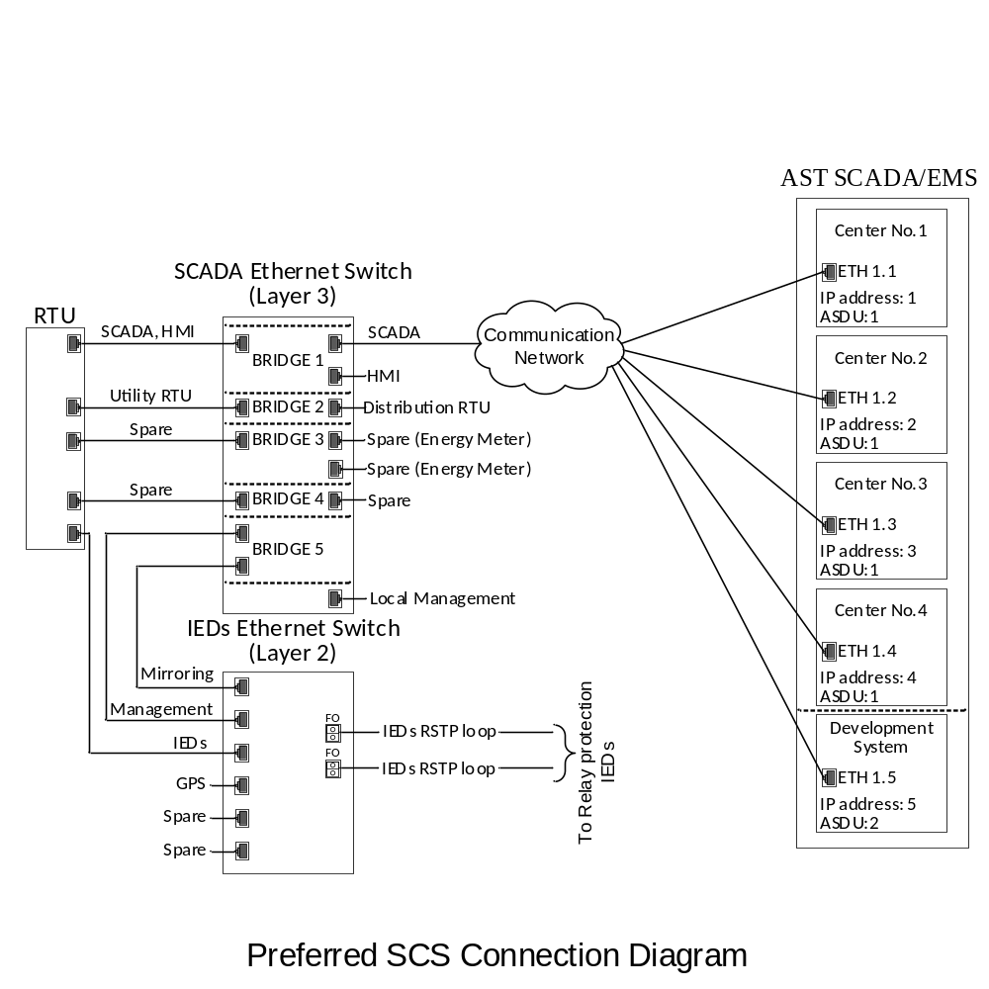

Drawing 1
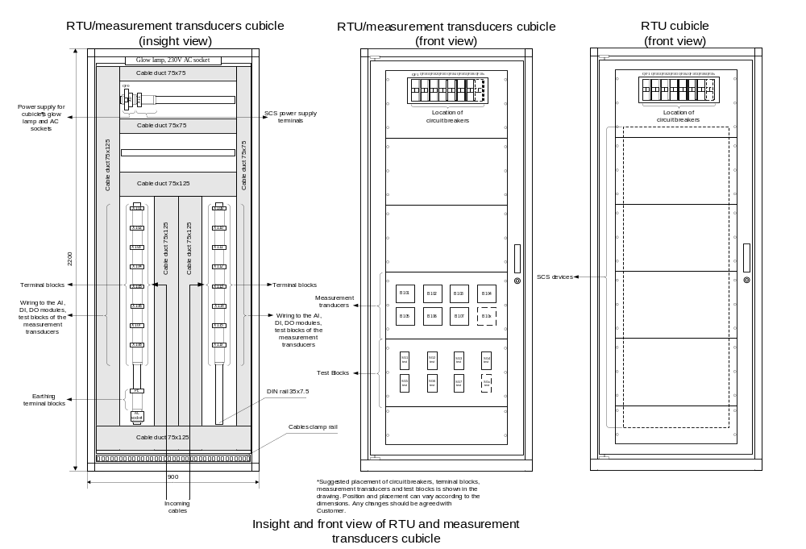
Drawing 2

