

Report on current status of CO2 emissions of the LVR Flote pilot fleet
LVR Flote operates in the transport node of Riga (Latvia). Therefore, the baseline scenario and CO₂ emissions reporting for Project’s D.1.1.1 are provided only for this location. Reporting period: 01.01.2025-31.12.2025.
- Ship data
For pilot transfer we use five state-of-art pilot boats- DINA, DAINA, DĒKLA, DACE and DORE.
No. | Pilot vessel name | Use case ship in project? | Home port
1 | DACE | Yes | Riga (Latvia)
2 | DAINA | No | Riga (Latvia)
3 | DĒKLA | No | Riga (Latvia)
4 | DINA | Yes | Riga (Latvia)
5 | DORE | Yes | Riga (Latvia)

  - Main dimensions and technical data
DACE
Dace is a high-speed pilot boat with an aluminium hull, designed for efficient operation during the summer months. Its lightweight construction ensures lower fuel consumption while providing quick and reliable service.
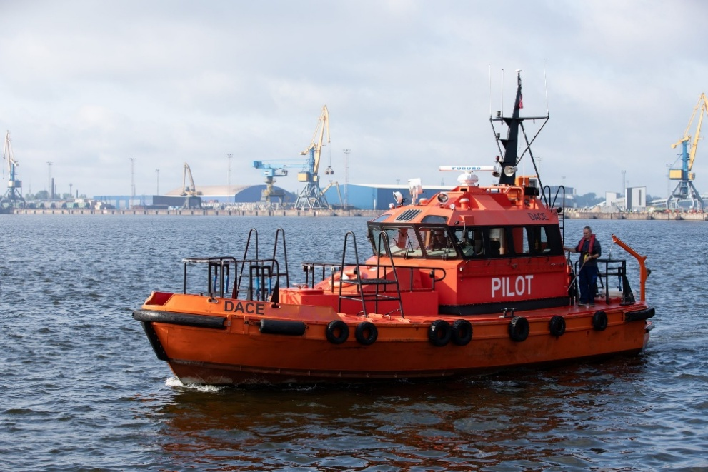
Source: www.lvrflote.lv
LOA: 12.66 m
BOA: 4.55 m
Draft: 1.50 m
Speed: Maximum 15 knots
Range: Riga port waters
Total power: 524 kW
Main engine: MTU 8V 2000 M 70 – 1 × 524 kW
Auxiliary engine: None
Propulsion system: Diesel propulsion
The heater “Hydronic 30” should also be taken into account, as it also consumes diesel fuel, but we have not previously tracked the amount consumed.
Tank capacities: Fuel tanks- 1,000 litres, Freshwater- Not used, Greywater - Not used
Main construction material: Aluminium
GA drawing: Attachment No. 1

DAINA
This pilot transfer boat features a durable steel hull, built to withstand the harshest conditions. Designed for heavy ice navigation, it operates at slow speeds to ensure safety and stability during pilot transfers.
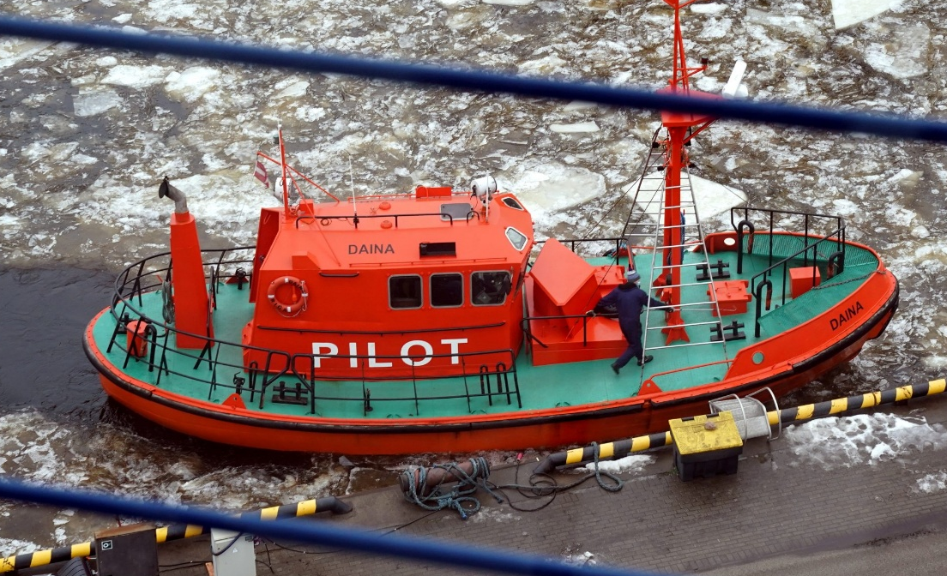
Source: www.lvrflote.lv
LOA: 13.34 m
BOA: 4.80 m
Draft: 1.96 m
Speed: Maximum 10 knots
Range: Riga port waters, Liepaja port waters- under a bareboat charter agreement.
Total power: 426 kW
Main engine: Caterpillar NAE 36-545-425 – 1 x 403 kW
Auxiliary engine: Wartsila Perkins – 1 x 23 kW
Propulsion system: Diesel propulsion
Tank capacities: Fuel tanks- 2,000 litres, 1,700 litres, 3,500 litres and 500 litres; Freshwater- Not used, Greywater- Not used
Main construction material: Steel
GA drawing: Attachment No. 2

DĒKLA
This pilot transfer boat features an aluminium hull for reduced weight and increased fuel efficiency. Designed for high-speed operation during summer months, it ensures quick and reliable pilot transfers.
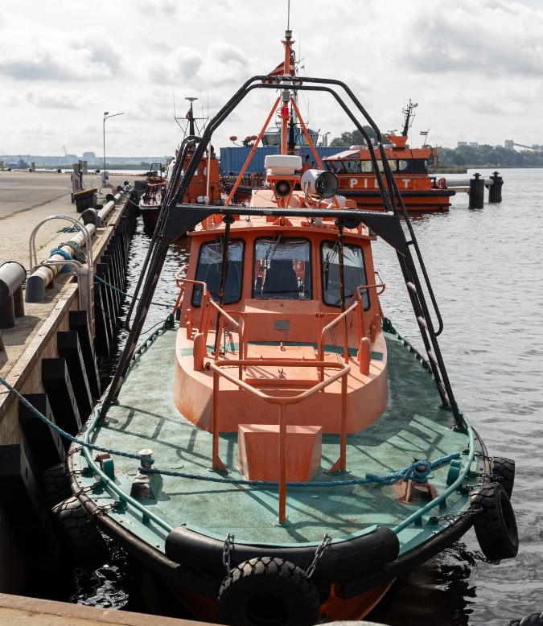
Source: www.lvrflote.lv
LOA: 10.48 m
BOA: 3.55 m
Draft: 0.86 m
Speed: Maximum 10 knots
Range: Riga port waters
Total power: 284 kW
Main engine: Volvo Penta TAMD 122 A – 1 x 284 kW
Auxiliary engine: None
Propulsion system: Diesel propulsion
Tank capacities: Fuel tanks- 800 litres, Freshwater- Not used, Greywater- Not used
Main construction material: Aluminium alloy
GA drawing: Attachment No. 3

DINA
Modern, high-speed pilot boat DINA is suitable for operations in variable sea conditions offering the best mission-capability and crew comfort.

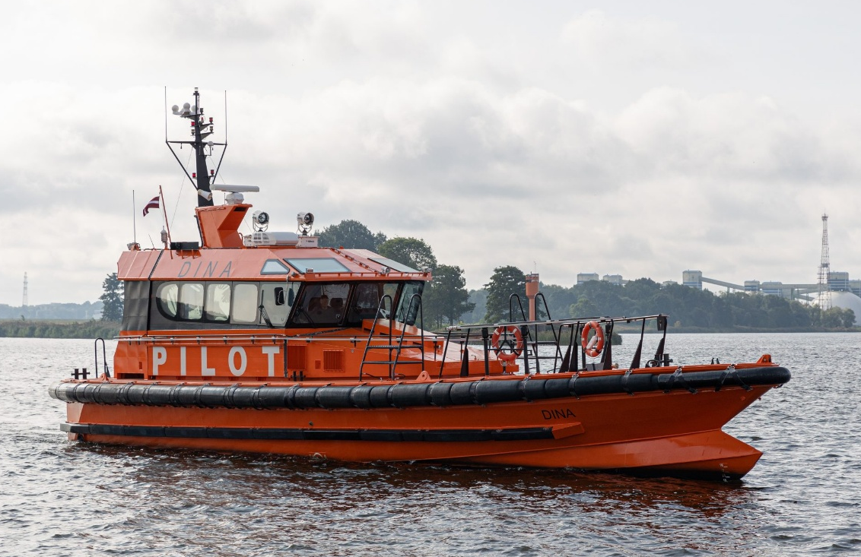
Source: www.lvrflote.lv

LOA: 20.36 m
BOA: 6.00 m
Draft: 1.50 m
Speed: Maximum 30 knots
Range: Riga port waters
Total power: 1111 kW
Main engine: Volvo Penta D16 MH – 2 x 552 kW
Auxiliary engine: Kohler – 1 x 9 kW
Propulsion system: Diesel propulsion
The heater “KABOLA” should also be taken into account, as it also consumes diesel fuel, but we have not previously tracked the amount consumed.
Tank capacities: Fuel tanks- 1,500 litres, 1,500 litres; Freshwater-200 litres, Greywater- 200 litres
Main construction material: Aluminium
GA drawing: Attachment No. 4

DORE
Dore is a highly durable boat used for pilot transfer, carrying a reliable steel hull to navigate harsh ice conditions
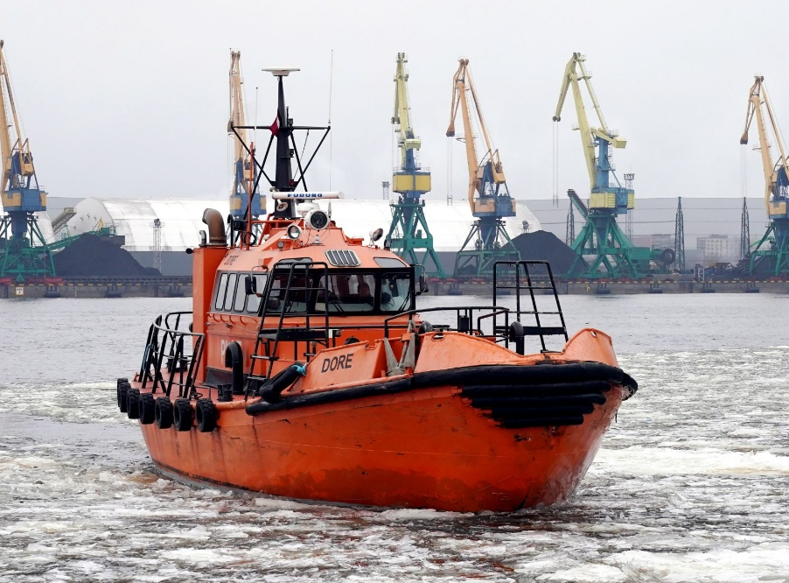
Source: www.lvrflote.lv
LOA: 14.88 m
BOA: 5.30 m
Draft: 2.40 m
Speed: Maximum 10 knots
Range: Riga port waters
Total power: 630 kW
Main engine: MTU 12V 2000 M60 – 1 x 600 kW
Auxiliary engine: Susidiesel Finl 200 – 1 x 30 kW
Propulsion system: Diesel propulsion
The heater “KABOLA” should also be taken into account, as it also consumes diesel fuel, but we have not previously tracked the amount consumed.
Tank capacities: Fuel tanks- 7,000 litres, 2,000 litres; Freshwater- Not used, Greywater- Not used
Main construction material: Steel
GA drawing: Attachment No. 5
- Fuel
2.1. Used fuel type: MDO.
2.2. Specification - Attachment No. 6 and No. 7
2.3. Main engine working hours:
No. | Pilot vessel name | Working hours 2025 (hours) |  |  |  |  |  |  |  |  |  |  |  | Yearly total
No. | Pilot vessel name | Jan | Feb | Mar | Apr | May | Jun | Jul | Aug | Sep | Oct | Nov | Dec | Yearly total
1 | DACE | 79 | 234 | 262 | 105 | 92 | 71 | 131 | 177 | 142 | 131 | 180 | 146 | 1750
2 | DAINA | bareboat charter agreement | bareboat charter agreement | bareboat charter agreement | 163 | 59 | 0 | 0 | 0 | 32 | bareboat charter agreement | bareboat charter agreement | bareboat charter agreement | 254
3 | DĒKLA | 12 | 15 | 6 | 4 | 6 | 4 | 4 | 4 | 6 | 4 | 0 | 0 | 65
4 | DINA* | 235 | 79 | 126 | 162 | 208 | 193 | 156 | 165 | 157 | 171 | 128 | 139 | 1919
4 | DINA* | 235 | 79 | 126 | 162 | 208 | 193 | 156 | 165 | 157 | 171 | 128 | 139 | 1919
5 | DORE | 0 | 8 | 1 | 0 | 2 | 0 | 0 | 0 | 19 | 1 | 0 | 0 | 31

*PB DINA is equipped with two main engines

2.4. Monthly and yearly fuel consumption totals per ship
Reporting period: 01.01.2025-31.12.2025.
No. | Pilot vessel name | Monthly fuel consumption in 2025 (litres) |  |  |  |  |  |  |  |  |  |  |  | Yearly total
No. | Pilot vessel name | Jan | Feb | Mar | Apr | May | Jun | Jul | Aug | Sep | Oct | Nov | Dec | Yearly total
1 | DACE | 4494 | 10448 | 9750 | 6184 | 4602 | 2556 | 4716 | 6372 | 5428 | 4794 | 7040 | 6116 | 72400
2 | DAINA | bareboat charter agreement | bareboat charter agreement | bareboat charter agreement | 3716 | 236 | 0 | 0 | 0 | 1317 | bareboat charter agreement | bareboat charter agreement | bareboat charter agreement | 5269
3 | DĒKLA | 312 | 330 | 180 | 120 | 156 | 112 | 112 | 128 | 204 | 120 | 0 | 0 | 1774
4 | DINA | 15776 | 4740 | 8524 | 11050 | 11648 | 14668 | 11232 | 10560 | 9896 | 10076 | 9164 | 10398 | 127732
5 | DORE | 1098 | 1260 | 840 | 560 | 908 | 0 | 0 | 0 | 5347 | 596 | 640 | 1688 | 12937

2.5. Monthly and yearly fuel consumption per working hour and per operated nautical miles: Only working hours are recorded. Operated nautical miles are not tracked.
No. | Pilot vessel name | Monthly and yearly fuel consumption per working hour (litres/hour) |  |  |  |  |  |  |  |  |  |  |  | Yearly total
No. | Pilot vessel name | Jan | Feb | Mar | Apr | May | Jun | Jul | Aug | Sep | Oct | Nov | Dec | Yearly total
1 | DACE* | 56.89 | 44.65 | 37.21 | 58.90 | 50.02 | 36.00 | 36.00 | 36.00 | 38.23 | 36.60 | 39.11 | 41.89 | 41.37
2 | DAINA | N/A | N/A | N/A | 22.80 | 4.00 | N/A | N/A | N/A | 41.16 | N/A | N/A | N/A | 20.74
3 | DĒKLA | 26.00 | 22.00 | 30.00 | 30.00 | 26.00 | 28.00 | 28.00 | 32.00 | 34.00 | 30.00 | N/A | N/A | 27.29
4 | DINA* | 33.57 | 30.00 | 33.83 | 34.10 | 28.00 | 38.00 | 36.00 | 32.00 | 31.52 | 29.46 | 35.80 | 37.40 | 33.28
5 | DORE* | N/A | 157.50 | 840.00 | N/A | 454.00 | N/A | N/A | N/A | 281.42 | 596.00 | N/A | N/A | 417.32

* The heater should also be taken into account, as it also consumes diesel fuel, but we have not previously tracked the amount consumed.
2.6. Source of fuel consumption data: Fuel consumption is based on fuel level readings at the beginning and end of each month and divided by the number of main engine working hours
- Number of pilotages
The number of pilotages per ship in 2025 was not tracked and started to be recorded from May 2026. Only the total number of pilotages for all five pilot boats combined is recorded.
No. | Month | Number of pilotages
1 | 01.01.2025-31.01.2025 | 487
2 | 01.02.2025-28.02.2025 | 492
3 | 01.03.2025-31.03.2025 | 535
4 | 01.04.2025-31.04.2025 | 510
5 | 01.05.2025-31.05.2025 | 485
6 | 01.06.2025-30.06.2025 | 438
7 | 01.07.2025-31.07.2025 | 490
8 | 01.08.2025-31.08.2025 | 526
9 | 01.09.2025-30.09.2025 | 483
10 | 01.10.2025-31.10.2025 | 456
11 | 01.11.2025-30.11.2025 | 479
12 | 01.12.2025-31.12.2025 | 432

- Maintenance
4.1. Technical modifications: No technical modifications were carried out during the reporting period.
4.2. Docking:
No. | Pilot vessel name | Docking | Docking period
1 | DINA | No | -
2 | DAINA | Yes | 02.07.2025-06.08.2025
3 | DĒKLA | No | -
4 | DACE | No | -
5 | DORE | No | -

4.3. Ice conditions:
No. | Pilot vessel name | Operated under ice conditions | Period of operation under ice conditions
1 | DINA | Cannot operate under ice conditions | -
2 | DAINA | Yes | 01.02.2025-01.04.2025
3 | DĒKLA | Cannot operate under ice conditions | -
4 | DACE | Can operate in light ice conditions; not capable of icebreaking | 01.02.2025-01.04.2025
5 | DORE | Yes | 01.02.2025-01.04.2025

Attachment No. 1
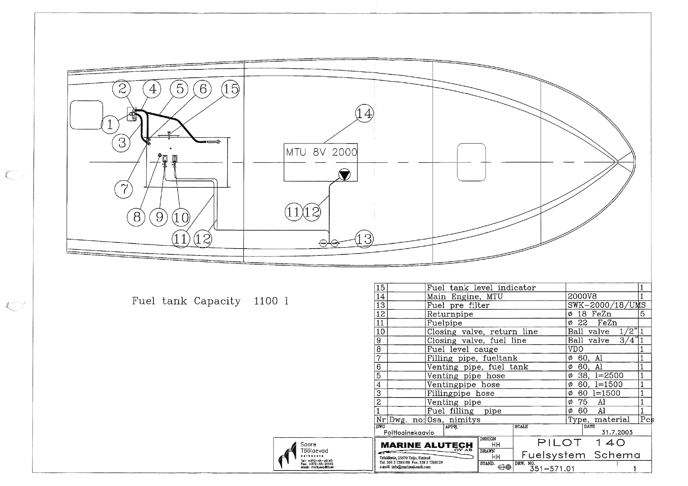
Attachment No. 2
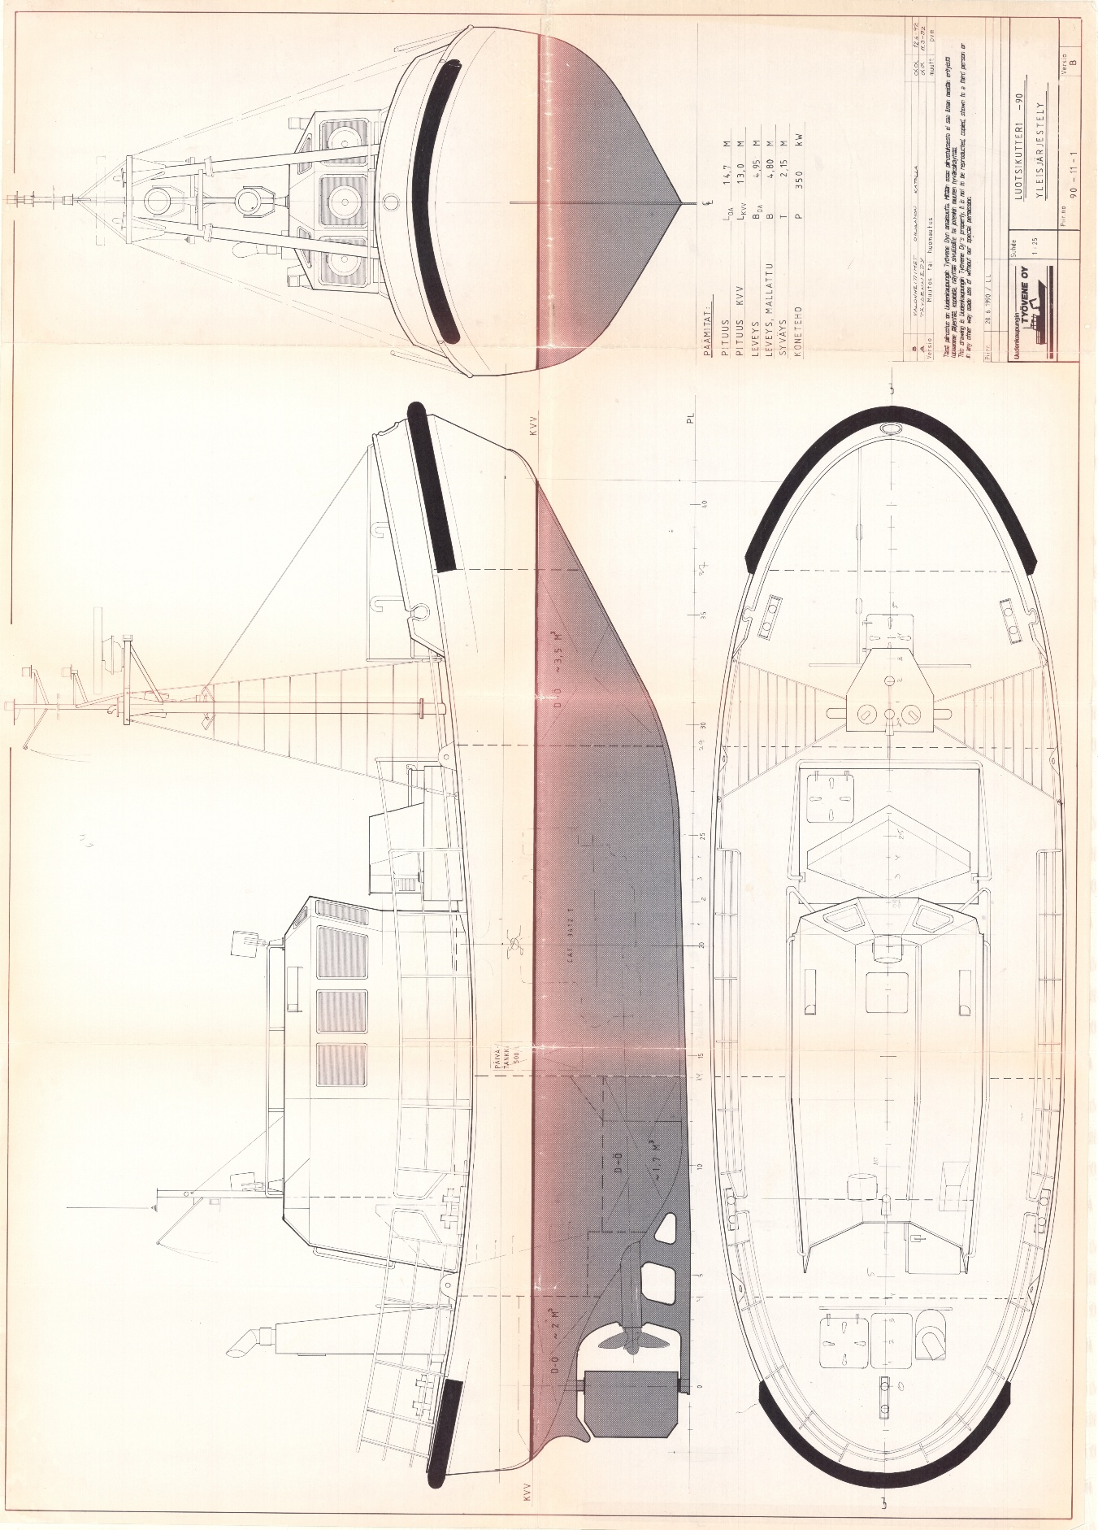
Attachment No. 3
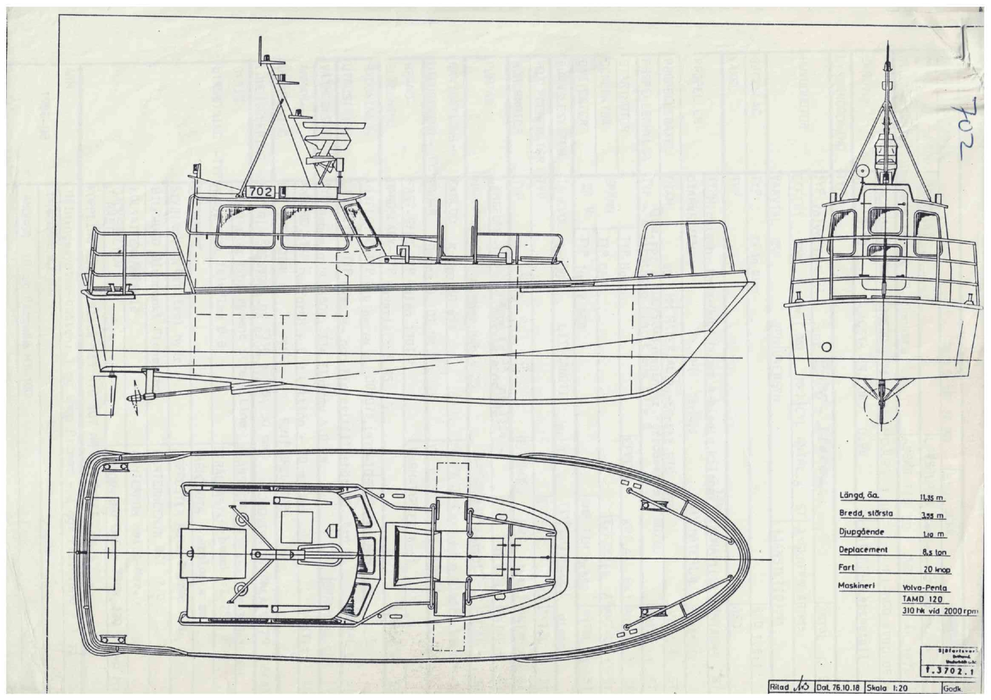
Attachment No. 4
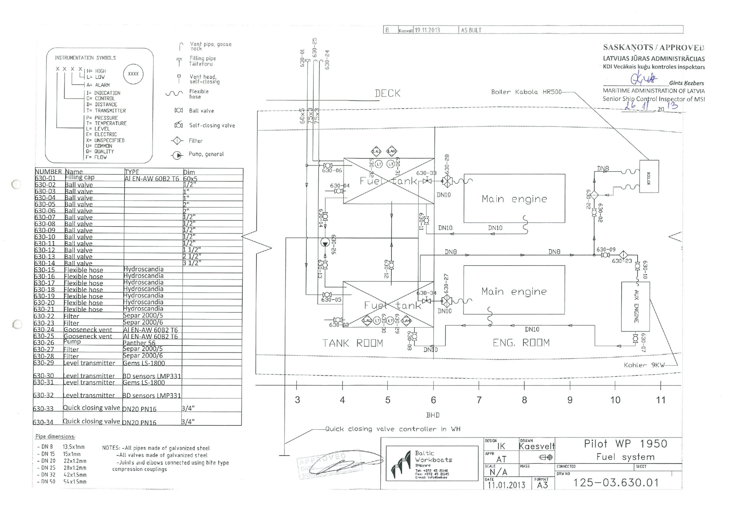
Attachment No. 5
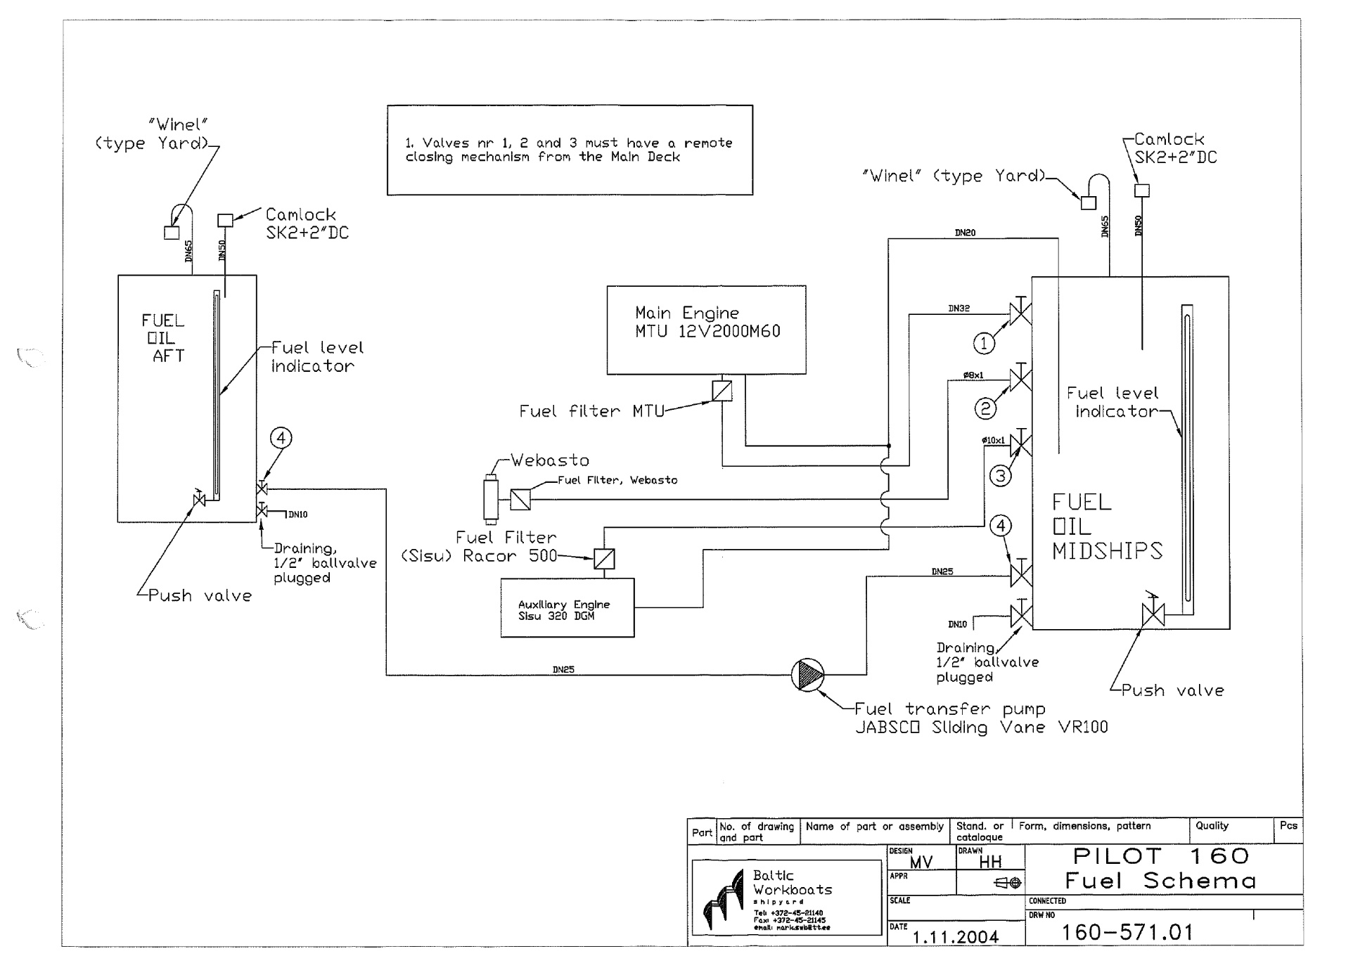

Attachment No. 6
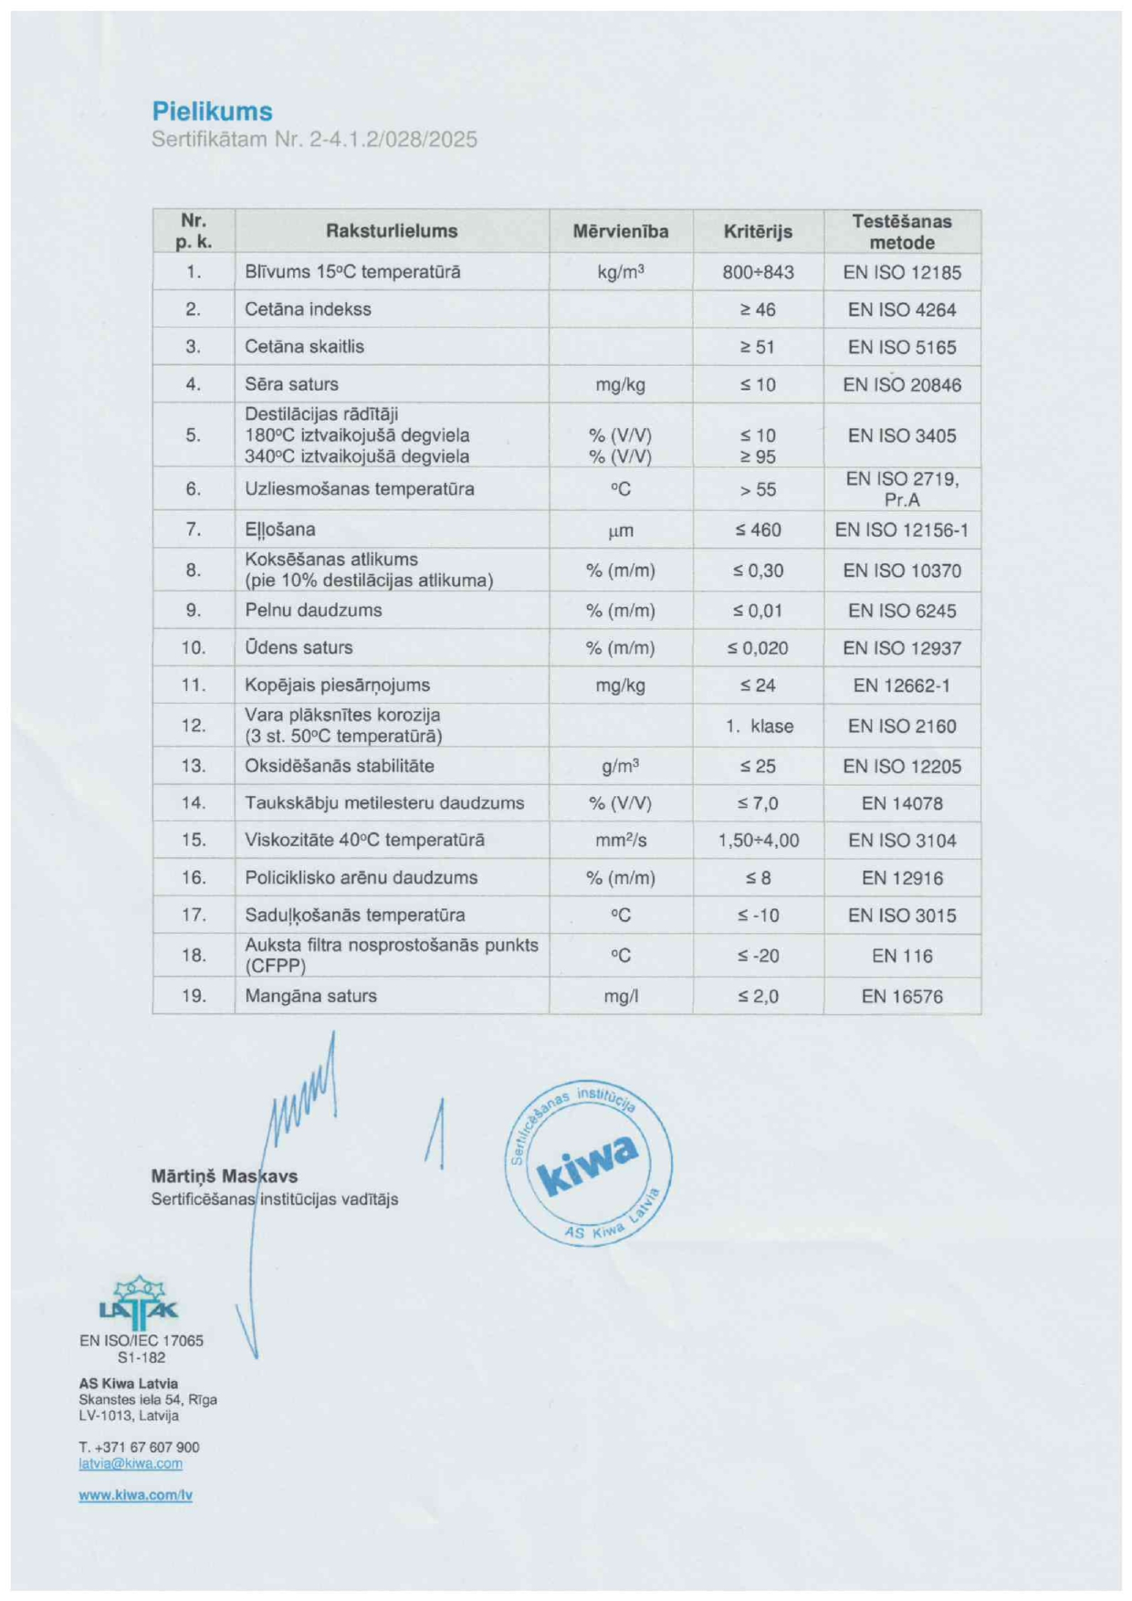
Attachment No. 7


