Annex no 1.
(update date: 06.03.2025.)

TECHNICAL SPECIFICATION
“Procurement of unmanned aerial vehicles and related management software for municipal police"

Content
Introduction 2
Definitions and acronyms 2
Context and purpose 2
1. Organisational requirements 3
2. UAV, equipment and docking stations 5
2.1. UAV parameters 5
2.2. UAV camera sensor 6
2.3. UAV Remote control 6
2.4. UAV Additional equipment 7
2.5. UAV docking station 8
2.6. UAV, docking stations and software testing 8
3. UAV operation, management and control software 8
4. Delivery 12
5. Installation 13
6. Safety 14
7. Warranty 14
8. Training 14
9. Architecture 15
10. Maintenance and servicing 16
11. Annexes 17

Introduction

Definitions and acronyms
1.table. Definitions and acornyms.
Acronyms and abbreviations | Definition
AGL | Above ground level (altitude)
BVLOS | Beyond visual line of sign (operation)
C2 | Command and Control (C2) link: the data link between the UAV and the UAV control station for the purposes of managing the flight
Duration of the project | Grant project "Development of 5G systems for protection of life and public health in Riga - 5G4LIVES" (PVM ID APS 1609) will be implemented by 31 december 2026.
ERP | Emergency Reaction Plan
GPS | Global Positioning System
MTOW | Maximum take off weight
UAS | An Unmanned aerial system is an unmanned aircraft and the equipment necessary for the safe and efficient operation of that aircraft. An unmanned aircraft is a component of a UAS
UAV | Unmanned Aerial Vehicle
UAV management software | UAV management software supports simultaneous flight planning, execution and monitoring of multiple UAVs, allowing the operator to control all UAVs from a single interface
UTC | Coordinated Universal Time
VLOS | Visual line of sign (operation)  'Line-of-sight operation' ('VLOS') is a type of UAV operation whereby the remote pilot can maintain unaided visual contact with the UAV at all times, thereby controlling the flight path of the UAV in relation to other aircraft, people and obstacles, in order to avoid collisions

Context and purpose
This document is an annex to the terms of reference of the procurement procedure entitled 'Procurement of unmanned aerial vehicles and related management software for municipal police' (procurement identification number CAIP 2025/02 (hereinafter referred to as the Procurement)). The technical specification defines and describes the requirements.
The procurement shall be carried out within the framework of the European Commission Connecting Europe Facility Digital programme (CEF Digital programme) grant project "Development of 5G systems for protection of life and public health in Riga - 5G4LIVES" (PVM ID APS 1609), implemented by the Riga State City Municipality Agency "Riga Digital Agency".
The Supplier shall deliver and install four (or other number if required for functionality) unmanned aerial vehicles (UAVs) with the appropriate number of charging platforms (docking stations) at two Riga City Police rescue stations (at least two UAVs and a docking station at each station). The UAVs will be used for surveying the water area as well as for providing support during rescue operations. In view of the above, the UAVs should be equipped with both thermal imaging and video surveillance cameras for use during daylight and dark hours, as well as with a loudspeaker to give remote commands to swimmers. The existing lifesaving stations in Ķīšezers and Vecāķi will be used as UAV base stations. The UAS should be able to perform automated flights 24/7 over a 5G network, as well as automated charging for flight continuity. When not flying 24/7, the UAV shall be ready to take off within 3 (three) minutes.
The Supplier shall ensure the installation of docking stations.
Timeframes for the provision of the service:
  - Delivery of one UAV and installation of a temporary docking station for testing purposes within 6 months from the date of conclusion of the Contract;
  - Within 6 months from the date of conclusion of the Contract, software developed for testing purposes (can run in the Supplier's production environment), planned software development rate 80 %;
  - Delivery and installation of all UAVs and docking stations at the intended locations within 12 months from the date of conclusion of the Contract.
  - Full (100 %) software development and installation in the Customer's production environment within 12 months from the date of conclusion of the Contract.
From the date of conclusion of the Contract until 31 December 2026 - overall maintenance of the UAVs, docking stations and provision of warranty and maintenance of the software.
The Technical Specifications shall specify the requirements of the services to be provided within the scope of the procurement, which shall be met in the performance of the work to be procured.
The Supplier is expected to propose, in its tender as well as during the lifetime of the contract, solutions that best achieve the objective of the requirement. The decisive criterion for the fulfilment of a requirement shall be the achievement of the objective of the requirement.
Each requirement shall be structured as follows:
- The Claim Number (ID) is an identifier that denotes the sequence number of a particular requirement in the Technical Specification. The index numbering is in ascending order starting with '1' and allows each specific requirement defined in the technical specification to be uniquely identified, with the aim of facilitating the reading and quick orientation of the technical specification (quick identification of a specific requirement, linking the technical specification to the regulations, etc.).
- The title of a requirement is the title of a specific requirement, which provides information on the content of the requirement.
- Description of the requirement - a description of the specific requirement to be fulfilled which is sufficiently detailed to enable the Contracting Authority to assess the conformity of the technical tender and the solution to be supplied with the aims and objectives defined in the tender specifications and, in turn, to provide the Supplier with information on the requirements to be met and on the cooperation arrangements for implementing the technical specification as a whole.

Organisational requirements
Claim ID | Claim title and description | Supplier offer:
PROJECT MANAGEMENT
The procurement shall be implemented as a single, sequential project, managed using project management methodologies that are focused on the rapid and accurate delivery of a result that meets the Client's requirements.
The Supplier shall prepare and agree with the Employer a Project Implementation Plan (including a detailed Project Schedule). The plan may be updated and agreed with the Customer after the conclusion of the Contract.
PROJECT LANGUAGE
The Supplier shall ensure that all communications and documentation developed or improved under the Project, including UAV and software warranty shall be in Latvian.
The Supplier shall ensure that the materials are translated into Latvian.
PARTICIPATION IN PROJECT MEETINGS
The Supplier shall, according to the competence of its specialists, ensure the participation in person/online at any Project meeting at the request of the Customer, providing information within its competence, e.g. on the progress of UAV manufacturing, software development and construction of docking stations, etc. At the request of the Customer, provide a presentation at the meeting. The minutes of the project meetings shall be taken by the Customer.
COMPLIANCE WITH STANDARDS AND LAWS
When planning the production and development of the UAV software, the Supplier shall ensure that it complies with applicable laws and regulations, both in terms of business processes, security of the UAVs production and software, and the protection of personal data:
- Regulation (EU) 2018/1139 of the European Parliament and of the Council of 4 July 2018 on common rules in the field of civil aviation and establishing a European Aviation Safety Agency, amending Regulations (EC) No 2111/2005, (EC) No 1008/2008, (EU) No 996/2010, (EU) No 376/2014 and Directives 2014/30/EU and 2014/53/EU and repealing Regulations (EC) No 552/2004 and (EC) No 216/2008 and Council Regulation (EEC) No 3922/91 of the European Parliament and of the Council;
- Commission Implementing Regulation (EU) 2019/947 of 24 May 2019 on rules and procedures for the operation of unmanned aerial vehicles;
- Regulation (EU) 2016/679 of the European Parliament and of the Council of 27 April 2016 on the protection of natural persons with regard to the processing of personal data and on the free movement of such data and repealing Directive 95/46/EC (General Data Protection Regulation) and the Law on the Processing of Personal Data;
- General Data Protection Regulation and the Law on the Processing of Personal Data;
- Law on Aviation;
- National Cyber Security Law and the laws and regulations issued on its basis;
- Cabinet of Ministers Regulation of 14 July 2020 No 445 "Procedure for Institutions to Post Information on the Internet",
- Cabinet of Ministers Regulation No 248 of 23 April 2024 "Rules for the Flight of Unmanned Aircraft";
- - Cabinet of Ministers Regulation No 508 of 6 July 2021 "Procedures for the identification, security measures and business continuity planning and implementation of critical infrastructure, including European critical infrastructure";
- Other requirements included in the relevant regulatory enactments that are adopted and enter into force during the project implementation which can be sufficient for additional costs, if any arise.

UAV, equipment and docking stations

UAV parameters
Claim ID | Claim title and description | Supplier offer:
BGK-1 | SIZE  The diagonal size of the UAV (during flight, counting the propellers size) should not exceed 1 meter 15 cm
BGK-2 | MTOW  No more than 4000 grams (including power elements, propellers, etc. equipment)
BGK-3 | UAV TYPE  Multirotor
BGK-4 | FLYING TIME  At least 25 minutes non-stop UAV flight (without additional payload)
BGK-5 | GLOBAL POSITIONING SYSTEM  Built-in global positioning system that supports GPS and support at least two of the following systems: GLONASS, Galileo , BEIDOU.  • Vertical accuracy: at least 0.5 m.  • Horizontal accuracy: at least 1.5 m.
BGK-6 | GEOFENCing  Geo-restriction feature that uses GPS technology to establish virtual geographical boundaries, s, within which drones can operate
BGK-7 | NETWORK  The UAV must be equipped with a 4G/5G modem, that can support following 3GPP bands:  - n28: 703 MHz – 748 MHz / 758 MHz – 803 MHz;  - n20: 832 MHz – 862 MHz / 791 MHz – 821 MHz;  - n75: 1432 MHz – 1517 MHz;  - n3: 1710 MHz – 1785 MHz / 1805 MHz – 1880 MHz;  - n1: 1920MHz – 1980 MHz / 2110 MHz - 2170MHz;  - n40: 2300 MHz – 2400MHz / 2300MHz – 2400 MHz;  - n7: 2500 MHz – 2570 MHz / 2620 MHz – 2690 MHz;  - n38: 2570 MHz – 2620 MHz / 2570 MHz – 2620 MHz;  - n78: 3300 MHz – 3800 MHz,  and can provide both control of the UAV and video streaming through the mobile network.
BGK-8 | VIDEO STREAMING  ONVIF support, 2 separate video streams (FHD and thermal), video encoding H.264.
BGK-9 | OPERATION CONDITIONS  Intended for use in Latvian climatic conditions. Must be able to operate in temperatures from -10 C to +40 C. IP 44 or higher protection or signed confirmation from the executor.
BGK-10 | WIND RESTRICTIONS  The feasibility of using UAS (Unmanned Aerial Systems) under wind conditions with speeds of up to 10 m/s.
BGK-11 | OBSTACLE DETECTION SYSTEM  Equipped with at least front-facing obstacle detection system with a range of at least 20 meters.
BGK-12 | SPEAKER  The UAV is equipped with a built-in or connectable speaker (horn) capable of producing at least 100 dB at a distance of 1 meter.
BGK-13 | IDENTIFICATION  Network remote ID
BGK-14 | CERTIFICATION  CE certification

UAV camera sensor
Claim ID | Claim title and description | Supplier offer:
BGK-15 | SENSOR EFFECTIVE RESOLUTION  At least 12 MP with a CMOS sensor.
BGK-16 | VIDEO RECORDING  4K: 3840×2160 at 30fps
BGK-17 | THERMAL IMAGE SIZE  At least 640x480 at 30 fps
BGK-18 | LENS  The digital zoom must be at least 10x for the standard lens and 2x for the thermal lens.  The focal length should be no less than 13 mm and no more than 19 mm in full-frame equivalent.  The lens must support 1080p video streaming for an RGB camera.
BGK-19 | CAMERAS CONFIGURATION OPTIONS  Options to combine thermal and visual video in real-time.  The video stream should display the GPS coordinates of the UAV and the camera angle
BGK-20 | OPERATION Conditions  Aligned with the requirements of BGK-9.
BGK-21 | CAMERA STABILIZER  A 3-axis camera stabilizer (gimbal) that ensures the oscillation of additional equipment (camera equipment) within a range of 90° (from the vertical reception axis to a positive angle for upward tilt).
BGK-22 | LOCAL DATA STORAGE  Built-in memory with at least 50 GB by SD-Card insertion or any other method.

UAV Remote control
Claim ID | Claim title and description | Supplier offer:
BGK-23 | REMOTE CONTROL  The remote control must have two physical lever controls (joysticks).  It should be equipped with 1 x HDMI port and 1 x USB port (Type A or Type C).  The USB port must support the connection of an external data storage.
BGK-24 | SCREEN  A built-in screen with a diagonal size of at least 5 inches and a brightness of at least 600 nits
BGK-25 | BATTERY  Built-in battery capable of providing 3 hours of continuous operation at a temperature of 15°C and 50% relative humidity.
BGK-26 | SOFTWARE  Includes built-in, free of charge UAS management software.
BGK-27 | REMOTE SOFTWARE CAPABILITIES  The software must support the following functionalities:  • Manual (hand) control  • Autopilot with automatic return to the departure point  • Scheduled flight selection  • Flight tracking on an external display device  • Remote recording control  • Live video streaming
BGK-28 | LOCAL DATA STORAGE  Built-in memory with at least 32GB
BGK-29 | CONTROL  The command and control (C2) connection signal delay—time between the remote pilot's command and the corresponding UAS execution—must not exceed 1 second.
BGK-30 | Minimum requirements for C2 connection:  • If a maneuver requires the transmission of multiple messages in a specific sequence, they must be sent such that execution occurs within a single uplink transmission.  • Each message must be timestamped, indicating the time when the initiator commits the message for transmission.  • The timestamp must represent the exact time the initiator generates the message for further processing.  • All data processing steps (input, encoding, transmission, decoding, representation) must preserve the integrity and content of the original message.  • The recipient system must automatically reject messages that are not addressed to it.  • The initiating system must notify the end user if a response is not received within the specified time.  • If a received message contains a timestamp indicating that the time limit has been exceeded, the receiving system must automatically reject the message and either notify the initiator or display an appropriate warning.  • If the remote pilot is informed that a response was not sent within the specified time, a defined procedure must be in place to address the issue.  • The recipient system must be capable of detecting corrupted messages.  • A dynamic message prioritization mechanism must be implemented to handle expired messages or messages received in a corrupted state effectively

UAV Additional equipment
Claim ID | Claim title and description | Supplier offer:
BGK-31 | PROPELLERS  Each UAV must be equipped with two complete sets of propeller blades.
BGK-32 | BATTERIES  The supplier must provide a sufficient number of batteries to support a total flight duration of 10,000 hours. Calculations should consider the maximum number of battery charge cycles specified by the manufacturer and the maximum flight duration of the UAV under ideal conditions.
BGK-33 | SUPPLY OF BATTERIES  Batteries must be delivered in a staggered delivery, ensuring that the quantity of batteries requested is delivered within 10 working days of the Customer's request. Upon use of contracted batteries within duration of the supply contract, additional batteries can be supplied upon separately agreed timeline but on price proposed in this proposal with terms of the contract.

UAV docking station
Claim ID | Claim title and description | Supplier offer:
BGK-34 | SIZE  The size of the docking station should not exceed 2x3 meters
BGK-35 | OPERATION AND CONDITIONS  • Must have an IP53 or higher protection rating.  • Must be compatible with the offered UAV and capable of automatically charging or replacing the battery.
BGK-36 | SENSORS  Temperature, wind speed and humidity.
BGK-37 | NETWORK  The docking station must be connected to internet or equipped with a 5G modem supporting following bands:  - n28: 703 MHz – 748 MHz / 758 MHz – 803 MHz;  - n20: 832 MHz – 862 MHz / 791 MHz – 821 MHz;  - n75: 1432 MHz – 1517 MHz;  - n3: 1710 MHz – 1785 MHz / 1805 MHz – 1880 MHz;  - n1 (1920MHz – 1980 MHz / 2110 MHz - 2170MHz);  - n40 (2300 MHz – 2400MHz / 2300MHz – 2400 MHz)  - n7: 2500 MHz – 2570 MHz / 2620 MHz – 2690 MHz;  - n38: 2570 MHz – 2620 MHz / 2570 MHz – 2620 MHz;  - n78: 3300 MHz – 3800 MHz.
BGK-38 | FEEDING  AC 230V
BGK-39 | RESERVE POWER SUPPLY  Must be able to ensure full operation of the docking station for at least 60 minutes

UAV, docking stations and software testing
Claim ID | Claim title and description | Supplier offer:
TEST-1 | Testing  Before the delivery of the system (UAVs, remote control, docking station, software), the supplier must conduct testing, which includes at least the following:  - Functional tests  - Integration tests: verification of interoperability with related systems (if applicable).  - Security Tests  The customer reserves the right to perform independent software security testing. The supplier is obligated to address all identified deficiencies and vulnerabilities within these tests under the software warranty without additional payment.  The testing period is up to 20 working days. The supplier and the customer may separately agree on an extended testing period if necessary.  Testing to be carried out in accordance with the overall business process description and project objectives (Annex 2)

UAV operation, management and control software
Claim ID | Claim title and description | Supplier offer:
PROG-1 | access rights levels  The software must support user authorization with four levels of access rights. User roles should be defined during the user creation process, ensuring access is restricted to the appropriate functions based on the assigned role.
PROG-2 | ADMINISTRATOR  - Full access to all functions of the UAV, docking stations, and software.  - User management, including creation, deletion, and editing of user accounts.  - Management of full flight plans, including creation, editing, and deletion.  - Monitoring and maintenance of the UAV, docking stations, and software.
PROG-3 | CHIEF PILOT Level  - Creation of new flight plans.  - Rescheduling or cancellation of existing flight plans.  - Forced termination of flights.  - Monitoring the condition of the UAV and related equipment.
PROG-4 | PILOT level  - Execution of established flights.  - Forced termination of flights.  - Monitoring the condition of the UAV and related equipment .
PROG-5 | THE OBSERVER level  - flight monitoring;  - UAV and equipment condition monitoring.
PROG-6 | AUTHENTICATION  The software must provide secure login for users, utilizing multi-factor authentication.
PROG-7 | MAIN menu  After logging in, the user is presented with a main screen featuring an OpenStreetMap layer or another map layer with higher detail. This screen provides access to all necessary functions for UAV management and monitoring.
PROG-8 | INFORMATION SHOWN ON THE MAIN MENU  The Executor provides the software with the following functionalities (must have all of the below mentioned in any distribution/pathway):  - UAV control:  In this menu, the user can:  - Select and control multiple UAVs.  - Switch between different active UAVs.  - Select previously created flight plans.  - Create new flight plans.  - Cancel flights.  - UAV and docking station status:  Displays the location and status of UAV and docking stations, including:  - Charge levels.  - Wind speed.  - UAV and docking station IDs.  - Active flights or planned flight trajectories:  Viewable on the map interface.  - Information displayed during active flights:  - Distance between the docking station and UAV.  - Battery charge level.  - Remaining battery life.  - Remaining time for the scheduled flight.  - Current wind speed in m/s.  - Current GNSS signal strength (categorized as strong, medium, or weak).  - Functions during active flights:  - Suspend UAV during a scheduled flight.  - Replace the UAV at a specific location and take over the task (depending on battery charge level).  - Start and stop video recording.  - Capture photos.  - Interrupt the scheduled flight.  - Start a new scheduled flight.  - Take direct control of the UAV.  - Online video streaming:  - Display online video before and during the flight.  - Switch between thermal and standard video streams.  - Video image information:  - GPS coordinates of the UAV location.  - UAV flying altitude.  - Video camera direction and angle.  - Zoom index.  - Date and time of video recording.
PROG-9 | WARNINGS  The software must provide the following warnings:  - Notification of the validity period of the user's access rights after logging in (displayed in red if the validity period is less than one month).  - UAV deviation from the planned flight route or altitude.  - Low battery level.  - Notification of upcoming UAV technical maintenance (parameters defined in UAV settings).  - Detection of a flying object approaching the UAV (at 500 m, 200 m, and 50 m in the horizontal and vertical planes).  - GPS signal interference.  - Video stream interruption.  - Obstacle detection system alerts.  - Inaccessibility of certain system equipment.  - Problems with the docking station, including power failure.  - Inability to land at the docking station.  - Activation of manual control mode (active until the UAV has landed at the docking station or a new scheduled flight has started)..
PROG-10 | CREATING A NEW FLIGHT PLAN  The function can be displayed in the main menu. Its purpose is to create scheduled flights by configuring the following parameters:  - UAV flight route.  - Holding points.  - Flight height for each segment of the route.  - UAV replacement points to continue the flight.  - Flight speed for each stage of the flight.  - Camera direction and angle.  - Camera zoom index.  - The ability to manually perform a flight and save it as a new scheduled flight.  - The option to import new scheduled flights.
PROG-11 | FLIGHT LOG RECORDS  - Record the connection or disconnection from the software, including the time of the event, synchronized with Coordinated Universal Time (UTC).  - Record the Internet Protocol (IP) address from which the operation was performed.  - Record the identifier of the initiator of each operation.  - Log all operations performed in the system.  System audit records must be created and stored for a minimum of 36 months after their creation. These records, or their copies, must be stored separately from the system to ensure their integrity .
PROG-12 | OPERATIONS RECORDS JOURNAL  A dedicated section for browsing historical events and recording Emergency Response Plan (ERP) activation events. This section must store the following information:  - Information about UAV (manufacturer, model, serial number).  - Date, time, take-off, landing location, and flight route.  - Duration of each individual flight.  - Total flight hours and cycles.  - Remote pilot in charge of the flight.  - Actions taken during the flight.  - Significant incidents or accidents occurring during UAS operation.  - Information about ERP activation and actions taken, including:  - Completed ERP control card.  - ERP initial report form.  - Completed pre-flight inspection.  - Completed post-flight inspection.  - UAS defects and corrective actions taken.  - Details of any repairs or changes to the UAS configuration as a part of a separate logbook.  - Warnings received during the historical flight.  Each new flight generates a separate record, ending when the flight is completed, terminated, or when a new manual or scheduled flight begins.  Data Selection Functionality:  The journal must include filtering options based on the following criteria:  - Date and time.  - Scheduled flight.  - Type of flight (scheduled or manual).  - Remote pilot in charge of the flight.  - ERP records.  - Flight time by remote pilot for a specified period.
PROG-13 | CREATION OF USERS  User creation is managed by the administrator.  The following user information must be recorded:  - Username: email address.  - Password: must be at least nine characters long and include:  - At least one uppercase Latin letter.  - At least one lowercase Latin letter.  - At least one number or special symbol.  - Name and Surname.  - Role: user's assigned role and access rights.  - Expiration Date: the date when the user's rights will expire.
PROG-14 | DIGITAL CHECK-LIST FUNCTIONALITY  The system must allow for the creation of checklists (checkpoint tables) and their completion at the appropriate stages of flight operations, such as:  • Pre-flight checklist.  • Post-flight checklist.  • ERP incident checklist.  Pilot Features:  The supplier must provide pilots with the ability to complete the control card by marking the fulfillment of each checkpoint during operations.  Emergency Reporting (ERP):  In the event of an emergency, the system must support the initial completion of an ERP report. The software should automatically populate the following fields with available information:  - Date and time of the incident.  - Last recorded location of the UAV.  - Remote pilot in charge.  - UAV name and serial number.  - UAV take-off mass.  - Flight altitude at the moment of leaving the operating area (AGL).  - Flight direction (skyward or relative to a clearly identifiable object).  - Estimated remaining flight duration.  - Maximum flight speed.  - Theoretical maximum flight distance.  - Maximum possible flight altitude.
PROG-15 | TYPE OF SOFTWARE  If the software is not a web-based service or cannot be installed and used on a stationary device running the Windows operating system, the supplier must provide five units of computer equipment meeting or exceeding the following technical specifications:  - Screen dimensions: At least 24 inches.  - RAM: At least 8 GB.  - Storage: At least 512 GB SSD.  - Processor: no older than the last three generations of the current publicly available processor generation from the manufacturer.
PROG-16 | SOFTWARE DEPLOYMENT  By prior agreement between the Parties, the Software shall be deployed on infrastructure managed by the Customer or the Supplier. If the Software is deployed on the Customer's infrastructure, it shall be capable of running on VMware vSphere 7.x server virtualisation or Microsoft Azure cloud computing platforms using open source technologies where possible.
PROG-17 | SOFTWARE LICENCES  Where licences are required to provide the necessary functionality of the software, the licences required to manage all the UAVs supplied, plus at least 30 user licences for the duration of the contract, shall be provided at no additional cost.

Delivery
Claim ID | Claim title and description | Supplier offer:
PIEG-1 | DELIVERY  The UAV system (UAV, docking station, software) must be delivered with a user manual containing at least the following information:  - UAV parameters, including but not limited to: UAV mass (with reference configuration description) and MTOM;  - general characteristics of the payload to be carried, describing the mass values, interfaces with the UAV and other possible limitations;  - UAV remote control devices and software;  - reference to the transmission protocol used for direct remote identification communications, the acoustic power level, and a description of the operation of the UAV in the event of loss of the data link;  - clear operating instructions;  - maintenance instructions;  - troubleshooting procedures;  - operating limitations (including but not limited to meteorological conditions and day/night operation);  - an adequate description of all risks associated with the operation of the UAV system.
PIEG-2 | DOCUMENTS to be submitted:  - CE certificate;  - EU Declaration of Conformity (in accordance with Chapter 11 of Commission Delegated Regulation (EU) 2019/945)  - Relevant IP level certificate.  - User manual according to the requirements of PIEG-1.  - Document certifying that the probability of leaving the operational area per flight hour is less than 10⁻⁴.
PIEG-3 | DELIVERY TIMEFRAME  - Delivery of one UAVs and installation of a temporary docking station for testing purposes within 6 months from the date of conclusion of the Agreement;  - within 6 months from the date of conclusion of the Contract - software developed for testing purposes (can run in the Supplier's production environment), planned software development volume - 80%;  - Delivery and installation of all UAVs and docking stations at the intended locations within 12 months from the date of conclusion of the Contract.  - Delivery time for replacement of the UAVs system (UAV, docking station, software) - 10 working days.  - Delivery time for parts replacement, battery delivery or repair - 10 working days.  - Training, according to section 8 of this Technical Specification.

Installation
Claim ID | Claim title and description | Supplier offer:
UZSTĀD-1 | UAVs AND DOCKING STATION INSTALLATION  The supplier shall deliver and install UAVs with respective charging platforms (docking stations) at two Riga City Municipal Police rescue stations (two UAVs and docking stations at each station) in Ķīšezers and Vecaki.  The supplier shall ensure the installation of the docking stations.
UZSTĀD-2 | SOFTWARE INSTALLATION  The Supplier shall provide the installation of the software. (Please provide information on your proposed solution for software deployment and updating).

Safety
Claim ID | Claim title and description | Supplier offer:
DROŠ-1 | UAV System Fail-Safe and Additional Features  - The UAV system must be equipped with a fail-safe system that supports the following functionality (and more):  - Hold position: maintain the UAV at its current position until the command-control connection is restored.  - Return to home: automatically return to a pre-specified location if the positioning sensors allow it.  - Controlled landing: execute a controlled landing at the point where the command-control connection signal was lost or a previously programmed safe landing point.  - Battery charge calculation:  The UAV system software must provide a calculation of the UAV battery charge level to ensure safe return to the docking station.
DROŠ-2 | The supplier must ensure that the manufacturer of the software and UAS system used to provide the service is either:  • A legal entity registered in a NATO member state, a European Union member state, or a European Economic Area member state; or  • A natural person who is a citizen of the Republic of Latvia, or a citizen of a NATO, European Union, or European Economic Area member state.
DROŠ-3 | ENCRYPTION  Communication between system components must be encrypted wherever technically supported by the protocol. For protocols that do not support encryption, secure mechanisms such as message signing must be implemented to prevent manipulation of message content.

Warranty
Claim ID | Claim title and description | Supplier offer:
GAR-1 | Warranty  At least 2 (two) years from the date of delivery of the UAS (UAV, docking station, software). Requirements defined in the delivery contract.

Training
Claim ID | Claim title and description | Supplier offer:
APM-1 | PROVIDING TRAINING  The Supplier shall provide training to the Customer's personnel on the Supplier's UAV System ( UAV, docking station, software ) within 8 (eight) weeks from the date of delivery of the UAV System ( UAV, docking station, software ):  - Number of trainees - 30 persons  - Training can be divided by levels - instructors and pilots.  Training content:  - Theoretical part;  - Practical part, which includes working with the software and piloting the supplier's UAV.

Architecture
Claim ID | Claim title and description

SCalability
The UAV management and administration software must allow the UAV and docking stations to be used in a single interface without structural modifications to the system.

Preferably, the software should be centrally hosted on the Supplier's or Customer's infrastructure. The software shall preferably support the addition of new flight areas as well as the addition of new UAVs to existing and new flight areas.
ACCESSIBILITY REQUIREMENTS
The system shall provide backup of components (hardware and software) as far as possible to safeguard against unforeseen component failures and to enable the UAV to return safely from the flight.

Critical software components must be able to be backed up, thus protecting against unforeseen failures and allowing the delivery of software fixes without interrupting the flight tasks of the UAV.
INTEROPERABILITY REQUIREMENTS
The Supplier shall provide the necessary data retrieval to the Supplier in the form of APIs. The specific interfaces (data) shall be agreed between the Supplier and the Customer.

PERFORMANCE REQUIREMENTS
The system must be able to provide performance (network, hardware, applications) that ensures the lowest possible latency (especially for management, video image transmission, object identification).

USABILITY REQUIREMENTS
The graphical user interfaces of the software must be simple and easy to understand. The procedures for flight initiation, UAV control, route programming and flight termination shall be as simple and intuitive as possible. Error messages, warnings and system status shall be easy to understand and visible.
MONITORING REQUIREMENTS
The Customer will use a single monitoring solution to monitor the ICT infrastructure and application software components.

Where software is deployed on the Customer's infrastructure, the following key elements of software monitoring should preferably be provided:

- Application healthcheck call/options;
- The ability for the single monitoring solution to obtain metrics of application performance (e.g. as a Prometheus exporter); The ability for the single monitoring solution to obtain API status information;
- The possibility for the single monitoring solution to obtain metrics describing the performance of the components of the UAV equipment ( batteries, on-board computer, etc.);
- The possibility for the unified monitoring solution to obtain metrics characterising the performance of containers.

- A | ARCHITECTURAL DOCUMENTATION  The Contractor shall create and maintain an IT architecture document, as defined by the Customer, containing as a minimum the following information:  - System Architecture - architectural drawing and description of related systems;  - Technology characteristics - description of the languages, frameworks, libraries, technologies and ICT resources used to run the system;  - Module/Component List - a list of the System's modules/components, accompanied by a figure showing the interdependencies between modules;  - Integration Catalogue - list of integrations, source and target systems, protocols used, ports and a brief description;  - Integration API documentation - detailed information on each of the integrations (including integration types and encryption protocols).  The Contractor shall agree with the Customer the exact content and requirements of the documentation before starting the documentation work.  The Contractor shall update the documentation in the event of changes to the architecture of the solution.  The Customer may require the Contractor to prepare additional documentation if the need is identified during the development of the System.

STORAGE OF FILES
If the software is deployed on the Supplier's infrastructure, it is necessary to ensure that the Customer's data, including and not limited to files, can be retrieved via APIs.

INTEGRATIONS
The system shall integrate with the Riga municipal police Operations Control Centre (Annex 1 - Remote Operations Control Centre infrastructure diagram)

Maintenance and servicing
Claim ID | Claim title and description | Supplier offer:
SOFTWARE MAINTENANCE SCOPE
As part of the maintenance until the end of the Contract Term, the Supplier shall insure: Delivery of the latest versions (updates) of the Software. If the Software is to be installed on the Customer's infrastructure, the update delivery shall be made by sending the updates to the address specified by the Customer's Contract Authorised Person.

Maintenance
The Supplier shall provide the maintenance of the UAV, including the docking station, in accordance with the maintenance plan and at no extra cost. The maintenance plan shall be submitted with the Technical proposal and shall include at least the following information:
- - frequency of maintenance (calendar days or flight hours);
- - type of maintenance (full maintenance, partial maintenance);
- - the work to be performed for each maintenance:
  - o parts/assemblies to be replaced;
  - o work to be performed (inspection, calibration, etc. activities).
Minimum maintenance shall include docking station wear parts and UAV wear parts.
Assessment of the project is that during first phase until 31 December 2026 it is foreseen to have 10 000 hours of flights, while after that stage estimated 7000 hours of flights per year.

Pretendenta likumiskā vai pilnvarotā pārstāvja amats, vārds, uzvārds un paraksts* un datums*

*Rekvizītus “paraksts” un “datums” neaizpilda, ja dokuments parakstīts elektroniski ar drošu elektronisko parakstu un satur laika zīmogu

Annexes

Annex 1
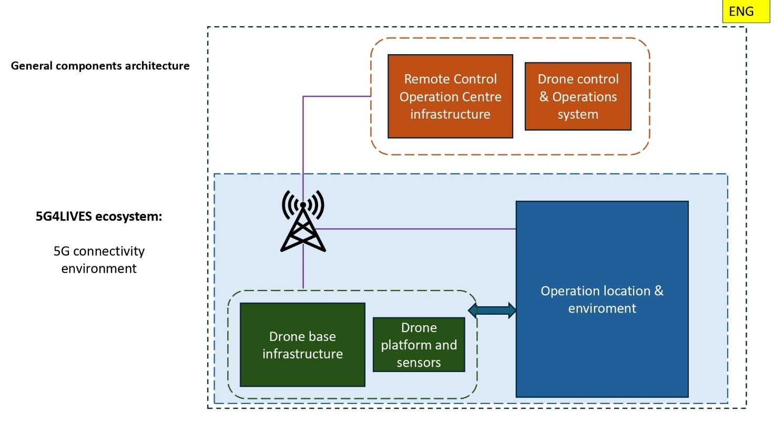
  - picture General compotents architecture
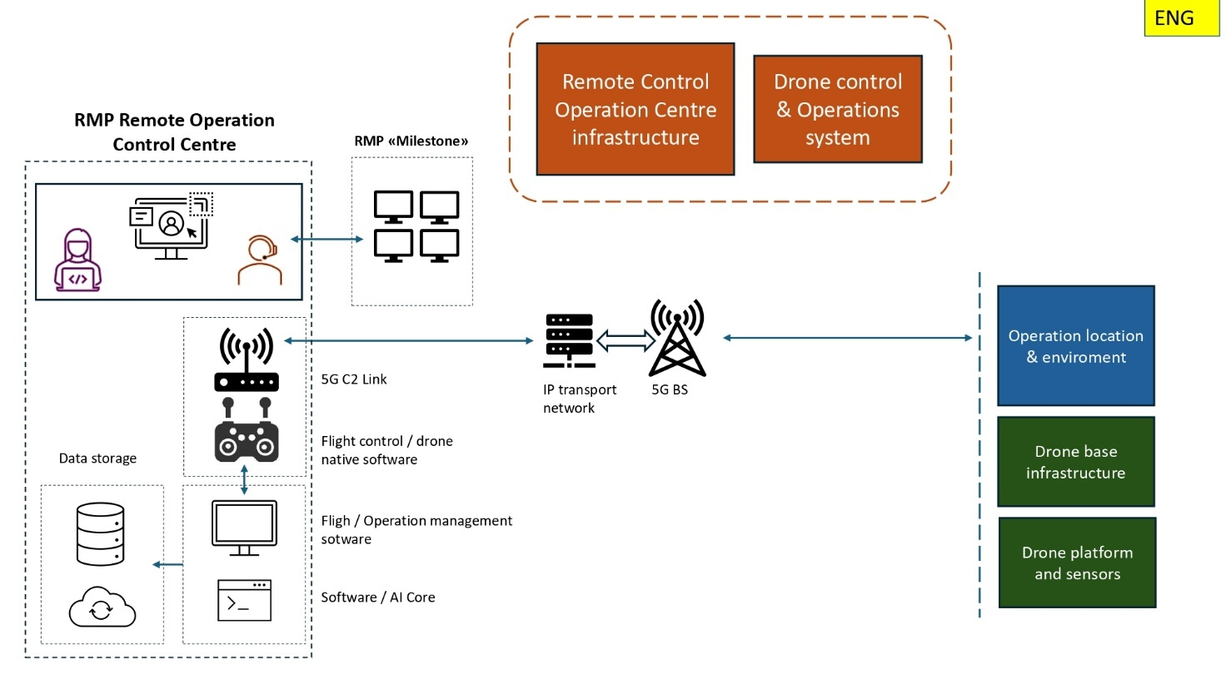
  - picture Remote operations control centre
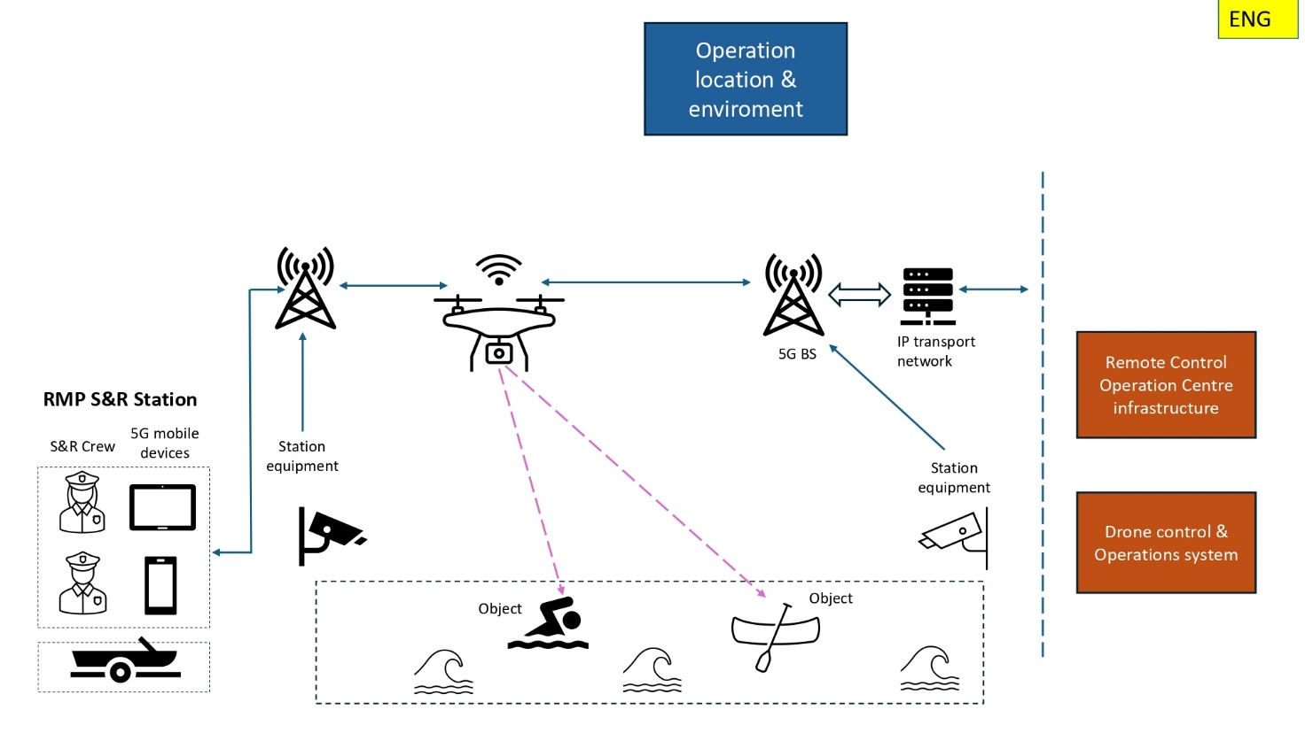
- picture Operation location & enviroment

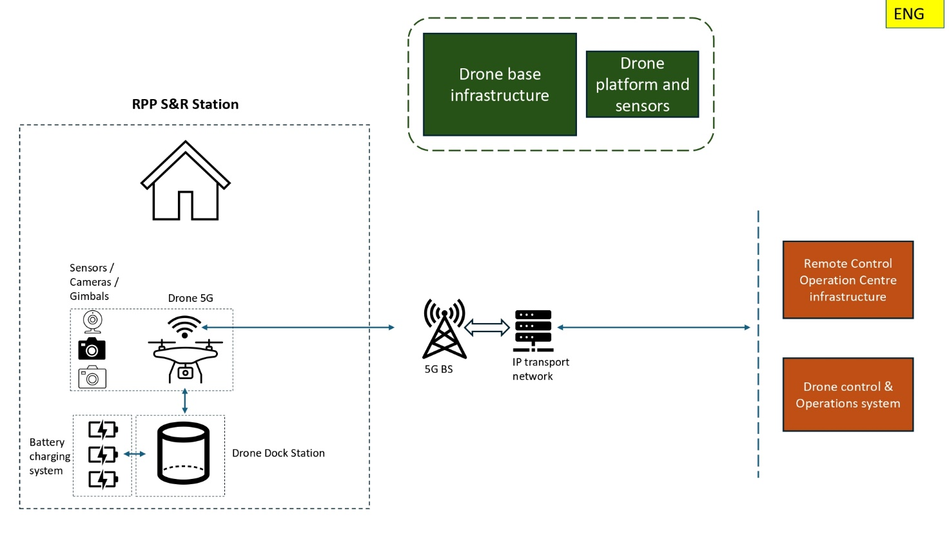
- picture UAV base infrastructure

Annex 2
Overview of the 5G4LIVES project
In Riga, there are nine swimming areas where lifeguards operate. One of the competencies of the Riga Municipal Police is to perform rescue operations at the swimming sites of Riga city. In addition, residents of Riga also swim in other areas where there are no rescue stations and which are not monitored by the police, prompting an increase in the management area of the police officers, at least covering the territory of all nine swimming sites. Currently, 2-3 lifeguards per station monitor the public beach area, which will be a very demanding and tiring task.

Project "5G for a Better Tomorrow: Protecting Lives and the Environment in Riga and Turin" (Hereby - Project) aims to provide real-time aerial situational awareness and automatic vulnerability assessment for at-risk areas through the dynamic fusion of 5G connectivity and unmanned aerial vehicles (Hereby - UAV). The project in Latvia involves using drones and 5G technology for monitoring and rescue operations, especially at Vecaku Beach and Kisezers Lake in Riga where the 5G network will enable real-time control of unmanned aerial vehicles (UAVs) to monitor large recreational areas in emergency situations and transmit high-definition video and sensor data, allowing monitoring of search and rescue operations, identification of persons at risk (in water or on ice) and monitoring of possible safety hazard zones. Each location has the existing static infrastructure - a rescue station. The use of an UAV rescue situations should be ensured both in summer and winter weather.

In addition to the municipal police of the city of Riga, other partners based in the Republic of Latvia are involved in the project:

- The municipal agency of the city of Riga "Riga Digital agency", which provides administrative and coordinating support in the implementation of the Project's activities, as well as providing technical expertise in the provision and management of the ICT solutions provided in the Project.
- The state capital company "Elektroniskie Sakari", which ensures the management of the radio frequency spectrum and numbering, as well as the issuance of permits throughout the country, while adapting it in the selected pilot areas to the needs of the Project.
- LTD "Latvijas Mobilais Telefons", which in the Project provides 5G data transmission coverage, infrastructure construction in the pilot areas, as well as system architecture planning.
Successful use of UAVs in the Project would ensure the following improvements in performance indicators:

- Decrease in reaction time for law enforcement.
- UAV deployment level.
- An increase in the proportion of successful rescue operations.
- Faster decision-making time.
Existing UAV deployment description
The RMP also have separate unmanned aerial vehicles (UAVs) under direct operator control, which allow for the observation of swimmers. These UAVs allow for surveillance with both a regular video camera and a thermal camera. However, considering that the flight duration of these UAVs is not long and a pilot is required to operate them, these drones are used periodically. Due to staff shortages, lifeguards at the rescue station often do not have the opportunity to continue piloting the drone if a person with an injury arrives at the station who needs first aid, or a parent who has lost a child. Thus, at this moment, the primary observation of the swimming area is performed by a person with a boat. However, when the person with the boat is on a break, a drone is used, which can also give audio commands to a person who has swum beyond the buoys. It should also be mentioned that in cases where rescue operations are required, such as pulling a drowning person out of the water or performing resuscitation measures on the shore, all police lifeguards will be involved. Currently, it is not possible to use regular UAVs for the coordination of rescue workers, as the drone pilot also has to be in the boat and go to sea. In addition, if the drone is already up, the pilot has to bring it back, which takes a certain amount of time, which can be critical in the case of performing rescue work.

Cases where it is useful to send a drone with or without employee involvement:

- Information has been received that a person needs help in the water and the accident site is not in the lifeguard’s field of vision.
- Information has been received about a missing person with specific characteristics (clothing, swimsuit) and the accident occurred outside the lifeguard’s field of vision.
- When a person is noticed swimming beyond the swimming area boundary - buoys.
- In case a large crowd of people is observed in a specific place, which could indicate a possible accident.
- When information has been received about a dead wild animal.
- When information has been received about an animal in the swimming area that is outside the lifeguard’s field of vision.
- First aid (cut hands, legs).
- Monitoring of navigation devices so that they do not swim in prohibited areas.
- When information has been received about a victim who has swum far from the shore, but the accident is outside the swimming area, is not in the lifeguard’s field of vision.
- Received news about an exhibitionist or some other suspicious person or group.
The vessel is sent:

- It is noticed that the victim in the water needs immediate help (shouting, attracting attention, or drowning).
- To perform daily patrols.
- When information has been received or noticed that a person is drowning or has gone underwater in the water part of the swimming area.
- When a person refuses or ignores the request not to swim beyond the swimming area boundary - buoys.
- The presence of fishing nets in the swimming area.
Preferred UAV use and rescue operation scenario
The project aims to operate a fleet of UAVs as Beyond Visual Line of Sight (Hereby - BVLOS) flights in a dynamic, complex, populated environment, using native communication infrastructure with safety and cybersecurity considerations. The system will provide a fleet of UAVs with a high availability level, ready to execute a mission on demand. The described three territory stations will be equipped with two UAV solutions, each consisting of a UAV, network remote ID, payload (camera), and docking station (drone-box). The docking stations will be installed on existing infrastructures, such as roofs, and will be used to store, protect, and recharge the UAVs. The UAVs and docking stations will cooperate to open/close the roof and start/stop recharging. The UAVs will operate in a special UAV zone, which will be defined for each area to increase air, ground, and operation safety. Each area will be under continuous surveillance, with peak periods during the summer when warm weather attracts people to public beaches for sunbathing and swimming and during the winter when freezing lakes and the sea attract people to do winter sports like skating and ice fishing.

Cellular connectivity, particularly 5G, will be used as the primary communication channel to control the UAVs and send/receive live video feed. Network availability forecast solution will be used to increase flight safety by network availability prediction and almost real-time information. UAVs pilots will be able to create and launch automatic UAV missions to perform regular area surveillance with point of interest. Each use case has different goals to achieve and different restrictions or limitations due to geographical and regulatory aspects, hence, each use case will be looked upon separately.

Basic operating scenarios are stored in the Project platform, and according to the schedule or specific operation call, the Remote Pilot selects a scenario, ensures the possibility of operation according to the checklists and OM, and activates the scenario. When activating the scenario, special tools supporting BVLOS capability components check operational-specific parameters. Tactical corrections to the saved operating route and other flight parameters can be made based on the responses received from the 5G4LIVES platform tools. Thanks to the platform's automation and special tools, checking, tuning, and activating the scenario takes minutes.
Monitoring is carried out during daylight and night hours, with a specified number of operations per period. This activates the scenario according to the schedule or on demand, and the following components of the 5G4LIVES platform are activated:
- UAS GCS;
- BVLOS Capability support tools.
- UAS Dock-station systems.
- UAS Platform.
- Network UAS ID broadcasting.
- Operations management software platform.
- Tools and components with AI and automatization capabilities.

Table 1. Improvement processes based on identified difficulties
Problem/ Difficulties | Solution | Enabling technologies
Limited personnel for UAV management | Automation and semi-automation of UAV operation | - 5G Network  - UTM tools and systems  - Mission planning and control software  - Drone with 5G and BVLOS capabilities  - Software and applications based procedures and processes  - Monitoring hardware with 5G capability  - AI-based components for automation of data processing
Need for quick and accurate interpretation of information received from drone | Data processing and postprocessing with appropriate visualization | - 5G Network  - Image processing  - Tools for information receiving and processing with 5G capabilities  - High resolution cameras and sensors with 5G network transmission capabilities  - Gimbal with capability to send online axis position data  - AI-based components for automation of data processing  - User-centric interface
Need for information retrieval during nighttime | Data processing and postprocessing with appropriate visualization | - 5G Network  - Image processing  - Night vision capabilities camera
Need to provide audio information close to objects | Special payload equipment installed into UAV for voice command repeated (online / recorded) | - 5G network  - Loudspeaker installed into payload / drone
Need for geolocation parameters of objects | Special hardware / software integrated into UAV sensors and systems | - Gimbal with capability to send online axis position data  - 5G Network
Need for quick deployment of UAVs | Automatization and digitalization of components and processes | - Doc-station with platform support automation  - Digitalization of procedures and operations  - Near real-time data flow and processing

EIROPAS PARLAMENTA UN PADOMES REGULA (ES) 2016/679 (2016. gada 27. aprīlis) par fizisku personu aizsardzību attiecībā uz personas datu apstrādi un šādu datu brīvu apriti un ar ko atceļ Direktīvu 95/46/EK (Vispārīgā datu aizsardzības regula).
Ja mainās likumdošana Pasūtītājs izmantos spēkā esošo likumdošanu.
Derīgā krava - instrumenti, mehānismi, iekārtas, daļas, aparatūra, piederumi vai papildierīces, tostarp sakaru iekārtas, kas uzstādītas gaisa kuģī vai piestiprinātas gaisa kuģim un ko neizmanto vai ko nav paredzēts izmantot, ekspluatējot vai kontrolējot gaisa kuģi lidojumā, un kas nav daļa no gaisa kuģa korpusa, dzinēja vai propellera.

